S H E F F I E L D C I T Y C O U N C I L
CYCLE FORUM

Minutes of the meeting held on Thursday 17 February
at 5.00 p.m. online

1. APOLOGIES FOR ABSENCE/ATTENDANCE
Apologies were received from Insp Kevin Smith (South Yorkshire Police)
In attendance: Cllr Peter Price (Chair), Andrew Rodgers (Cycle Sheffield), Cllr Ruth Mersereau, Yvonne Witter, Paul Sullivan (SCC), Rob Wormald, David Holmes, Tom Mutton, Jamie Irvine, Cllr Richard Shaw, Simon Ogden, Jo Maher, Simon Geller Andy Buck, Lenny Fairhall, Greg Challis (minutes)
Guests: Neal Byers and Grant Martin
2. NOTES OF DECEMBER FORUM
The notes of Cycle Forum meeting held 16 December 2021 were reviewed. A
correction was required to make it clear that the connections to Kelham Island referred to the Rutland Road crossing not Ball Street bridge.
With that amendment, the notes were accepted as a correct record.

3. SHALESMOOR GATEWAY PROJECT
Neil Byers and Grant Martin from Nota Bene Consulting introduced a presentation about the proposed remodelling of this Inner Relief Road (IRR) junction.
Funding would be sought via the DfT’s Major Road Network “pot” which was
available for roads connecting motorways to local neighbourhoods such as the A61
Penistone Road. The proposed scheme would cover the section from Rutland Road,
including the junction itself, and the current roundabout by the tram stop at Shalesmoor.
The aim was to improve resilience, relieve congestion and help the economy by
assisting productivity as part of Covid 19 recovery thus enabling growth in the
locality. The project also addressed connectivity, both locally to the emerging
neighbourhoods and across Penistone Road itself, between the city’s two hospitals and to the Parkway/M1.
Challenges at the location included: traffic congestion, private traffic impinging on
operation of the tram network, the need to enable further growth – particularly in
Kelham Island and Neepsend – air and noise pollution, improving active travel links. These at alongside the broader need to address the climate emergency and help contribute towards net zero carbon.
As part of a wider plan for the city, improvements were needed to the active travel networks, ensuring connections to the Transforming Cities Fund projects. Any
redesign therefore had to address how to enable, particularly local, trips to be made more safely by walking and cycling; such interventions would need to meet
requirements of LTN 1/20. The needs of different users had to be balanced in a multi-modal rather than a purely highways scheme. The locality needed to be shaped in a positive fashion, with user friendly spaces and improved public realm as part of a new gateway to the city, linking to the tram and city centre.
At Shalesmoor Junction reducing conflict between different transport modes was
essential, with greater priority for pedestrians and cyclists at crossing points.
A key requirement was to address the lack of a controlled crossing for pedestrians and cyclists at the junction with Rutland Road and the absence of a right turn out of Rutland Road onto the A61 for motor vehicles given how this influenced journey
decisions.
A variety of options had been considered before arriving at a preferred design to support the Business Case. It included a remodelled Rutland Road junction with
additional capacity including new vehicle lanes, a dedicated right turn lane and a right turn exit. A controlled segregated crossing for pedestrians and cyclists would be provided across Rutland Road.
Turning movements would be rationalised at the A61 junction with St Phillips Road; removing the right turn for vehicles would make it buses only and improve both bus and tram reliability.
At a remodelled Shalesmoor Gateway movements again would be rationalised with traffic signals replacing the current roundabout; all multi crossing points would be
replaced with Toucan crossings resulting in a more efficient operation for all users. A 4m wide cycle track would again be provided linking to the east of Penistone Road with better connections to A61 crossing points. A dedicated Toucan crossing towards Green Lane on Penistone Road was proposed along with nearby improved green space.
Overall, the proposals would improve safety and create a sense of arrival at a new gateway to the city for all users. It would reduce severance caused by highway and tram at this location. Longer term impacts included the creation of a more attractive area, more reliable public transport, better connected communities, improved active travel take up, easier connections to the wider transport network and reduced
congestion leading to less pollution.
The next steps were seeking feedback from engagement prior to submission of the OBC to Government in Spring 2022; a decision was expected in the summer, before further engagement to Full Business Case and construction to start by 2024.
Questions and comments were invited from Forum members.
The following has been supplied by Nota bene as a reflection of the points raised (there may be some duplication with the above text)
Following the presentation of the slides, a number of questions and points of clarity were recorded from members of the forum, these are captured below along with the initial responses provided by Nota Bene Consulting:

Attention was drawn to the NCN route 627, making sure the project team were aware of the route and to ensure this is not compromised as the scheme evolves.
Has there been any modelling or analysis which indicates when the proposed scheme will reach capacity in the future?
NB Response – future year analysis has been undertaken for the business case in line with guidance. The modelling has identified that there are other elements of the wider highway network which would likely experience capacity issues in the future which will contribute to operational constraints. These issues have been flagged to SCC for inclusion in future strategic studies, and to inform prioritisation of new schemes.
Current issues with cyclists passing over the tram tracks, and indeed personal experience having fallen off my bike while crossing the tracks. How will the scheme look to address these issues?
NB Response – Aware of the issue and also experienced the challenges in cycling over the tracks. The scheme aims to facilitate and encourage cyclist away from the tram tracks, with a desire to accommodate cyclist on the northern side of the A61, with clear crossing points for those cyclising travelling south.
Some concerns with the reference to segregated cycle and pedestrian areas and whether this creates a false sense of safety.
NB Response – The segregated cycle track along the A61 was identified through various discussions as a key feature for this latest scheme. The design reflects best practice and the latest design guidance in developing the layout, to provide for
different users whilst accommodating existing demands and services within the
community.
Some concerns with the routing of cyclist through/around the Shalesmoor junction, latest scheme will increase journey time/distance versus passing straight through the junction as currently provided.
NB Response – noted and agreed that off-road routes may be longer than on-route options, and this will be explored through the detailed design of the scheme. On balance, the scheme aims to provide a safe and pleasant cycle route versus a direct route which requires cyclist to mix with motorised vehicles. In providing for off-road routes it is an objective of the scheme to encourage more cycle trips which will
include new cyclists who would benefit from quieter routes.
How does the scheme accommodate cyclists to the south of the A61, the scheme includes areas of shared space but it is unclear what is available for cyclists.
NB Response – this was not directly responded to during the session, however the scope and extents of the scheme were noted in terms of providing and
accommodating for future connections as these come forward as different projects. Scheme aims to facilitate and indeed encourage opportunities and avoid
compromising wider routes/connection should these be identified for investment.
Has the modelling taken into consideration the development sites which have been identified in the local area, particularly Housing Zone North.
NB Response – yes, the future year modelling takes into consideration sites which are identified within the local plan as part of developing forecast growth in demands. A number of the surrounding sites are included as individual sites, with agreement from SCC on the appropriate trip generation from each, this includes a reduced trip rate where sites are planned as car free or low car ownership sites.
Will the new signals include pedestrian and cycle priority at crossing points, and also priority for the tram?
NB Response – the detailed design of the signals will consider opportunities for on demand crossings and optimised network operation. The tram currently benefits from priority, and will feature in the new layout.
Does the scheme include a reduction of the speed limit on the IRR?
NB Response – the function and role of the IRR is important in the wider context of the highway network, and delays or disruption to the IRR has the potential to cause traffic re-routing onto local roads which should be avoided. One of the objectives of the scheme is to ensure the function of the IRR is not compromised. The current scheme does not include a speed reduction on the IRR.
Why has the cycle track been stopped at the Green Lane junction, could this not continue parallel with the A61?
NB Response – we are aware of wider plans for Green Lane as part of the
Connecting Sheffield project, it was agreed to stop the scheme extents for Shalesmoor Gateway at this point. It is envisaged that Green Lane would be a
continuation of the cycle route leading toward the city centre, albeit not direct.
Cyclist would still have the opportunity to continue beyond the cycle track as shown and connect back onto the A61 beyond the bus lane.
Can anything be done to facilitate cyclists crossing two lanes of traffic after the Shalesmoor Gateway, if trying to get across to make the right turn into
Gibraltar Street?
NB Response – noted and agreed to record this for review at detailed design stage. There is a similar issue with buses having to cross these lanes of traffic in order to make the right turn, although acknowledged not as challenging as it would be
cyclists. The Green Lane route would avoid this issue and lead cyclist to the
crossing at Russell St, albeit this is a longer route than the on-road alternative.
Whilst the focus of the discussion was the Shalesmoor junction, it was noted that the Rutland Road plans were well received.
Confirmation on next stage and timescales, with detailed design likely to commence in summer 2022 with the potential for consultation later in the year.

4. SCHEMES UPDATE
Paul S ran through an update on the latest with all the cycle schemes.
Cycle Hub City Centre – RFQ about to be issued, just waiting on written
confirmation of rental amount
Fit out to be complete if not well underway by September 2022
Cycle Hub OLP – Funding confirmed- business case being progressed. Not certain of any deadlines
Connecting Sheffield schemes funded through TCF (2b) these are now in or about to begin the tendering process, this gives an indication that schemes are around 10-12 months from commencement on the ground.
Nether Edge/City Centre - tender being combined to be issued late March early April
Pinstone Street issue has been resolved, now seeking options for the city centre bus route
Kelham Island/Neepsend – contractor appointed -should be on site by December 2022
Darnall/Attercliffe – tender to be issued March /April, largest of the schemes so will be final one complete - as it stands we estimate completion June 24
Magna/Tinsley – given the scale of the scheme it is likely this will be handed to Amey direct to deliver, so this may well end up being the first of the TCF2b schemes delivered
Active Travel Fund 2 schemes -all to be delivered this year
Sheaf Valley Phase 1 experimental measures implemented Spring 22, permanent measures Summer 22
ATNS -Crookes and Nether Edge implementation Spring 22. Significant lead in time to order planters, and then to marry that up with the Experimental Traffic
Regulation Order so we are not storing them for too long if at all. The crossing points should go in as the first measure, the request for these was prominent during the
initial consultation. Three are being installed in Crookes and two in Nether Edge
City Region Sustainable Transport Settlement (CRSTS)– covered at an earlier
forum by Matt Reynolds , this will predominantly fund a connection between the city centre and Northern General Hospital. Our allocation was reduced so we will not be delivering as much as we had hoped.
Active Travel Fund 3 – We have had an indication that we will be getting a reduced allocation. We should hear in March but there has been a delay while we believe
Active Travel England oversee applications. They have some interim posts but are in the midst of appointing to permanent roles.
Smaller schemes
Repairs and improvements to the access point at Smithywood at the top of
Blackburn Valley, reinforcing the restriction while creating an improved access for standard and non-standard bikes.
Sandford Grove cycle lane protection - delayed should be onsite end of March.
Extending the build out, additional bollards, relocating existing bollards. If this doesn’t work, then we have a further measure we can install.
Prince of Wales Road, under the rail bridge at Darnall, removing the raised cycle lanes and replacing with something a bit better (but will not be to LTN1/20) Scheme in preliminary design, expecting detailed design and costings in April, hopefully with a May delivery.
Leaveygreave/Ring road segregated crossings, issue with the call forward for peds and cyclists. This is being progressed, but just waiting on a price to fix.
5WW barriers alteration to a number of barriers starting at Tinsley South Tramstop, Newhall Road, and a change to the access where the Upper Don Trail emerges at Bridgehouses opposite Tesco. All ordered should be altered in March.
NCN 627 barrier alteration – more significant interventions panned for section of the national cycle network from Manor through to Shirebrook. These new barriers being proposed will allow non-standard bikes through. We will including the clean air butterfly as the symbol in the middle of the barrier. Just waiting on final designs from Sustrans.
Netherthorpe Road underpass – in detailed design, aiming to be built April /May
Cycle stands -this year’s small programme to be installed in March
Little Don Link - minor improvements underway but should be complete in the Spring
Bridge Hill Oughtibrdige – to be delivered Autumn 2022, no longer a closure but a mandatory right turn plus pedestrian priority across the junction
Questions
Clarification was required on where exactly the interventions were taking place on the Little Don link these would be at Deepcar, with some additional vegetation
cutback at both Deepcar and Stocksbridge
Needs signing from Fox Valley. PS to investigate with Highways DC
ACTION PS
Two questions from Cllr Mersearau
Update on school streets, and parking at rail stations
School streets going well, being run on a trial basis, we have a waiting list of other schools interested but would need to speak to the person responsible for the scheme to get more detail. Eight being trialled at the moment, one proposed through ATF 2
ACTION PS
Dore station parking has been installed, vast improvement but in the future we would look to upgrade further.
Meadowhall, SCC is making a contribution, Northern Rial informed us this would be on site in March.
5. SUSTRANS
Southey Green proposals – Lenny Fairhall went through some ideas for developing a light touch route in the north of the city connecting Tongue Gutter across to
Grenoside. He explained with some minor interventions, use of parallel access road, some build outs, 20mph speed limits etc. the following could be achieved see plan below
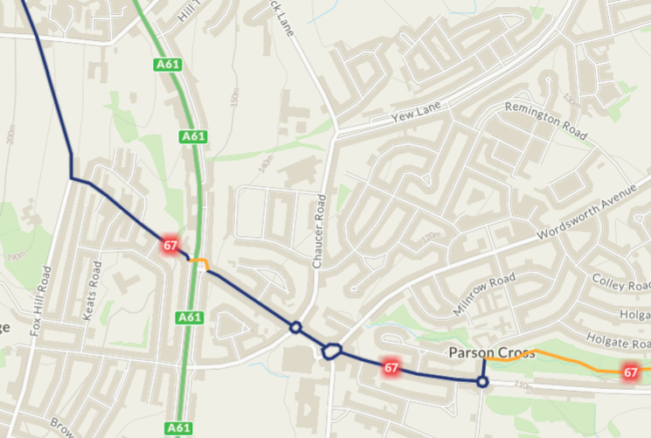
Blue solid existing, dotted line alternate route
Current situation:
1 – Off road cycle path, Tongue Gutter, ends at Holgate Avenue. Route goes left on Holgate Avenue.
2 – Route joins Deerlands Avenue at roundabout.
3 – Route follows Deerlands Avenue to junction with the A61. It is a suburban main road which is busy with traffic leading to a large school, Chaucer Academy, and an Asda supermarket as well as other shops.
4 – Busy roundabout where Deerlands Avenue meets Wordsworth Avenue outside Asda Supermarket
5 – Further roundabout at junction with Chaucer Avenue.
6 – Steep climb up Cowper Avenue to Fox Hill Road, leading to a right turn onto Fox Hill Road, which is busy in both directions.
7 – Fox Hill Avenue busy traffic up to Skew Hill Lane.
This whole section of route NCN 67 feels unsafe and unpleasant to ride.
Alternative route
1 - Holgate Avenue, Margetson Road, Margetson Crescent, Knutton Road, Remington Road, Dugdale Road, to Yew Lane.
2 – Yew Lane service road
3 – Off Road cycle path behind Mansel Primary school from Yew Lane to Halifax Road service road.
4- Halifax Road service road to Wheel Lane.
5 – Salt Box Lane to Fox Hill Road
Sections 1 to 4 need minimal infrastructure – signage mainly.
Section 5 Salt Box Lane requires traffic calming measures in addition to signage.
Suggested possibilities:
- 20 mph speed limit
- Rumble strips on West to East direction.
- Build- outs to constrict the route at both ends of Salt Box Lane

Discussion bullets
- Minor concerns were raised over Saltbox Lane, volume and speed of traffic
- Possible intervention with traffic calming and speed limit combined may solve that? Use of build outs etc
- First impressions that any route along Saltbox would need segregating, and any crossings of major roads would need similar treatment
- Worth pointing out that in discussion with Sustrans over route rationalisation then we would not be investing in this particular route, as its likely to be dropped from the National Cycle Network
- However some of the route could be delivered through the installation of Active Travel Neighbourhoods -this area is prime for it
- Worth also bearing in mind everything we do now has to be LTN1/20 standard, if not its unlikely to get funded, or blocked by Active Travel England
- Regardless of NCN status, tongue gutter is still a good piece of active travel infrastructure, and this route would also benefit mountain bikers accessing Wharncliffe Woods etc
- This route still forms part of the Trans Pennine Trail, irrespective of whether it remains National Cycle Network, and would help utility cycling
- It’s an option to bear in mind once we start to develop routes in the north of the city

2nd suggestion was to connect Penistone Road with NCN 67 at Parson Cross
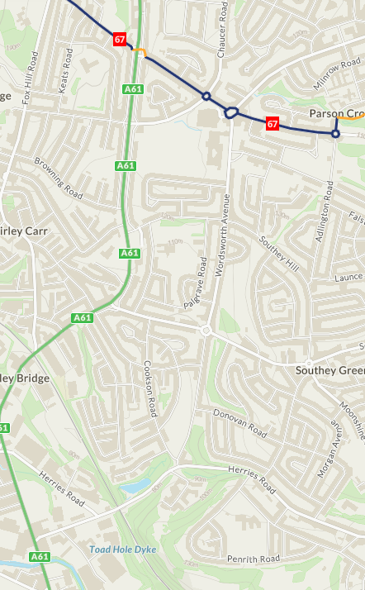
- Herries Road South and Wordsworth Avenue (south of the junction with Southey Green Road) have wide pavements which make them potentially suitable for ‘Shared Use’ for pedestrians and cyclists.
- Wordsworth Avenue (north of the junction with Southey Green Road) could accommodate identified cycle use lanes.

This would effectively create a ‘North Sheffield Circular’ linking with Tongue Gutter, Chapeltown Greenway, the Five Weirs Walk, and the Don Valley Trail.
It would involve using the wide pavement on Herries Road, and the wider pavement on one side of Wordsworth Avenue, then combined with some traffic calming a nice route onto NCN 67/Tongue gutter and connecting into the first proposal. It would also benefit a larger residential area that has no infrastructure.

Discussion bullets
- Part of Herries Road is already a shared use path but runs out after 50 yards or so
- This would provide a great connection into the Upper Don Trail, and doesn’t need too much engineering
- The alignment is on the cards, but we currently have no funding for either of these interventions
- Wordsworth has the room to create a segregated route
- Does everything have to be LTN1/20 compliant, can we not use quiet roads as an alternative
- Yes. Quiet roads will no doubt form a significant percentage of the network in Sheffield, If they either eixist now, or can be delivered using ATN measures to reduce through traffic flows, it’s not all about segregation
- Similar to option 1 this area is prime for ATN interventions
For both it comes down to available funding and that will be down to funding criteria, fit with LCWIP, the propensity to cycle tool and then ultimately what is presented to councillors. As mentioned, we do have an allocation for Northern Communities in the CRSTS.
If Active Travel Fund continues then we could look to introduce in to northern areas of the city. Crookes and Nether Edge will be trialled this summer so we wil learn form those as we roll them out across the city.
LACs could be approached to fund (fully or part).
Transport Planning need to do some work on an ATN map for the city.
Ranger Update
briefly
30 rangers working around the city
always contacting council to help make repairs, improvements etc
more at the next forum?

6. CYCLING MATTERS
Paul S
Five Weirs Walk update on closed section
Amey have undertaken an investigation, pictures of the investigation were shared with the group, we were now waiting on repair options and costs for each of those options
The investigation took some logistical planning, and quite a bit of time.
Whiteley Woods/Woofindin Ave
There has been quite a bit of discussion about the route along here. The direct route is through a private estate so on a private road, and residents are now blocking that route. There is a route around the back of the area but needs considerable investment to bring it up to standard.
Events
Cycle City Active City is coming to Sheffield in July -2 day event 5th and 6th. Dept for Transport have already been up to look around
Park Hill Uprise
Cobbled hill climb multiple categories including cargo bikes and children’s races. That takes place in May
Later in July there will be a cycle cross event at the Olympic Legacy Park
The Magnificent 7 which typically runs in March is going to be moved to a Sunday in June or July, date to be confirmed. If this works it could be the new permanent date for the event. This year will be the seventh running.
Questions/Discussion
Five Weirs Walk
Cost of the investigation did not look cheap
The planning application by British Land seems to take no notice of the 5 Weirs Walk in the area, they should be installing a controlled crossing of Weedon Street which was conditioned as part of an earlier application.
Woofindin
It was pointed out that the private road at Woofindin had been used as a right of way for many years before residents started to get involved
ACTION PS to investigate history
7. ANY OTHER BUSINESS
Next meeting date - bringing it fwd to the 14th Aprilas neither Greg or Paul would be around for the 21st, and the forum needs some continuity from council officers.
This was agreed.
Date of next meeting 14th April 2022 5pm

--------------------------------------

