Commissioning Plan for Adult and Parent Carers

(2016-2020)

YOU are likely to be a carer at some point in your life. This could be at any age whether as a child, teenager or in your 20s and 30s or later in life.

- The word carer throughout this document means someone who looks after a person; a family member or friend because that person would not be able to be safe and well without that help.

- This document sets out a Commissioning Plan for the following population: adults who provide unpaid support to family or friends. The person they may care for may be an adult or child.

INTRODUCTION

- In Sheffield, the City’s Carers Board is chaired by a local Councillor and has had strong political leadership to drive the development of the Framework to Improve Carers Lives (2016-2020).

- The Framework to Improve Carers Lives (2016-2020) has been informed by local carers, national policy and effective practice. This Plan should be read in conjunction with the other documents which make up the framework, please follow the link for more information
https://www.sheffield.gov.uk/caresupport/carers/carers-strategy.html

- The Plan will articulate how Sheffield City Council will deliver their part of the Carers Strategy and will outline the Council organised services only.

- The Council is a key partner and committed to supporting and improving carers lives but this plan is only part of the picture and this document does not intend to cover partners’ services.

HOW THIS COMMISSIONING PLAN IS SET OUT

A: THE FUTURE

- Section 1 STRATEGIC CONTEXT
- Section 2 CURRENT SERVICES AND WHAT CARERS HAVE SAID
- Section 3 COMMISSIONING INTENTIONS

B: BACKGROUND

- Section 4 POLICY
- Section 5 THE STRATEGY
- Section 6 NEEDS ANALYSIS AND TARGETED SUPPORT

PART A: THE FUTURE

SECTION 1: STRATEGIC CONTEXT

- The Council is committed to reducing inequalities in the city – a theme that features prominently in the city’s Health and Wellbeing Strategy.

- The Council is committed to supporting people to achieve good health and wellbeing. Carers can be at a particularly high risk of negative health outcomes and poor overall wellbeing.

- This Commissioning Plan is also set within the context of the Communities Portfolio’s priorities, particularly ‘People Keeping Well’, which includes a commitment to proactive outreach services for people at high risk of poor outcomes.

- The Council has committed dedicated commissioning resource to implement the Commissioning Plan

WHY: should we support carers?

- 1 in 10 people in Sheffield are carers; they are a hidden community that is a huge strength for the city.

- We know in the future there will be fewer public services but a greater demand as more people are living longer, (possibly not be in well health). Therefore building family and community assets and resources will be important because caring will become more vital to us all.

- With the reductions in public spending, we need to find innovative and different ways to do more with the available funds.

- It is difficult to monetise caring, but there are tangible benefits to commissioners and funders to providing services to carers, in summary they are:

- Reducing the need for emergency health and social services interventions because of carer breakdown
- With the right support, reducing emergency hospital admissions (for carers and the cared for person)
- Carers (with the correct support or training) could aid the recovery of their cared for or slow down the progression of the person’s condition (where appropriate)
- Reduction or delay of statutory services for the cared for person

SECTION 2: CURRENT SERVICE AND WHAT CARERS HAVE SAID

Current support for carers

- There is a significant amount of support for carers in the city delivered by statutory and commissioned services. It ranges from:

- Carers specific support services purchased by the council
- Adult social care
- Services for cared for people via adult social care packages
- Support from primary and secondary care e.g. GPs and hospitals
- Services and support from condition specific organisations and charities e.g. dementia, cancer

- For the details of current Sheffield City Council services for carers and contracted provision please see appendix 1

What did carers tell us? – what it is like NOW (2015/16)

- Overwhelmingly carers have told us:

- They are resilient people but how services are delivered (or not) for the person they care for can be a significant barrier and make life more difficult
- Caring can impact on all areas of life – carers should be able to continue to have a life alongside caring i.e. be in good health, have a social life, be able to balance working and caring.

- Carers told us about their lives through 1:1 conversations, support groups, workshops and a questionnaire (approx. 750 respondents). The issues raised can be grouped into the following areas:

- My role as carer
- The impact of caring on my life
- Interacting with services for the person you care for

Further detail of the issues raised are listed in appendix 2

What could carers’ lives look like? – THE FUTURE

- The following are examples of how the world could be for carers through:

- Changes to commissioned services to support carers
- Implementation of wider carer strategies

- Mrs Khan is attending an English class at her local community centre which is part of the local Community Partnership (People Keeping Well); the tutor learns that she cares for her mother-in-law who has dementia. The tutor is aware of a number of other women in a similar position and has introduced them to Mrs Khan. She has asked if she would like a referral to the Social Prescribing Service and someone can come have a chat about what support is available.

- Mrs Bales has been referred by her community nurse to the Community Support Service which is part of the People Keeping Well programme as she keeps visiting the doctor with low level anxiety . She seems to be very isolated, as she is caring for her husband. The worker has talked to Mrs Bales and has identified a gentle exercise class and a volunteer led support group at the community centre. Mrs Bales is now seeing more people and is not visiting the doctor as much.

- Mrs Jones husband had had a stroke and is in hospital:
  - The volunteers in the cafes and shops in the hospitals have identified that Mrs Jones is a new carer through her daily visits – they have given her some information on a stroke and what it might mean when he gets home
  - As part of the discharge of Mr Jones – someone from the local Carers service has given Mrs Jones early advice and support in the ward

- Marjorie Whitley cares for her son who needs supervision whilst not at day services. When she rings the doctor for an appointment for her own health condition, the receptionist realises there is a flag on her record identifying appointments need to be at a flexible time. Marjorie is able to make an appointment whilst her son is at day care tomorrow rather than being offered a same day appointment and unable to organise support for her son.

SECTION 3: COMMISSIONING INTENTIONS

How will we make the FUTURE reality? What we plan to DO…

- Supporting carers is everyone’s business. Improving carers’ lives will not happen just through services aimed directly at carers but also by changing behaviour of the workforce and the services that support service users and interact with carers.

- Finding and identifying carers earlier and equipping them with the right support for them and their family is seen as the best prevention to carer breakdown (NB support - this does not need to be statutory and in many cases it is not)

- Through this Commissioning Plan, the Council will outline how we will contribute to this change. The changes have been identified through co-production activities with carers.

- We will make STEP CHANGE to improve carers lives by:

- Changes to council tendered carer support services

- A menu of different options for breaks (see Section 33)
- Community based outreach to help find hidden carers (see Section 38)
- Core city wide contract including the statutory duty carers assessments (see Section 47)

- Changing behaviour of the wider society and services to carers e.g. employers, doctors, family and friends and getting services that support cared for people to recognise and support carers

- General awareness raising campaign (see Section 56)
- Sheffield Standard – for organisations who will interact with carers e.g. social care providers, housing, GPs, hospitals, employers (see Section 59)
- Sheffield Carer Card (carer passport) (see Section 61 )
- Advocate changes in Adult Social Care (see Section 65)

The diversity of carers

- Although the issues that carers face are similar, the solutions to enable carers to continue to care will be different. Providers and services will need to take account of the following:

- that more men are caring and this will continue to increase
- carers are providing more hours of care
- differing caring situations, the following is a list of some examples and is not exhaustive:
  - Parent carers
  - Caring for partner due to frailty and being elderly
  - Caring for a disabled spouse
  - Caring for parents who don’t live in the same house
  - Sandwich carers – caring for elderly and other family members
  - Lifelong caring, from birth – learning disability or other disability
  - LBGT carers
  - Carers within the black and ethnic communities
- the cared for situation e.g. differing conditions, long term conditions and disabilities, whether they live together, or they are a family member or friend

Contracted carer support services

- See the diagram below detailing the existing commissioned services for carers and how they will transform (due to start January 2017)

NB Current contracted services are for adults who care for adults who reside in Sheffield. New services will support any adult care - they may care for an adult or child.

FUTURE
CURRENT

Carers Assessments

- One of the most ambitious changes outlined in this Commissioning Plan is including carers assessments in the new ‘core city wide support service’

- Currently, carers assessments are delivered by Adult Social Care.

- Anecdotally and evidenced by the carer scores in the Adult Social Care Outcomes Framework, it is clear that some carers are not satisfied with services provided via the council.

- Therefore this important statutory duty (as set out in section 10 of the Care Act 2014) will be tendered to a provider who will undertake this service on behalf of the city council.

- This new approach will enable
- An end to end holistic service for the carer
- A dedicated assessment and approach that concentrates on the needs of the carer
- To separate possible conflicts of interest with the needs of the cared for person.

- The provider will undertake the following activities:

- Assessment of the carer
- Determination of eligibility in line with the eligibility regulations
- Allocating a personal budget (if required) in line with criteria set out by the Council
- Developing a support plan
- Helping identify services
- Managing the overall budget available to support carers

Future contracted carers services:

Breaks – ‘respite’
- Current: ‘the following outlines the current ‘short break’ options for carers:

- Tendered carers services:
  - Weekly sitting service
  - Time for Me: short break grant fund

- Adult Social Care via a social care package
  - Specialist respite e.g. for mental health, dementia or learning disabilities
  - Nursing or residential care respite
  - Day care / opportunities

For more details of existing provision see appendix 3
- What carers have told us about having a break:

- 68% of respondents to the questionnaire said that caring had had an impact on going on holiday.

- People wanted a Sitting Service which had personal care as part of the service
- Carers want more or some activities for the person they care for – this enriches and engages the person they care for and gives them a break from each other
- Carers don’t always want a break from the person they care for, but support to socialise with the person they care for
- Anecdotally carers don’t go on holiday as they are unable to pre book a short stay bed in either residential or nursing accommodation (the occupancy rate is over 90% - see appendix 4 for more information)
Future

- We will end the existing commissioned Sitting Service for carers that has had little flexibility and has reached less than 1% of Sheffield’s carers

- The existing monies will be reinvested in carers services to provide a greater range of options

- The following list outlines the short break options that will be implemented via commissioned services and adult social care

- Commissioned support services for carers
  - Continued Short breaks fund – ‘Time for Me’
  - New: Respite broker – someone to help organise a break e.g. respite for holidays, bed vacancy bureau or day activities
  - New: Carers assessments will identify and fund short break requirements
NB these activities will be part of the ‘core’ carer support specification

- Adult Social Care – for those cared for people with eligible needs
  - Continued Short Breaks
  - New: Sitting service via Adult Social Care processes

- Alignment with other commissioned social services - exploring options
- New: to create capacity for short breaks e.g. paid retainer for short stay beds to allow carers to ‘pre book’ respite
- New: to increase more day opportunities for older people

Community support for Carers (finding hidden carers)

- Hidden carers: getting carers to identify themselves as a carer earlier and arming them with appropriate information and relevant tools to continue to care is key to preventing or delaying the need for services.
- Current: although we have 60,000 carers in Sheffield, just over 8,000 are known to carers services. We also know through national research (Carers UK) that the caring population in Sheffield continually changes:

- Approx. 20,000 start caring every year (about. 55 people every day)
- Approx. 19,000 stop caring every year

- A Macmillan survey in Carers Week (2013) identified that over 70% of carers come into contact with health professionals (including GPs, doctors and nursing staff) during their journey. Yet health professionals only identify one in ten carers and GPs only identify 7%.
- What carers have told us: anecdotally, carers have told us that it has taken them a long time to find and access services to support themselves. They have often been referred or found services via an organisation that is supporting the person they care for.

- Society and therefore carers do not recognise the term ‘carer’ or use it readily. Most people use the term ‘carer’ for care support worker – someone who is paid to care.

- Evidence from NHS England, Commitment for Carers states it takes a carer an average of 2 years to recognise them self as a carer. - ‘How do you look for support and help if you don’t know or use the word carer?’
Future:

- People Keeping Well (PKW) in the Community is a strand of Sheffield’s Better Care Fund, Integrated Health and Social Care Commissioning Programme. The PKW approach is focussed on community based prevention activity that can improve people’s health and wellbeing and prevent and delay access health and social care services. For more information about People Keeping Well see appendix 5

- The basis for aligning with the PKW approach is that:

- Partnerships will include at least one GP surgery, therefore providing outreach in primary care
- Many avenues of outreach through the activities of the partnerships – carers don’t need to know they are carers to be identified and supported
- Building an awareness of carer issues in communities and wider society

- We will pool some of the dedicated carers monies with the PKW budget and for this funding we will expect locality based partnerships to:

- Work with local GP practices to identify carers, particularly those who could be at risk e.g. number of hours of care, own conditions, level of stress
- Identify carers through the wide range services the PKW partnership delivers
- Provide low level advice and navigation about accessing benefits and services
- Support carers to build social assets / capital and look after their own health
- Provide carer support and peer support groups

NB PKW partnerships will not have a ‘caseload’ of carers or replace specialist carer support. Where carers are in crisis or close to crisis, partnerships would be expected to refer to the city wide ‘core’ contract

Core city wide services for carers – ‘universal services / information and advice’
- Current: The existing service is a well-received service and receives good feedback, with the carers newsletter rated the most useful by questionnaire respondents.
- What carers have told us: the key thing that carers told us was ‘If you got the services and support right for my family member, I wouldn’t have any needs’

- Whilst this may be true for some, all carers’ needs won’t entirely disappear if support and services are right for the person they care for.

- As outlined in the ‘Priorities’ and ‘What did carers tell us’ sections, carers told us that
- Need help to access information and advice for the person they care for and themselves
- I want help understanding social care
- I need help to understand all the benefits and forms
- I worry about emergencies and planning for the future, especially older family carers of people with learning disabilities – what happens to my (adult) child when I can no longer care for them
- Caring is lonely for me
- I struggle to look after my own health
- I find caring and working difficult
Future:

- This contract will be central to enabling carers to continue to care via a city wide carer core offer of Information and Support will be tendered. This vital resource for carers will build on the effective practice and lessons learnt from the existing provision.

- It will start with a ‘strengths based’ conversation and wholly implement the spirit of the Care Act of prevent, reduce and delay the need for services for carers.

- The Care Act 2014 states the need to ‘consider the person’s own strengths and capabilities, and what support might be available from their wider support network or within the community to help’ in considering ‘what else other or alongside the provision of care and support might assist the person in meeting the outcomes they want to achieve’. In order to do this the assessor ‘should look at the person’s life holistically, considering their needs and agreed outcomes in the context of their skills, ambitions and priorities’.

Changing behaviour of the wider society and services to carers e.g. employers, doctors, family and friends and getting services that support cared for people to recognise and support carers

- Carers have told us that wider society and services to be carer aware and understand the impact and implications of caring e.g. employers, health professionals, family and friends.

- As with the strategy, the following actions will be co-produced with carers and carer organisations and will involve a range of activities:

  - General awareness raising campaign
  - Sheffield Standard – for organisations who will interact with carers e.g. social care providers, housing, GPs, hospitals, employers
  - Sheffield Carer Card (carer passport)
  - Changes in Adult Social Care

Carers marketing campaign
- Current: There isn’t a local or national awareness raising campaign regarding carers
- What carers have told us: they would like to see an active campaign to raise the awareness of professionals, employers and the community about caring and its impact
Future

- Key aim: raise awareness among society of carers

For:
- Hidden carers
- Employers
- Services who will interact with carers and cared for people

We will reutilise existing materials and resources from a previous campaign

Sheffield Standard
- Current: There isn’t a set of standards regarding working with carers for employers, professionals or organisation
- What carers have told us: they would like recognition and understanding from employers and professionals who support the person
Future

- Key aim: raise awareness of carers among employers and organisations that provide services

A set of Standards outlining how organisations should work and support carers. It will also involve an award scheme for employers, health and care organisations.

Sheffield Carer Card
- Current: there is no such this as a carer ID card. Other local authority areas have ‘carer passports’
- What carers have told us:

- Carers and the person they care for have hidden access needs e.g. toilets in a shop, but shop assistants don’t understand as there is no obvious disability
- Carers do not have any formal ID to access carers discounts
Future

- Key aim: a card that will identify carers and access discounts

Advocate changes in Adult Social Care
- What carers have told us: via Quality Live event and anecdotally that Adult Social Care Systems are:

- Confusing and difficult to navigate
- Carers would like a named contact

Future

- Key aim: services and processes are understandable and easy to navigate.

- The Director of Adult Social Care is committed to listening to carers (he is the lead officer who attends the Carer Service Improvement Forum) and is changing services based on feedback from carers and service users

PART B: BACKGROUND

SECTION 4: POLICY

CONTEXT: Sheffield City Council Corporate Plan

- The Council is committed to supporting people to achieve good health and wellbeing. And this is highlighted in the Council’s corporate plan and priorities: Support for Carers: If people are ill, we will help them to access short term support in their communities and we will improve support for carers.

CONTEXT: Communities Portfolio Priorities

- This Commissioning Plan is also set within the context of the Communities Portfolio’s priorities, particularly ‘People Keeping Well’, which includes a commitment to proactive outreach services for people at high risk of poor outcomes. Supporting carers will be integral to the delivery and achievement to all three of these themes.

Care Act 2014

- Along with the moral and economic reasons for supporting carers, the Care Act 2014 legislates the need also to support carers.

- The vision for the Care Act 2014 is that the care and support system should: ‘work to actively promote wellbeing and independence, and does not wait to respond when people reach a crisis point’ (guidance section 2.1)

- Key to this approach is: prevent, reduce and delay people needing and accessing services. An example given for delaying services (section 2.10) ‘improve the lives of carers by enabling them to continue to have a life of their own alongside caring, for example through respite care, peer support groups like dementia cafés, or emotional support or stress management classes which can provide essential opportunities to share learning and coping tips with others.’

- Therefore as highlighted in the Care Act guidance, it is crucial for Local Authorities to also consider carers and enable them to:

- Continue to care (reduce and delay)
- Maintain their own wellbeing (prevention)
- To proactively support the person they care for to either recover or reduce and delay the onset of poor health
https://www.gov.uk/guidance/care-and-support-statutory-guidance/general-responsibilities-and-universal-services

Adult Social Care Outcomes Framework (ASCOF)

- The ASCOF measures how well care and support services achieve the outcomes that matter most to people. Carers who receive a service from the council are surveyed biennially.

- Regarding carers, ASCOF outcomes cover carers reported quality of life; whether carers have as much social contact as they’d like; whether carers are included in decisions and how easy it is for carers to get information.

- The Council’s current carer ASCOF scores (2015) have seen a downward trend since 2013 and are the lowest for all the councils in Yorkshire and Humber.

- This commissioning plan will be part of a number of changes to help improve carers lives.

SECTION 5: THE STRATEGY

THE CARERS STRATEGY: Vision, Principles and Priorities

- Sheffield’s Young Carers and Parent and Adult Carers Strategy 2016-2020 has been co-produced extensively with carers, carer organisations, staff and other stakeholders and it forms the basis of this Commissioning Plan. The following section outlines the Strategy’s vision, principles and the priorities that carers identified:

The vision for Sheffield’s carers is:

- A City where Carers are valued and have the right support to continue to care for as long as they want to

- The Strategy sets out that we want every carer to have:

- a life of their own
- the choice to care and stop caring without recrimination
- equality of opportunity to life chances including education, training, work and leisure activities

Along with enabling families to stay well, we will try to reduce financial hardship.

Principles

- The overarching Principles (below) of the Strategy reflect the needs of all carers:

- Access at the right time, the right type of information and advice for them, their family and the person they care for
- Understand their rights and have access to an assessment
- Have a voice for themselves and the person they care for
- Have regular and sufficient breaks
- Continue to learn and develop, train or work (if they wish to)
- Look after their own health

Priorities

- Throughout the consultation many carers told their stories; the following list of priorities was identified as most important to them:

- Information and advice: I want the information I need, when I need it
- I want good advice to help me through the maze
- If services are right for the cared for person then it will make it easier for me
- Time for me so I can have a life outside of caring
- I want to feel in control and safe and have a plan for emergencies
- I don’t want to be in financial hardship

For more detailed information on the priorities see appendix 6

SECTION 6: NEEDS ANALYSIS AND TARGETED SUPPORT

- The city is not unique in that our carer statistics reflect the national picture – 1 in 10 people is a carer (57, 373 carers in Sheffield). Many people do not see the benefit of saying they are a carer or even identify themselves with the word and the figure in the 2011 census is probably lower than the true number of carers in Sheffield.

- Key points to note:
- There is significant number of new people starting to care every year – approx. 20,000 / 30% of carer population with about 19,000 stopping caring every year
- Carers do not recognise themselves as a carer or use the term for themselves
- Carers do not readily seek services for themselves until crisis point – Sheffield carers consultation
- Caring does not discriminate and the needs of carers are similar e.g. information and advice, need to look after their own health, have a break but the solutions / services required will be different based on:
  - Their age and circumstance e.g. the type of information, advice and navigation an older retired man who doesn’t use the internet will need is different to a middle aged woman who does use the internet.
  - The person they are caring for e.g. a child, a spouse a parent who lives across the city

- In comparing the last two censuses (2001 and 2011) there have been a number of changes in specific groups of carers:

NB the information in the census is self-reported by the person and not verified
- An increase in the number of male carers who provide 20+ hours of care; this is most marked in the 20-49 hours bracket (+596 carers or +2.3% of all male carers)
- There is also a decrease in the number of men who provide 1-19 hours of care (844 less carers or a 4.4% reduction of all male carers).
- There has been an increase in the number of women who provide 20+ hours of care; this is most marked in the 50 hours or more group
- There is a decrease in the number of carers reporting good health and an increase in the number of carers reporting bad health. The reduction of good health (77% to 52%) and increase of poor health (15% to 23%) is more marked in carers providing 50 hours and more of care.

- Carers Allowance (ONS) there has been an increase in claiming Carers Allowance from 1.1% to 1.3% between the two census. In 2015 this rate is now 1.8% which is 0.3% above the national average but lower than the rest of South Yorkshire.

- Employment (ONS) Over half of carers are in work - 56%

Carers health

- There is no specific data about carer’s health locally but we know from national research the following findings:

- Research by Carers Scotland (Sick, Tired and Caring) in 2011 found that almost half of carers with health problems reported that their conditions began after they started caring. Of those whose condition pre-dated their caring role, a quarter said their condition had worsened since becoming a carer.

- National research by Carers UK has shown:

- The biggest barriers to getting health and wellbeing support are a lack of awareness of who and where to get it from, and the belief that there isn’t any support out there
- Carers’ biggest priority is the health and wellbeing of those they care for, rather than their own, but the research revealed that many feel they need to learn to look after and create space for themselves in order to continue
- 20% of carers consider themselves to have a mental health condition yet
- 58% don’t get support to manage their health and wellbeing

The Health and Wellbeing of Unpaid Carers, Carer UK 2015
http://www.carersuk.org/for-professionals/policy/policy-library/the-health-and-wellbeing-of-unpaid-carers

- The GP Patient Survey in 2015 highlighted the impact of caring on carer health – whilst 51% of non-carers had a long-standing health condition. This rose to 63% of all carers and 70% of carers caring for 50 or more hours a week. The survey also highlighted higher levels of arthritis, high blood pressure, long-term back problems, diabetes, mobility problems, anxiety and depression amongst carers.

WHERE do carers live in Sheffield?

- The maps and tables below show the distribution of carers across the city. Maps 1- 4 show the percentage of carers of the population of lower super output areas:

- All carers aged 25 and above
- Carers providing care 1-19 hours aged 25 and above
- Carers providing care 20-49 hours aged 25 and above
- Carers providing care 50 hours and more aged 25 and above

- The analysis of the map of ALL carers shows the greatest number of carers are in the more affluent areas of the South West, North and South East of the City.

- When looking at the maps by the number of hours of care provided, the distribution of carers across the city changes, with carers providing the greatest number of hours more likely living in the more deprived areas of the East of the city

To see more details about carers in each ward and the numbers of hours of care provided see appendix 7

- ALL CARERS aged 25 and over | - Carers caring for 1-19 hours aged 25 and over
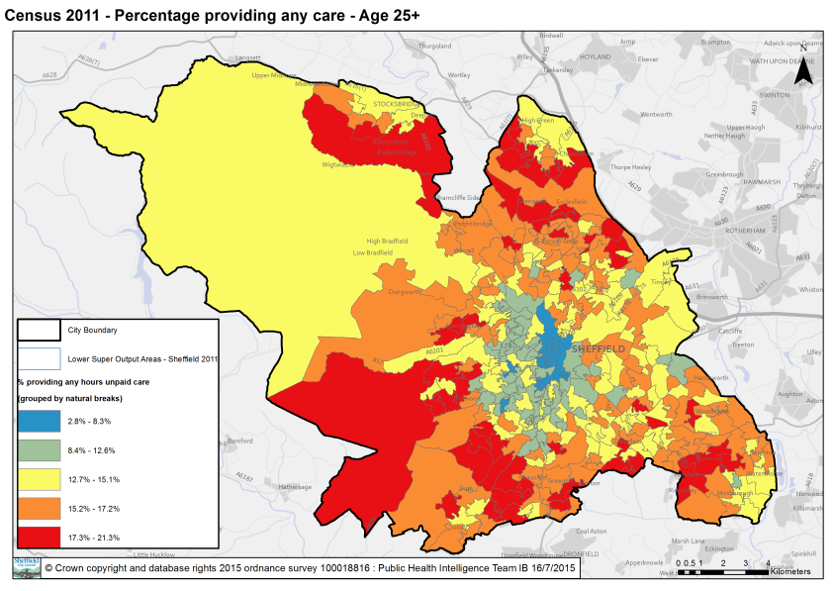 | 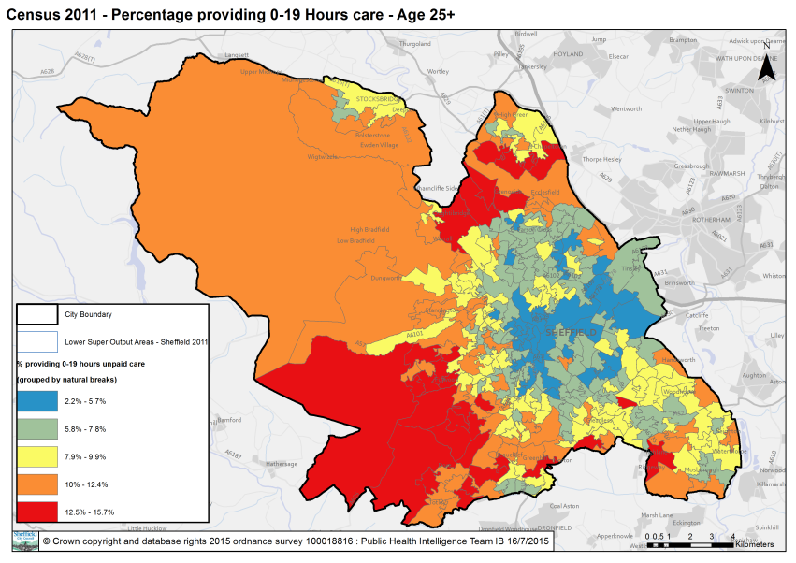
- Carers caring for 20 to 49 hours aged 25 and over | - Carers caring for 50 hours and over aged 25 and over
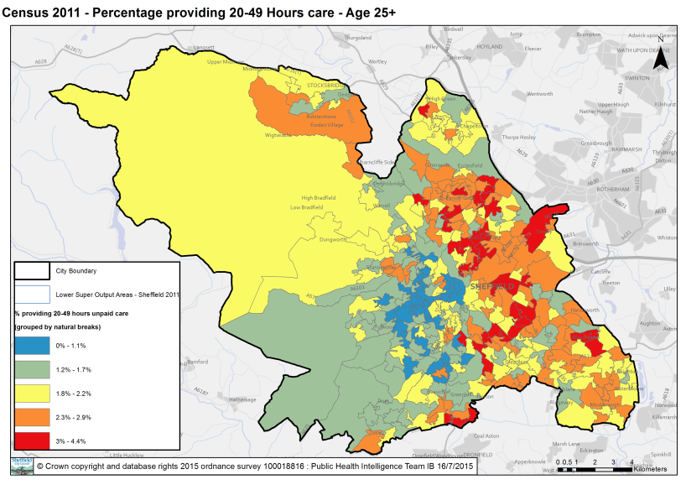 | 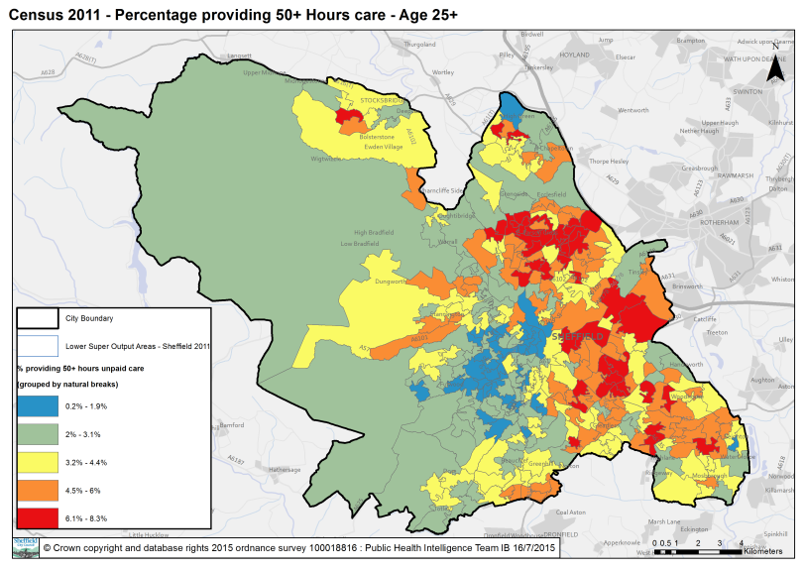

Hours of care

- Previously in carer policy, the number of hours of care delivered per week has been seen as a ‘proxy’ for the level of need a carer required. Whilst delivering 3 hours of care compared to 40 is very different, the Care Act has changed convention and this perceived concept.

- The Care Act 2014 requires a personalised approach to be taken when assessing risk and the needs of a carer and their family e.g. someone working full time, with a family and providing less hours of care may have more needs than someone who doesn’t work, has a family and is providing more hours of care.

- The pyramid diagram below describes the city’s caring and non-caring population by the hours of care provided. This pyramid is an unusual shape because the carer population providing greater numbers of hours of care increases rather than reduces.

14,512 | Providing 50 hours and over of care per week
7,732 | Providing 20-49 hours of care per week
35,129 | Providing 1-19 hours of care per week
552,698 | People who do not provide any unpaid care

Better targeting

- Rather than just using hours of care provided as a proxy for the level of support required it is useful to use other factors:

- Age
- Where carers live

Better targeting –hours of care and age of carer:

- The following graph and table splits the number of hours of care by the age of carer. It is clear that:

- 60% of our carers provide 19 or less hours of care – and these carers are more likely to be younger
- 25% of our carers are providing 50 hours or more care per week
- Our older carers tend to be providing more hours of care
- There are almost as many 25-49 yr olds as 65 and over providing over 50 hours of care

Better targeting: hours of care, age and location

- In considering the distribution of carers across the city – it was clear it changed with the number of hours of care provided. The table below details the wards with the greatest number of carers by hours of carer and age:

- All carers split by all age categories
- Providing 1-19 hours of care per week by all age categories: 25-49, 50-64 and 65+
- Providing 20-49 hours of care per week by all age categories: 25-49, 50-64 and 65+
- Providing 50 and more hours of care per week by all age categories: 25-49, 50-64 and 65+

- Analysis of this data shows that:

- All carers:
- Younger carers(aged 25-49) live in some of the most deprived wards of the city
- Older carers live in the more affluent wards

- Delivering 1-19 hours of care, this replicates the ‘all carer’ data
- Delivering 20-49 hours of care, at all ages carers tend to live in less affluent areas but high deprivation for the youngest age category (25-49)
- Delivering 50 hours and more, likely to live in the most deprived part of the city

- Youngest carers: at all categories of hours of care, the ward with the greatest number of younger carers (aged 25-49) live in the Burngreave ward
(NB this ward is characterised by high deprivation and many different ethnic minorities)

- Older carers: The greatest numbers of older carers tend to reside in the more affluent areas of the city except in the 50 hours or more category which then reflects the most deprived parts of the city.

Age 25-49 | Total unpaid care | Age 50-64 | Total unpaid care | Age 65 and above | Total unpaid care
Burngreave | 1,365 | West Ecclesfield | 974 | Dore and Totley | 690
Darnall | 1,012 | Ecclesall | 922 | West Ecclesfield | 623
Manor Castle | 994 | Stocksbridge and Upper Don | 885 | Stannington | 618
Shiregreen and Brightside | 953 | Dore and Totley | 861 | Beauchief and Greenhill | 588
Southey | 921 | East Ecclesfield | 856 | East Ecclesfield | 562
Age 25-49 | 1-19 hours of care | Age 50-64 | 1-19 hours of care | Age 65 and above | 1-19 hours of care
Burngreave | 649 | Ecclesall | 772 | Dore and Totley | 417
Darnall | 578 | Dore and Totley | 708 | Ecclesall | 309
Gleadless Valley | 568 | West Ecclesfield | 689 | Fulwood | 304
East Ecclesfield | 541 | Stocksbridge and Upper Don | 632 | West Ecclesfield | 294
Central | 512 | Fulwood | 629 | Stannington | 279
Age 25-49 | 20-49 hours of care | Age 50-64 | 20-49 hours of care | Age 65 and above | 20-49 hours of care
Burngreave | 313 | Beauchief and Greenhill | 121 | Stannington | 83
Manor Castle | 204 | West Ecclesfield | 120 | Arbourthorne | 78
Darnall | 187 | Shiregreen and Brightside | 118 | West Ecclesfield | 74
Shiregreen and Brightside | 167 | Woodhouse | 112 | Beauchief and Greenhill | 74
Southey | 164 | Firth Park | 111 | East Ecclesfield | 73
Age 25-49 | 50 or more hours | Age 50-64 | 50 or more hours | Age 65 and above | 50 or more hours
Burngreave | 403 | Firth Park | 239 | Southey | 275
Firth Park | 330 | Manor Castle | 224 | Richmond | 266
Shiregreen and Brightside | 299 | Southey | 214 | Arbourthorne | 263
Southey | 296 | Darnall | 211 | Stannington | 256
Manor Castle | 290 | Shiregreen and Brightside | 188 | West Ecclesfield | 255

Wider determinants of health

- Health is determined by an interconnected and complex range of factors including biological, behavioural, and environmental factors. The general socio-economic, cultural and environmental conditions of society will have a profound impact on the living and working conditions experienced by particular groups of people in that society. Similarly, these broader ‘social determinants’ of health along with constitutional factors and social and community networks will shape individual lifestyle factors that are important for health (e.g., exercise, nutrition, smoking and drug use).

- General socio-economic, cultural and environmental conditions have a profound impact on shaping the material and psychosocial characteristics of our living conditions. They influence the types and quantity of food we can access, our risk of exposure to infectious diseases, the education we receive, the type and quality of housing we can afford, the types of employment that may be available to us, our opportunities for leisure activities, our security and safety, our access to social networks and to timely and effective health care. There are, however, some stark inequalities within the UK with regard to the ability of different groups in society (e.g., people living in poverty, people from some minority ethnic communities, people with disabilities) to access the types of living conditions that promote positive health.

Multiple and Complex Needs (Compounded Needs)

- Some carers face a number of challenges and barriers that impact on both their ability to care for someone and the quality of life for the person they care for. No-one individual faces the same challenges as another. Our newly commissioned services will take a ‘personalised’ approach to ensure the carer is at the centre of the conversation in order to identify their needs which will potentially be multiple or complex. We will work with Public Health to analyse and understand how ‘social’, ‘environmental’, ‘economic’ and ‘cultural’ compounders’ impact carers and this analysis has and will continue to shape our approach to commissioning services. This will mean we continue to improve health related outcomes for carers.

Appendix 1: Current Carer Services (as of March 2016)

The following three contracts are the existing support services for carers for which the budget is approx. £1,000,000 per year

Service | Description | Provider
Carers in Sheffield | Support Services for Carers | Cubed in partnership with Sheffield Carers Centre, Sheffield Mencap and Gateway, MIND, PACA, Roshni, MAAN
Carer Respite Services | Flexible sitting service | Making Space
Older People Support Services | Support for older families with learning disabilities | Sheffield Health and Social Care Trust

The following table outlines the wider support for Carers via commissioned via Sheffield City Council, it includes:

- Direct delivery via Adult Social Care
- Commissioned services for the cared for person e.g. respite, day services

Service | Description | Provider
Adult Social Services | Includes:  - Access and Care Management  - Intermediate Care  - Carer Emergency Response Team  - City Wide Alarms | Sheffield City Council
Mental Health respite | 1 x respite bed | Wainwright Crescent, SHSC
Learning Disabilities respite | 21x respite beds | Longley Meadows  Warminster
Dementia respite | 20 x beds | Hurlfield View Resource Centre
Older peoples respite | Spot purchasing for respite | Care homes
Respite | Organised via Direct Payments | Care homes
Day opportunities | Activities for the service user i.e. the cared for person | Multiple providers

Appendix 2: Description of carers issues

Role as a carer:

Problem | Description
- Hidden carers – not recognising them self as a carer | - Many carers do not recognise themselves as a carer or use the term carer  Evidence from NHS England, Commitment for Carers states it takes a carer an average of 2 years to recognise them self as a carer  - Many professionals through providing services to the ‘cared for person’ do not recognise / identify carers or their specific needs  Evidence from Macmillan Carers Week survey identified that 70% of carers came into contact with health professionals but less than 12% identify carers
- How to find out about information and get advice | Carers during the consultation said:  - I went to outpatients and received 10 leaflets – I didn’t have the time to read them all.. alternatively… I read all these leaflets but only 2 were relevant to me  - If only I found out about this … ‘xxx’… 2 years ago  - It was a crisis and there was so many different websites, I didn’t know where to start  There is a plethora of information and advice available e.g. Sheffield Directory, NHS Choices, MIND Directory, leaflets, condition specific websites. Carers either are:  - unclear what to search for i.e. if you don’t use the term carer, how would you know to look for ‘carers websites’.  - Overwhelmed with the number of paper and print information available
- Planning for the long term and emergencies | Over 50% of the respondents to the questionnaire suggested they had a plan in place, although over 200 people suggested they would call social services, the doctors or emergency services.  Support groups and 1:1s reported regularly that people didn’t know what to do in an emergency or the long term e.g.  ‘it keeps me awake at night… I don’t know what will happen to my son when I am no longer here’

The impact of caring

Problem | Description
- Getting a break – respite | The questionnaire highlighted short breaks and activities for the person they care as the most important.  67% said caring had impacted on going on holiday  Carers reported throughout the consultation:  - carers struggle to find and be able to book residential respite beds so they can to take a holiday – care homes have very few vacancies and often don’t have empty beds or won’t book a bed for the future  - carers wish to socialise with the person they care for but need support to do so  - carers would like more activities for the person they care for
- Caring causing financial hardship | From the consultation  - Carers didn’t know they could apply for benefits  - Caring had meant they had had to either reduce their working hours or give up work altogether having an impact on their finances  - Carers didn’t know about local discounts e.g. buses, local theatre  Evidence from Carers UK State of Sheffield 2015 said that 48% of carers ‘were struggling to make ends meet’
- Being able to continue to work and train | From the consultation  - Carers have found employers neither flexible or understanding of their caring responsibilities  - Carers reported reducing working hours or giving up work altogether  Evidence from Carers UK State of Sheffield 2015 68% of carers had used annual leave to care and 46% had worked overtime to make up hours for caring
- Being lonely and socially isolated | 73% of respondents to the questionnaire said caring had impacted on their social life.  Some carers reported through the questionnaire and the consultation that they had good networks through family, friends and faith organisation but a frequent comment was:  - I am lonely, all my family and friends have drifted away, they don’t understand
- Health Caring having an impact on health | 71% of people responding to the questionnaire reported that caring had impacted their health  Carers throughout the consultation reported  - The doctor had never asked or was not interested about their caring role  - Had not been able to get a doctors appointment due to inflexibility of the system e.g. can’t take an appointment this afternoon as I can’t get replacement care at short notice  Evidence from Carers UK In Sickness and Health 39% have put off medical treatment because of caring and 53% said they had a long term condition themselves

Services for the ‘cared for person’

Problem | Description
- Carers are not seen as partners – engaging with health organisations and professionals | Health staff:  - Are not carer aware  - Take account of the carer’s knowledge of the patient  - Include carers in decision making
- Adult Social Care and commissioned services are complicated and not always good quality | - ASC processes are difficult and complicated e.g. I called with a problem, I got passed round 4 people who were all nice but couldn’t help me  - Staff are process driven and not carer aware  - The quality of Home Care is poor
- Getting a carers assessments | Carers and carer organisations report that it is difficult to request / get a carers assessment
- Transition of the person you care for from Childrens to Adult services | Transition between services is difficult
- Wider workforce | People aren’t carer aware

Appendix 3: Current ‘short break’ respite provision

Area | Service | Description | Criteria | Charging | Comment
Commissioned via Carers support services | Sitting Service | 3 hours per week (no personal care service) | Caring for a person who is resident in Sheffield | No charge | No eligible need assessment  Not subject to any charging
 | Short breaks fund – ‘Time for Me’  (part of Support Services for Carers) | Grant toward a break from caring | Resident of Sheffield and caring for 35 hours or more | No charge – this is a contribution of up to £200 for the carer | Drafting note: impact of T4M
Social care commissioned services | Short Breaks | Short stay nursing or residential | Social care eligible needs assessment | Adult Social Care  Subject to Social Care charging dependent on circumstances | Bed occupancy is over 90% in Sheffield and most homes will not pre-book a bed therefore carers are unsure whether they would be able to get respite for future holidays  Short breaks can also be privately arranged – there is still the issue of not being able to pre book
 | Specialist respite provider e.g. Longley Meadows, Warminster Hurlfield View or Wainwright Crescent | Specialist short stay respite for people with particulate conditions e.g. learning disabilities, dementia and mental health | Social care eligible needs assessment | Subject to Social Care charging dependent on circumstances
 | Day opportunities for older people, dementia and learning disabilities |  | Social care eligible needs assessment | Subject to Social Care charging dependent on circumstances
Council delivered service | Sharing Lives | Befriending, siting. Day care or respite | Resident of Sheffield  Can be part of a social care package | Subject to Social Care charging dependent on circumstances  Or charged service for those who do not have assessed eligible needs

Appendix 4: Occupancy rates of care homes

Nursing

Occupancy rate | Total number of beds | Vacancies June 2015 | Vacancies Oct 2015 | Vacancies Dec 2015
Nursing | 2313 | 173 | 199 | 177
Available beds |  | 97 | 132 | 104
Occupancy level |  | 96% | 94% | 95.5%

Residential

Occupancy rate | Total number of beds | Vacancies June 2015 | Vacancies Oct 2015 | Vacancies Dec 2015
Residential care homes | 1509 | 120 | 220 | 102
Available beds |  | 120 | 220 | 95
Occupancy Level |  | 92.5% | 86.5% | 94%

Appendix 5: People Keeping Well

The PKW approach is built around an outcomes framework that has been jointly developed by a wide range of stakeholders including Health, Social Care, Public Health, Housing, Providers and service users. The framework builds on lessons learned from:

- a pilot study in Lowedges, Batemoor and Jordanthorpe, and subsequent work in Hallam and South, and Central localities;
- a rich history of community-based health interventions, including the Community Wellbeing Programme;
- a range of schemes developed and delivered by the VCF sector (e.g. Life Navigators);
- years of learning from what works in housing support;
- a literature review carried out by Sheffield’s Public Health team;
- Input from national organisations (e.g. Think Local Act Personal); and,
- a range of other initiatives (e.g. GP Care Planning).

The model we are using is a proactive, preventative community-based approach that was initially designed to improve the health and wellbeing outcomes of people identified as being at moderate to high risk of unplanned hospital admission or needing formal social care support. However, it has been developed over time to be equally relevant to improving wellbeing across the population. It is increasingly clear, for example, that the model is as relevant to employment outcomes as it is to health.

The Ingredients

The model is based around six ingredients (or functions) that, when mixed together in the right way for a particular local community, can deliver demonstrable benefits for individuals and the wider health and social care system. These are described below.

Local advice and information that helps people maintain independence and wellbeing – including innovative models of delivery. For example training local hairdressers and shop staff to spot signs of deteriorating health and wellbeing and provide initial advice like who to contact, or where to go for support.

Risk stratification: Utilising the Combined Predictive Modelling tool (CPM) as a starting point, 19,000 people in the city have been identified as falling into the moderate to high risk category. It is this group where the PKW model is being currently used to make a difference.

Social Care, Housing and other ‘on the ground’ local intelligence (e.g. from GPs) and self-referral supplements the formal risk stratification data to make sure those at immediate risk are identified (there are areas of the city where hundreds of families are not registered with a GP). This can be built into local intelligence gathering processes and workforce development (e.g. public health training on making every contact count).

Risk stratification provides the intelligence needed to inform an individually targeted approach that should enable Sheffield to make progress on its key strategic aim of addressing health inequalities. The rich picture of who is at most risk, why they are at risk, and where they live, will also enable resources to be both concentrated where they are needed most; and, tailored to the specific needs of local communities.

Community assets / activities tuned to the needs of people at risk. The PKW model relies on not only developing community assets and activities – but making sure they are focused on, and reached by, people at risk of declining health and wellbeing. This relies on smart local needs assessment, strong local partnerships, and the effective local management of the whole model.

We are lucky in Sheffield that we have strong local partnerships in place due to a long history of capacity building in many areas of the city (e.g. Objective 1, SRB, ERDF and Community Wellbeing Programme).

Sort and Support: The best way to connect people at risk to information and advice, and community activities and other available support is to make this a ‘human contact’ – people on the ground having conversations. This requires people with the right skills to engage the individual, listen to their story, and then support them to take action to improve their health and wellbeing. This could involve making sure people they have a ‘winter plan’; encouraging people at risk to access health checks and self-care advice; arranging one-off fixes such as ensuring glasses prescriptions are up to date, finding a cleaner, de-cluttering, matching to transport options, and arranging handy-persons and tele-care support.

Again, we have lots to build on here – with a range of people in our communities that perform this ‘sort and support’ work including Health Trainers, Community Health Champion, Community Support Workers, Community Volunteers, SCCCs workers, and so on.

‘Life navigators’ to provide more intensive support for people who are at high risk of declining health and wellbeing, have no family or friends to support them, and do not access social care. Support includes: helping people as they return home after a stay in hospital (this will link to other work in the city regarding shortening the length of stay in hospital); (re)connecting people to local activities and social networks; supporting people during the life events that can easily derail people (such as a bereavement, a fall, a period of ill-health); helping people manage everyday problems often associated with ageing (such as managing appointments, correspondence, shopping and household and health management).

There are also a range of roles in communities that perform this medium-term support role including floating support workers (Shelter, Age UK, SYHA), Independent Living Coordinators (Age UK), Life Navigators (SCC), family key workers and so on.

‘Wellness planning’ and self-care is a key component of the framework. It involves people setting goals and coming up with actions to achieve that goal. Wellness planning can be done by individuals themselves or with support. A wellness plan can be as simple as someone having a fridge magnet with a phone number on they can call when they start to struggle with life, or it could be a detailed plan shared between agencies describing the longer term actions someone is taking to manage and live with a long-term condition.

A good example of wellness planning is the work that Health Trainers do on a one to one basis with individuals – many of who may have long term conditions. The plan enables people to goal set and action plan in order to better manage their condition, retain maximum independence and make better use of health and social care services. Health trainers work closely with GPs with this service to contribute to the care planning process.

Effective Local Multi-Disciplinary Teams

Key to the model are responsive multi-disciplinary teams working seamlessly with and across services in partnership with the local VCF sector. MDT’s are needed to provide a key link / conduit in the community between PKW and the work of Active Support and Recovery, social work and the statutory sector. This is key to getting the ‘recipe’ right.

The model can be simply explained as follows:

- Local workers / volunteers on the ground know a lot about what is available in their local community and who to talk to locally and city-wide to get things sorted out
- Local workers / volunteers are trained to have quality conversations with people about how they can achieve their wellbeing goals (without reliance on paid for services)
- A MDT approach involving primary care is (typically) used to identify people at risk and help identify the right person to do the outreach (generally in peoples’ homes)
- The assigned local worker has a conversation with the individual and connects them to things that will help them achieve their wellbeing goals and reduce their risk of declining health and wellbeing – this can take a few visits
- If people are likely to need more medium-term support, they are connected through to someone who can help (e.g. a life navigator, housing support worker etc)
- Local workers check back after seeing people to make sure that people are following their plan and reducing their risk
- The intelligence gathered from speaking to people at risk in a neighbourhood is brought together and analysed. This is used to guide the development of new community assets / activities – using bits of cash where needed to make things happen quickly
- In theory, the more we get the above right, the less demand on formal health and care services in the short- and long-term

Appendix 6: Sheffield Adult Carers Priorities

- Information and advice: I want the information I need, when I need it  For example  - Information that is timely, easily available and relevant to my situation  - Information that is easy to understand e.g. Plain English  - Emotional support from other carers so I can talk to people who understand what it’s like e.g. carers support groups  - Someone to give advice who knows the health/social care system  - A knowledgeable person who can help with form filling, paperwork and other practical support if I need it  - Confidentiality is not used as a barrier to communication with me as a carer | When we got the diagnosis, we got given lots of leaflets which had lots of information that wasn’t relevant to my husband and I didn’t have the time to sort through it myself
- I want good advice to help me through the maze  For example  - Support through the ‘maze’ of health/social care and good information about processes and timescales  - Good communication so that information is shared and I don’t have to tell my story over and over again  - Good and timely information about transition periods e.g. moving from Children’s to Adult services, moving to a care home  - One point of contact for me so it’s easier to access information, advice and guidance  - All professionals talk to me about the needs of the person/people I care for and respect my expertise and knowledge as the carer | I called social services, they passed me on to one person and they weren’t the department. This happened three or four times, they were all pleasant but it didn’t sort my problem.
- If services are right for the cared for person then it will make it easier for me  For example  - People delivering care and support who are reliable, knowledgeable and trustworthy  - Continuity of care so professionals get to know the person/people I care for  - The care worker gives care and support whilst with the person/people I care for, for the full allocated time  - Training for staff who work with the person/people I care for so they understand their specific conditions/disabilities  - Regular evaluation and monitoring of services to ensure good quality | When we got allocated a care worker, they didn’t know anything about my Mum even though we had told our story a number of times. She is alright but doesn’t always turn up on time or do quite the right things.
- Time for me so I can have a life outside of caring  For example  - Time for me so I can have a life outside of caring  - Flexible respite that gives me a break from being a carer  - Time to myself so I can go to work, have interests or hobbies without worrying about the person/people I care for  - Time and support to manage my own health needs – with carer friendly GPs and health services  - Local activities for me as a carer and inclusive activities I can do with the person/people I care for e.g. peer support groups, Cafes, gym | I had to come home early from holiday because my husband was so unhappy in respite.  I never get to go to the cinema anymore because I can’t get respite in the evenings.  I don’t want a break from my wife; I would like a support worker to help us go to a concert like we used to do.  I have had to give up work, it was too stressful, they didn’t understand why I was late all the time  I don’t get to have a conversation with anyone now since my husband has had a stroke
- I want to feel in control and safe and have a plan for emergencies  For example  - I want to feel in control and safe and have a plan for emergencies  - A plan so I know who to contact in an emergency.  - A card scheme or way of letting people know I care if anything happens to me.  - Having access to training such as first aid, hygiene, moving and handling, etc  - Staff with good listening skills who sort out issues promptly so there is no breakdown in care | I still wake up in the night and worry what will happen to my son when I am no longer here
- I don’t want to be in financial hardship  For example  - I don’t want to be in financial hardship  - Easily accessible information/services so I know what benefits or support I’m entitled to e.g. Carers Allowance/personal budgets/direct payments.  - Support to help me through the process of appeals or tribunals in relation to benefit claims  - A wide range of affordable local activities for me and the person/people I care for  - Knowing where I can get discount due to me being a carer | We have the heating on all day and the gas bill is so high

Appendix 7: Where carers live

(2011 Census data ONS)

2011 wards | All persons in the ward | Provides unpaid care |  | Provides 1 to 19 hours unpaid care a week |  | Provides 20 to 49 hours unpaid care a week |  | Provides 50 or more hours unpaid care a week
 |  | Number | % | Number | % | Number | % | Number | %
Arbourthorne | 18653 | 2064 | 11.1 | 1068 | 5.7 | 342 | 1.8 | 654 | 3.5
Beauchief and  Greenhill | 18719 | 2329 | 12.4 | 1397 | 7.5 | 338 | 1.8 | 594 | 3.2
Beighton | 17859 | 2177 | 12.2 | 1352 | 7.6 | 282 | 1.6 | 543 | 3.0
Birley | 16730 | 1990 | 11.9 | 1174 | 7.0 | 276 | 1.6 | 540 | 3.2
Broomhill | 16542 | 884 | 5.3 | 709 | 4.3 | 57 | 0.3 | 118 | 0.7
Burngreave | 27169 | 2668 | 9.8 | 1331 | 4.9 | 532 | 2.0 | 805 | 3.0
Central | 30766 | 1640 | 5.3 | 1070 | 3.5 | 234 | 0.8 | 336 | 1.1
Crookes | 17595 | 1592 | 9.0 | 1210 | 6.9 | 133 | 0.8 | 249 | 1.4
Darnall | 23342 | 2347 | 10.1 | 1221 | 5.2 | 394 | 1.7 | 732 | 3.1
Dore and Totley | 16623 | 2138 | 12.9 | 1570 | 9.4 | 206 | 1.2 | 362 | 2.2
East Ecclesfield | 18106 | 2308 | 12.7 | 1477 | 8.2 | 288 | 1.6 | 543 | 3.0
Ecclesall | 18391 | 2087 | 11.3 | 1618 | 8.8 | 188 | 1.0 | 281 | 1.5
Firth Park | 20874 | 2212 | 10.6 | 994 | 4.8 | 367 | 1.8 | 851 | 4.1
Fulwood | 15942 | 1770 | 11.1 | 1377 | 8.6 | 145 | 0.9 | 248 | 1.6
Gleadless Valley | 20898 | 2123 | 10.2 | 1271 | 6.1 | 314 | 1.5 | 538 | 2.6
Graves Park | 16548 | 1885 | 11.4 | 1364 | 8.2 | 176 | 1.1 | 345 | 2.1
Hillsborough | 18571 | 1868 | 10.1 | 1195 | 6.4 | 226 | 1.2 | 447 | 2.4
Manor Castle | 21196 | 2116 | 10.0 | 988 | 4.7 | 381 | 1.8 | 747 | 3.5
Mosborough | 17040 | 2039 | 12.0 | 1250 | 7.3 | 292 | 1.7 | 497 | 2.9
Nether Edge | 18731 | 1626 | 8.7 | 1195 | 6.4 | 186 | 1.0 | 245 | 1.3
Richmond | 17569 | 2053 | 11.7 | 1154 | 6.6 | 255 | 1.5 | 644 | 3.7
Shiregreen and  Brightside | 20762 | 2274 | 11.0 | 1120 | 5.4 | 377 | 1.8 | 777 | 3.7
Southey | 18976 | 2242 | 11.8 | 1078 | 5.7 | 351 | 1.8 | 813 | 4.3
Stannington | 18085 | 2274 | 12.6 | 1498 | 8.3 | 250 | 1.4 | 526 | 2.9
Stocksbridge and  Upper Don | 18373 | 2237 | 12.2 | 1467 | 8.0 | 274 | 1.5 | 496 | 2.7
Walkley | 20133 | 1800 | 8.9 | 1143 | 5.7 | 230 | 1.1 | 427 | 2.1
West Ecclesfield | 17659 | 2386 | 13.5 | 1530 | 8.7 | 298 | 1.7 | 558 | 3.2
Woodhouse | 17212 | 2076 | 12.1 | 1153 | 6.7 | 334 | 1.9 | 589 | 3.4
Total | 539,064 | 57,205 | 10.6 | 34,974 | 6.5 | 7,726 | 1.4 | 14,505 | 2.7

Macmillan Carers Week (2013) Prepared to Care? Exploring the impact of caring on people’s lives
https://www.sheffield.gov.uk/your-city-council/policy--performance/what-we-want-to-achieve/corporate-plan.html
Transitions in and out of caring: the information challenge, Carers UK, Nov 2014 http://www.carersuk.org/for-professionals/policy/policy-library/need-to-know
Understanding Carers, NHS Choice, 2014

