**Sheffield Children’s University for**



**Home Educated Children & Young People**

**What is Sheffield Children’s University?**

The aim of Sheffield Children’s University (CU) is to encourage children aged 4/5 years to 19 years, to take part in a wide range of worthwhile out-of-school-hours learning.  National and local research concludes that keeping a record and celebrating participation in these activities through the Children’s University has a big impact on success at school and elsewhere.

The key objectives of Sheffield Children’s University are to:

* Encourage children, young people and families to seek **high quality learning opportunities** both in school and in the community
* **Raise aspirations** of children, young people and their families
* **Raise attainment and attendance** at school
* Have a **positive impact on attitude** and behaviour
* **Support children’s health** and wellbeing
* Encourage children and young people to **take control of their learning**
* **Inspire, demonstrate and share best practice** in extended learning provision

**How does it work?**

Over 42,000 children in Sheffield have been earning credits through clubs and extra-curricular activities held on school premises. But in Sheffield we know that there are many more equally valuable learning opportunities beyond the school gate. With the introduction of the national CU Passport to Learning, Sheffield began implementing a wider strategy in 2011 to ensure that children and young people are able to collect learning credits from other activity providers that contribute to their Children’s University Award certificates. These include libraries, museums and parks, and local community groups such as Scouts, martial arts and dancing classes – referred to as ‘Learning Destinations’. The pupils take their Passport to Learning to the Learning Destination and after completion of an activity, their participation is recorded in their Passport and also on a register, which is then sent to the CU team so they are able to award CU credits. Credits gained through their Passport to Learning are added to any gained at CU subscribed schools, giving an accumulative grand total. Through the Passport to Learning scheme, children who are educated at home can get involved.

**What awards do they receive?**

A credit is awarded for each hour of participation which we track and then present awards at different intervals – 30 credits is a Bronze Award, 65 credits is a Silver Award and 100 credits is a Gold Award. The award system continues at those increments right up to 1000 hours, so there are 30 to collect in total! Accompanying each certificate is a specially designed badge and also a record of their learning which has contributed to that award – rather like a bank statement, it itemises all the activities they have taken part in, so it creates a personalised learning journey for the child.

Twice per year (around September and April), the CU Team will generate a report which identifies which children have reached an award level. At these times, any Bronze and Silver awards reached will be created and posted to the child’s home address as held on record. Any children who have reached a Gold award level (i.e. 100, 200, 300 hours, etc.) will be sent (via post to their home address) an invitation for them and a parent/carer to attend our special award ceremonies.

**What activities count?**

The activities MUST take place out of normal school time, which is more difficult to define for Home Educated children and young people. However for purposes of clarity, the following times will be counted as ‘out of school’ hours for CU eligibility…

* Before school (up to 9am)
* Lunchtime (between 12pm and 1.30pm)
* After school (after 3pm)
* Evenings
* Weekends
* School holidays (as defined by Sheffield City Council School Holidays and Term Dates)

This is to keep in line with the CU principle of awarding children who give up their OWN TIME to undertake additional learning beyond the ‘normal school day’, and to retain the equal value and fairness of the credits being awarded across the board.

All activities MUST take place at a validated Learning Destination, of which there are over 200 in Sheffield alone, but there are thousands more beyond Sheffield. These can be found on the national CU Trust website ([www.childrensuniversity.co.uk](http://www.childrensuniversity.co.uk/maps)). If attending a Learning Destination BEYOND Sheffield, instead of adding their name to a register, learners must download, complete and return a Passport to Learning Diary Activity Sheet. Once received by the CU Team, the associated credits will be awarded. Credits cannot be awarded without this sheet. If you are aware of an activity provider who you think would be an ideal Learning Destination, please let us know the details and we can invite them to become a Learning Destination.

**How does it work for Home Educated children and young people?**

Each child/young person will need a Passport to Learning (available for £3.50 from any Sheffield library) and their parent/carer must sign the consent sticker in the front. They should then visit a Learning Destination, take part in an activity, have their Passport to Learning stamped/signed AND make sure their name is added to the special CU register at the Learning Destination (if in Sheffield, or complete a diary sheet for Learning Destinations beyond Sheffield). It also needs to clearly state on the register that the child is HOME EDUCATED rather than ‘school attended’. The Learning Destination then sends us the registers and we input the data, awarding the credits. So, if their name is NOT on the register (or we don’t receive a diary sheet), we will not be able to award the credits, even if they have them recorded in their Passport to Learning. To cover the costs of administering the scheme, there is a membership charge as follows…

|  |  |  |
| --- | --- | --- |
| Initial joining date*… | 1st child | Siblings (living at same address) |
| 1st Sept – 31st Dec | £35 | £20 |
| 1st Jan onwards | £20 | £15 |

*The cost for subsequent years will be the price for the full academic year.

This will be a contribution towards the cost of the following:

* their award certificates and badges
* building a personalised learning record for each child
* their attendance at a Gold award ceremony (when they reach 100 hours), including their first three awards at that time (subsequent awards will be charged at £1 per award)
* the administration which enables the credits to be tracked and awards generated
* postage of the certificates and badges and invitations to Gold ceremonies, to their home address

**What do we need to do next?**

If your child is educated by you at home, you will need to register with Sheffield CU by completing and returning the registration form (see attached or it can be downloaded from our website – [www.sheffield.gov.uk/cu](http://www.sheffield.gov.uk/cu)). Your payment will also need to be made over the phone with a debit/credit card, by calling 0114 2813761. Once we have received your registration form and payment, we will begin tracking your child’s credits when we receive their details on one of the registers from a Learning Destination. If they have earned credits in a Passport to Learning already, please send a copy of their Passport to Learning (including their name and DOB) and we will record their credits earned so far, back-dated to the start of the current academic year or January of the current year (if the subscription starts from 1st January onwards). In due course, we will send their Bronze and Silver certificates to their home address on file, and/or send their invite to a Gold Award ceremony.

**Further information**

This can be found on our website: [www.sheffield.gov.uk/cu](http://www.sheffield.gov.uk/cu) or by contacting Helen Oades (0114 2813761) or by email [CU@sheffield.gov.uk](mailto:CU@sheffield.gov.uk)

We look forward to presenting your child with their CU certificates very soon.

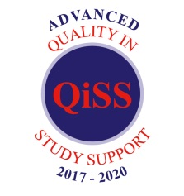 Copyright © 2019 Sheffield Children’s University 

**Registration Form**

**Children and Young People Educated at Home**

**Child’s First Name**________________________________________

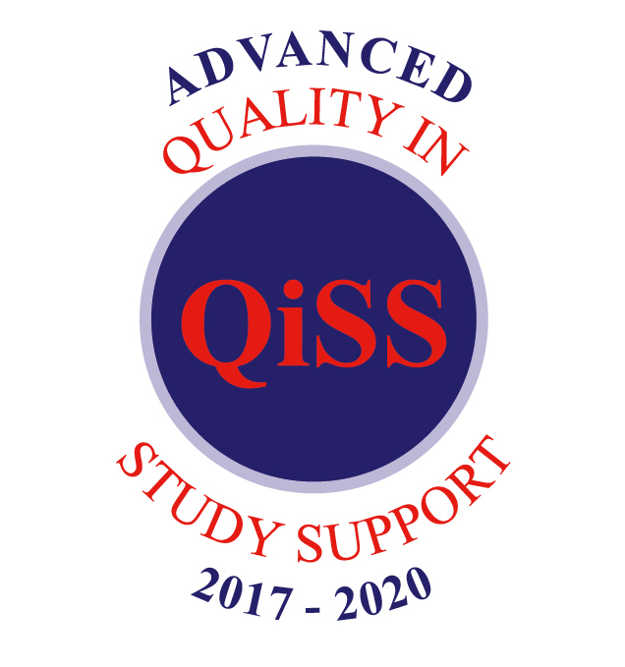

**Child’s Surname**_________________________________________

**Child’s Date of Birth** _______ / _______ / _______

(day) (month) (year)

**Home address**__________________________________________________

__________________________________________________

**Postcode** ______________________

**Parent/carer Contact Email**\*_________________________________________

(*optional – providing your email will enable you to receive emails about activities and events where you may be able to collect CU credits. It will not be passed onto any other parties and you can unsubscribe at any time by contacting the CU Team – see our Privacy Notice attached)

I understand the information provided on this registration form will be used solely by the Sheffield Children’s University Team to track my child’s Children’s University credits and to post out their awards and invitations to award Ceremonies. My email address (if provided) will solely be used to communicate information associated with Sheffield Children’s University and will not be passed to other parties. I understand that I can unsubscribe from this mailing list at any time by contacting the CU Team. Your child will remain registered with Sheffield Children’s University and will continue to have access to our services. It is my responsibility to update the information with the CU Team as required.

I understand the annual membership charge of £35 per child per academic year (and £20 for each sibling thereafter living at the same address), or reduced pro-rata fees as detailed above contributes towards the cost of administration of my child’s credits, their award certificates and badges and associated award ceremonies. Additionally, they require a Passport to Learning to collect their credits in which cost £3.50 each.

I understand credits can only be earned by taking part in activities being delivered at validated Learning Destinations, out-of-school hours.

Signed (parent/carer)_________________________________

Date______________________

Please complete and return this form to [CU@sheffield.gov.uk](mailto:CU@sheffield.gov.uk) or post to Sheffield Children’s University, Floor 7 North, Moorfoot Building, Sheffield, S1 4PL



*Copyright © 2018 Sheffield Children’s University*

**Sheffield Children’s University Privacy Notice**

Who we are

Sheffield Children’s University (CU) is a member of a national initiative that encourages and celebrates children and young people who take part in learning activities outside of school hours. Learning can be at either CU subscribed schools in Sheffield or at registered activity providers, called Learning Destinations.

One credit is awarded for every hour of learning, earning CU awards and special award ceremonies take place in schools and prestigious venues across the city. Sheffield CU is part of Sheffield City Council and uses the Capita ONE database to track and reward children with CU credits.

How we will use personal information

We will use the information provided by you, our schools and Learning Destinations to:

* track and reward children and young people in Sheffield with CU credits for their participation in out of school activities
* maintain and update contact details so we can provide our service to schools, Learning Destinations and partners and share information about activities
* book and manage events, activities and award ceremonies
* analyse the impact of taking part in Sheffield CU
* record your permission to use images and gain feedback on the service we provide

Who we will share personal information with

Information will be shared with other Council services and CU subscribed schools so we are able to deliver our service. Reports on participation are also provided back to children and families along with award certificates. When personal data is used for this purpose of analysing impact, any information shared is always anonymised; we will never use information to identify or contact any individual.

How long we will keep personal information

The information you provide will be kept in accordance with Council retention and disposal schedules and will be deleted when no longer required for the purposes for which it was obtained.

What are your rights?

You have rights under Data Protection law. For further details about your rights, the contact details of our Data Protection Officer and your right to make a complaint please see our Data Protection webpage: <http://www.sheffield.gov.uk/privacy>

You also have the right to contact the [Information Commissioner’s Office](http://www.ico.org.uk).

****