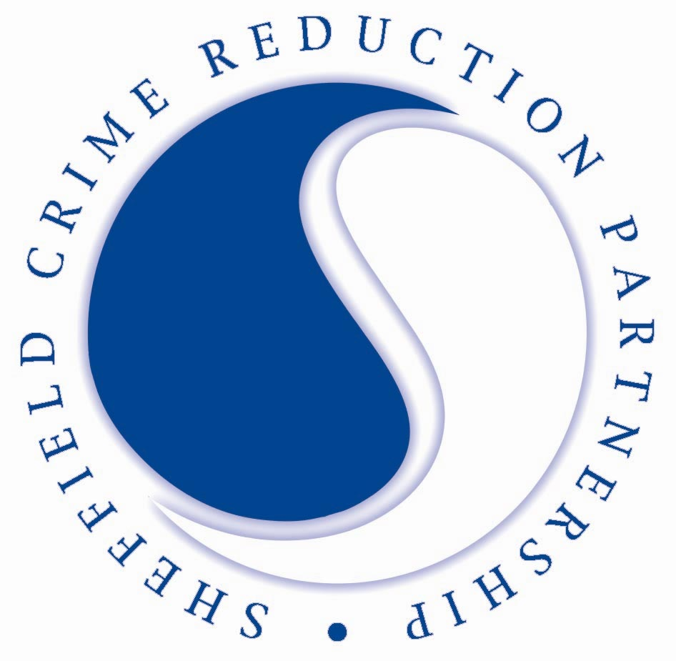

Development, Environment & Leisure
Strategic & City Centre Services

The Sheffield Crime Reduction Partnership charter is:

“Our Promise to You”

- We will deal with all enquiries and requests promptly and professionally

- We will assist you in the prevention and detection of crime at all times and provide you will business crime reduction advice when requested or when relevant information is identified

- We will ensure that any information we give you is accurate

- Where we are unable to resolve your problems or queries, we will do everything in our power to put you in touch with someone who can

- We will try to ensure that when technical failures occur, we provide you with temporary back up equipment to ensure we continue to provide the radio service

- We will contribute actively to Sheffield City Council’s vision of a cleaner, greener, safer city

- We will provide staff training on relevant crime prevention/reduction issues wherever possible

“Your Promise to Us”

- You will inform us immediately of any changes to the contact details we hold for your premises or any plans to close down your business

- You will ensure that any equipment linked to our frequencies is kept safe and in full working order at all times. You will report any technical defects or loss of equipment immediately

- Any information we give you will only be used for the purpose for which it was given to you. This being the prevention and detection of crime. All information will be kept in a secure office

- You will adhere to the principles laid out in the Data Protection Act 1998 at all times

- You will use professional etiquette on the radio at all times

- You will ensure that your membership invoices are paid in accordance with Sheffield City Council’s 30 day payment policy and that wherever possible a usable purchase order is provided to assist us in ensuring your payment are met promptly

