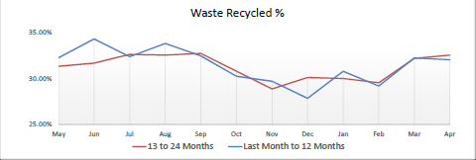
Chart 1 shows the percentage of waste recycled by month. This includes materials recycled through the blue bin (paper and card), brown bin (glass, cans, and plastic bottles), green bin (garden waste), from Household Waste Recycling Centres (HWRCs) and local recycling sites. Recycling performance is highest during the spring and summer months which coincides with the peak growing season (garden waste). Recycling performance increases during December and January (Christmas) due to more packaging.

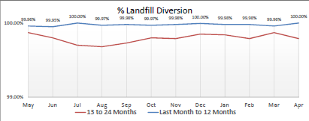
Chart 2 shows the percentage of household waste that was not sent to landfill by month. This includes waste sent for recycling recycled and energy recovery. Performance is consistently close to 100% landfill diversion. Waste sent to landfill includes a small amount of non-recyclable waste from Household Waste Recycling Centres including asbestos. Landfill can also occur during maintenance periods of the energy recovery facility.

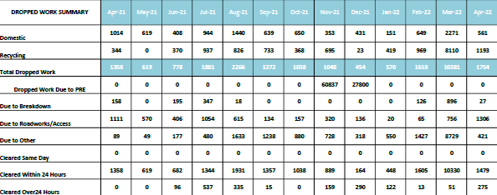
Chart 3 shows a breakdown of bin collections not completed on the scheduled collection day for that month. Provides the total number of collections (black bin and recycling) not completed on the scheduled day, a breakdown showing the reason for non-collection, and the length of delay before collection took place. Performance can be affected by an increasing/decreasing number of roadworks. Peaks are shown in July 2020, February 2021, and April 2021, with the lowest number of dropped collections coming in April and May 2020 and December to January 2021.

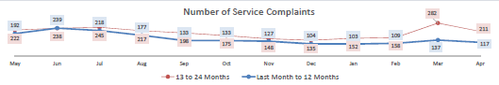
Chart 4 shows the number of complaints received by Veolia by month.
The blue line shows the most recent 12 months data, and the red line shows the previous year.
Shows the number of complaints received by Veolia for all services, including bin collections, Household Waste Recycling Centres, local recycling sites, bulky waste collections, clinical collections
Performance needs to be considered in the context that Veolia carry out approximately 1 million bin collection each month.

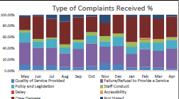

Chart 5 shows the type of complaint received by month. All complaints received are categorised against one of these complaint types as a monitoring tool to assess complaints received.

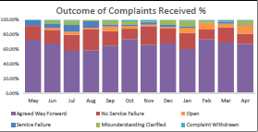

Chart 6 shows the outcome of the complaints received by month. All complaint investigation and responses are categorised against one of these complaint outcomes as a monitoring tool to assess complaints received.

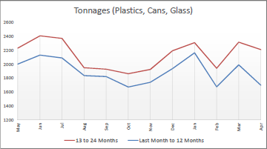

Chart 7 shows the tonnage of plastic bottles, cans and glass collected by month.
Blue line shows the most recent 12 months data, red line shows the previous year.
Includes the tonnage of plastic bottles, cans and glass bottles and jars collected from the brown bin.
Tonnages increase over the festive period. Increases can also be seen due to large sporting events when more drinks are consumed. Tonnages can reduce during the peak holiday season due to fewer people being at home.

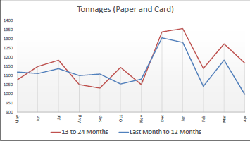

Chart 8 shows the tonnage of paper and card collected by month.
Blue line shows the most recent 12 months data, red line shows the previous year.
Includes the tonnage of paper and card collected from the blue bin.
Tonnages increase over the festive period.

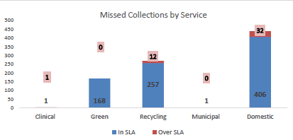

Chart 9 shows the number of missed collections by service for that month.
It shows the number of reports received where a mistake was made by the collection crew which meant that a bin, despite being presented, was not emptied on the correct day.
Other than a genuine mistake, reasons for missing a collection can include a new/back up collection crew who is not familiar with the collection round, as well as a property that is new to the assisted collection service. Performance needs to be considered in the context that Veolia carry out approximately 1 million bin collections each month.

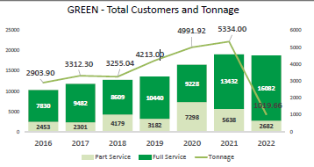

Chart 10 shows the number of customers signed up to receive garden waste collections by year and tonnage collected on the fortnightly green bin service.
The light green box shows the number of customers who signed up to receive fewer than the full service (19 collections). The current year’s tonnage data can only be compared with the previous year once the full collection season has been completed in November.

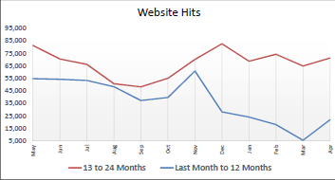

Chart 11 shows the number of visits to Veolia Sheffield webpages. www.veolia.co.uk/sheffield by month.
Blue line shows the most recent 12 months data, red line shows the previous year.
The number of web visits will increase over the festive period when residents look to see if their bin collection dates will change. Increases are also seen during periods of bad weather when collections can be affected, and people look to see when their bins will be emptied. Visits can also increase during January and March when customers look to sign up for garden waste collections.

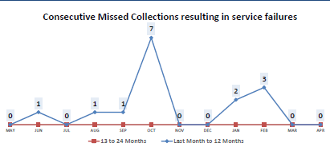

Chart 12 shows the number of occasions when an address suffered from three consecutive missed bin collections (same service e.g., black bin and same address).

Chart 13 shows the number of Twitter followers (Recycle4sheffield)

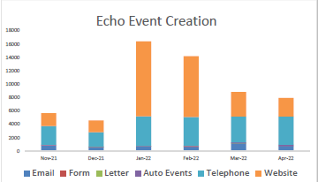

Chart 14 shows the number of service requests received by Veolia by month for the past 6 months.
The service request number includes reports of missed bins, replacement bin requests, sign-ups for garden waste collections, bulky collection requests). The chart breaks down the total number of service requests for each month into how it was received e.g., website, telephone. Auto Events are generated automatically e.g., where the crew damage a bin during collection, a replacement is automatically generated. Service requests increase during Jan-March which coincides with the peak sign-up period for garden waste collections.

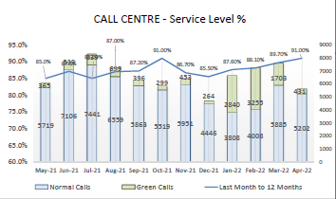

Chart 15 shows the number of calls received by the Veolia Sheffield call centre by month, and the proportion of calls answered within the service level agreement thresholds. Calls typically increase during Jan-March which coincides with the peak sign-up period for garden waste collections as well as the peak period for service disruption by snow.

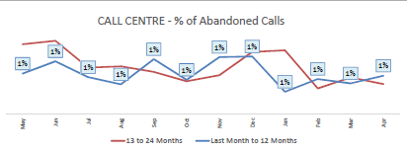
Chart 16 shows the % of abandoned calls by month for the Veolia Sheffield call centre.
Blue line shows the most recent 12 months data whereas the red line shows the previous year.
Abandoned calls are defined as calls which were made to the Veolia call centre, but where the customer ended the call before getting through to an advisor. This may be due to frustration at the length of time taken before the call was answered, or simply because the customer changed their mind. Typically, the percentage of abandoned calls increases during periods of peak calls – e.g., Jan-March which coincides with the peak sign-up period for garden waste collections as well as the peak period for service disruption by snow. In 2020, performance was affected by the impact of COVID-19 on call centre resource availability.

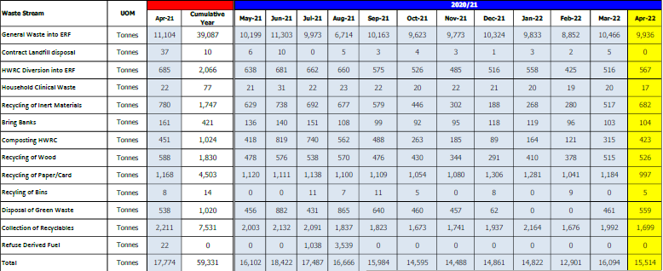

Chart 17 shows a breakdown of waste collected by service/waste type per month. The tonnage for each waste type is provided for each month.
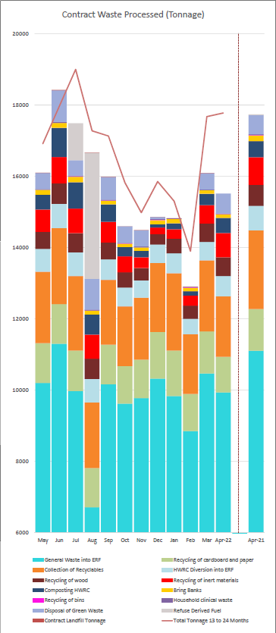

Chart 18 shows a graphical breakdown of waste collected by service/waste type by month.
Blue line shows the most recent 12 months data, red line shows the previous year. Waste tonnages are higher during the Spring/Summer months coinciding with the peak growing season (garden waste).

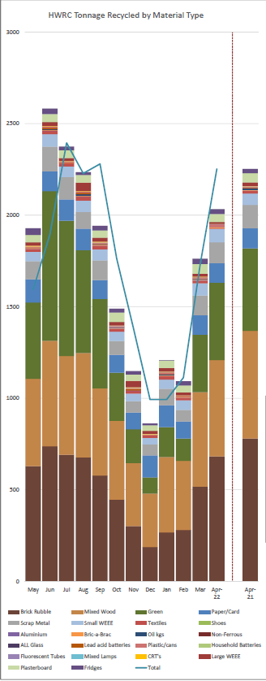

Chart 19 shows a graphical breakdown of waste recycled from Sheffield’s five Household Waste Recycling Centres by waste type by month. Tonnages have been affected by COVID-19 due to restrictions on the number of vehicles allowed on site between March 2020 and April 2021.
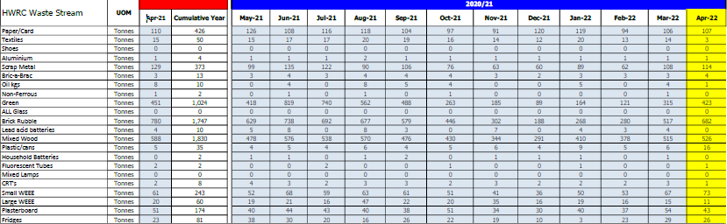
Chart 20 shows the breakdown of waste recycled from Sheffield’s five Household Waste Recycling Centres by waste type by month.
Garden waste tonnages are higher in the spring/summer months due to the peak growing season.
Tonnages generally have increased from April 21 which coincided with the relaxation of COVID-19 traffic restrictions at the sites. Between April 20 and March 21, the number of vehicles allowed on a site at any one time was reduced.

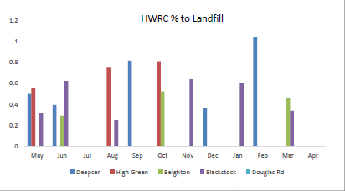
Chart 21 show the percentage of waste sent to landfill from each Household Waste Recycling Centres by month.
This includes asbestos and other non-recyclable waste.

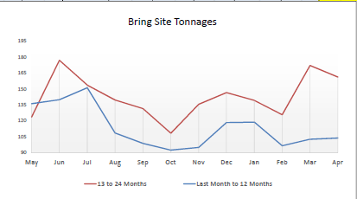
Chart 22 shows Total recycling tonnage collected from Bring Sites (local recycling sites) by month. Includes paper, cardboard, glass, cans, plastics, textiles collected from bring sites which are typically located in supermarket car parks. Tonnages have increased during the COVID-19 pandemic because of more home shopping (carboard packaging) and more people being at home.

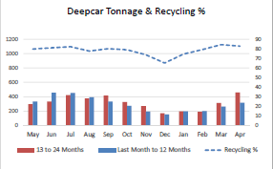
Chart 23 shows the waste recycled at Deepcar HWRC.
It includes all materials recycled from the site including green waste, electricals, wood, soil and rubble, metals, plastics, textiles, glass, paper and cardboard, fluorescent tubes, oil, and batteries.
Tonnages are higher in the spring/summer months due to the peak growing season (garden waste).
Tonnages have been affected by COVID-19 due to restrictions on the number of vehicles allowed on site between March 2020 and April 2021.

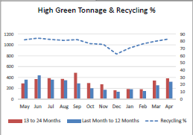

Chart 24 shows the waste recycled at High Green HWRC.
It includes all materials recycled from the site including green waste, electricals, wood, soil and rubble, metals, plastics, textiles, glass, paper and cardboard, fluorescent tubes, oil, and batteries.
Tonnages are higher in the spring/summer months due to the peak growing season (garden waste).
Tonnages have been affected by COVID-19 due to restrictions on the number of vehicles allowed on site between March 2020 and April 2021.

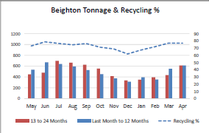

Chart 25 shows the waste recycled at Beighton HWRC.
It includes all materials recycled from the site including green waste, electricals, wood, soil and rubble, metals, plastics, textiles, glass, paper and cardboard, fluorescent tubes, oil, and batteries.
Tonnages are higher in the spring/summer months due to the peak growing season (garden waste).
Tonnages have been affected by COVID-19 due to restrictions on the number of vehicles allowed on site between March 2020 and April 2021.

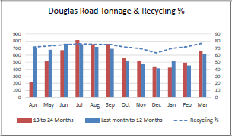
Chart 26 shows the waste recycled at Douglas Road HWRC.
It includes all materials recycled from the site including green waste, electricals, wood, soil and rubble, metals, plastics, textiles, glass, paper and cardboard, fluorescent tubes, oil, and batteries.
Tonnages are higher in the spring/summer months due to the peak growing season (garden waste).
Tonnages have been affected by COVID-19 due to restrictions on the number of vehicles allowed on site between March 2020 and April 2021.

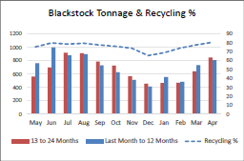
Chart 27 shows the waste recycled at Blackstock HWRC.
It includes all materials recycled from the site including green waste, electricals, wood, soil and rubble, metals, plastics, textiles, glass, paper and cardboard, fluorescent tubes, oil, and batteries.
Tonnages are higher in the spring/summer months due to the peak growing season (garden waste).
Tonnages have been affected by COVID-19 due to restrictions on the number of vehicles allowed on site between March 2020 and April 2021.

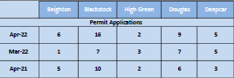

Chart 28 shows the number of applications approved for a HWRC permit.
These allow up to 12 visits to a HWRC in a 12-month period and are provided for vans and trailers.

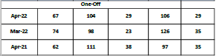

Chart 29 shows the number of requests approved for a One-Off visit to a HWRC.
These are provided to allow access to a HWRC in a hired van, or a van where the household also owns a car and is not eligible for a permit.

