Sheffield Autism Partnership Board

6th August 2025
3:15 - 4:45pm

Action Notes

Attendees
Richard Groves (RG) | Anna Guest (AG) | Mubarak Darbar (MD)
Avi Derei (AD) | Liz Tooke (LT) | Susan Kirkman (SK)
Rachel Hardy (RH) | Jessica Beech (JB) | Katie Monette (KM)
David Newman (DN) | Joe Hamshere (JH) | Barry Tickell (BT)
Michelle Cook (MC) | Danielle Grant (DG) | Ben Duke (BD)
Rebecca Fletcher (RF) |  | Emma Roebuck – Smythe (ERS)

Time | Item | Speaker
3:15pm | Welcome and introductions  - AG welcomed attendees to today’s meeting.  - Housekeeping rules mentioned.  - Agenda shared with the board. | Chair
3:20pm | Minutes of the last meeting and sign off  - AG summarised the minutes of the last meeting on the 4th of June 2025 highlighting key points.  - RG advised that there was no agreement made around securing funding for project management of the workstreams.  - Minutes approved and signed off as a true record.  - ERS to liaise with SS in respect of ratified minutes being available on the Council’s APB website. | Chair  ERS/SS
3:30pm | Presentation – Introduction to our CQC Self-Assessment  - MD advised the Board of the upcoming CQC visit from the 8th September 2025.  - MD presented the CQC self-assessment presentation, explaining the assessment framework, the themes and the importance of the assessment. MD also discussed the strengths and challenges identified in the self-assessment and the upcoming inspection.  - MD asked the board to consider, how does your area of work relate to the Adult Care and Wellbeing vision and strategy and what are you most proud of as a team.  - MD welcomed any questions or comments.  - SK advised the board of her personal concerns around self-assessment and that there should be more opportunities for families to speak up, especially for people that cannot speak up for themselves.  - MD explained that the CQC provide specific criteria in terms of who they would like to meet as part of their assessment. Unfortunately, we cannot control this.  - Rachel Hardy asked why this presentation has been shared today? MD explained that it is important Board members are aware that the Local Authority is about to be inspected, also should the CQC wish to speak with you.  - AG asked how the Board could review the performance data. MD to advise once clarified. | Mubarak Darbar  MD
4:00pm | 10-minute comfort break
4:10pm | Discussion around APB and functions of members and officers  - RG led a discussion on the APB’s functions and members, seeking feedback on the boards purpose, membership and direction.  - The All-Age Autism Strategy was discussed at the Directorate Leadership Team meeting this week and has been tabled for further discussion.  - RG shared the ‘golden circle’ to support this discussion. 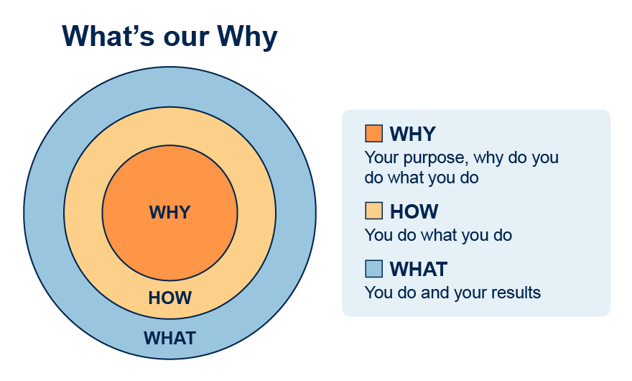  - Thoughts were shared on the Boards effectiveness, representation and areas for improvement.  - Points shared were, membership that includes family carers and representation for people that cannot speak for themselves, representation from Housing would be useful, less complex meetings, shorter meetings and all ability meetings. It was felt that nothing changes.  - Should there be a children and adult board together?  - KM asking where the Children’s part sit, should there be a children’s focus occasionally.  - RH raised the statutory requirements of the APB and what are the guidelines it operates within.  - JB explained that it was impossible to tell you what we have achieved as a Board as the aims are not clear and there is no direction.  - Members agreed that we need to be clear on Governance, where does it sit in terms of other boards and priorities and what are the Terms of Reference for this board (Terms of Reference shared via the Chat function. RG agreed to look at this along with the Strategy.  - DN asked if the board could look at 1 workstream at each meeting?  - Members agreed this has been an important discussion and we need to utilise our collective assets in terms of impacts.  - RG asked all members of the board to email him directly or the operational PA support inbox, what do you feel we should be doing as a board, what are the values that underpin the strategy that we should be upholding?  - AG reminded attendees that for people that are autistic, there is a pre board meeting a week prior to the APB and it is good to come along and ask questions. | Chair  ALL
4:20pm | Discussion around projects – reprioritisation of workstreams  - Workstreams discussed.  - There have been delays in getting them up and running.  - Workstream leads require clarity on what is expected of them as leads.  - Agreed that the board will look at Workstream 1 during the October meeting, an update from the lead will be required in terms of where the workstream is at, what support can be offered by the board, the lead to make the decision as to whether workstream members attend for this item. | Richard Groves
4:30pm | Feedback from autism week  - AD shared presentation  - AD explained the purpose of the presentation, share feedback themes, highlight successes, identify areas for improvement, reflect on lessons learnt and prompt discussion.  - AD shared 4 videos with the group from within the presentation.  - AD summarised lessons learned  - AD requested that future discussion points are discussed at a future APB meeting. ERS to add to the forward plan.  - AD to share the presentation with ERS so this can be shared with members of the board. | Avi Derei  ERS  AD
4:45pm | Summarise agreed actions and responsible person(s)  - Ratified minutes to be uploaded to the website. ERS to liaise with SS.  - MD to confirm how board members can review Performance Data that is available within the public domain as part of the CQC inspection.  - RG asked all members of the board to reflect on the boards vision and values and email him directly or the operational PA support inbox (contact details provided below), what do you feel we should be doing as a board, what are the values that underpin the strategy that we should be upholding?  - AD to share the presentation from Autism week with ERS for distribution to the board members. | Chair  ERS/SS  MD  ALL  AD
 | Forward planning  - Autism week, future discussion points  - Workstream 1  - PIP, advice and support  - Acknowledgement that the Autism Strategy ends in 2026 | RG/AG
Contact details

Richard.groves@sheffield.gov.uk
Operational_deputy_dass_pa_support@sheffield.gov.uk

Next Meeting: Wednesday 1st October 2025, 10am – 11.30am

