Sheffield’s Interim Technology Enabled Care (TEC) Product Catalogue
N | Product/Monthly Charge | Category | Purpose | Targeted Outcomes | Risks Mitigated
1 | Telecare Digital Careline  £30.39  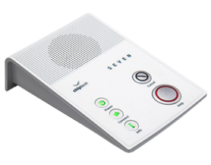 | Telecare | Telecare is a technology-enabled service that promotes safety and supports independent living.  It uses remote monitoring devices, sensors, and rapid-response communication systems to detect and respond to emergencies such as falls. Tunstall Response can be linked directly to fall alerts, ensuring timely assistance. This approach helps reduce avoidable hospital admissions and provides reassurance to individuals and their families. | Independence  Enable living at home  Support Carer Needs | -Risk of Falls  -Lack of confidence living alone  -Safeguarding Issues  -Violence or Abuse  -Carer Fatigue
2 | Telecare Smoke Detector  £2.39  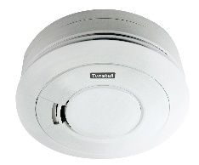 | Telecare | When smoke is detected, an alarm is triggered. If multiple alarms are installed, call monitoring staff will be able to identify the exact location of the activated alarm. | Support Carer Needs  Enable Living at Home | -Risk of Smoke or Fire  -Wandering or untoward events associated with Dementia/memory loss  -Other risks Smoker,  Bed Bound,  Slow to mobilise, Hoarding
3 | Telecare Falls Detector  £5.21  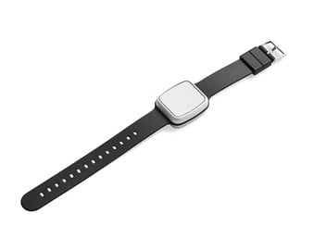 | Telecare | When the unit detects a fall, an alarm is raised. This helps to cover for situations where someone has a fall, but cannot press the button to raise the alarm, for example if they are unconscious or experiencing an epileptic fit. | Support carer needs  Prevent hospital admission  Enable living at home | -Risk of falls  -Cognitive Decline  - Epileptic or other seizures
4 | Telecare Bed Occupancy Sensor  £5.65  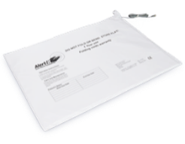 | Telecare | This can fit under or on top of a mattress and can be set to operate for a certain period. If the person is out of bed for longer than the pre-set delay, the alarm will be triggered. This can help monitor situations where people may have fallen in the night. | Support carer needs  Prevent hospital admission  Enable living at home | Risk of falls  Cognitive decline
5 | Telecare Chair Occupancy Sensor  £5.21  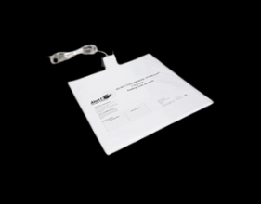 | Telecare | This is fitted under a cushion and works in a similar way to the bed occupancy sensor, as it sets off an alarm if the person leaves the chair and does not return within a specified time. | Support carer needs  Prevent hospital admission  Enable living at home | Risk of falls  Cognitive decline
6 | Telecare Carbon Monoxide Detector  £3.26  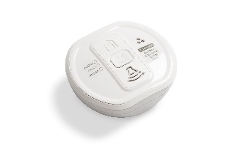 | Telecare | An alarm is raised when a dangerous level of carbon monoxide is detected. | Support carer needs  Prevent hospital admission  Enable living at home | Cognitive decline
7 | Magic Plugs  Free for now while stocks last will need to replenish  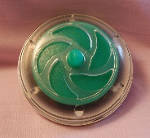 | Telecare | Is a safety device that automatically stop water from overflowing if taps are accidentally left on. | Support carer needs  Enable living at home | - Risk of Flooding  -Cognitive Decline
8 | Telecare Fixed Alarm Button  £2.39  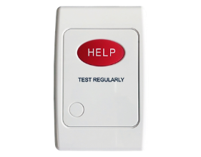 | Telecare | An alarm button can be fixed anywhere in a property, for example, by the front door to contact the call monitoring staff for help with potential bogus callers, or in the bathroom in case of falls at night. | Support carer needs  Enable living at home | -Safeguarding Issues  -Lack of confidence in living alone  -Violence or Abuse
11 | Tunstall Heat Detector  £3.91  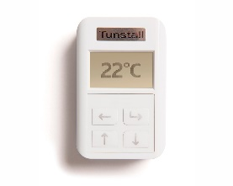 | Telecare | This can provide additional protection against fires in rooms where smoke detectors are unsuitable, e.g. kitchen. An alarm is raised when the temperature reaches between 54 and 62 degrees centigrade. | Support carer needs  Enable living at home | Cognitive decline
12 | Telecare Property Exit Sensor  £6.08  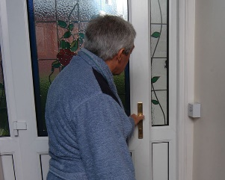 | Telecare | This checks for people leaving a building. It can be set to operate at certain times of the day and night, (within limits). A delay can also be set, so that the alarm is only raised if someone does not return within a set period, (allowing people to go out and empty a bin etc.) It can also detect if a main exit door has been left open. A family member, neighbour or friend will need to respond if the person does not return within the set period. | Enable living at home  Support carer needs | Wandering or untoward events associated with Dementia/memory loss
13 | Telecare Epilepsy Sensor  £6.95  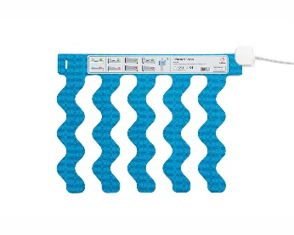 | Telecare | This bed-based sensor monitors the user’s movements, including heartbeat and respiration. It can separate normal movements from epileptic  seizure symptoms such as tonic-clonic shakings or similar continued movement. The sensor also detects hyperventilation and partial convulsions as seizures. The alarm triggers if the person has abnormal movements longer than a pre-set delay, which can be between 7 and 20 seconds | Support carer needs  Prevent hospital admission  Enable living at home | Epileptic seizures
14 | Telecare Medication Dispenser  Challenges in some Pharmacies filling  £4.78 plus £1.30 for tipper if needed  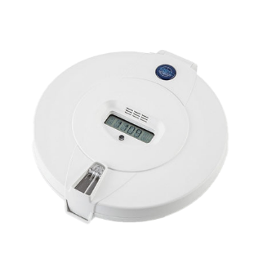 | Telecare | This has multiple compartments to store pills. It can be programmed to provide an audible reminder to the user each time medication should be taken. The unit needs to be tipped upside down to drop the medication out. The act of tipping the unit cancels the alarm. If the reminder isn’t cancelled then an alert is raised. | Independence  Support carer needs  Enable living at home | -Missing medication  -Cognitive Decline
15 | Telecare Pager  Supported Living  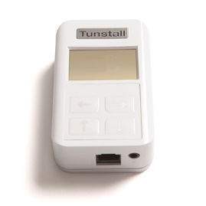 | Telecare | Is usually used within a supported living environment. It allows Support Workers/Carers to respond to alarms. It can also be linked to Tunstall systems if not response is received, ensuring safety and supports independent living. | Support Carer needs  Enable living at home | -Risk of falls  -Lack of confidence in living alone  -Safeguarding Issues  -Epileptic of other seizures  - Wandering or untoward events associated with Dementia/memory loss  -Other, personal care
17 | Telecare Enuresis Sensor  Supported Living - carer available on site  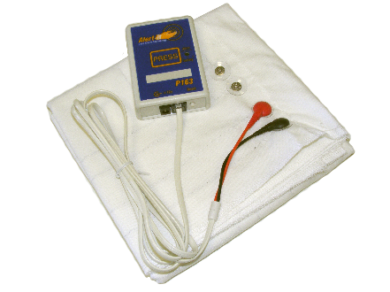 | Telecare | Designed to detect bedwetting in real time. It alerts care givers promptly, helping support independence and comfort for the individual. | Support carer needs  Address unmet need  Independence | Other, Personal Care
22 | Chiptech Go Pendant 4G  Pricing under development  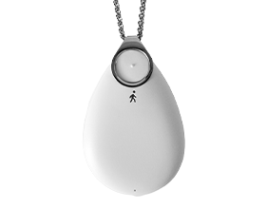 | Telecare | Available for use in the home and out and about in the Neighbourhood  CWCA response when the person is using the device in the Home, with family and friends required to support the response when the person if out and about in the community.  Is a wearable personal alarm that uses 4G connectivity to allow users to call for help anywhere. | Support Carer needs  Enable living at home | -Wandering or untoward events associated with Dementia/memory loss  -Risk of fall  -Carer Fatigue
24 | Howz Assessment & Review Tool  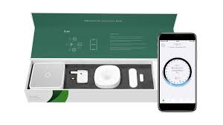 | Connected Care (NG) | Is a digital platform to monitor and review individuals wellbeing remotely. It collects data on daily activity, habits and health trends, helping care teams identify changes early, make informed decisions and provide timely personalised support. | Support carer needs  Prevent hospital admission  Aid timely hospital discharge  Enable living at home  Address unmet need | -Risk of falls  - Carer Fatigue  -Lack of confidence in living alone  -Wandering or untoward events associated with Dementia/memory loss  - Safeguarding Issues
25 | Just Checking Review Tool  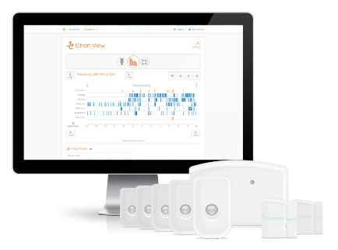 | Connected Care (Std) | Is a digital monitoring system used to observe daily routines and wellbeing. It helps care teams detect changes in behaviour or health, supporting timely interventions, informed care planning and increased independence for individuals. | Support carer needs  Prevent hospital admission  Aid timely hospital discharge  Enable living at home  Address unmet need | -Risk of falls  - Carer Fatigue  -Lack of confidence in living alone  -Wandering or untoward events associated with Dementia/memory loss  - Safeguarding Issues
26 | Holistic Connected Care  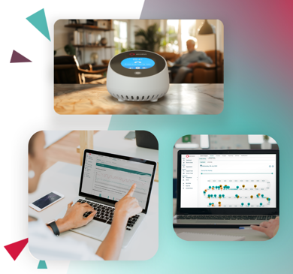 | Telecare/  Connected Care | Tests of Change –  Provides a complete view of a person’s health and wellbeing. They enable real time monitoring, data driven insights and coordinated responses supporting personalise care, safety and independence. | Support carer needs  Enable living at home  Other – allows independence | Lack of confidence in living alone
27 | Ethel Care  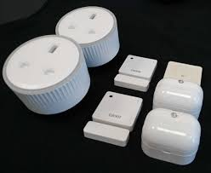 | Virtual Care | Test of Change  Provides a complete view of a person’s health and wellbeing. They enable real time monitoring, data driven insights and coordinated responses supporting personalise care, safety and independence. | Support carer needs  Enable living at home  Other – allows independence | Lack of confidence in living alone
28 | YOURMeds  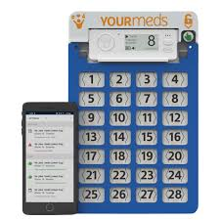 | Medication only support | Test of Change  Is a digital medication management system that helps people take the right medicines at the right time. It provides reminders, tracks adherence, gives care teams visibility supporting safety, independence and better health outcomes. | Support carer needs  Prevent hospital admission  Enable living at home | - Missing Medication  - Safeguarding
29 | Vocala – Alexa  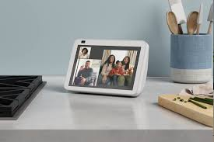 | Virtual Care | Test of Change  Provides a complete view of a person’s health and wellbeing. They enable real time monitoring, data driven insights and coordinated responses supporting personalise care, safety and independence. | Support carer needs  Enable living at home  Other – allows independence | Lack of confidence in living alone
30 | Nobi Care  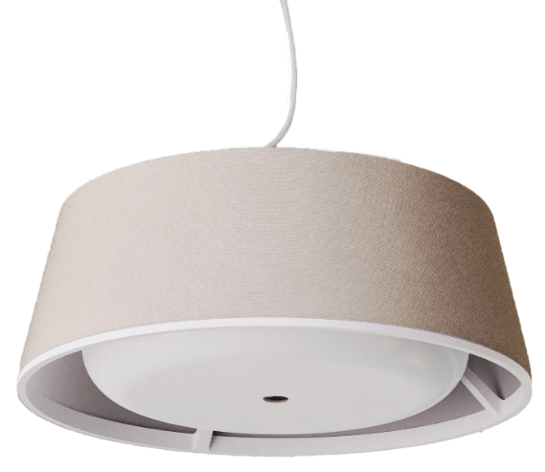 | Falls Management | ICS Test of Change  Supports individuals in daily living and safety. Using sensors and alerts, it helps detect falls, monitor wellbeing and provide timely support, promoting independence and peace of mind. | Support carer needs  Enable living at home  Other – allows independence | -Risk of falls  - Carer Fatigue  -Lack of confidence in living alone  -Wandering or untoward events associated with Dementia/memory loss  - Safeguarding Issues

