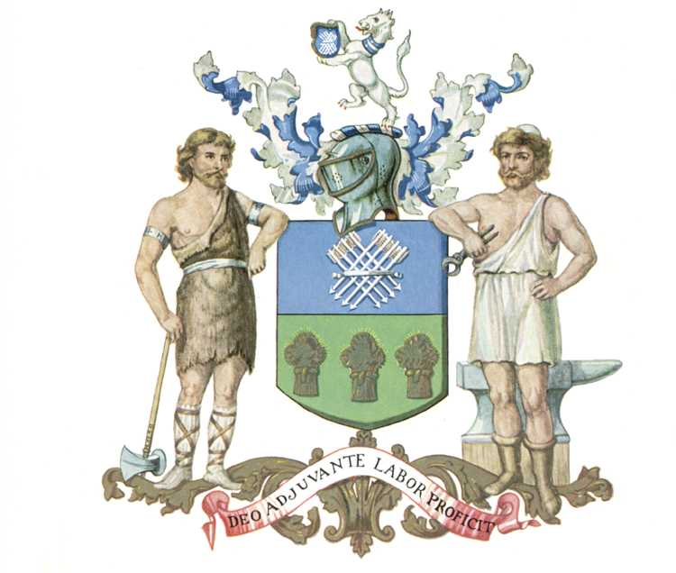
Lord Mayor's Office
Sheffield City Council

Town Hall, Sheffield, S1 2HH

Sheffield Legends 2025

Criteria for nomination: An individual or group with a strong and well-known association with Sheffield that has made a substantial contribution to the positive promotion of the city. Their reputation should be such that they are a nationally or globally well-known public figure, with a high level of acclaim or standing due to being at the top of their field and which clearly demonstrates their level of status and achievement

Name of the person or group that you would like to nominate:
Why are they well-known and what have they achieved?
The reasons for your nomination:

Please return your completed nomination to: civicawards@sheffield.gov.uk
Or
Sheffield Legends 2025, Lord Mayor’s Office, Town Hall, Sheffield, S1 2HH

