Sheffield Safe Accommodation Needs Assessment

2023



**Table of Contents**

1. Introduction and Methodology 3

2. National Policy and Guidance 4

3. National Data and Prevalence 9

4. Sheffield Prevalence 28

5. Children and Young People Affected by Domestic Abuse in Sheffield 31

6. Sheffield Refuge Activity 35

7. Sheffield Safe Zones 49

8. Temporary and Supported Accommodation 53

9. Support in the Community 56

10. Service User Experience 61

11. Projections for future need in Sheffield 66

12. Conclusion 68

13. Recommendations 69

# Introduction and Methodology

This Needs Assessment is the annual refresh of the 2021 Safe Accommodation Needs Assessment that was been compiled to help inform the commissioning of safe accommodation in Sheffield, to feed into the Safe Accommodation strategy and domestic abuse strategy. The refreshed report supports the requirement of the Department for Levelling Up, Housing and Communities (DLUHC) for local authorities to collate data into a needs assessment for the purpose of creating a local strategy.

This report reviews national policy and guidance, as well as national reports to show the requirements of local authorities and provide a national picture. Findings from research and the Crime Survey of England and Wales help us to understand the prevalence of domestic abuse, and the need for safe accommodation. These national estimates are then applied to the local population to help us understand the potential prevalence in Sheffield.

National data is compared to what we know happens in Sheffield to help provide an overview of areas of good practice locally, but also where we need to improve. By comparing local activity with what we know about national prevalence and activity the report aims to identify where there is a lack of provision both in accommodation and additional support provided to victims / survivors of domestic abuse and how funding can be directed to better address gaps in the support offered in Sheffield.

In this document where gaps in provision and data collection are identified these will be collated to provide a list of recommendations that can feed into the local strategy, commissioning decisions, and working to improve the data that is collected locally to provide more insight in future needs assessments.

# National Policy and Guidance

The UK government has published documents that outline the governments expectations and requirements of local authorities to provide suitable care, support, and housing to those in need and victims / survivors of domestic abuse. These documents impact on the commissioning of refuge and alternative accommodation for survivors of domestic abuse. Key points taken from recent publications are provided below.

**Domestic Abuse Act**

The Domestic Abuse Act 2021[1] places a statutory duty on tier one local authorities to provide support to victims / survivors of domestic abuse and their children within refuges and other safe accommodation.

The Act has maintained a broad definition of safe accommodation in recognition of the diversity of housing in which victims / survivors and their children may live.

The new duty covers the provision of support to victims / survivors and their children residing in refuge accommodation; specialist safe accommodation; dispersed accommodation; sanctuary schemes; and move-on or second stage accommodation.

Domestic abuse support is defined as:

Advocacy support – development of personal safety plans, liaison with other services (for example, GPs and social workers, welfare benefit providers).

Domestic abuse-prevention advice – support to assist victims / survivors to recognise the signs of abusive relationships, to help them remain safe (including online) and to prevent re-victimisation.

Specialist support for victims / survivors with protected characteristics and / or complex needs, for example, interpreters, faith services, mental health advice and support, drug and alcohol advice and support, and immigration advice.

Children’s support – including play therapy and child advocacy.

Housing-related support – providing housing-related advice and support, for example, securing a permanent home and advice on how to live safely and independently; and

Counselling and therapy for both adults and children.

The Act aims to help millions of people by transforming the response to domestic abuse across all agencies. It provides further protections for those who experience domestic abuse and enhances measures in place to bring perpetrators to justice.

The measures in the Domestic Abuse Act 2021 aim to:

* Promote awareness.
* Protect and support victims / survivors.
* Hold perpetrators to account.
* Transform the justice response
* Improve performance in the response to domestic abuse

Anyone can be a victim / survivor of domestic abuse, the 2021 Act introduces a statutory definition of domestic abuse:

*Behaviour of a person towards another person is domestic abuse if the two people are aged 16 or over and are personally connected, and the behaviour is abusive. Behaviour is abusive if it consists of any of the following:*

1. *Physical or sexual abuse*
2. *Violent or threatening behaviour*
3. *Controlling or coercive behaviour*
4. *Economic abuse*
5. *Psychological, emotional, or other abuse*

*It does not matter whether the behaviour consists of a single incident or a course of conduct. For the purposes of the Act the perpetrators conduct could mainly be directed to a child under 16 who is a child of the victim.*

**Spending review 2020**

Provided £98 million of additional resource funding, bringing total funding to £125 million, to enable local authorities to deliver the new duty to support victims / survivors of domestic abuse and their children in safe accommodation in England. This new burdens funding continued under the Conservative Government with the final agreed allocation due to end in March 2025. At the time of writing there is no information as to the current governments plans in relation to continuing funding for Domestic Abuse Act duties.

Local Partnership Board - Tier 1 local authorities are required to convene a multi-agency Local Partnership Board (LPB) to support them in performing certain specified functions. These will be to:

* **Assess the need and demand** for accommodation-based support for all victims / survivors and their children, including those who require cross-border support.
* **Develop and publish strategies** for the provision of support to cover the locality and diverse groups of victims / survivors.
* **Give effect to strategies by making commissioning / de-commissioning decisions**
* **Meet the support needs of victims / survivors and their children**
* **Monitor and evaluate local delivery**
* **Report back to central Government**

There is also a duty for the DLUHC to produce [statutory guidance](https://www.gov.uk/government/publications/domestic-abuse-support-within-safe-accommodation); and a duty for LAs to have regard to statutory guidance in exercising the above functions.

Needs Assessment - A standardised needs assessment has been developed by the DLUHC to support LAs in assessing local need and demand on services.

Local strategies - LAs are required to develop and publish a robust local strategy based on the needs assessment.

The clauses in the Domestic Abuse Act aim to ensure local authorities, with support from their LPBs, have the right knowledge and steps in place to accommodate the needs of all victims / survivors.

The duty to convene a Local Partnership Board came into force in April 2021. Sheffield’s existing Domestic and Sexual Abuse Strategic Board has taken on the role of the Local Partnership Board.

In Sheffield, the DLUHC funding is used to support women in refuges and people in Safe Zones dispersed safe accommodation, together with those at risk of domestic abuse in their own homes who have Sanctuary Scheme items fitted, plus support for children and young people in safe accommodation, counselling and advice re. debt, benefits and housing.

**Supported Housing: National Statement of Expectations[2]**

The National Statement of Expectations (NSE) was developed in collaboration between the Ministry of Housing, Communities and Local Government (MHCLG, now the DLUHC) and the Department for Work and Pensions (DWP) with input from local councils and the supported housing sector. Together, they are committed to seeing delivery of good quality supported housing which meets residents’ needs and represents good value for money. The NSE provides a mechanism for establishing the vision for accommodation standards, quality, and value for money. The NSE is not a statutory requirement, and to date there has been no definitive set of guidelines on what should reasonably be expected from the accommodation element of supported housing. However, it is hoped that organisations involved in the provision of supported housing will use, adopt, and find the principles and examples of best practice helpful.

In supported housing, accommodation is provided alongside support, supervision, or care to help people live as independently as possible in the community, including for people fleeing domestic abuse with their children.

In order to deliver the ambitions of the NSE local authorities should work alongside providers and local delivery partners to:

* Assess local demand and plan effectively
* Ensure safe and good quality supported housing
* Ensure supported housing provides good value for money

The strategy in Sheffield was designed in line with these principles. And the new strategy currently in development will continue to do so.

# National Data and Prevalence

National data helps to provide an estimate of the scale of domestic abuse in England. We can use this data to look at the current position and the historical trend of domestic abuse prevalence. This can also help to inform estimates of domestic abuse prevalence in Sheffield. We can also look at national data regarding refuge placements and utilisation as a result of domestic abuse across England.

**Crime Survey for England and Wales**

The Crime Survey for England and Wales (CSEW) is an important means to understand the true level of crime due to its ability to find out about crimes which do not get reported to, or recorded by, the police. However, the CSEW is increasingly recognised as limited in its assessment of prevalence of domestic abuse particularly as it does not routinely ask questions about coercive control. [3]

Also, the CSEW data is an estimate and based on subjective interpretation of individuals as to whether a crime has been committed and what they remember of the previous 12 months.

Date year ending March 2023 suggests around 2.1m estimated victims / survivors, with only approx. 889k cases recorded by the police (around 42%).

The most recent crime survey data for domestic abuse is for the 2022/23 financial year. However, the 2017/18 CSEW asked some specific questions around domestic abuse that have not been asked since. These questions found that for those that did not report domestic abuse, the most common reasons given were:

* the abuse was too trivial or not worth reporting (45.5%)
* it was a private family matter and not the business of the police (39.5%)
* the victim didn’t think the police could help (34.2%).

Sexual offences and domestic abuse-related crimes recorded by the police provide a good measure of crime related demand on police but do not provide a reliable measure of trends in these types of crimes. Improvements in police recording practices and increased reporting by victims / survivors have contributed to increases in recent years. The figures do, however, provide a good measure of the crime-related demand on the police. The CSEW provides a better picture of the overall trend in violent crime and a more reliable measure of the long-term trends in sexual assault, stalking and harassment, and domestic abuse.[4]

Previous Needs Assessments have reported CSEW findings with reference to research by Gadd et al (2002)[5] regarding male victims / survivors. This research is over twenty years old and more recent research has shown increasing numbers of men reporting being a victim of domestic abuse. For example, research by Respect Men’s Advice Line[6] reported an increase in demand of 57% in comparison to 2019/20. The Mankind Initiative’s 70 Key Facts About Male Victims / survivors of Domestic Abuse and Partner Abuse (June 2023) states that despite 25% of domestic abuse crimes being committed against men, only 4.7% of victims / survivors being supported by DA services are men.

This report will use the reported CSEW estimates to understand the potential national prevalence of domestic abuse for both females and males. As stated above there are concerns about how the CSEW collects data on domestic abuse and how this impacts on estimates of prevalence particularly in relation to gender.

**Prevalence estimates for the number of victims / survivors of domestic abuse in the last 12 months and since the age of 16 years**

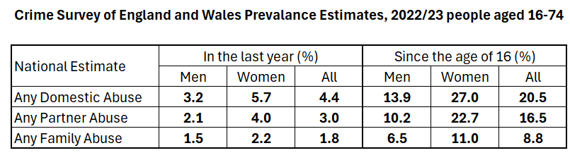

In 2022/23 it is estimated that:

* 4.4% of people aged 16 -74 experienced any form of domestic abuse (down 0.6% on 2021/22); 5.7% of women (down 1.2%) and 3.2% of men (up 0.2%)
* 3% reported partner abuse (down 0.5%); 4% of women (down 0.8%) and 2.1% of men (no change)
* 1.8% reported any family abuse (down 0.3%); 2.2% of women (down 0.7%) and 1.5% of men (up 0.3%)

In total 20.5% of people reported having been a victim of domestic abuse at some point since the age of 16 (down 1.4%) comprising of 27% of women (down 2.3%) and 13.0% of men (down 0.2%)

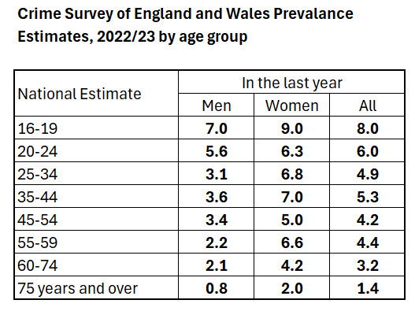

The 2022/23 CSEW provided an age update for the first time since the 2019/20 CSEW. It found that prevalence of domestic abuse in the last year was highest amongst younger age groups, with 9% of females aged 16 – 19 experiencing domestic abuse in the last year. This data suggests many of the people accessing accommodation are likely to be younger and either in need of single properties or have young children and need family units. This should therefore be considered alongside commissioning decisions.

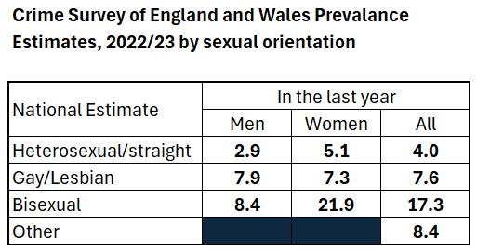

Prevalence of domestic abuse in the last year was reported to be highest amongst people who are bi-sexual in 2022/23 with 17.3% reporting being a victim (6.2% higher than 2021/22), compared to 4.6% (up 0.6%) of heterosexual people. To understand this data in context however, it should be noted that in 2022 the ONS Annual Population Survey estimated that 1.8% of the population identify as gay or lesbian, 1.5% as bisexual, and 0.6% defined as Other.[7]

Although a small proportion of the total population this data suggests that the safe accommodation offer needs to ensure it meets the needs of the LGBT+ community. Questions on LGBT+ needs were part of service user consultations and will continue to inform commissioning and practice.

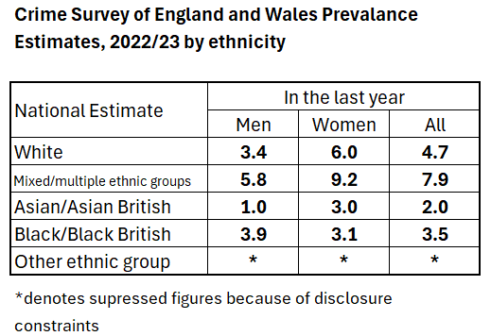

From the data made available rates of domestic abuse are estimated to be higher amongst women than men in all categories except black/black British

Estimated rates in 2022/23 are significantly highest amongst people of mixed/multiple ethnicities. The 2nd highest prevalence rate was amongst those who are White (a change to 2021/22 where Black/Black British was 2nd highest).

This data suggests that the safe accommodation offer needs to continue to ensure it meets the needs of minoritised communities. Questions on ethnicity were part of service user consultations and will continue to inform commissioning and practice.

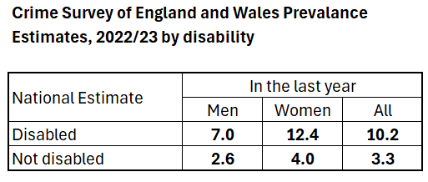

The 2022/23 CSEW estimates that 12.4% of disabled women (down 0.7% on 2021/22) and 7% of disabled men (up 0.3%) have been a victim of domestic abuse in the last year, the table above also shows that these rates are more than twice as high as rates amongst people who are not disabled[8]. These estimates highlight the potential need for suitable accessible accommodation for victims / survivors of domestic abuse as the data suggests that a disabled person is more likely to be a victim of domestic abuse. However, this data does not indicate the type of disability that is most common e.g., whether this indicates the need for more units that are accessible for people with mobility issues or other forms of disability.

Table showing CSEW data on partner abuse and accommodation. 

For the 2022/23 CSEW the Office for National Statistics (ONS) published a detailed section on partner abuse[9]. The data shows that for victims / survivors of domestic abuse in the last year, just under 19% (just under 1 in 5) lived with the abusive partner, down from 21.4 six years ago. The proportion could be higher as 11.6% did not want to respond to the question. Of those living with an abusive partner in the last year the majority (69.9%) did not leave the accommodation because of the abuse, this is up 4.4% on six years ago. However, this means three in ten did leave due to domestic abuse which indicates the need for safe accommodation.

A table showing CSEW data on why the victim did not leave the abusive partner. The main reason being love/feelings for the partner.

The reason for not leaving the abuse is asked on the CSEW. The three main reasons given were love / feelings for partner, presence of children and nowhere to go. These are only based on a sample of 72 people however, so caution needs to be given to these figures.

Other key findings on partner abuse from the CSEW 2022/23 included:

* An estimated 3% of adults aged 16 to 74 years had experienced partner abuse in the last year. This is down 1.5% on the same metric five years ago
* Male victims / survivors of partner abuse reported experiencing higher levels of non-physical abuse (emotional, financial) than female victims / survivors of partner abuse (89% compared to 87%)
* Male victims / survivors of partner abuse reported experiencing higher levels of physical force than female victims / survivors of partner abuse (31% compared to 19%)
* In almost one-third of households where there was a victim of partner abuse, there was at least one child under the age of 16 years living there at the time of the abuse (32.4%); 71.9% of victims / survivors reported the child or children did not see or hear the abuse.
* Of partner abuse victims / survivors, 16.4% reported that they sustained a physical injury as a result of the abuse and 52.0% experienced a non-physical effect.
* More than four in five victims / survivors of partner abuse (81.0%) reported they told someone [10]about the abuse they had experienced in the last year, with 18.9% telling the police.

A majority of victims / survivors do confide in someone they know regarding the abuse they suffer (68%), but only 28% report the abuse to someone in an official position.

While the rate of male victims / survivors of domestic abuse appears to be rising, female victims / survivors experience higher levels of serious harm. Male victims / survivors account for 6.4% of high risk victims / survivors heard at MARAC, and at the end of 2023 7 in 10 victims / survivors of domestic homicide were women (70%) and 3 in 10 were men (30%). The most common suspect for female homicide victims / survivors aged 16 years and over was their partner or ex-partner.

**Recommendations**

* Continue to promote domestic abuse services to the general public to raise awareness of the support available, to increase awareness amongst victims / survivors but also the people they talk to
* Continue to commission professional domestic abuse awareness training in order to help professionals identify abuse victims / survivors
* Provide targeted promotion to under-represented groups, such as those with disabilities as the data suggests prevalence rates are higher amongst this group than the general population

**ONS Police Recorded Crime Data 2022/23[11]**

* the police recorded 889,918 domestic abuse-related crimes in England and Wales (excluding Devon/Cornwall), this is similar to the previous year having historically seen year on year increases.
* 36.3 arrests per 100 domestic abuse-related crimes were made by the police, up from 29.6 the previous year.
* There were 69,314 referrals to the CPS from the police in 2022/23, an increase from 67,063 the year before.
* the charging rate was 76.5%, an increase on the previous year.
* over three-quarters of domestic abuse-related CPS prosecutions were successful in securing a conviction (76%), a similar level to the previous year.

**Women’s Aid Annual Audit 2023[12]**

The annual audit presents information on the provision and usage of domestic abuse services (both accommodation and community support services) in England, mainly focusing on the financial year 2021/22. This year the report again includes a section on the impact of the Covid-19 pandemic. Key findings from the audit included (all comparisons are from the previous year):

* It is estimated (based on the On Track data collection) that 10,502 women supported by a refuge in 2021/22 (around 300 lower than the previous year). 131,094 women accessed all community based services
* 74.6% of clients were aged 21-45, with 28.7% having a disability.
* 4,244 refuge spaces in England (up 55 in 21/22), however this is still falling short of the number of spaces recommended by the Council of Europe by 1,311, which represents a 23.2% shortfall[13].
* It is estimated that a total of 27,348 referrals were received by refuges, 16,847 of those referrals we declined. This means that 61.6% of all referrals received for refuge were rejected. The main reason for rejection was a lack of space or capacity with 26.2% of all declined referrals being this reason.
* Only 28% (up 2%) of refuges commissioned by local authorities indicated that the funding covered all aspects of the support staff costs.
* 62% of women in refuge services had children (up 2.3%) and 6.1% were pregnant (down 1.2%).
* 85.5% of service users had experienced emotional abuse (down 2.5%), 64.4% had experienced jealous or controlling behaviour (down 2.6%).
* 50.2% of service users in a refuge had support needs around mental health (up 13.6%).
* 47.5% of service users in a refuge reported feeling depressed or having suicidal thoughts because of the abuse (up 12.4%).
* 29.9% of women at refuge services have a disability (up 5.4%); most common were mental health disabilities, 8.1% had a physical disability (down 0.9%).
* Of service users who were not British nationals, 30% (same as last year) had no recourse to public funds (NRPF).
* Only 9.1% of vacancies posted on Routes to Support[14] could consider women who had no recourse to public funds (up 2.8%)
* Under half of refuge vacancies can accommodate a woman with two children and less than one in five for a woman with three children.

These statistics highlight that nationally there are barriers for some women to enter refuge. This includes women who are NRPF and who are a parent. Sheffield therefore needs to continue to commission an adequate refuge offer that accepts women who are NRPF, who are parents and that provides sufficient therapeutic support to the significant cohort who are likely to have mental health needs. We also know that people with a disability are more likely to experience domestic abuse. The small percentage of women in refuge with a physical disability, is likely not reflective of demand from this group and impacted by the availability of accessible accommodation.

**Women’s Aid Nowhere to Turn 2023 – Findings from the No Woman Turned Away Project**

The No Woman Turned Away (NWTA) project[15] (now in its seventh year) provides dedicated support to women who face barriers in accessing a refuge space, the most marginalised women tend to face the greatest barriers in their search for refuge provision. The barriers faced by women searching for refuge include no recourse to public funds, health and disability needs, women with substance use support needs, and women with 4+ children and older male children, with many experiencing more than one barrier.

In 2022 the project received 394 (up 57 on last year) referrals of which, 271 (up 51) went on to receive support from the service and 123 (down 4) referrals did not. For those not engaging with the service the most common reason for not engaging were inability to contact the survivor (41.5%) and did not want to continue with accessing support at that time (18.7%)

In total 254 women engaged and finished their support in the year, the rest continued to receive ongoing support. The table below, taken from the NWTA 2023 report, shows the barriers to accessing refuge that the 254 women experienced:

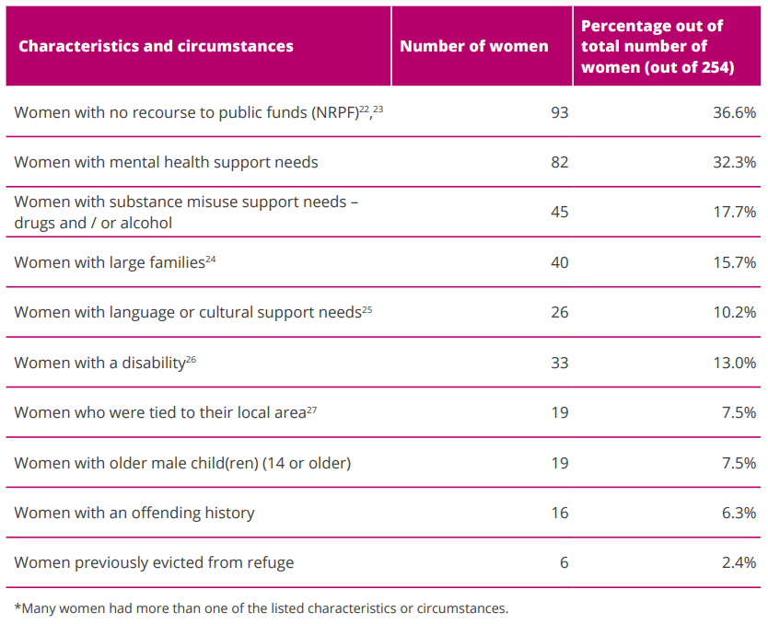

The table shows that the three most common challenges for women seeking a refuge space were no recourse to public funds, mental health support needs, and women with substance misuse support needs

106 (42%) of the 254 women were from BME backgrounds, a figure that could be higher as 47 respondents stated they didn't know their ethnicity or didn't provide a response. The Survival to Sustainability Report[16] states that many women from these backgrounds prefer to be supported by specialist ‘by and for’ BME services.

Whilst waiting for a refuge space, 18.1% of women sofa-surfed (down 3.6%), 15% spent time in emergency accommodation in the same local authority (down 2.4%), 7.9% spent time in emergency accommodation in a different local authority (down 3%), 4.3% paid to stay in a hotel/hostel/B&B (same as last year), and 3.5% slept rough (up 0.2%)

The impact on health and well-being whilst waiting for a refuge space can be seen on the table below:

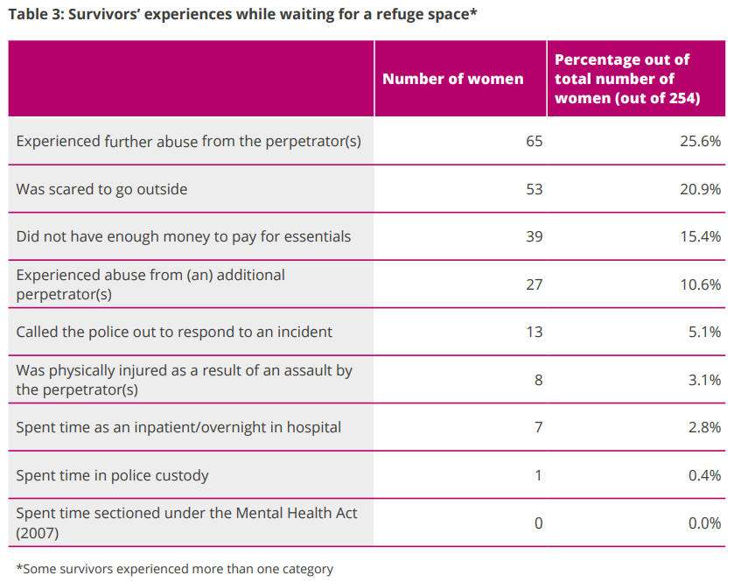

All the women received specialist support from the No Woman Turned Away project but due to some of the barriers faced not all women are placed in a refuge space. The outcomes at the end of support for the 254 women were recorded as follows:

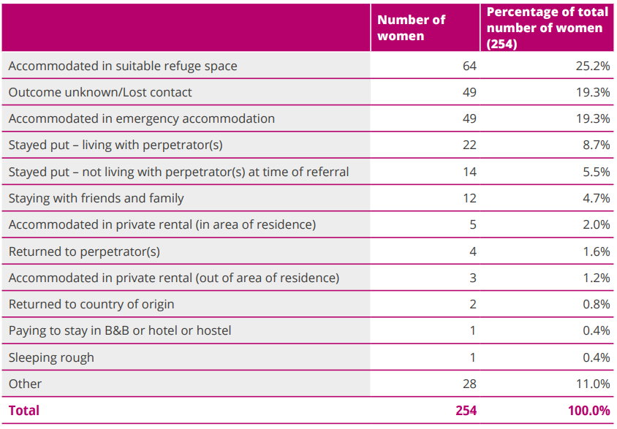

The data shows that only around a quarter of the women were accommodated in a suitable refuge space, 19.3% accommodated in emergency accommodation and 1.2% accommodated in private rental properties. It also shows that 8.7% stayed living with the perpetrator.

Although all these women had barriers to accessing a refuge space there also remain inequalities, as reported in previous Nowhere to Turn reports, within this group depending on the specific barrier(s) they faced. The table below shows that proportion of women with each support need who were accommodated in a suitable refuge.

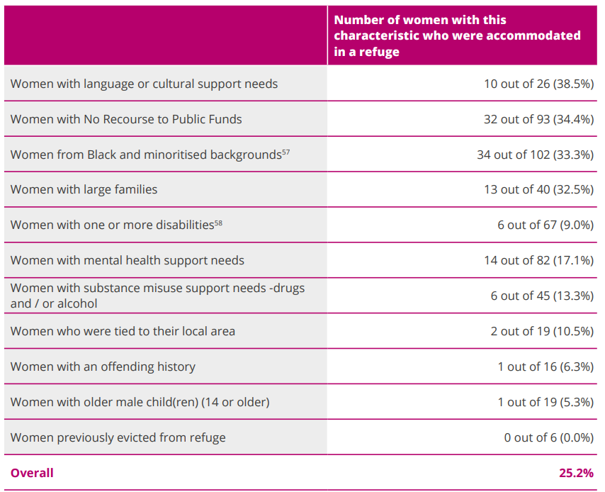

Women previously evicted from a refuge had the lowest chance of finding refuge provision. Only one (5.3%) of the women with older male children and one woman (5.9%) with an offending history was accommodated, and two women (10.5%) were accommodated who had ties to their local area. Overall, 25.2% (down 2.8%) of women with multiple support needs were accommodated by a suitable refuge. These outcomes due to barriers highlight the need for making available and funding a range of accommodation types, including self-contained refuge.

In Sheffield, the organisation Paradigm[17] is commissioned to support providers to ensure supported accommodation (including the women’s refuges) are ’psychologically informed environments (PIE) which supports services to work in a trauma informed way and to mitigate against evictions. ’PIE uses psychological theory to support staff and organisations to create residential and workplace environments which maximise the positive impact on service users through developing the skills of staff who work with them, through:

* Group staff training sessions
* Individual staff supervision
* Facilitating reflective practice sessions for staff’[18]

The Nowhere to Turn 2023 Report makes the following recommendations for national governments:

* Commit to a minimum funding settlement of £427 million annually for specialist domestic abuse services in England, of which a minimum of £189 million is ring-fenced for refuge services
* The funding settlement should be distributed in accordance with a national needs assessment for refuge services, including a review of provision for victims / survivors with protected characteristics.
* To ensure that funds are distributed with maximum impact, local commissioning of specialist domestic abuse services must be consistent, informed by best practice, and tailored to local demographics, and there must be national oversight of commissioning practices
* The financial settlement must be regularly reviewed and updated in line with population and inflation changes

**Recommendations**

* The above recommendations from the Nowhere to Turn report are already mostly implemented locally and should continue to be addressed.

**Domestic Abuse in the LGBT+ Community**

The national CSEW estimates show that domestic abuse prevalence is highest amongst gay, lesbian, and bi-sexual people (in terms of the proportion of LGBT+ people who are affected). In contrast to this, the Sheffield data on people accessing safe accommodation (discussed in sections 5 through to 11) shows that LGB people are underrepresented in some services. This hinders our understanding of the needs of people locally, as they are hidden. We also know that the wider LGBT+ community are underrepresented locally, supporting the view that there are barriers to the community in accessing support. National findings on domestic abuse experiences of the LGBT+ community are therefore important for us to commission an appropriate offer in Sheffield and work to reduce the barriers that people face.

A Needs Assessment produced by Durham University for Central Bedfordshire Council[19] found that the impact of the public story on domestic abuse, which focuses on cis[20]-heterosexual couples, leads to LGBT+ people believing that what is happening to them does not count as domestic abuse. Existing services are designed with the needs of cis-heterosexual women in mind, and LGBT+ people are wary of services that are not explicitly LGBT+ inclusive due to a fear of discrimination and/or a belief that their experiences will not be understood. The prevalence of some types of abuse are higher amongst LGBT+ people, and some of this increase can be attributed to the length of time a person suffers the abuse due to them not coming forward for support. As early interventions are key to reducing future domestic abuse and preventing escalation of harm, another problem is that LGBT+ inclusion is often lacking in the programmes and campaigns that are delivered in the UK. A third of LGBT+ people experiencing abuse from a partner or ex-partner told no one about the abuse they had experienced and for people experiencing abuse from a family member 15% told no one. The report finds that prevalence of domestic abuse amongst LGBT+ people are at least as high as they are for cis-gender heterosexual women. The largest barriers experienced to accessing support are from distrust of services. This is either because of a perceived or experienced instance of homophobia and transphobia.

It is therefore imperative that services are inclusive to all people and that the promotion of services informs the public that anyone can be a victim of domestic abuse and that support available for domestic abuse is for everyone.

**Department for Levelling Up, Housing & Communities (DLUHC)[21]**

DLUHC produce an annual report to provide a summary of progress made by local authorities in implementing their duties under Part 4 of the Domestic Abuse Act 2021[22]. In 2022/23 50,670 individuals received support in safe accommodation an increase from 36,545 in the first year of the duty. Of the 50,670 individuals supported 21,170 (42%) were children. In total there were 16,350 commissioned bed spaces available in 2022/23 of which, 8,550 (52%) were accommodation in sanctuary schemes. 3,850 bed spaces (23.5%) were at refuge. 44% of individuals were supported with accommodation at a refuge, 26% sanctuary scheme, 13% dispersed safe accommodation.

The image below from the DLUHC report illustrates that Sheffield has one of the highest numbers of individuals in the country supported in safe accommodation.

#### **Figure 1. Map of number of individuals supported by local authority area by 100,000 population (April 2022 to March 2023)[23]**

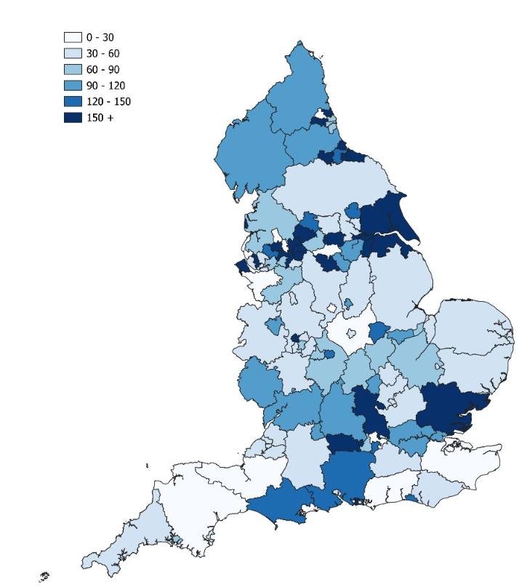

In 2022/23 despite the increases in the number of people supported, local authorities reported 24,580 instances where a household referred to a safe accommodation service could not be provided with support. Capacity was the reason a household couldn’t be supported on 9,820 instances, equating to 40% of all instances where support could not be provided.

The Office for National Statistics (ONS) have produced an article looking into the experiences of women who have survived domestic abuse and have current or previous experience of temporary safe accommodation in England[24]. The research included women who had lived at different types of safe accommodation and with different levels of support provided. The research found that in contrast to accommodation provided in hotels or mixed-needs hostels survivors spoke positively about temporary safe accommodation that was most similar to a traditional home setting and with access to high quality emotional and practical support.

Survivors reported that where they were accommodated in place that did not feel physically safe (e.g. a lack of CCTV) this had a negative impact on health and well-being. They also reported that personalised practical and emotional support helped survivors feel that their needs and circumstances were being considered, making them feel emotionally safer.

Suggested priorities for future service provision from survivors included:

* flexibility in addressing accommodation and support needs,
* better availability of accommodation with safe and appropriate facilities, and
* better provision of mental health support within accommodation and after they leave.

These findings help to highlight the benefits to survivors of providing appropriate and safe accommodation with additional support and highlight the need for more provision of appropriate and safe accommodation.

# Sheffield Prevalence

**Prevalence of Domestic Abuse in Sheffield**

The CSEW provides a national estimate of the prevalence of domestic abuse across England and Wales. We can use these findings and apply them to the Sheffield population of 16 -74-year-olds to estimate the prevalence of domestic abuse in Sheffield amongst this age group. However as referred to above there are concerns about the estimates provided via the CSEW particularly in relation to gender. [25]

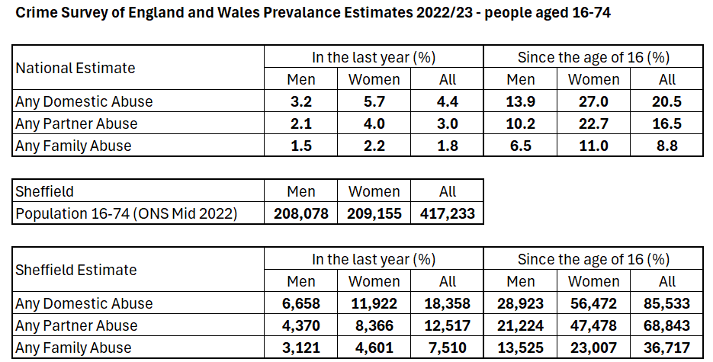

This allows us to estimate that in the last year there may have been as many as 18,358 victims / survivors of domestic abuse in Sheffield (which is around 3,300 less than the number in this document last year as the national estimate has reduced). 65% (down 4%) of the victims / survivors are female (11,922) and 35% (up 4%) are male (6,658). These numbers equate to 3.2% of men and 5.7% of women having been a victim of domestic abuse in the last year.

Nearly two sevenths (27%) have experienced domestic abuse at some point since the age of 16 (down 2.3%) and 13.9% of men (down 0.2%). This would equate to around 85,533 people in Sheffield having been a victim of domestic abuse at some time since the age of 16 (down around 9,500). 66% (56,472) of these victims / survivors are female (down 1%) and 34% (up 1%) are male (28,923).

The estimated rate of domestic abuse in the last year amongst 16 – 74-year-olds overall shows some reduction on the previous year when 5% reported being a victim.

The findings on partner abuse and those that live with the abuser from the 2022/33 CSEW showed what proportion of victims / survivors of domestic abuse in the last year left their partner following the abuse. Applying these findings to the estimated number of victims / survivors of domestic abuse in the last year in Sheffield shows the following:

Tables showing partner abuse data from 2022/23 CSEW data.

Of the 28,358 victims / survivors in the last year we can estimate, based on the findings in the tables above, that 3,470 (21.4%) lived with an abusive partner and of these, 1,044 would have left the shared accommodation because of the abuse. We know from local data for 2022/23 that in Sheffield 23% of people accessing the community domestic abuse service (with a home status recorded) were living with their partner, based on the prevalence estimate of 18,358 victims / survivors this would equate to 4,222 living with their partner.

The CSEW provides estimates on the reason the victim / survivor didn’t leave the shared accommodation. Applying these to the estimated number of people in Sheffield who would not have left the shared accommodation suggests that 861 individuals (35.5%) wouldn’t have left because of the presence of children, 684 individuals (28.2%) had nowhere else to go and 298 (12.3%) relied on their partner for financial support. These reasons are not mutually exclusive; a victim / survivor may have cited more than one reason for not leaving the shared accommodation.

# Children and Young People Affected by Domestic Abuse in Sheffield

We know from the Women’s Aid annual audit that 12,602 children were accommodated in refuge during 2021/22 and 10,502 women. This equates to 1.2 children per female on average (0.1 higher than the previous year).

Using the Sheffield prevalence and data from the Women’s Aid Annual Audit 2022/2312 which calculates that for every domestic abuse service user (both of community based support services and refuges) there are 1.3 children affected, we can estimate that there were 23,865 children affected by domestic abuse in Sheffield in the previous calendar year.

Changes brought in by The Domestic Abuse Act 2021 recognise that children who experience domestic abuse in their families are direct victims / survivors in their own right[26], therefore, their needs should be taken in to account when planning and commissioning services, including domestic abuse safe accommodation and support.

It is important that support for children who have been affected by domestic abuse is available and tailored to the needs and circumstances of the child or young person. Children / young people living with a parent who accesses safe accommodation because of domestic abuse in the family home are offered support via the commissioned domestic abuse services in Sheffield and new services have been commissioned using the DLUHC funding to support children living in all forms of safe accommodation, including homes with Sanctuary Scheme measures installed, however, we know that these services are not sufficient to meet demand.

Some young people experience homelessness because of family breakdowns due to domestic abuse and present to services as homeless. If the young person is not a direct victim / survivor of domestic abuse, there is a risk that support as a result of being affected by domestic abuse is not offered. There is no data for the number of young people that may be in this cohort, but it is recommended that this is explored, that providers are aware of the support available to young people affected by domestic abuse and collect data to inform future needs assessments of the potential demand for support. When commissioning support for young people capacity should be made available to include young people not in the family home.

As part of a service user consultation (the service user experience is discussed later in this report Section 11) people responding to the survey were asked about the impact of domestic abuse on their child(ren). The chart below shows how participants in the consultation felt their children had been affected:

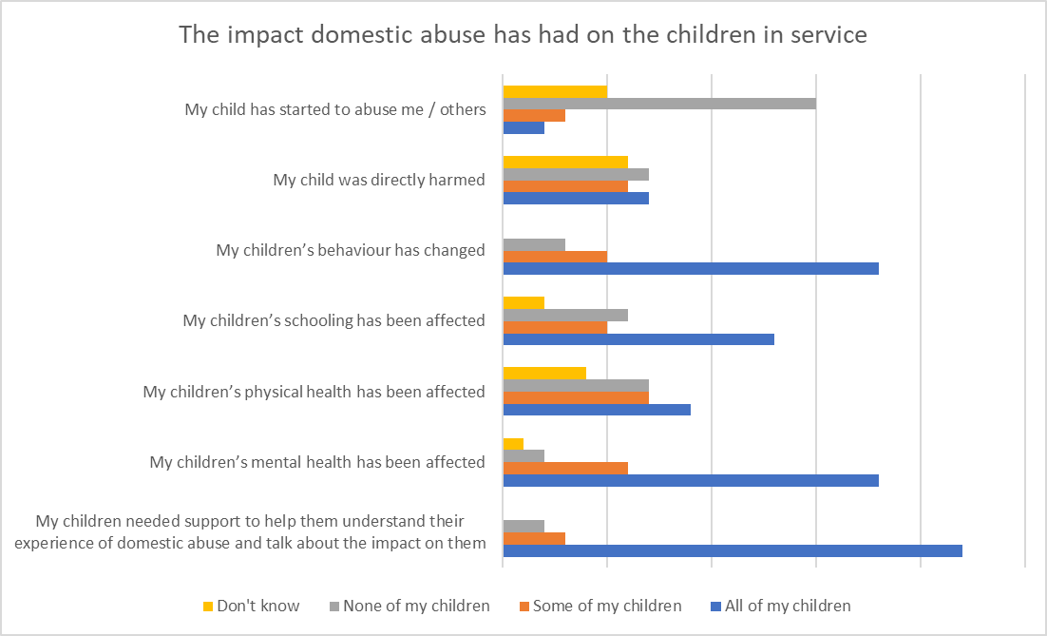

93% stated that all or some of their child(ren) needed support to help them understand their experience of domestic abuse and to talk about the impact it had on them. 89% had seen the abuse impact on some or all of their children’s mental health, with 88% reporting that they had seen a change in some or all of their children’s behaviour. 69% of parents stated that some or all their children’s schooling was also affected. Some or all the children had been directly harmed as a result of domestic abuse in 50% of cases. 20% of parents had seen at least one of their children start behaving abusively towards other people including towards the non-abusing parent. These responses from victims / survivors in Sheffield show the extent to which children are affected by domestic abuse in their families and leaves them with support needs that need to be addressed and should therefore be included in the commissioning of safe accommodation provision for people affected by domestic abuse.

The chart above is based on responses to the specific questions asked, the survey also asked respondents to give more detail of how the children were affected or if there were other impacts on them. A variety of answers were received and included:

* Emotional Abuse and manipulation by the perpetrator
* Low confidence / self esteem
* Direct abuse of children by the perpetrator
* Child turned against the parental victim / survivor
* Child doesn’t see consequences because the perpetrator was not held to account

52% of respondents stated that a worker had talked to the family regarding children’s support needs and it was helpful, an additional 9% had spoken to a worker but the child was not interested in the support offered. However, the remaining 39% had not had a positive experience with a service regarding their children’s support needs; 17% had spoken to a worker but it was not helpful and the remaining 22% were not offered any support. Overall, 58% did not think that support for children in Sheffield was adequate. Local services with long experience of seeking additional funding to meet the gap in provision for children and young people are finding this increasingly challenging against a backdrop of more competition for funding.

**Recommendations**

* Adequate provision to support children needs to be provided and should be included in core support requirements when commissioning domestic abuse safe accommodation with appropriate levels of funding allocated
* All families accessing safe accommodation should have the opportunity to discuss their children’s needs with key workers.
* Appropriate support / interventions need to be available in a timely manner to address the child’s needs so that parents and children have a positive experience of support and find it helpful.

These recommendations are further supported by the findings of the Women’s Aid Federation England Making Children Visible report[27] which recommends that as well as support to DA survivors in accommodation-based services, this must be underpinned by support services for all survivors and their children.

# Sheffield Refuge Activity

In 2022/23 53 new referrals were accepted and entered the refuge, the highest number of accepted referrals since 2019/20[28]. This is in comparison to an average of 69 referrals being accepted per year between 2017/18 and 2021/22.

The Sheffield Housing Support Pathway data and data from the Oasis case management system below provides an insight into activity at the refuge:

* 100% had a female victim (which is line with the contract for refuge which is female only provision).
* 87% of those in the refuge have domestic abuse as either the primary or secondary need (this may be a recording issue as only women / families needing refuge due to domestic abuse are eligible).
* In 2022/23 51% of residents at the refuge were with children, a decrease from 65% in 2021/22 where the proportion with children had been similar for the preceding three years.
* 53% of females supported at refuge were between the ages of 21 and 35, with 17% being aged 31 – 35. This data shows that 94% of service users were under the age of 56. We know that prevalence rates are higher in younger age groups, but there is also a lack of older age women accessing support. The oldest person at refuge in 2022/23 was 62 years old.
* 85% were heterosexual, 5% LGB+, 7% did not wish to disclose their sexuality.
* 48% of those in refuge during 2022/23 stated their ethnicity as White British, 28% Asian/Asian British, 8% Black/Black British, the remaining 16% were spread across other Black and minoritised ethnicities.
* 95% of those exiting the refuge in 2022/23 were UK nationals.[29]
* 44% of victims / survivors at the refuge during 2022/23 stated they had no religion, 31% said they were Muslim, 10% were Christian, 11% did not have this information recorded.
* A total of 57% reported a disability, 59% cited mental health only as their disability. Some reported mental health as their disability but stated no to having a disability which is why the primary figure is higher.
* The main source of referrals to the refuge in 2022/23 were self-referrals which made up 28% of all referral sources that were recorded. A further 16% of referrals were received from domestic abuse agencies.
* In 2022/23 the refuge made 3 referrals to Sheffield MARAC.[30] Other residents will have been heard at MARAC but referred by other agencies e.g. the police.
* In 2022/23 72 children were accommodated alongside their mother at the refuge. This included 38 boys with an age range from 1 – 15.

Sheffield Women’s Aid also report that they support a number of mothers each year to be reunited with their children after they initially arrive at the refuge without them i.e. if they are with the perpetrator or looked after as a result of child protection procedures.

In contrast to the findings of the national Women’s Aid annual audit the Sheffield refuge data shows that applications are accepted from women of all backgrounds, those with additional support needs and those with older male children. It is however recommended that work continues to address inequalities in the provision available which will build on the progress already made in Sheffield against the recommendations of the Nowhere to Turn report.

There are also gaps in the data collected in respect of disability locally and this is also seen in the national Women’s Aid data. We can identify the number of people who, for example, have a physical disability or a hearing disability, but the data does not tell us the living adjustments that they require such as wheelchair access or that an individual communicates using British Sign Language. It is imperative that this is addressed to better understand the need for accessible accommodation. In the absence of this data, it is important to remember that accessible accommodation is accessible to all, but standard accommodation will not be accessible for people with additional access needs.

It has also been identified through this needs assessment that although some improvements have been made since the previous report was compiled, there is not a lot of information locally on the LGBT+ community. As shown in the bullet points above 5% of residents at refuge stated that they were LGB+, a similar percentage to the 4% in the previous report. There is also a gap in the data collected in respect of people who are transgender, whilst the question is asked when inputting personal details onto the housing support pathway system, 32% were ‘not known’ and work needs to be done to implement appropriate data collection to accurately collect this information. Due to the limited data and lack of visibility of these communities in Sheffield, the national findings need to be taken into consideration in local commissioning.

**Recommendations**

* Continue to provide support to people who face barriers to address inequalities.
* Improve the collection of disability data to better understand the access requirements needed.
* Ensure that promotion of services shows that they are inclusive and available to all
* Collect appropriate sexual orientation and gender identity data

The refuges receive referrals from victims / survivors fleeing from a number of local authority areas, and therefore are not an exclusive provision for Sheffield residents. Similarly, Sheffield residents can and are referred to refuges in other Local Authority (LA) areas, if required. Limited information is known about Sheffield residents that seek refuge in other LA areas.

**Refuge Outcomes**

There was a total of 51 households that exited the refuges in 2022/23, this compares to 46 in 2021/22, 34 in 2020/21 and 62 in 2019/20. Exits were affected by the Covid-19 pandemic and increased pressure on social housing stock in the city has slowed exits since the pandemic, the average number of households to exit the refuges per year was 103 during the 3 years 2016/17 to 2018/19.

The average length of stay for exits during 2022/23 was 263 days which is over 8 months but ranges from fewer than 30 days to over 2 years. However, 75% of exits were for people who had been at the refuge for 12 months or less, and 35% stayed for 6 months or less.

See the table below for the exit data by length of stay in 2022/23 in comparison to 2021/22.

The data shows that 2022/23 saw a large increase in the proportion of exits from refuge that had been a resident between 6 – 9 months. For example, in 2021/22 there were 8 leavers in comparison to 12 leavers in 2022/23. The proportion of leavers at over 12 months has shown the biggest fall indicating higher throughput. However, prior to the Covid-19 pandemic an average of 103 households left the refuges per year – twice as many as currently.

On exit from the refuge move-on outcomes are recorded. They record if the move-on from refuge was positive, neutral, or negative. The outcomes for the 51 households leaving the women’s refuge in 2022/23 are found below.

Whilst the proportion of positive outcomes appeared to decrease slightly in 2022/23, 3 move-on outcomes were either not recorded or marked as out of hours. A 90% positive outcome rate is still within the range seen between the previous three years. Consequently, the proportion of outcomes that were negative was the same as in 2021/22 but lower than in the previous two financial years. It should be noted however, that pre 2020/21 the number of exits per year exceeded 100 in the two years prior.

Outcomes:

* 46 households or 90% of all leavers had a positive outcome.
* Of the positive outcomes 33% became an LA tenant with floating support, 15% became a HA tenant with floating support, 13% moved to women’s refuge, another 13% became LA tenants (without floating support – likely to be because they were rehoused in another Local Authority area) and 7% returned home.
* Of the remainder of positive exits these were spread across the following exit reasons; became HA tenant, moved to living with family, moved to dispersed (supported accommodation) and moved to supported accommodation.
* The negative exit reason in 2022/23 was because the resident had abandoned the placement.

The Oasis case management system collects additional information on people leaving the refuge and provides data on health and well-being allowing us to look at how the refuge has supported the victim / survivor to move on from the abuse.

Other outcomes achieved are collected for those exiting the refuge, the tables below show the types of support received and the impact this had on the victim / survivor. An individual may have more than one outcome in each of the tables:

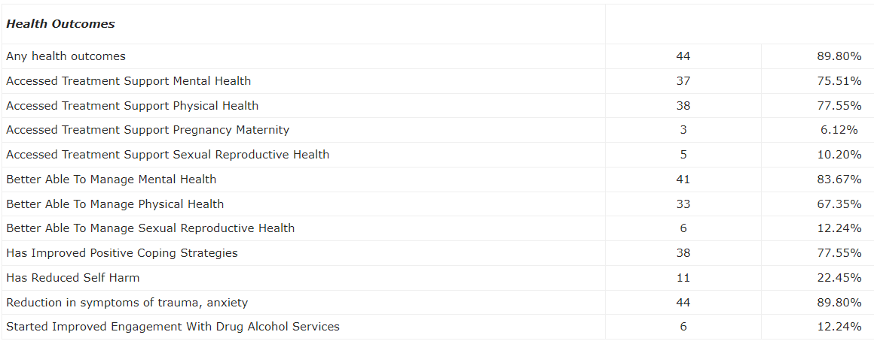

Around 90% of exits reported at least one health outcome. 78% received support for physical health and 75% for mental health, with 84% reporting that they feel better able to manage their mental health. 90% of exits also reported a reduction in symptoms of trauma and anxiety.

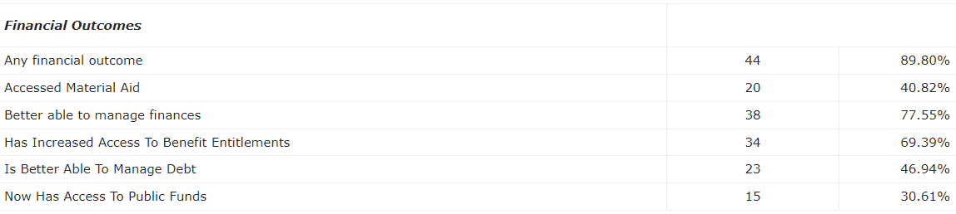

90% of women leaving the refuge received financial support. The refuge supported women to access material aid, better manage their finances, access the correct benefit entitlement, supported women to better manage their debts, and assisted service users to receive access to public funds. A specialist provider was commissioned to offer money and debt advice to refuge clients in 2021 using Domestic Abuse Act funding and this is ongoing.

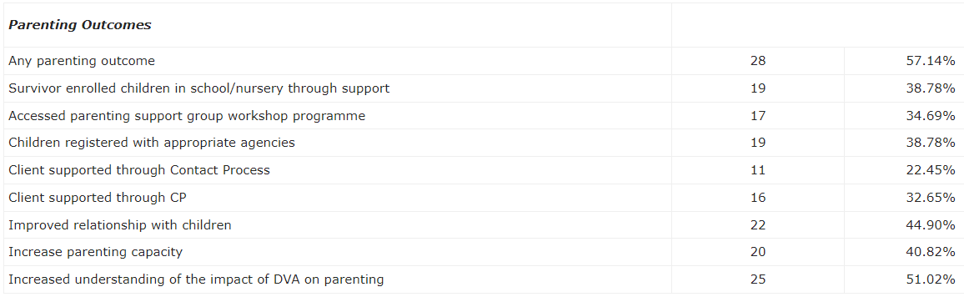

57% of women also accessed parenting support. Women were supported to enrol their children in education and register children with appropriate agencies. Women were also supported to improve their relationship with their children and increase their understanding of the impact of the perpetrator’s domestic abuse on their parenting. Again, extra support for children in refuges was commissioned using Domestic Abuse Act funding in 2021 that is ongoing.

Information is also collected at the beginning and end of support to look at how the victim / survivor’s health and well-being changes during their time at the refuge. The information collected is for the OnTrack POWeR[31] scales produced by Women’s Aid and available on the Oasis case management system. The forms ask how the victim / survivor is feeling about themselves and their ability to cope at a given point in time. By asking the same questions at the start and end of support we can see the person’s improvement or deterioration over time. The form asks the following questions, and all are answered on a scale ranging from none of the time to all of the time:

* Have you been feeling safe?
* Have you been feeling confident?
* Have you been feeling good about yourself?
* Do you feel close to other people?
* Are you able to deal with problems well?
* Are you able to make up your own mind about things?
* Do you feel optimistic about the future?

In 2022/23 overall scores from these questions improved for around 84% of all exits from the service in comparison to 77.5% the previous year, 2% had an overall score that remained the same (7% in the previous year) and 14% had a score that worsened (10% in the previous year).

At the end of support the following questions are also asked:

* Do you feel better able to recognise abusive behaviour?
* Do you feel more confident about asking for help when I need it?
* Has your support network improved?
* Are you clear that the abuse was not your fault?
* Do you feel more confident in your parenting skills?
* Do you understand more about the impact of abuse on your child(ren)?

In 2022/23 around 90% of those who responded to the questions said that they agreed or strongly agreed with each of the statements.

The data highlights the importance of additional support provided to women who are accommodated at the refuges, beyond the access to a safe place to live, and the percentages reported show that this additional support is beneficial to most service users.

**Additional information on the complex needs of refuge residents**

The Oasis case management system reports the following needs for all who accessed the refuges during 2022/23:

* 45% had an insecure immigration status including being on a spousal visa, no status, and being on a visitor’s visa.
* 23% required an interpreter.
* 37% had no recourse to public funds.
* 4% had accessibility requirements.
* 2% were pregnant.
* 11% had drug support needs.
* 13% had alcohol support needs.
* 18% had a physical disability.
* 75% had mental health needs.
* 4% were offenders.
* 87% had physical health needs.
* 78% were unemployed.
* 3% at risk of trafficking
* 21% at risk of Honour Based Abuse (HBA)
* 7% involved in sex work.

The data above highlights the ability for Sheffield refuge to accommodate women with complex needs / vulnerabilities. This also contrasts with the findings of the Women’s Aid Annual Audit report which showed that these additional needs prevented some women from gaining a place at refuge. It also highlights the need to be able to support those with disabilities and mental health needs.

Further information regarding needs/issues:

* Experienced abuse before: Of those responding to the question 47% stated that they had experienced abuse before, and 35% had experienced or witnessed abuse as a child.
* Residents had a range of mental health illnesses including borderline personality disorder, severe depression, PTSD, self-harming, eating disorders and thoughts of suicide.
* Residents often have a lack of self-esteem and confidence, trust issues, feel isolated and lonely, have little family support, and have a lack of control in their own life. Sometimes residents can be in debt as a result of the domestic abuse and therefore may have difficulties budgeting.
* Residents are vulnerable due to a range of other issues including substance misuse issues and may have experienced adverse childhood experiences e.g. are more vulnerable due to having grown up in a household where one parent was subjected to domestic abuse by the other or having been a victim of abuse as a child or young person.
* English was not a first language for 32% of victims / survivors accessing the refuge in 2022/23, they may have cultural and or religious needs including accessing children’s religious education and sometimes a lack awareness of their legal rights.

The refuge supports the complex needs of the victims / survivors by applying a multi-agency model. This includes workers from the Homeless Assessment and Support Team (HAST) which provides access to healthcare and support services for homeless people in Sheffield who have mental health problems.

Staff also support residents with access to a midwife, solicitors and specialist BAMER support services and referrals are also made to drug and alcohol services where required. Following the retendering of the Substance Misuse Service for the city, the new contract includes a substance misuse liaison worker for domestic abuse safe accommodation to work directly into refuges (amongst other domestic abuse safe accommodation) in order to ensure that residents have access to treatment for their substance misuse difficulties in a timely way.

A barrier to accessing refuges can be owning a pet. Sheffield Women’s Aid has long had a policy of accepting pets into the accommodation on a discretionary basis and as such many victims / survivors / families have not had to be separated from a loved animal.

Despite this, IDAS reported for this needs assessment that:

‘Clients with pets who want to move, this is often a barrier for them being able to move.’

**Social media and the refuge -** Historically a refuge hid the woman / family from the perpetrator; however, this appears to be changing. The use of and access to social media by residents (mobile smartphones etc.) means that often the victim / survivor’s location is shared and known to those who know her, and therefore refuges remain a safe haven to protect the victim / survivor physically, but residents are often no longer ‘hidden’ from the perpetrator. Staff provide advice to residents about this but there is no total solution to the issue.

**Going into a refuge is a big decision.** When service users were consulted it was found that they had had initial fears or concerns over accessing such provision. For example, one of the service users did not consider a refuge as she thought this would mean giving up her home, and another did not consider refuge initially because she had an older male child and a number of other children and therefore did not think it would be an option based on the size of the family. Some stereotypes about the quality of accommodation offered by refuges also persist. Efforts have been made to dispel such fears by including films and photos of the interior of the refuges on the Sheffield Women’s Aid website. [32]

When the Sheffield refuges are full refuge options may be available via the national Women’s Aid Routes to Support database. The Women’s Aid Annual Audit 2023 reports the change in refuge vacancies posted in England during 2021/22. Although there was an increase in the number of spaces, fewer vacancies were made available compared to last year.

The number of available places reduced further when specific needs were considered. Of the total spaces available 39% could accommodate a woman plus two children a reduction of over 3% compared to last year, and 13.7% a woman with three children, a 1.6% reduction compared to last year. 9.1% were available to women with NRPF, a rise from 6.3% last year. 0.9% had full wheelchair access and 1.1% could also accommodated a person with limited mobility.

For male victims / survivors of domestic abuse, the number of available spaces nationally for men only in May 2022 had reduced by 1 in comparison to the previous year, however, the overall number of spaces which men can access (because they are available to both men and women) has increased by 26 spaces. 15.9% of all refuge services on Routes to Support had space for men. Overall, there has been an increase in provision available for men in comparison to the previous year, mainly due to there being an increase in provision available to men and women. Sheffield offers dispersed safe accommodation for male victims / survivors – see Safe Zones section.

**Victims / survivors of domestic abuse with No Recourse to Public Funds** **(NRPF) in refuges**

Sheffield domestic abuse refuges provide accommodation for some domestic abuse victims / survivors who have No Recourse to Public Funds, these are victims / survivors who are staying in the UK with a temporary immigration status.

The local authority has a duty since April 2012 to pay housing benefit for such individuals for an initial three-month period if they are granted temporary recourse to public funds under the Destitution Domestic Violence Concession (DDVC)[33]. During 2022/23 the concession only applied to women on spousal visas[34], therefore it was even more complex for victims / survivors who are an *‘over stayer’* or for those not on a spousal visa (e.g. student visa) to receive assisted funding. However, during the Covid-19 pandemic the Home Office put in place a £1.5 million pilot fund to support those with no recourse to public funds in securing safe accommodation. This pilot will also be used to assess the level of support needed for migrant victims / survivors, to inform future funding decisions.[35]Local access to the scheme is via by and for organisation Ashiana[36] in Sheffield.

Information from the refuge case management system shows that out of all females accessing the refuge in 2022/23, 14.5% did not have recourse to public funds – demonstrating Sheffield’s commitment to supporting women in this cohort.

Of these residents at the refuge[37]:

* 25% had multiple vulnerabilities.
* 55% had mental health needs and 73% had emotional health and well-being needs
* 64% had at least one need for their child(ren), 45% needed to access specialist support for their children, 45% had issues around child contact.
* 27% had a work, training and education need.
* 64% required support regularising their immigration status and 45% support with clarifying their status.
* Emotional and financial abuse (often features of coercive control) were the most experienced forms of domestic abuse suffered by 100% and 82% of victims / survivors, respectively.
* On average, victims / survivors had suffered domestic abuse for 5.5 years.
* 50% were at risk from a perpetrator with a history of violence
* 10% were vulnerable because of cultural issues
* 10% were involved in sex work.
* 40% were at risk of honour-based abuse. No victims / survivors were recorded as being at risk of forced marriage or FGM.

The data shows that individuals who have NRPF are more likely to need additional support.

# **Sheffield Safe Zones**

Safe Zones, a project offering dispersed safe accommodation with specialist domestic abuse support, was commissioned to work with men and women with complex needs, as well as women from LGBT+ communities, and those who did not wish to go into a refuge. This was initially commissioned with DLUHC funding awarded in early 2020 with support provided by IDAS. The project now has up to 35 individual units of accommodation available in various locations across the city comprising of:

* 1 bed properties = 8
* 2 bed properties = 16
* 3 bed properties = 10
* 4 bed properties = 1

In 2022/23 there were 55 people supported via Safe Zones[38], 54 females and 1 male, 3 fewer people than were supported in 2021. 67% (36) of the women had children, with a total of 116 children accommodated.

There was a total of 44 referrals to Safe Zones in 2022/23 and 35 of them (80%) were accepted. This compares to 68 referrals in 2021 with 46 (69%) accepted.

In 2021/22 16% of those accommodated were aged 16 – 25, 51% aged 26 – 35, 26% 36 – 45, and 7% 46 – 55. In 2022/23 there was still no one supported through Safe Zones over the age of 55 but a higher proportion were between the age of 36 and 55 than in 2021 /22 and accounting for 49% of all placements in comparison to 33% in 2021. In 2022/23 9% of those accommodated were aged 16 – 25, 42% aged 26 – 35, 38% 36 – 45, and 11% 46 – 55.

65% of Safe Zones residents have a disability, and 39% of those have more than one disability. The most common reported disability was mental health reported by 86% of those with a disability. Other disabilities reported were learning disability, long term health condition, physical, visual and speech impairment. The proportion with a disability has decreased from 70% in 2021, the proportion with more than one disability has increased from 33% to 39%.

29% of service users with Safe Zones in 2022/23 were Black, Asian or from another ethnic minority group.

16% Safe Zones service users were recorded as LGB+ in 2022/23, up from 2% in 2021. 2% were recorded as transgender.

Support plans for people accessing support via Safe Zones show that with the exception of housing need, service users mainly seek support around emotional health and well-being, criminal and civil justice, finances, safety, mental health, and children.

For those who have exited the service, the duration of stay varies greatly from 1 week to over 12 months. 18% of service users were resident for over 12 months, an increase from 6% in 2021. 9% were resident for 6 days or fewer, in comparison to 28% in 2021. 39% were resident for between 1 and 7 months. Positive outcomes were recorded for 72% of exits from Safe Zones in 2022/23.

From a data perspective there appears to be little difference in outcomes of refuges to Safe Zones provision, which is encouraging and indicates that the dispersed model is having a positive impact for those who need to flee domestic abuse.

# **Young Women’s Housing Association (Specialist Safe Accommodation)**

In Sheffield, we also commission Young Women’s Housing project to provide specialist safe accommodation and specialist therapeutic support services for young women, girls and their children affected by sexual abuse, sexual exploitation and domestic abuse in Sheffield.

The service provides 20 bed spaces of safe accommodation with a shared safe house and self contained dispersed accommodation for young women with children.

In 2022/23

* There were 65 referrals made to the service, of which 38 were not supported (58%) the most common reasons for this were a lack of capacity at the time of the referral being made and clients declining the referral/finding alternative accommodation
* 33 young women received support from the service in 22/23.
* 100% of those who were accepted into the service had an individual support plan drawn up within 14 days of acceptance into the service and all of those left the accommodation in the year had a planned move on from support.
* The proportion of those accessing YWHP from racialised communities in 2022/23 was 27%.
* The overall proportion of LGB survivors supported in the year was 16%
* There were 8 young women supported in the year who were parents who had 8 children between them.

Young Women’s Housing project report outcomes for those who have used their specialist service and in 2022/23

* 100% of those who had needs identified around welfare benefits, debt management, budgeting and energy saving advice had their needs met.
* Where a need was identified around training and education, 80% reported that their needs were met
* 100% of needs that were identified around isolation were met.
* Where needs were identified around improving physical and mental health, 100% were met.
* 100% of those who reported that they needed help to manage anxiety had their needs met.
* 60% of survivors had an identified need to better manage self harm, with 100% of those having their needs met
* 100% reported improved safety in their home/had their needs met in this respect.
* On average, 92% of all needs identified were met by the service

# Temporary and Supported Accommodation

In 2022/23 there were 811[39] homeless presentations in Sheffield because of domestic abuse (from 775 individuals), a 6% increase on the previous year. 86% of presentations were female, staying at a similar level to the previous year. Out of all accepted domestic abuse applications in 2022/23 9% were for males.

Regarding suitable accommodation for homeless applications because of domestic abuse, around 51% of female applicants had dependent children with them, in contrast to this around 10% of male applicants had children with them.

Of the 811 homeless presentations, data from the Housing Support Pathway (HSP) shows that 195 were allocated supported accommodation, a further 71 went to a Sheffield refuge and 412 were placed in other temporary accommodation locations across Sheffield. An additional 28 people received other types of support following their application, such as floating support. In total (including those who received only floating support) 535 of the 811 presentations were supported, equating to 66% of presentations. Some people may have received more than one type of support. In terms of those actually placed in accommodation the proportion is 63%.

Using the ONS population estimates for the relevant years we can see that, in 2022/23 homeless presentations because of domestic abuse were 0.14% of the Sheffield population, the same percentage as the 2021/22 year. However, this is an increase on the percentage seen in the 2020/21 year of 0.091% equating to an increase of 0.049 percentage points. If this percentage point increase had continued and remained the same year on year, we could estimate that by 2030 0.4% of the Sheffield population may present as homeless because of domestic abuse equating to 2,473 people (population estimate for 2030 is 618,260). If we suggest that the proportion presenting will remain somewhere around 0.14% this would equate to 866 presentations in 2030. The mid-point between the estimate of 2473 presentations and 804 presentations would be 1639 presentations per year.

**Supported Accommodation**

Including refuge provision 25% of female homelessness presentations to Sheffield City Council were placed into supported accommodation in 2022/23, this compares to 28% in 2021/22, and 10% in 2020/21. It is reassuring to see that the proportion of females placed has increased following the Covid-19 lockdowns and this is linked to increased move-on rates. In 2022/23 22% of male presentations were placed in to supported accommodation in comparison to 33% in 2021/22, and 20% in 2020/21. In respect of the actual number of people placed in supported accommodation, the number of females equated to 88% of all supported accommodation placements in 2022/23. Out of all males placed in supported accommodation 0% had a child, in comparison to 10% of all male presentations. For females 40% of those placed in supported accommodation had a child, and this compares to 51% of all female homelessness presentations having at least one child.

**Temporary Accommodation**

51% of female presentations and 50% of male presentations were placed in temporary accommodation at some point during their accommodation pathway, equating to 357 females and 55 males. This represents an increase from 18 for males placed, and an increase from 240 females placed in 2021/22. 51% of females placed in temporary accommodation had children with them, 15% of males placed in temporary accommodation had children with them, a decrease from 2021/22 when 33% of males placed in temporary accommodation had children. The high proportion of people placed in temporary accommodation highlights the need for more specialist safe accommodation to be available in Sheffield.

**Unplaced Domestic Abuse Homeless Presentations**

Out of the total 811 homeless presentations because of domestic abuse 66% received support following their application. 66% of all female presentations were supported and 67% of all male presentations. This is the same percentage of females and males supported in 2021/22. There is no data available on the outcome of the homeless presentations that do not receive support via the Housing Support Pathway. However, what we do know is that 3% of all presentations received only floating support in 2022/23. We also know that 43% of placements in the Sheffield Women’s Aid refuge in 2022/23 were from outside of Sheffield, an increase from 31% in 2021/22. If 43% of domestic abuse homeless presentations that couldn’t be offered support in Sheffield were accommodated outside of Sheffield in 2022/23, this would equate to 119 people.

We also know from the Women’s Aid No Woman Turned Away report that 4.7% of victims / survivors presenting to that service went to live with family or friends. Applying this to the 811 presentations in Sheffield in 2022/23 would equate to 38 presentations that may have had a similar outcome.

However, it would be good to understand with more certainty the outcomes for the people who presented as homeless due to domestic abuse who were not supported.

**Recommendation**

* Determine if information can be gathered on the outcomes for the people who presented as homeless due to domestic abuse who were not supported.

# Support in the Community

**Dispersed Temporary Accommodation**

Using funding allocated via Part 4 of the Domestic Abuse Act, the provider of community based domestic abuse support was commissioned to provide specialist domestic abuse support into a number of council properties which are utilised as temporary accommodation, therefore these additional properties are included in the definition of domestic abuse safe accommodation, the number fluctuates according to need and availability. As at the end of March 2023, there were 52 households supported in this way, more than twice as many as at the same period the previous year.

**Housing referrals domestic abuse community support service**

In 2022/23 housing support agencies[40] made 244 referrals to IDAS the community domestic abuse service in Sheffield, up from 181 in the previous year. During the same period housing support agencies also made 267 contacts. Showing that there are now more contacts with the service from housing support agencies.

The proportion of referrals from housing support agencies that were high risk (of serious harm or homicide) in 2022/23 was 55%; higher than the average for the service overall which is around 35% of referrals to the service being high risk. This indicates that when domestic abuse victims / survivors are in housing need this corresponds with them experiencing more serious forms of abuse.

**Sanctuary scheme**

The Sanctuary Scheme provides victims / survivors of domestic abuse with safety equipment to keep them safer in their own home. This is offered to victims / survivors when the perpetrator is not living with them or they have been rehoused but may still be at risk of harassment from the perpetrator.

In 2022/23 501[41] households received Sanctuary Scheme support; this is a slightly lower number to the previous year when 599 people received Sanctuary Scheme support.

In 2022/23 210 safety items are reported to have been installed at victims’ / survivors’ properties through the Sanctuary Scheme. Safety items include, solar lights, door chains, door bolts and window alarms. The most installed item was a window alarm, 56% of people receiving support from the Sanctuary Scheme received window alarms. 13% had their locks changed, 8% solar lights 7% an external letter box, and 6% received a door bolt. An individual may have received more than one item. Overall the number of items reported to have been installed has dropped significantly in comparison to the previous year, and this report recommends the need for robust data collection of this information going forward.

A table showing the demographics of those in receiving sanctuary measures. 

In 2022/23 97% of people receiving support from Sanctuary Scheme were female, 23% were from Black, Asian or other minority ethnic backgrounds, 9% LGB+, and 1% transgender. The data also shows that recipients of Sanctuary Scheme support are weighted towards younger age groups, with the 26 – 30 and 31 – 35 age groups each accounting for over 40% of all recipients.

44% of those receiving Sanctuary Scheme support had one or more disability:

A table showing the disability data for those receiving sanctuary measures. 

The most prevalent disability was mental health, 27% of those with a disability have mental health issues, 7% had a physical disability and 6% other long-term disability. As highlighted previously, there is a need to better understand the additional access requirements of people with a disability.

It is difficult to determine the full impact of Sanctuary Scheme provision for those who accessed it from the data available, and there is a need for this to be improved in order to understand the effectiveness of the provision. What we can see in the data is that in 2022/23 only 4% disengaged with the scheme, 86% completed their support with the scheme positively and 2% went on to receive additional domestic abuse support from IDAS following Sanctuary Scheme support. Also, for those who had the data recorded, 95% of people receiving Sanctuary Scheme support did not move to a new address (in comparison to 92% the previous year), showing that the Sanctuary Scheme offer provided additional security to victims / survivors to allow them to be safe in their own home.

**Further support for people at risk of domestic abuse**

Specialist domestic abuse floating support is commissioned within the Homeless Prevention and Resettlement Service provided by Shelter.

Shelter provides support to people who are at risk of, or experiencing domestic abuse, to access safe and secure housing and enable them to receive the necessary advice, assistance, and support. Shelter will complete DASHs and will refer to MARAC where appropriate.

Once in new accommodation, Shelter continues to provide support; and will support someone, if the victim chooses to remain in their own home. The support worker is responsible for “case co-ordination”, ensuring that all components of the safety and support plans work together to help clients increase their safety and reduce risks to themselves and their children as well as enable recovery from the impact of domestic abuse.

The service provides group activities to enable social interaction, combat isolation and promote recovery from the impact of domestic abuse. Additionally, they will facilitate access to provision in the city including structured group work programmes.

In 2022/23 Shelter supported 138 people with a domestic abuse support need, a small increase on the previous year when 75 were supported. 66% were female, a decrease from over 90% of the people the previous year. In 2023/24 these figures were 155 overall with 94% of clients being female.

In 2022/23 48% of people supported were Black, Asian or form other minority ethnic backgrounds, however, this has increased in comparison to 2021/22 when 31% of those supported were BAMER.

Some of the service users were individuals and families referred to Shelter by Sheffield Women’s Aid for resettlement support when leaving the refuges and moving into a new tenancy in the community.

In 2022/23 Shelter supported 22 households comprising 25 adults and 26 children to resettle from the refuges, and in 2023/24 Shelter supported 28 families comprising 24 adults and 40 children to resettle from the refuges.

Shelter reported for this needs assessment that:

* They are seeing an increase in non-fatal strangulation.
* The are seeing an increase in perpetrators involving associates in the harassment of victims.
* Where English is second language they are finding that often victims don’t understand what “domestic abuse” is in all its forms.
* Perpetrators who have been issued with non-molestation orders or DVPO’s often breach on multiple occasions and the courts do not act.
* There is not enough suitable emergency accommodation to cater for victims who present with complex needs and experience multiple disadvantages.
* Victims / survivors can be mistrusting of services

Shelter also hold a small contract to offer housing advice and support to victims / survivors in safe accommodation – directly and via consultations with refuge workers and IDVAs.

# Service User Experience

In spring 2021 a consultation questionnaire on domestic abuse was promoted which included questions on the experiences of service users who have used domestic abuse related accommodation services. This consultation was carried out to help inform this Needs Assessment and the Domestic Abuse Safe Accommodation Strategy 2021-2024 for Sheffield. For this needs assessment refresh, this consultation has not been replicated. However, influenced by the information gathered in 2021, a range of additional support options for those in safe accommodation have been commissioned and continue to be so, including mental health counselling, access to substance misuse support, specialist welfare benefit and debt advice, therapeutic support for children and specialist housing advice and support.

We know from The Women’s Mental Health Taskforce report from 2018[42] that there is an urgent need for support to better respond to women’s traumatic experiences and the realities of their lives and so this survey helped us to look at the needs that are not being met as well as those that are met.

**Refuge –** For women accessing a refuge 90% reported that they felt safe and secure, the remaining 10% stated that they felt somewhat safe and secure. The majority (85%) reported receiving the right amount of support from the refuge, however, 5% did not think that they had received enough support. The types of support received whilst at refuge are shown in the table below:

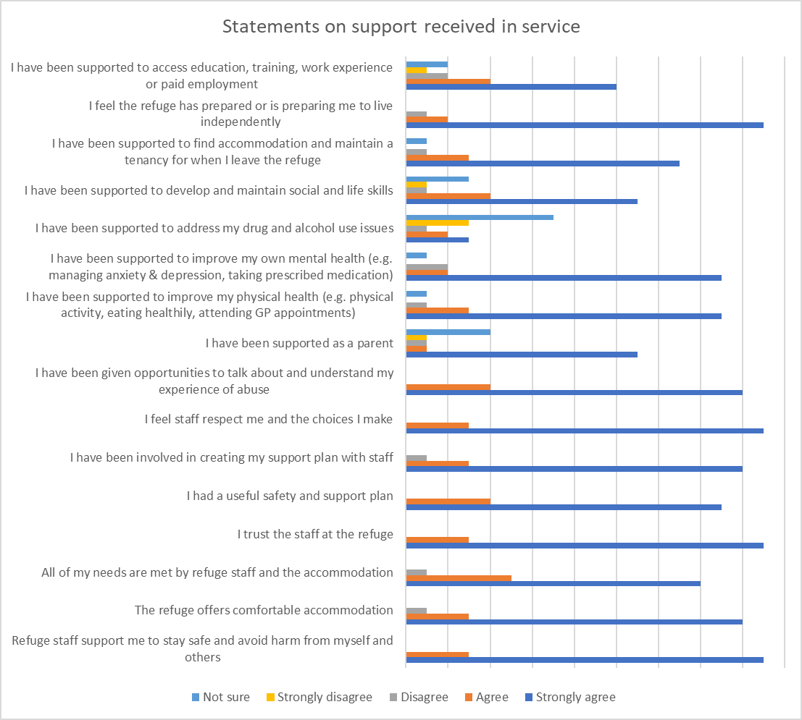

It is reassuring to see in the chart above that for every support type the majority of service users agreed or strongly agreed that they were supported in each of the areas listed. Given that the majority of women who accessed refuge stated that they received the right amount of support the responses to this survey highlight the need to ensure the support offer from refuge continues to include this range of support needs. However, the data also highlights the need to make improvements in some areas. This may be enhancing the offer available or ensuring that staff / support workers at refuge are aware of all the support available in Sheffield and how to access it. Areas for consideration based on the findings of the survey are:

|  |  |
| --- | --- |
| I have been supported to address my drug and alcohol use issues | 25% of service users disagreed or strongly disagreed with this statement |
| I have been supported to access education, training, work experience or paid work | 16% of service users disagreed or strongly disagreed with this statement |
| I have been supported as a parent | 11% of service users disagreed or strongly disagreed with this statement |
| I have been supported to develop and maintain social and life skills. | 10% of service users disagreed or strongly disagreed with this statement |

People were also asked what else could have been offered by the refuge to support them. Reponses included educational classes, cooking skills, self-defence, and counselling / therapy for children. With regards to children of victims / survivors that stayed at refuge, 13% did not think that their child(ren) were supported to access and maintain their education while at refuge, the same percentage also felt that their child(ren) were not supported to understand their experience of domestic abuse and the impact it had on them.

**Other Safe Accommodation –** for people placed in alternative safe accommodation that was not a refuge, 20% responded to say that they did not feel very safe or secure in the accommodation, and 60% stated that the did not receive enough support from services when they were in the accommodation. Residents of safe accommodation also responded to questions on the support they received, and this is shown in the chart below.

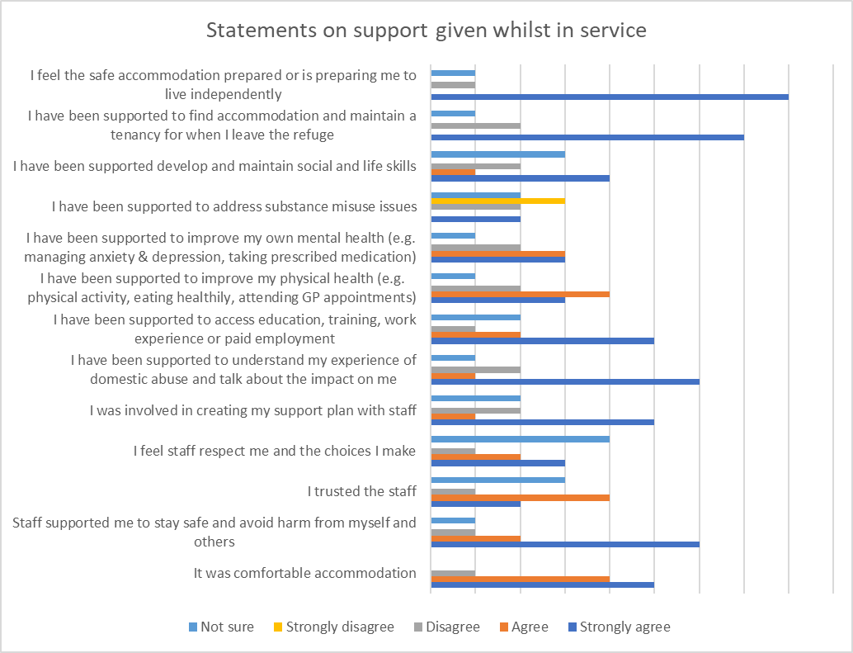

As with the refuge most people responded to say that they either strongly agreed or agreed with most of the statements above. However, similar to the experiences of refuge residents there was a varying proportion of people who disagreed with each of the questions asked, again reinforcing the need to continue to have the provision of these support types, but also to understand why some people’s needs have not been met and what could be done differently, either by the domestic abuse service supporting the individual or the support / services that provide the additional support. Support to address substance misuse issues stands out the most in the chart above. 71% of those responding to this question either disagreed or strongly disagreed that they were provided with support to address substance misuse issues.[43]

Comments were received by those who had been placed in other safe accommodation to highlight that their individual circumstances were not properly taken into consideration when being offered alternative accommodation and they were given accommodation that was not suitable for them. These comments are not included in this document due to the sensitive nature of them, but the findings should be reviewed and considered so that they inform future decision making.

**Sanctuary Scheme –** Of the people receiving Sanctuary Scheme support 86% stated that the Sanctuary Scheme security measures made them feel safer in their own home. However, it was noted in the responses that none of the equipment offered had the ability to record video and they therefore felt that the equipment offered was not sufficient.

In regard to gaps in the provision provided to people who accessed support from the Sanctuary Scheme people felt they needed more support for their children and how to keep the children safe, longer-term support from providers, more legal advice, and also feeling that their safety issues were not fully addressed. Respondents also felt that services need better promotion and that overall there was not enough support available in Sheffield.

**Recommendations**

* Continue to provide a wide range of support for service users to support individual circumstances
* Ensure up to date information about additional support available and the appropriate pathways are available to support staff to find the right support for a service user’s needs, and their children
* Explore additional and alternative practical and therapeutic support options
* Review the types of equipment made available through Sanctuary Scheme.

During the consultation for this needs assessment and the strategy development victims and survivors told us:

* The Housing Solutions Pathway is challenging to access with long wait lines on the telephone which results in people being not able to access safe accommodation
* Limited information is provided by council staff on what residents are entitled to e.g. Housing Support Fund
* They felt that some temporary accommodation offered is unsafe
* When they have rent arrears this impacts on their ability to access safe accommodation, and they feel there is a lack of recognition of the possibility that these could be caused by financial abuse
* Victim-survivors feel there is a lack of understanding of the need to be rehoused near family home and support networks even when this is not considered to be far enough away from the perpetrator

# Projections for future need in Sheffield

The Office for National Statistics projects that the population of Sheffield will continue to grow as is shown in the chart below, with an increase of around 29,000 people over the next 10 years[44]:

Nationally police reported incidents also continue to grow and it can be estimated that demand for refuge and safe accommodation for those fleeing domestic abuse will increase year on year and this needs to be factored into commissioning decisions.

Sheffield City Council’s Housing and Neighbourhoods Service has made projections based on HSP data from 2019, alongside expert insights into the rate of homelessness in the city. In 2022/23, there were 3,945 homelessness presentations. Based on data from April to August 2024, it is anticipated that the total number of homeless applications in 2024/25 will range between 3,800 and 4,000. Looking ahead, it is projected that overall homelessness presentations will begin to decrease gradually each year but are not expected to drop below pre-Covid levels within the next five years.

Domestic abuse is among the top three causes of homelessness presentations. Another significant factor is individuals being asked to leave by family or friends, which may also obscure some cases of domestic abuse. As a result, the number of homelessness presentations related to domestic violence is likely to remain higher than pre-Covid levels.

However, it is important to note that pressures such as the lingering impacts of austerity and the Covid pandemic have left a situation where levels of homelessness of highly susceptible to external events. An unexpected event, like another cost-of-living crisis, could lead to an increase in homelessness presentations, rather than the expected period of gradual decline.

Due to the sharp rise in homelessness during the Covid pandemic and with presentation levels now stabilising at a higher baseline, there remains a shortage of safe, supported accommodation that must be addressed. Projections from Sheffield City Council’s Housing and Neighbourhoods Service, based on presentations where there was an assessed need for accommodation for domestic violence from April to August 2024 compared with the same period in 2023, indicate that roughly 600-650 places will be required in 2024/25. A gradual decrease in demand is expected in subsequent years, although more detailed projections are still being developed to provide a clearer picture.

# **Recommendation**

* The Local Partnership Board for Domestic Abuse Safe Accommodation should consider planning to meet future need for specialist domestic abuse safe accommodation.

# Conclusion

It is also clear that current commissioned capacity does not meet the demand for safe supported accommodation as a result of domestic abuse and that this demand is likely to grow over the next few years. Commissioning to meet future need for specialist domestic abuse safe accommodation needs strategic consideration. However the outcomes from the provision of Sanctuary Scheme measures are encouraging and indicate that expanding this provision would be a cost effective homelessness prevention measure for victims / survivors of domestic abuse.

The data shows that the Sheffield refuges and Safe Zones service caters for a wide range of needs, which is encouraging as the national Women’s Aid report indicates that not all refuges / safe accommodation schemes provide the same expansive offer.

Whilst recognising that Sheffield offers a broad offer of support this report has shown that some victims / survivors and their children do not always receive all the support they need. The provision of mental health support, including specialist counselling, and pathways into substance misuse treatment for those who require it also need to continue to improve. Additionally, support options need to stay in place for those who are NRPF and further work needs to be undertaken to better support those with additional needs due to disability.

The needs of children must continue to be taken into account in future commissioning decisions, particularly given the change in legislation which recognises children as direct victims / survivors of domestic abuse in their own right.

The public need to know that the services and safe accommodation offer is inclusive and available to all victims / survivors, fair representation of all groups should be seen across all services.

# **Recommendations**

1. Continue to build on progress made in Sheffield on the Nowhere to Turn Recommendations.
2. Review the impact of the additional DLUHC funding to services.
3. Ensure future commissioning of safe accommodation includes appropriate spaces to meet the needs of the LGBT+ community.
4. The safe accommodation offer needs to continue to ensure it meets the needs of minoritised communities. Questions on experiences of accessing safe accommodation for people from ethnic minorities to be part of any service user consultation and will inform commissioning and practice.
5. Continue to promote domestic abuse services to the public to raise awareness of the support available, to increase awareness amongst victims / survivors but also the people they talk to.
6. Continue to commission professional domestic abuse awareness training to help professionals identify abuse victims / survivors.
7. Consider the prevalence estimates and findings that suggest domestic abuse rates are higher amongst younger people, meaning that safe accommodation provision needs to be suitable for single units and those with small children.
8. Increase the number of safe accommodation spaces available to reduce the need for those affected by domestic abuse to be placed in temporary accommodation.
9. Provide targeted promotion to under-represented groups, such as those with disabilities as the data suggests prevalence rates are higher amongst this group than the general population.
10. Ensure services to be provided to meet the needs of the individual through innovation and utilising technology so that support can be delivered in different ways such as online group work.
11. Ensure that services providing homeless support to young people are trained to identify those who have been affected by domestic abuse and are aware of support available to them.
12. Collect data on homeless young people to inform future needs assessments of the demand for support from this cohort.
13. Additional support options for victims / survivors should be available to support individual needs and circumstances.
14. Adequate provision to support children needs to be provided and should be included as additional support requirements when commissioning domestic abuse safe accommodation. Focus should be given to counselling and therapeutic support for children, helping the child to understand the abuse, access their education and recover from their experience.
15. All families should have the opportunity to discuss their children’s needs with key workers who will support then in a domestic abuse informed way.
16. Appropriate support / interventions need to be available in a timely manner to address the child’s needs so that parents and children have a positive experience of support and find it helpful.
17. Ensure up to date information about the additional support available and the appropriate pathways are available to support staff to find the right support for a service user’s needs and their children. Such as the support available to help a parent address their substance misuse.
18. Continue to explore additional and alternative practical and therapeutic support options.
19. Continue to provide support to people who face barriers to accessing services to address inequalities.
20. Improve the collection of disability data to better understand the access requirements needed.
21. All commissioned services need to improve data collection of service user demographics and equalities data.
22. Provide appropriate accommodation that can be accessed by people with disabilities, such as appropriate facilities for a person with a mobility or visual disability.
23. Ensure that promotion of services shows that they are inclusive and available to all
24. Collect appropriate gender identity data
25. Determine if information can be gathered on the outcomes for the people who presented as homeless due to domestic abuse who were not supported.
26. Review the types of equipment made available through Sanctuary Scheme
27. Consider options for expanding the Sanctuary Scheme offer.
28. The Local Partnership Board for Domestic Abuse Safe Accommodation should consider planning to meet future need for specialist domestic abuse safe accommodation.
29. Use the findings of this report to inform strategy and future commissioning.

1. <https://assets.publishing.service.gov.uk/government/uploads/system/uploads/attachment_data/file/1089015/Domestic_Abuse_Act_2021_Statutory_Guidance.pdf>
2. https://www.gov.uk/government/publications/supported-housing-national-statement-of-expectations/supported-housing-national-statement-of-expectations
3. [The Measurement of Domestic Abuse – Redeveloping the Crime Survey for England and Wales | Journal of Family Violence (springer.com)](https://link.springer.com/article/10.1007/s10896-023-00507-9#Sec29)
4. <https://www.ons.gov.uk/peoplepopulationandcommunity/crimeandjustice/bulletins/crimeinenglandandwales/yearendingmarch2022#domestic-abuse-and-sexual-offences>
5. Gadd, D., Farrall, S., Dallimore, D & Lombard, N (2002) *Domestic abuse against men in Scotland*, Scottish Executive Central Research Unit <http://www.gov.scot/Publications/2002/09/15201/9609> - pages 33-46
6. Respect Men’s Advice Line Service Review 2020/21: Supporting male victims / survivors of domestic abuse during Covid-19
7. <https://www.ons.gov.uk/peoplepopulationandcommunity/culturalidentity/sexuality/bulletins/sexualidentityuk/2020>
8. The definition of disability used in the CSEW is consistent with the core definition of disability under the Equality Act 2010. A person is considered to have a disability if they have a long-standing illness, disability or impairment which causes difficulty with day-to-day activities.
9. <https://www.ons.gov.uk/peoplepopulationandcommunity/crimeandjustice/datasets/partnerabuseindetailappendixtables>
10. [Homicide in England and Wales - Office for National Statistics (ons.gov.uk)](https://www.ons.gov.uk/peoplepopulationandcommunity/crimeandjustice/articles/homicideinenglandandwales/yearendingmarch2023#suspects-in-homicide-cases)
11. <https://www.ons.gov.uk/peoplepopulationandcommunity/crimeandjustice/articles/domesticabuseandthecriminaljusticesystemenglandandwales/november2023>
12. https://www.womensaid.org.uk/wp-content/uploads/2023/01/The-Domestic-Abuse-Report-2023-The-Annual-Audit-FINAL.pdf
13. Council of Europe (2008) “…recommends safe accommodation in specialised women's shelters, available in every region, with one family place per 10 000 head of population.
14. Routes to Support is the UK directory of domestic abuse services and refuge vacancies
15. https://www.womensaid.org.uk/wp-content/uploads/2023/06/Nowhere-to-turn-2023-report.pdf
16. Imkaan 2018
17. [Psychologically Informed Environments – Paradigm Psychology](http://paradigmpsychology.co.uk/our-services/psychologically-informed-environments/)
18. ibid
19. LGBT+ Domestic Abuse Needs Assessment for Central Bedfordshire Council, Donovan C. et al, April 2021
20. Describe a person whose gender identity matches their sex assigned at birth
21. Now renamed the Ministry for Housing, Communities and Local Government
22. <https://www.gov.uk/government/publications/delivery-of-support-in-domestic-abuse-safe-accommodation-annual-progress-report-2022-23/annual-progress-report-from-the-domestic-abuse-safe-accommodation-national-expert-steering-group-2022-to-2023>
23. https://www.gov.uk/government/publications/delivery-of-support-in-domestic-abuse-safe-accommodation-annual-progress-report-2022-23/annual-progress-report-from-the-domestic-abuse-safe-accommodation-national-expert-steering-group-2022-to-2023
24. <https://www.ons.gov.uk/peoplepopulationandcommunity/crimeandjustice/articles/womenwhohavesurviveddomesticabuseandtheirexperiencesoftemporarysafeaccommodationinengland/januarytojune2023>
25. [The Measurement of Domestic Abuse – Redeveloping the Crime Survey for England and Wales | Journal of Family Violence (springer.com)](https://link.springer.com/article/10.1007/s10896-023-00507-9#Sec29)
26. <https://www.legislation.gov.uk/ukpga/2021/17/section/3/enacted>
27. Making Children Visible: A good practice guide from women’s Aid specialist services from children and young people 2021
28. HIS HSP Data
29. CRD Analysis tool
30. Sheffield MARAC Rolling Record
31. <https://www.womensaid.org.uk/what-we-do/ontrack/>
32. [Refuge Accommodation — Sheffield Women's Aid (sheffieldwomensaid.org.uk)](https://www.sheffieldwomensaid.org.uk/refuge-accommodation)
33. The DDVC became the Migrant Victims / survivors of Domestic Abuse Concession in 2024 [Migrant Victims / survivors of Domestic Abuse Concession (publishing.service.gov.uk)](https://assets.publishing.service.gov.uk/media/660eb038a43d91001c3af176/Migrant+Victims+of+Domestic+Abuse+Concession.pdf)
34. <https://www.gov.uk/government/publications/application-for-benefits-for-visa-holder-domestic-violence>
35. [SMV Scheme - Southall Black Sisters](https://southallblacksisters.org.uk/our-services/sbs-no-recourse-fund/smv-scheme/)
36. [Ashiana Sheffield | Violence & Abuse | Support | Help | DonateAshiana Sheffield](https://www.ashianasheffield.org/)
37. Oasis reports wizard client outcomes report (Needs Identified at Assessment)
38. Data taken from the Oasis Case Management System
39. Data from the Housing Support Pathway (HSP)
40. Any organisation providing housing related support in Sheffield
41. IDAS contract monitoring PMF 2022/23
42. <https://www.gov.uk/government/publications/the-womens-mental-health-taskforce-report>, Department of Health and Social Care
43. Since 2021 a substance misuse link worker role for domestic abuse safe accommodation was commissioned to be based in the Sheffield support service. Then in 2023 a new contract was awarded with this role included in the service specification.
44. <https://www.ons.gov.uk/peoplepopulationandcommunity/populationandmigration/populationprojections/datasets/localauthoritiesinenglandtable2>