Sheffield Domestic Abuse Needs Assessment

2023/24

 

Table of Contents

1. Introduction and Methodology 2

2. Definitions and Policy 3

3. National Data and Prevalence 7

4. Estimated Prevalence of Domestic Abuse in Sheffield 14

5. Police Data 17

6. Domestic Homicide Reviews 22

7. Diversity 24

8. Harmful Cultural Practices 36

9. Domestic Abuse Support in Sheffield 41

10. Multi-Agency Risk Assessment Conference (MARAC) 46

11. Additional Support & Therapeutic Services 49

12. Perpetrators 53

13. Recommendations........................................................................................................................57

# Introduction and Methodology

This Needs Assessment has been compiled to help inform the commissioning of domestic abuse services in Sheffield, to feed into the Safe Accommodation strategy and Domestic Abuse strategy.

This report reviews national policy and guidance, as well as national reports to show the requirements of local authorities and provide a national picture. Findings from research and the Crime Survey of England and Wales help us to understand the prevalence of domestic abuse. These national estimates are then applied to the local population to help us understand the potential prevalence in Sheffield. However the CSEW is increasingly recognised as limited in its assessment of the prevalence of domestic abuse particularly as it does not routinely ask questions about coercive control. [1]

National data is compared to what we know happens in Sheffield to help provide an overview of areas of good practice locally, but also where we need to improve. By comparing local activity with what we know about national prevalence and activity the report aims to identify where there is a lack of provision of support provided to victims of domestic abuse and how funding can be directed to better address gaps in the support offered in Sheffield.

In this document where gaps in provision and data collection are identified these will be collated to provide a list of recommendations that can feed into the local strategies, commissioning decisions, and working to improve the data that is collected locally to provide more insight in future needs assessments.

# Definitions and Policy

The UK government has published documents that outline the governments expectations and requirements of local authorities to provide suitable care, support, and housing to those in need and victims of domestic abuse. These documents impact on the commissioning of service for survivors of domestic abuse. Key points taken from recent publications are provided below.

**Domestic Abuse Act**

The Domestic Abuse Act 2021[2] aims to help millions of people by transforming the response to domestic abuse across all agencies. It provides further protections for those who experience domestic abuse and enhances measures in place to bring perpetrators to justice.

The measures in the Domestic Abuse Act 2021 aim to:

* Promote awareness.
* Protect and support victims.
* Hold perpetrators to account.
* Transform the justice response
* Improve performance in the response to domestic abuse

Anyone can be a victim of domestic abuse, the 2021 Act introduces a statutory definition of domestic abuse:

*Behaviour of a person towards another person is domestic abuse if the two people are aged 16 or over and are personally connected, and the behaviour is abusive. Behaviour is abusive if it consists of any of the following:*

1. *Physical or sexual abuse*
2. *Violent or threatening behaviour*
3. *Controlling or coercive behaviour*
4. *Economic abuse*
5. *Psychological, emotional, or other abuse*

*It does not matter whether the behaviour consists of a single incident or a course of conduct. For the purposes of the Act the perpetrators conduct could mainly be directed to a child under 16 who is a child of the victim.*

Domestic abuse support is defined as:

Advocacy support – development of personal safety plans, liaison with other services (for example, GPs and social workers, welfare benefit providers).

Domestic abuse-prevention advice – support to assist victims to recognise the signs of abusive relationships, to help them remain safe (including online) and to prevent re-victimisation.

Specialist support for victims with protected characteristics and / or complex needs, for example, interpreters, faith services, mental health advice and support, drug and alcohol advice and support, and immigration advice.

Children’s support – including play therapy and child advocacy.

Housing-related support – providing housing-related advice and support, for example, securing a permanent home and advice on how to live safely and independently; and

Counselling and therapy for both adults and children.

**Spending review 2020**

Provided £98 million of additional resource funding, bringing total funding to £125 million, to enable local authorities to deliver the new duty to support victims of domestic abuse and their children in safe accommodation in England. This national funding was continued in 2021/22, 2022/23 and 2023/24.

Local Partnership Board - Tier 1 local authorities are required to convene a multi-agency Local Partnership Board (LPB) to support them in performing certain specified functions. These will be to:

* + **Assess the need and demand** for accommodation-based support for all victims and their children, including those who require cross-border support.
  + **Develop and publish strategies** for the provision of support to cover the locality and diverse groups of victims.
  + **Give effect to strategies by making commissioning / de-commissioning decisions**
  + **Meet the support needs of victims and their children**
  + **Monitor and evaluate local delivery**
  + **Report back to central Government**

**The Sexual Offences Act 2003[3]**

The Sexual Offences Act 2003 provides the definition of sexual abuse. The Act covers sexual offences, rape (including those aged 13 and under), assault by penetration and sexual offences. The act outlines sexual offences to those who are particularly vulnerable, including children, familial child sex offences, consent, abuse of positions of trust, individuals with a mental disorder, indecent photography, prostitution, trafficking, and sexual grooming.

**Tackling Violence Against Women and Girls 2021[4]**

The Violence Against Women and Girls (VAWG) strategy was updated in 2021. The ambitions of the new strategy are to:

1. Increase support for victims and survivors

Ensuring that they have access to quality support appropriate to their needs

1. Increase the number of perpetrators brought to justice

Through higher rates of offenders prosecuted

1. Increase in reporting to the police

Domestic abuse is under reported to the police, increasing reports can have a positive impact on both the number of victims receiving support and the number of perpetrators brought to justice

1. Increased victim engagement with the police and wider public service response

Reduce the proportion of victims withdrawing from criminal justice proceedings.

1. Reduce the prevalence of VAWG

Preventing these crimes in the first place and identifying more of the crimes that they do not prevent.

This is likely to be updated by the new government.

# National Data and Prevalence

National data helps to provide an estimate of the scale of domestic abuse in England. We can use this data to look at the current position and the historical trend of domestic abuse prevalence. This can also help to inform estimates of domestic abuse prevalence in Sheffield.

**Crime Survey for England and Wales**

The Crime Survey for England and Wales (CSEW) is an important means to understand the true level of crime due to its ability to find out about crimes which do not get reported to, or recorded by, the police. However, the CSEW data is an estimate and based on subjective interpretation of individuals as to whether a crime has been committed and what they remember of the previous 12 months. As stated above there are concerns about how the CSEW collects data on domestic abuse and how this impacts on estimates of prevalence particularly in relation to gender. The survey has previously shown that out of all crimes committed only 4 in 10 are actually reported to the police.[5]

The most recent crime survey data for domestic abuse is for the 2021/22 financial year. The 2017/18 CSEW asked some additional questions around domestic abuse that have not been included in the most recent data. The additional questions found that for those that did not report domestic abuse, the most common reasons given were: the abuse was too trivial or not worth reporting (45.5%), it was a private family matter and not the business of the police (39.5%), and the victim didn’t think the police could help (34.2%).

Sexual offences and domestic abuse-related crimes recorded by the police provide a good measure of crime related demand on police but do not provide a reliable measure of trends in these types of crimes. Improvements in police recording practices and increased reporting by victims have contributed to increases in recent years. The figures do, however, provide a good measure of the crime-related demand on the police. The CSEW provides a better picture of the overall trend in violent crime and a more reliable measure of the long-term trends in sexual assault, stalking and harassment, and domestic abuse.[6]

Previous Needs Assessments have reported CSEW findings with reference to research by Gadd et al (2002)[7] regarding male victims. This research is over twenty years old (while we acknowledge questions around male victimisation, we no longer include the statistics due to the age of the research) and more recent research has shown increasing numbers of men reporting being a victim of domestic abuse. For example, research by Respect Men’s Advice Line[8] reported an increase in demand of 57% in comparison to 2019/20. The Making Invisible Men, Visible report[9] highlights that while one in four of all victims who report to the police are male, only one in twenty of all victims supported by community services are men. The Mankind Initiative’s 70 Key Facts About Male Victims of Domestic Abuse and Partner Abuse (June 2023) states that despite 25% of domestic abuse crimes being committed against men, only 4.7% of victims being supported by DA services are men.

This report will use the reported CSEW estimates to understand the potential national prevalence of domestic abuse for both females and males. However, the finding from the Gadd research that around half of males presenting as victims are in fact perpetrators still needs to be considered in this process as a proportion of males presenting to surveys such as the CSEW as victims when they are perpetrators goes some way to explaining the disproportionate numbers of women referred and seeking support.

**Prevalence estimates for the number of victims of domestic abuse in 2022/23 and since the age of 16 years**

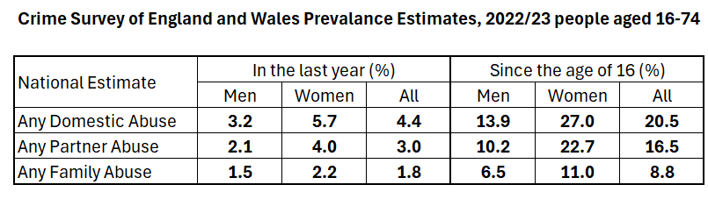

In 2022/23 it is estimated that:

* 4.4% of people aged 16 -74 experienced any form of domestic abuse (down 0.6% on 2021/22); 5.7% of women (down 1.2%) and 3.2% of men (up 0.2%)
* 3% reported partner abuse (down 0.5%); 4% of women (down 0.8%) and 2.1% of men (no change)
* 1.8% reported any family abuse (down 0.3%); 2.2% of women (down 0.7%) and 1.5% of men (up 0.3%)

In total 20.5% of people reported having been a victim of domestic abuse at some point since the age of 16 (down 1.4%) comprising of 27% of women (down 2.3%) and 13.0% of men (down 0.2%)

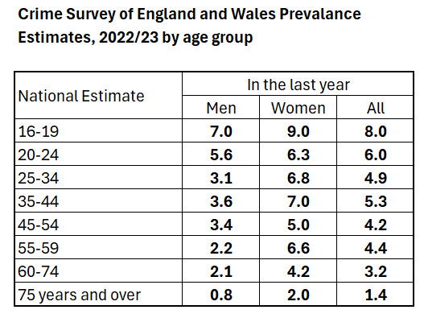

The 2022/23 CSEW provided an age update for the first time since the 2019/20 CSEW. It found that prevalence of domestic abuse in that year was highest amongst younger age groups, with 9% of females aged 16 – 19 experiencing domestic abuse in that year. This data suggests many of the people accessing support and accommodation are likely to be younger and either in need of single properties or have young children and need family units. This should therefore be considered alongside commissioning decisions.

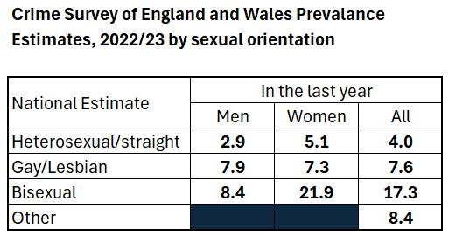

Prevalence of domestic abuse was reported to be highest amongst people who are bi-sexual in 2022/23 with 17.3% reporting being a victim (6.2% higher than 2021/22), compared to 4.6% (up 0.6%) of heterosexual people. To understand this data in context however, it should be noted that in 2022 the ONS Annual Population Survey estimated that 1.8% of the population identify as gay or lesbian, 1.5% as bisexual, and 0.6% defined as Other.[10]

Although a small proportion of the total population this data suggests that the support and safe accommodation offer needs to ensure it meets the needs of the LGBT+ community. Questions on LGBT+ needs were part of service user consultations and will continue to inform commissioning and practice.

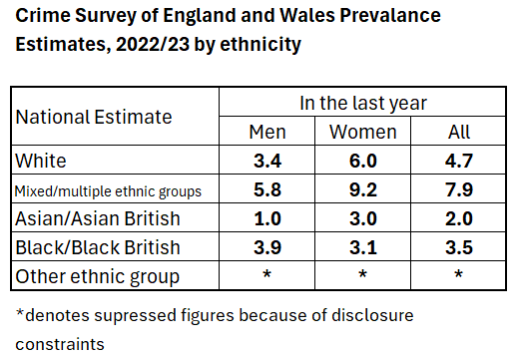

From the data made available rates of domestic abuse are estimated to be higher amongst women than men in all categories except black/black British.

Estimated rates in 2022/23 are significantly highest amongst people of mixed/multiple ethnicities. The 2nd highest prevalence rate was amongst those who are White (a change to 2021/22 where Black/Black British was 2nd highest).

This data shows that the domestic abuse support offer needs to continue to ensure it meets the needs of black and minoritised communities. Questions on ethnicity were part of service user consultations and will continue to inform commissioning and practice.

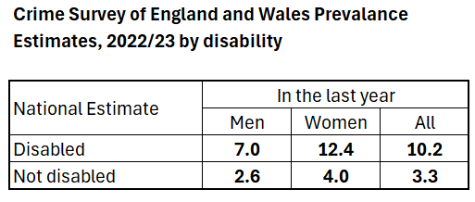

The 2022/23 CSEW estimates that 12.4% of disabled women (down 0.7% on 2021/22) and 7% of disabled men (up 0.3%) have been a victim of domestic abuse in the that year, the table above also shows that these rates are more than twice as high as rates amongst people who are not disabled[11]. These estimates highlight the potential need for suitable support options and accessible accommodation for victims of domestic abuse as the data suggests that a disabled person is more likely to be a victim of domestic abuse. However, this data does not indicate the type of disability that is most common e.g., whether this indicates the need for more units that are accessible for people with mobility issues or other forms of disability.

Tables with CSEW 2022/23 data on partner abuse and living situation.

For the 2022/23 CSEW the Office for National Statistics (ONS) published a detailed section on partner abuse[12]. The data shows that for victims of domestic abuse in that year, just under 19% (just under 1 in 5) lived with the abusive partner, down from 21.4 six years ago. The proportion could be higher as 11.6% did not want to respond to the question. Of those living with an abusive partner in that year the majority (69.9%) did not leave the accommodation because of the abuse, this is up 4.4% on six years ago. However, this means three in ten did leave due to domestic abuse which indicates the need for safe accommodation.

Table showing the main reasons the vicitm did not leave the shared accommodation with partner.

The reason for not leaving the abuse is asked on the CSEW. The three main reasons given were love / feelings for partner, presence of children and nowhere to go. These are only based on a sample of 72 people however, so caution needs to be given to these figures.

Other key findings on partner abuse from the CSEW 2022/23 included:

* An estimated 3% of adults aged 16 to 74 years had experienced partner abuse in the last year. This is down 1.5% on the same metric five years ago
* Male victims of partner abuse reported experiencing higher levels of non-physical abuse (emotional, financial) than female victims of partner abuse (89% compared to 87%)
* Male victims of partner abuse reported experiencing higher levels of physical force than female victims of partner abuse (31% compared to 19%)
* In almost one-third of households where there was a victim of partner abuse, there was at least one child under the age of 16 years living there at the time of the abuse (32.4%); 71.9% of victims reported the child or children did not see or hear the abuse.
* Of partner abuse victims, 16.4% reported that they sustained a physical injury as a result of the abuse and 52.0% experienced a non-physical effect.
* More than four in five victims of partner abuse (81.0%) reported they told someone about the abuse they had experienced in 2022/23, with 18.9% telling the police.

A majority of victims do confide in someone they know regarding the abuse they suffer (68%), but only 28% report the abuse to someone in an official position.

**Recommendations**

* Continue to promote domestic abuse services to the general public to raise awareness of the support available, to increase awareness amongst victims but also the people they talk to.
* Continue to commission professional domestic abuse awareness training in order to help professionals identify abuse victims.
* Provide targeted promotion to under-represented groups, such as those with disabilities as the data suggests prevalence rates are higher amongst this group than the general population
* Continue to engage with service users with protected characteristics to inform commissioning decisions.

# Estimated Prevalence of Domestic Abuse in Sheffield

**Prevalence of Domestic Abuse in Sheffield**

The CSEW provides a national estimate of the prevalence of domestic abuse across England and Wales. We can use these findings and apply them to the Sheffield population of 16 -74-year-olds to estimate the prevalence of domestic abuse in Sheffield amongst this age group.

We know that domestic abuse is a gendered crime, females are more likely to be ‘highly victimised’, and the number of females presenting to services in Sheffield is much higher in comparison to males. Gadd (2002) highlighted at that time that rates of domestic abuse victimisation amongst men could be as much as halved as many who report being a victim are in fact a perpetrator. The violent resistance research: Swan et al (2008), indicated that 86% to 92% of women who perpetrate domestic abuse are not the primary perpetrator of the abuse. Johnson explains that the majority (75%) are acting in self-defence, retaliating, or protecting their children. These areas of research are now old but can be considered when reviewing the rates reported below. The concerns flagged earlier about the way that the CSEW collects data about domestic abuse and its impact on estimates of gender should also be considered.

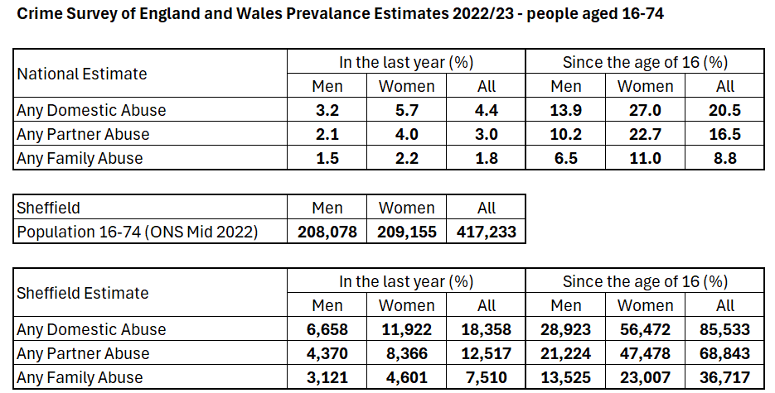

This allows us to estimate that in 2022/23 there may have been as many as 18,358 victims of domestic abuse in Sheffield (which is around 3,300 less than the number in this document for the year 2021/22). 65% (down 4%) of the victims are female (11,922) and 35% (up 4%) are male (6,658). These numbers equate to 3.2% of men and 5.7% of women having been a victim of domestic abuse in 2022/23.

Over a quarter (27%) have experienced domestic abuse at some point since the age of 16 (down 2.3%) and 13.9% of men (down 0.2%). This would equate to around 85,533 people in Sheffield having been a victim of domestic abuse at some time since the age of 16 (down around 9,500). 66% (56,472) of these victims are female (down 1%) and 34% (up 1%) are male (28,923).

The estimated rate of domestic abuse in 2022/23 amongst 16 – 74-year-olds overall shows some reduction on the previous year when 5% reported being a victim.

The findings on partner abuse and those that live with the abuser from the 2022/33 CSEW showed what proportion of victims of domestic abuse in that year left their partner following the abuse. Applying these findings to the estimated number of victims of domestic abuse in that year in Sheffield shows the following:

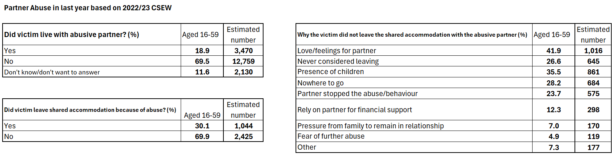

Of the 18,358 victims in 2022/23 we can estimate, based on the findings in the tables above, that 3,470 (21.4%) lived with an abusive partner and of these, 1,044 would have left the shared accommodation because of the abuse. We know from local data for 2022/23 that in Sheffield 23% of people accessing the community domestic abuse service (with a home status recorded) were living with their partner, based on the prevalence estimate of 18,358 victims this would equate to 4,222 living with their partner.

Of those that didn’t leave the shared accommodation 35.5% didn’t leave because of the presence of children, 28.2% had nowhere else to go and 12.3% relied on their partner for financial support. These reasons are not mutually exclusive; a victim may have citied more than one reason for not leaving the shared accommodation.

In 2022 a report on domestic abuse in Sheffield produced by SafeLives estimated that there may have been as many as 23,860 victims of domestic abuse in that year. These estimates were based on findings from previous years CSEW and were not based on the current population estimates. The data reported in this report is based on the most recent estimates available at the time of writing.

IDAS, the provider of the community based domestic abuse service, provided information for this needs assessment regarding the types of abuse disclosed by victims / survivors using the service in 2023/24:

* 44% had experienced coercive control
* 2% had experienced ‘honour’ based abuse
* 30% had experienced non-fatal strangulation
* 20% had experienced economic abuse
* 65% had experienced physical abuse
* 37% had experienced stalking and harassment

# Police Data

**ONS Police Recorded Crime Data 2022/23[13]**

* the police recorded 889,918 domestic abuse-related crimes in England and Wales (excluding Devon/Cornwall), this is similar to the previous year having historically seen year on year increases.
* 36.3 arrests per 100 domestic abuse-related crimes were made by the police, up from 29.6 the previous year.
* There were 69,314 referrals to the CPS from the police in 2022/23, an increase from 67,063 the year before.
* the charging rate was 76.5%, an increase on the previous year.
* over three-quarters of domestic abuse-related CPS prosecutions were successful in securing a conviction (76%), a similar level to the previous year.

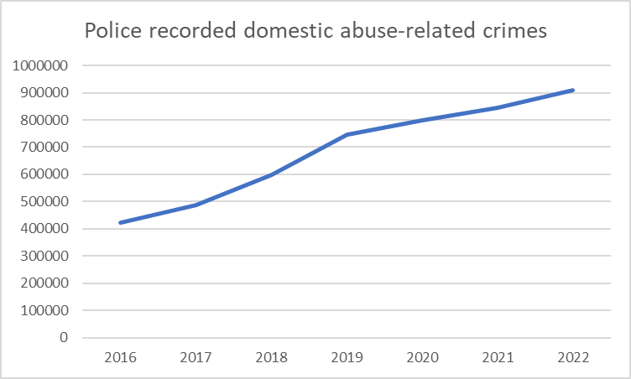

The chart above shows that overall, the number of offences recorded since January 2016 has increased year on year. We know that some of the increase in offences recorded can be attributed to better recording by the police and increased reports following high profile cases.

An increase in the number of reported incidents to the police could lead to more people being referred to support for domestic abuse.

We can also look at police incidents and crimes data for specific police force areas, since 2015/16 the total number of crimes and incidents reported to South Yorkshire Police (SYP) has increased overall as can be seen in the chart below:

The chart shows that total number of domestic abuse related crimes and incidents reported to SYP increased from 32,135 in 2015/16 to 39,016 in 2022/23. It also shows us that between 2017/18 and 2018/19 the number of incidents reported reduced as crimes increased during the same period. Over the most recent couple of years the number of incidents reported has plateaued, but crimes continue to gradually increase. The total of crimes and incidents reported can also be seen to increase in recent years having been relatively stable for the couple of years prior to this period, showing the increase in reports during the coronavirus pandemic.

We can also compare domestic abuse crimes reported to SYP with other police forces:

The bar shown in green above represents SYP which for the 2022/23 year reported a domestic abuse related crime rate of 18.1 per 1,000 population, the 10th highest rate across 42 police force areas. The highest rate of domestic abuse crimes per 1,000 population in 2022/23 was West Yorkshire Police with a rate of 27.3, the lowest was reported by Surrey Police with a rate of 6.8. This helps to show the impact of domestic abuse on policing in South Yorkshire.

According to the South Yorkshire Police Domestic Abuse Problem Profile for the period 1st July 2019 – 30th June 2022: *The volume of male victims reporting to SYP in Sheffield increased by 7% from year 2019 to 2022. Victims with the vulnerabilities ‘sexuality’ and ‘non-English speaking’ both increased by 200% from year one to three and 28% of victims had a recorded vulnerability.*

Regarding geographical prevalence, SYP’s DA Profile found:

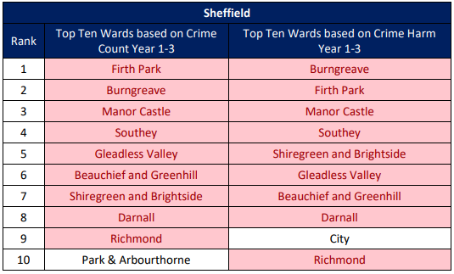

The South Yorkshire Police Problem Profile 2019-2022 includes a map of high-risk offences:

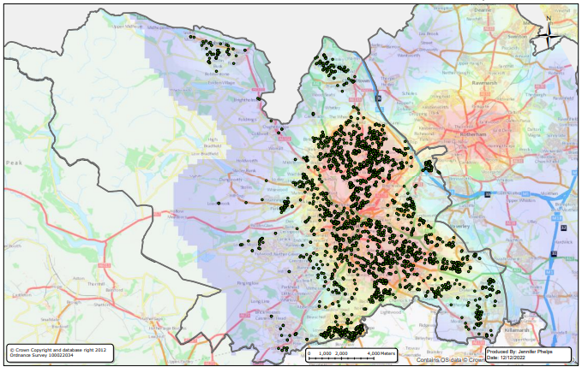

IDAS have also produced a heat map of high-risk cases (for 2023/24) which shows a similar distribution:

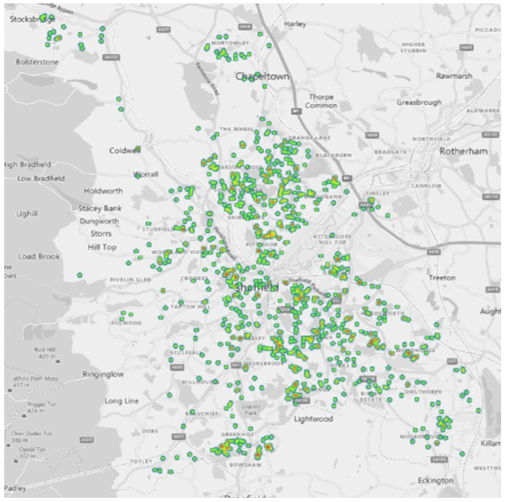

Referrals made by the police to the community based IDVA and support service are discussed in section 9.

**Recommendation**

* Ensure that awareness and prevention campaigns are targeted to areas of highest prevalence and informed by survivors and specialist services.

# Domestic Homicide Reviews

**Domestic Homicides[14]**

Data available for domestic homicides nationally combines data into a three-year period to account for year-on-year variability in the volume of homicides:

The number of domestic homicides reported is a total of 340, 67.3% of the victims of domestic homicide were female. This contrasts with non-domestic homicides where the majority of victims over the same time period were male (87.8%).

Of the 249 female domestic homicide victims, the suspect was male in the majority of cases (241). In the majority of female domestic homicides, the suspect was a male partner or ex-partner (74.7%), whereas in the majority of male domestic homicides, the suspect was a male family member (66.1%).

Rates of domestic homicide highlight the potential risk to victims who are unable to escape an abusive home environment, have recently separated or are attempting to separate.

A fuller discussion of Domestic Homicide Reviews is contained in a separate needs assessment document.

# Diversity

This section focuses on the demographical and diversity information of Domestic Abuse victims, the aim is to build a better understanding of the current service user profile, ascertain if services are accessible to victims of all demographics and understand where there may be barriers to accessing support.

Following the 2021 census, headline data has been published by ONS that shows the following breakdown of the population of Sheffield[15]:

**Age**

A table showing ONS census data for Sheffield broken down by age.

The data shows us that 82% of the Sheffield population are 16 years or older (81.3% of males and 82.7% of females). The 4-year age group that has the highest proportion of the population is the 20 – 24 years group with 9.1% of the population (9.3% of males and 8.9% of females). 64.9% of the population are aged between 16 and 64 (66.5% of males and 64.3% of females).

The South Yorkshire Police Domestic Abuse Problem Profile for the period 2019-2022 found that for older victims over 60:

* *63% were female, 94% White British and 60% aged 60-69. 34% with a recorded vulnerability had ill health and 24% of distinct victims were repeats.*
* *40% of older high-risk victims had a recorded disability*

A person who is older may have care and support needs under the Care Act definition and where this is the case specialist services must work closely with and make appropriate referrals to adult services.

The latest finding from the CSEW (shown in section 3) estimates that domestic abuse is overall more prevalent amongst younger age groups with 8% of 16 – 19-year-olds and 6% of 20 – 24-year-olds experiencing domestic abuse in 2022/23 in comparison to 4.4% of all 16 – 74-year-olds. In respect of the 16-19-year-olds age group which is the group with the highest estimated prevalence, the 8% prevalence can be split between men and women with the estimate being that 9% of women and 7% of men aged 16 – 19 have been a victim of domestic abuse in the 2022/23. Applying this proportion to the estimated population in the table above suggests that 1,393 females aged 16 – 19 in Sheffield could have experienced domestic abuse in 2022/23, and 1,117 men in the same age group.

The South Yorkshire Police Domestic Abuse Problem Profile for the period 2019-2022 found that for young victims:

* *Of those with a recorded vulnerability, 27% had a learning disability.*
* *Young victims were more likely to be victims of domestic sexual offending than the general population and suspects who offended against a young victim were more likely to have a history of sexual offences*
* *Young people were also more at risk from stalking and harassment online.*

**Gender**

Applying the data from the CSEW which suggests that 3.2% of males and 5.7% of females aged 16 – 74 have experienced domestic abuse in 2022/23, this would equate to 11,809 females and 6,518 males in Sheffield. In terms of an individual who has been a victim of domestic abuse since the age of 16, 29.3% of females and 14.1% of men reported having been a victim once or more.

The CSEW reports, based on Home Office data, that 97% of female domestic homicide victims were killed by a partner, ex-partner, or male relative.

SafeLives recommend that 5 – 10% of referrals to MARAC should be for male victims[16]; in Sheffield during 2022/23 9.1% of referrals to MARAC were male, this proportion has increased over recent years, for example, in 2013/14 3% of cases heard at MARAC were male. In South Yorkshire the percentage of referrals to MARAC that were male was 7.7%, 7.2% for the most similar Police force group, and 6.2% nationally. Based on the SafeLives recommendations all these proportions are within the recommended 5 – 10%, but Sheffield hears a greater proportion of male cases at MARAC than is seen across the region and England overall.

Local data available for Sheffield tells us that 88% of people receiving support from the community domestic abuse service in 2022/23 were female and 12% were male. This suggests that in Sheffield proportionate provision of support for males and females is available and accessed and highlights the need to maintain this.

The South Yorkshire Police Domestic Abuse Profile which looked at the years 2019 –2022 found that:

*Male victims are more likely to be abused by family members than the general victim base. There are lower rates of feeling able to support prosecution and rates of sexual assault are rising. However, the overall severity of domestic abuse from heterosexual partners or ex-partners is lower for male victims, with far fewer experiencing high-risk domestic abuse offences than female victims.*

**Transgender**

The 2021 Census asked the following voluntary question *‘Is the gender you identify with the same as the sex you were registered with at birth?’[17]*. In response to this question 0.5% of the population stated that the gender they identified with was different to the sex registered at birth. In 2022/23 1% (where the data was recorded) of people accessing the domestic abuse service in Sheffield stated that their gender identity was different to the sex registered at birth. The sexual abuse counselling service reported that 1.8% of their service users had a gender identity different to the sex registered at birth.

In 2021 Safelives published a briefing on Transgender Victims’ and Survivors’ Experiences of Domestic Abuse[18]. The key findings reported in the briefing are:

* Transgender victims experience specific types of abuse that can be linked to their trans identity.
* Trans victims experience large numbers of additional needs, particularly in relation to mental health.
* Trans people accessing domestic abuse services report that it had positive outcomes on their lives.
* Only a small proportion of trans victims with additional mental health needs are supported with these by domestic abuse services.

The briefing recommends that:

* Increase funding for LGBT+ and trans-specific specialist services.
* Enhance training for staff in non-specialist domestic abuse services so that they feel confident in asking victims about their gender identity and understand how this might affect their experiences and needs.
* Domestic abuse services should pay particular attention to the mental health needs when supporting trans victims and spend time supporting them with these needs.
* Encourage a public discourse where the high levels of violence against trans individuals are recognised and condemned.

The briefing also highlights that 56% of trans victims identified as male, and that 81% of perpetrators of domestic abuse against trans people were male. Both trans males and females are more likely to have a male than female perpetrator. 9% of trans victims experienced abuse from a family member, and this compares to 5% of cisgender victims.

Although a small proportion of the total people accessing domestic abuse services identify as transgender, the findings of the Safelives briefing highlight the need to provide mental health support and that provision is needed in relation to the needs of trans victims’ experiences.

**Ethnicity**

Data in the table below shows the population ethnicity breakdown of people living in Sheffield from the 2021 census. At the time of producing this report a breakdown split for males and females was not available and so the proportions for the total population have been applied to the number of males and females to give an indication of the number of males and females in each ethnic group.

A table showing ONS census data for Sheffield broken down by ethnicity.

The table shows that 74.5% of the population are White British, with a total 79.1% being White, 20.9% are from a BME group. The BME groups that make up the largest proportions of the Sheffield population are 5% are Asian, Asian British, or Asian Welsh: Pakistani, 3.3% Black, Black British, Black Welsh, Caribbean or African: African, 1.6% Other ethnic group: Arab.

The CSEW reports the percentage of men and women aged 16 – 74 that have been a victim of any domestic abuse in that year. This data is also split into high level ethnicity groups. For 2022/23 this data estimates that 4.7% of people who are White experienced domestic abuse in that year, 2% of people who are Asian / Asian British, 3.5% of people who are Black / Black British, and 7.9% of people from mixed / multiple ethnic groups.

The South Yorkshire Police Domestic Abuse Problem Profile which considered the years 2019-21 found in relation to ethnicity that:

* *Offences within this dataset increased by 18% from year one to three with White and Black African victims having the highest increase at 44%.*
* *Indian victims experienced the highest proportion of coercive control offences at 11% of their offences.*
* *Caribbean victims had the highest proportion of male victims at 34%, with 60% of their suspects being an ex-partner (heterosexual).*
* *Sibling family relationship related domestic abuse was higher than the general population at 8% (5% general population).*
* *Bangladeshi and Pakistani victims were more likely to experience domestic abuse by a child (adult or adolescent); 15% and 14% (respectively) within relationship types.*
* *Chinese victims had the highest proportion of offences in which current partner (heterosexual) was the suspect, at 53%. The general population figure was 25%.*
* *Chinese victims were also the most likely to consent to onwards referrals, with 36% consenting in the data period.*
* *Victims with a recorded ethnicity of Gypsy or Irish Traveller had the highest proportion of victim injury with 44% having a positive injury indicator.*
* *Victims with a recorded ethnicity of Gypsy or Irish Traveller had the highest proportion of violence with injury offences at 31%. This was followed by Chinese victims at just under 31%.*
* *63% of investigations with a White And Black African victim [dual heritage] resulted in Outcome 16 (NFA due to victim not supporting); 46% in the general population. Indian victims had the lowest proportion at 41%.*
* *Arab victims and Gypsy or Irish Traveller victims were more likely to experience a high-risk incident with 50% and 44% being high (respectively). Caution should be applied in interpreting these figures as there are low victim numbers for both; however low victim numbers but high severity suggests it is likely that these victims do not feel confident in reporting domestic abuse and may only do so when violence is escalating and fear levels are highest. White Irish and Bangladeshi victims also had high proportions of high-risk incidents at 25% and 23% respectively. White And Black African [dual heritage] victims had the lowest proportion at 10%.*
* *Any Other Black Background victims had the highest proportion of offences with the ‘Use of a Knife’ keyword at 3% (1% in the general population).*
* *Bangladeshi victims experienced the highest proportion of stalking and harassment offences at 34%.*
* *African victims were most likely to report in a week or under, at 87% with Chinese victims the least likely at 76%. Indian victims had the largest reporting delay, with 17% of offences reported over 90 days.*

*It is also important that specific methods of abuse (particularly coercive control) are considered, particularly threats by suspects to victims’ immigration status. A dip sample of the data did indicate that this was used by some suspects to keep victims in abusive and unsafe relationships.*

The proportion of black and minoritised clients accessing support services nationally differ according to reports; a Women’s Aid Federation Annual Audit for 2022[19] found that 29.4% of those recorded using the OnTrack data set were black and minoritised. SafeLives Insights data for 2022[20] states that 10% of service users were known to be black and minoritised. 16% of MARAC referrals in nationally for 2022/23 were for black and minoritised individuals, in Sheffield 22.3% of MARAC cases were black and minoritised.

At the end of 2022/23 26.6% of individuals receiving support from commissioned providers were black and minoritised￼. The proportion of service users in Sheffield that are black and minoritised, and the proportion of cases heard at MARAC in Sheffield that are black and minoritised both make up a greater proportion of people supported than the proportion of the Sheffield population they account for (20.9%).

A significant percentage of these victims / survivors may not speak English as a first language. Local specialist service Ashiana have fed back that they feel that front line workers need training on working with people with language needs.

**Sexual Orientation**

Information on the Stonewall Rainbow Britain Report for 2022[21] that uses findings from Ipsos’ online surveys estimated that 5% of the population are bi-sexual, 3% gay, 1% lesbian, 1% pansexual. The report also states that the publication of the 2021 census for England and Wales will give the best quality population estimates for LGBTQ+ identities.

The 2021 census for England and Wales found that 1.5 million people identified as LGB+, equating to 3.2% of the population aged 16+[22].

Using the 3.2% estimate and applying it to the Sheffield population 16 years and over gives an estimated 7,131 LGB males and 7,469 LGB females.

Safelives recommend 2.5-5.8% LGBT referrals on the MARAC caseload nationally; MARAC Performance data shows that 1.3% of referrals to MARAC are LGBT[23]. In Sheffield the proportion of referrals that are LGBT is 2.9%, higher than the national average. The rate of LGBT cases referred to MARAC is close to the 3.2% identifying as LGB on the 2021 census but it should be noted that the census rate does not include people who are transgender, meaning we should still strive to increase the proportion of LGBT cases heard at MARAC.

Data reported by the community domestic abuse service in Sheffield for 2022/23 shows that 4% of those in support were LGB however, 7.7% did not have their sexuality recorded.

The South Yorkshire Police Domestic Abuse Problem Profile which looked at the years 2019-2022 found that:

*LGBTQ+ victims were less likely to feel able to proceed with prosecution, more likely to experience a high-risk violent incident and more likely to be victimized online than the general population and the severity of offences is increasing.*

**Religion**

Religion can be of significance for some victims presenting at support services, for example beliefs can influence a victim’s response to domestic abuse e.g., if they feel that domestic abuse is accepted and perceived as the norm. This can impact on whether an individual will accept support, and/ or their interpretation of their own situation. The data below is from the ONS 2021 Census[24]:

A table showing ONS census data for Sheffield broken down by religion.

43.4% have no religion, 38.5% of the Sheffield population are Christian, and 10.3% are Muslim. 1% or less of the Sheffield population identified themselves in each of the other religious categories shown above.

In 2022/23 the community domestic abuse support service reported that out of all people accessing the service in the year who were asked their religion 52% stated that they had no religion, 16% stated that they were Muslim, and 15% stated that they were Christian. However, just 36% of all people accessing the service had their religion recorded. This data should be collected more consistently so that we have a robust picture of the people that access support and be able to identify factors that could contribute to how they feel about their experiences.

**Disability**

A 2015 report ‘Disability and domestic abuse. Risk, Impacts and Response’ produced by Public Health England[25] highlighted that disabled people experience disproportionately higher rates of domestic abuse than non-disabled people. The differences in experiences of domestic abuse between sexes is similar amongst disabled people as they are non-disabled people. Disabled women are significantly more likely to experience domestic abuse than disabled men and experience more frequent and more severe domestic abuse than disabled men. However, as being disabled carries further risk of domestic abuse, disabled men also experience higher rate of abuse than non-disabled men. The report states that disabled men experience a similar rate of domestic abuse as non-disabled women.

CSEW data from 2021/22[26] found that 13.1% of women with a disability reported having been a victim of any domestic abuse in that year in comparison to 5.6% of women with no long- disability. For men, the percentages were 6.7% for those with a disability, and 2.4% for those with no disability.

Additionally, A Spotlight on Disabled People and Domestic Abuse produced by Safelives[27] reported that disabled clients are:

* twice as likely to have planned or attempted suicide than non-disabled people.
* More likely to be suffering abuse from a current partner.
* More likely to experience abuse from an adult family member
* Typically experience abuse for a year longer on average before accessing support.

The South Yorkshire Police Domestic Abuse Problem Profile which considered the years 2019-21 found in relation to disabled victims / survivors that:

* *63% were female, 94% White British and 30% 20-29.*
* *Of those noted disabilities, 47% disclosed mental illness.*
* *70% of distinct victims were repeat victims, much higher than the general population figure and this is also reflected in risk levels; 23% being high-risk*
* *Victims with Autism were most likely to have an investigation resulting in an Outcome 16; 48% of investigations. Victims with a Learning Disability followed at 47%.*

For people accessing the Domestic Abuse Community Service in Sheffield during 2022/23 41% of people who were asked stated that they did have a disability. However, 20% of people accessing the service did not have this information recorded. Of those reporting a disability, 74% stated mental health needs, 20% a physical disability, 13% a learning disability, 1.9% hearing disability, 1.4% sight disability. 13% reported living with a long-term condition.

83% of people accessing the sexual abuse service in Sheffield in 2022/23 stated that they had a disability.

A person who is disabled may have care and support needs under the Care Act definition and where this is the case specialist services must work closely with and make appropriate referrals to adult services.

**Recommendations**

* There is a continued need to improve the recording and reporting of client disability data to meet the requirements of the Equalities Act 2011, so that all clients are asked about disability.
* Ensure commissioned services continue to include provision that is accessible for people with physical disabilities.

# Harmful Cultural Practices

**Forced Marriage**

*A forced marriage is where one or both people do not (or in cases of people with learning disabilities, cannot) consent to the marriage and pressure or abuse is used. It is an appalling and indefensible practice and is recognised in the UK as a form of violence against women and men, domestic/child abuse and a serious abuse of human rights.*

*The pressure put on people to marry against their will can be physical (including threats, actual physical violence and sexual violence) or emotional and psychological (for example, when someone is made to feel like they’re bringing shame on their family). Financial abuse (taking your wages or not giving you any money) can also be a factor.[28]*

The Anti-social Behaviour, Crime and Policing Act 2014[29] made it a criminal offence to force someone to marry. This includes:

* Taking someone overseas to force them to marry (whether or not the forced marriage takes place)
* Marrying someone who lacks the mental capacity to consent to the marriage (whether they’re pressured to or not)
* Breaching a Forced Marriage Protection Order is also a criminal offence
* The civil remedy of obtaining a Forced Marriage Protection Order through the family courts will continue to exist alongside the new criminal offence, so victims can choose how they wish to be assisted[30]

In Sheffield local protocols are implemented, in line with national guidance <https://www.gov.uk/forced-marriage#guidance-for-professionals>. These processes direct services to the relevant safeguarding service: where such victims are under the age of 18 to safeguarding children’s services and those aged 18 plus to adult support services which may include safeguarding adult services as necessary.

In 2022 the Forced Marriage Unit (FMU) gave advice or support related to a possible forced marriage or Female Genital Mutilation (FGM) in 302 cases representing a 10% decrease on the previous year, 13% of these cases were from the Yorkshire and Humber region. In addition to providing advice and support the unit also received 545 general enquiries. In 2013 the FMU gave advice or support to 1,302 victims, meaning there has been a 77% reduction in contacts over the last 10 years.

26% of cases were for victims aged 18-21 and 16% involved victims aged 16-17, 14% were about victims aged 15 or under. 78% of cases were for a female victim. There were 5 cases where the victim identified themselves as LGBT. In 2022 62 cases (21% of all cases) involved victims whose mental capacity to consent to marriage was in doubt.[31]

The above data includes people at potential risk of future forced marriage, those going through a forced marriage and those already forced to marry.

Sheffield commissioned services are required to work with individuals fleeing a forced marriage. Forced marriage victims can access support via the generic services of the helpline, the IDVAs, outreach and refuge, and data shows that individuals are doing so (although activity data is low, 14 contacts in 2022/23). The FMU supported roughly 39 cases from Yorkshire and the Humber in the same period. This represents individuals who accessed support, not the estimated prevalence.

**Female Genital Mutilation**

A person is guilty of committing Female Genital Mutilation (FGM) if they excise, infibulate or otherwise mutilate the whole or any part of a girl or young woman’s labia majora, labia minora or clitoris[32]. FGM is a crime, and it is child abuse. It is illegal in the UK under The FGM Act (2003)[33] which made it illegal for UK citizens of permanent residence to take a child from the UK abroad for FGM, even to a country where the practice is legal. These offences carry up to a maximum of a 14-year maximum prison sentence. FGM is also covered under the Serious Crime Act 2015[34] to extend protection to victims so that FGM acts carried out outside of the UK by a UK national or resident in the UK, or acts carried out on a UK national or resident in the UK, are prohibited.

The first UK conviction for FGM took place on 1st February 2019, the perpetrator was sentenced to 11 years in prison[35].

The Health & Social Care Information Centre (HSCIC) releases experimental statistics[36] for FGM. In 2022/23 there were 5,870 women and girls who had a healthcare attendance where FGM was identified, this was higher than the previous year but remains lower than in 2019/20 before pressure on NHS services increased because of coronavirus.

Forward UK[37] estimate that 137,000 women in the UK are living with the consequences of FGM.

Commissioned adult domestic abuse services can provide support to individuals over the age of 16 when FGM is an issue in the family and adult sexual violence services can provide support to those who are an adult survivor of FGM. However, in 2022/23 no one who accessed the domestic abuse service was recorded to be at risk of FGM. Data from the sexual violence service does not capture the number of people they supported who had experienced FGM, this should be improved so that we can get a better understanding of the local need and requirements.

**‘Honour-Based’ Abuse**

The police and CPS define Honour-Based Abuse (HBA) as *“an incident or crime involving violence, threats of violence, intimidation, coercion or abuse (including psychological, physical, sexual, financial or emotional abuse) which has or may have been committed to protect or defend the honour of an individual, family and / or community for alleged or perceived breaches of the family and / or community’s code of conduct.”[38]*

There is no specific criminal offence for ‘honour’ based violence; however, the actions of such practice, i.e. ’murder, kidnap, rape and violence’ are criminal offences. ‘Honour’ based violence can include FGM and Forced Marriage.

In 2022/23 there were 2,905 HBA related offences recorded by the police in England and Wales, 18 more offences than the previous year. Of the 2,905 offences there were 84 FGM and 172 forced marriage offences. The offences recorded for HBA related crimes in 2022/23 were:

The offences recorded for HBA related crimes in 2022/23 by police in England in a table.

Of the 2,905 HBA related offences 89 (3%) were recorded by South Yorkshire Police[39].

Data reported by the community domestic abuse service in Sheffield shows that 1.1% (42 people) of the people receiving support in 2022/23 were a victim of, or at risk of, HBA. MARAC hears HBA cases in a special session at the end of the regular meeting with only those agencies present who are involved with the case. In 2022/23 there were 70 HBA related cases heard equating to 6% of all MARAC cases in the year.

Ashiana, a long established provider in the city, specialising in support for victims / survivors from racialised communities has told us that 80% of their clients experience HBA – they therefore believe these figures are evidence of under recording. However they did not provide their numbers prior to the Needs Assessment being finalised.

Given the increase in reports to the police there is a need to ensure that support services promote that they support people affected by / at risk of HBA and that staff are appropriately skilled and experienced to respond to disclosures of this kind.

**Virginity Testing**

The Health and Care Act 2022 makes it an offence to carry out, offer or aid and abet virginity testing and hymenoplasty in the United Kingdom. There are separate offences for each UK jurisdiction.

The law defines ‘virginity testing’ as “the examination of female genitalia, with or without consent, for the purpose (or purported purpose) of determining virginity.”

The law defines ‘hymenoplasty’ as “the reconstruction of the hymen (with or without consent).”

Virginity testing is a form of ’honour’ based abuse. Data is not currently collected by support services around this form of abuse specifically.

**Recommendation**

* Agree methods for collection of data on virginity testing / people at risk of virginity testing with partners

# Domestic Abuse Support in Sheffield

There are a number of domestic and sexual abuse services in Sheffield providing support/ advice to:-

* victims of domestic abuse - aged 16 and over
* young people affected by domestic abuse
* victims of sexual abuse – aged 13 and over
* perpetrators of domestic abuse – aged 16 and over, and a programme for under 16s that are using harmful behaviour in their relationships.
* professionals working with those affected by domestic abuse.
* individuals who are concerned about the domestic abuse situation of another person, e.g. family member.

Domestic abuse service provision includes: IDVA, one to one support for domestic abuse and those affected by sexual abuse, group support, refuge provision, floating support, a helpline for domestic abuse, training for professionals and a number of voluntary sector services that are not commissioned by the local authority, but by other grants e.g. National Lottery.

These services provide a range of support covering all three risk areas; Standard, Medium and High risk. The DACT commission a helpline, community IDVA support service to support individuals at all levels of risk, and there are training contracts to provide training to health and public sector services. The DACT have also allocated some funding to provide behavioural change support to perpetrators, practical support for victims from the Citizens Advice Bureau, counselling for children affected by domestic abuse, and counselling for adult victims of domestic abuse.

**Domestic Abuse Helpline**

The Sheffield Domestic Abuse Helpline provides support for all victims, concerned family or friends of a victim, professionals, and referral services. The telephone number is 0808 808 2241 and is advertised widely in Sheffield. The helpline is provided Monday to Friday 08:00 – 20:00, and from 11:00 – 20:00 on Saturday, Sunday, and bank holidays.

The chart above shows the change in the number of calls to the helpline per year over the five financial years 2019/20 - 2023/24. It shows that calls increased year-on year between 2019/20 to 2021/22 and remained at over 5,000 calls in 2022/23. The most recent year (2023/24) saw calls increase again to 6,171. When comparing the 2023/24 number of calls with 2019/20 there has been a 57% increase in calls to the helpline.

Of the calls received in 2023/24 56% of calls came from individuals seeking advice and support for themselves. 32% of calls came from professionals seeking advice or support for their service users with the most calls in the year coming from children’s social care accounting for 4% of calls made to the helpline, followed by adult social care and adult safeguarding with 2% of all calls. Calls to the helpline from friends and family of victims accounted for 3% of all calls to the helpline in the year.

The main reasons cited for individuals calling the helpline are to provide an update on their situation, for emotional support / listening, to get information about local services, and to get information about their rights and options.

The current data suggests that to meet demand for helpline calls during the current operating hours the helpline needs to have capacity to receive more than 6,000 calls per annum.

**Community Based IDVA and Support Service**

The community-based service offers IDVA support, practical and emotional support, police triage, 1 to 1 support, group work, court support, Sanctuary Scheme measures, and support for the Multi-Agency Risk Assessment Conference (MARAC).

The chart above shows the total number of referrals into the service per year. Referrals to the service have remained high for the duration of the last five years, although the last two years do each show a small reduction on the year before.

Of the referrals in 2023/24, 1,217 were high risk and discussed at MARAC. High risk referrals that engage with the service generally require more intensive support. High risk referrals that do not engage with the service also impact on the services capacity because all high-risk cases are heard at MARAC and have an IDVA assigned to them. MARAC is discussed in more detail in the next section of this report.

Of all the referrals received by the service the police are the highest referring organisation accounting for 55% of all referrals into the service in 2023/24. The next largest referral source were self-referrals, accounting for 10% of all referrals in the year.

**Police Referrals**

From the service activity data in Sheffield, we know that SYP made 3,021 referrals to the domestic abuse support service, a reduction of 458 referrals when compared to the previous year. However, in 2023/24 SYP made 509 fewer medium and standard risk referrals to the service than the previous year but 52 more high risk referrals. The impact of this is that in 2023/24 high risk referrals accounted for 42% of all referrals made by the police, an increase from 35% in the previous year. In total police referrals accounted for 55% of all referrals to the domestic abuse service in 2023/24. Although lower than 62% for 2022/23 this information for both years further highlights the importance of the police role in helping people get support for domestic abuse.

We also know that of the 3,021 referrals the police made, 1,339 of them were already accessing the service at the time of the referral, equating to 44% of all the referrals made and shows the repeat victimisation of domestic abuse experienced by many service users.

**Health Referrals**

Many victims of domestic abuse come in to contact with health services which may or may not be because of the domestic abuse experienced. However, health professionals are well placed to identify signs of domestic abuse, and also to have incidents of domestic abuse disclosed to them. Health partners therefore need to be able to refer people to the domestic abuse community service. Also, in 2019 a report published by the Home Office[40] estimated the economic and social cost of domestic abuse to be £66 billion. The report also provided the following unit costs in 2016/17 to health services:

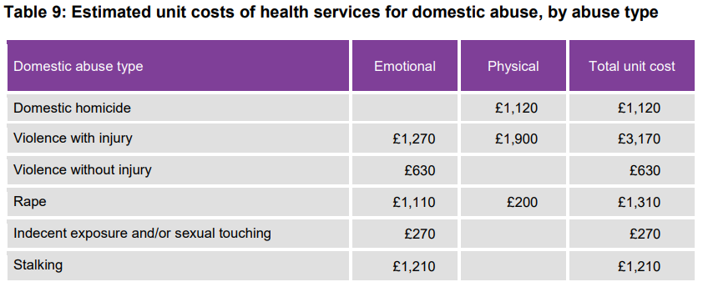Through support for domestic abuse, and by working with partners, we can aim to reduce the costs to services. Looking at all partner referrals (excluding referrals from the police) referrals from health partners accounted for 38% of all partner referrals in 2023/24, lower than the 43% the year before, but still an increase from 30% in 2021/22. In 2023/24 the highest health referrers into the domestic abuse support service were A&E accounting for 45% of health referrals, mental health services accounted for 13% of health referrals, GPs 12%, and midwifery 5%.

**Structured Support**

In 2023/24 1,442 individuals accessing the domestic abuse support service were offered structured support. In total, 2023 service users received structured 1to1 support. Structured 1to1 support is offered to service users with high needs. This compares to 647 receiving structured 1to1 support in 2022/23, which means 2023/24 saw a 212% increase in the number receiving structured 1to1 support.

The service also offers structured group work to service users, with a target for this to be provided to 100 victims per year. In 2023/24 153 individuals commenced the structured group work, 117 people completed the structured group work programme, equating to 76% of the commencements. The number of people starting the group work programme increased in 2023/24 in comparison to 2022/23 when 97 people commenced the programme.

# Multi-Agency Risk Assessment Conference (MARAC)

All identified high risk domestic abuse cases should be referred to the Multi-Agency Risk Assessment Conference (MARAC) and all cases should have an IDVA support worker assigned to them. MARAC and IDVAs are a national approach but with locally agreed processes. The increase in the number of high-risk referrals into the service means that more victims go through the MARAC process.

The aim of the IDVA worker working with high risk cases[41] is to reduce a victim’s risk level by representing victims at MARAC, creating safety plans, supporting the client through the criminal justice process, assisting them to secure safe housing and facilitate access to support services. The chart below shows the number of high-risk cases discussed at MARAC per year:

The chart shows the increase in the number of cases discussed at MARAC over the last five years. Comparing 2019/20 data to that for 2023/24 there has been a 26% increase in the number of cases heard. Both the number of female and number of male MARAC cases have increased year-on-year up to 2022/23, however, in 2023/24 fewer men were discussed at MARAC than during the previous two years. In 2023/24 male victims accounted for 7% of all cases heard at MARAC, this is an increase from 6% in 2019/20, but lower than 9% for the previous year. With 88 males discussed at MARAC in 2023/24 this shows that while rates of domestic abuse are much higher amongst females, the number of males at high risk of domestic abuse would require over 0.75 FTE IDVA to support them per year. The most recent data shows that the number of cases discussed at MARAC per year continues to increase, and there were over 100 MARAC cases discussed per month on average in 2023/24.

The rise in MARAC cases has also placed a burden on the administrative capacity of the service which resulted in a backlog of cases to be heard and of minutes shared. These issues are being addressed through additional administrative capacity – put in place in the last quarter of 2023/24.

A review of MARAC was conducted by SafeLives in 2023[42]. This found that:

*There is one Marac in Sheffield which serves the city. The Marac takes place three times a month, with additional meetings added, depending on volume. There is a strong commitment to the process especially from the domestic abuse partnership board and strong Marac governance is evident at all times. There is consistent and solid coordination of the Marac, although this is under capacity at present. The Chairs alternate between police, local authority commissioners (when chair absences arise) and an independent Chair. There is good engagement from other agencies around the operational table the majority of the time, and we were impressed by the input of some of the non- core agencies.*

*We observed many strengths throughout the process of this work as well as good practice; some areas for development can be addressed quickly. We are aware that volume at Marac is a current challenge, and by restructuring and streamlining the process this may be addressed. It is also positive that the themes we discovered were echoed in all parts of the process, thus demonstrating no anomalies. The lack of consistent chairing created a meeting where the calibre of the content and structure was dependent on who was chairing, as opposed to it being led by the Marac team. The commitment to the process was also clear at the workshop, where attendance and involvement was high. There was a strong sense of full engagement and dedication in moving the process forward and building on the practice already in place. This could be built on further by having a Marac team day once a year to review practice and enhance team culture.*

An action plan has been developed to address the recommendations of the review. Progress is reported to the Domestic and Sexual Abuse Strategic Board.

# Additional Support & Therapeutic Services

Previous Needs Assessments have identified the need for therapeutic services to support victims and children in addition to the support provided by the community domestic abuse service in Sheffield, currently provided by IDAS.

Through increased funding additional support provision is now available to people experiencing domestic abuse.

**Financial Support**

Citizens Advice Sheffield (CAS) have received funding to help meet unmet needs of victims of domestic abuse in respect of income maximisation through support with benefits entitlement, managing debts, and other financial pressures.

In 2023/24 CAS provided support and advice to 268 individuals who were in safe accommodation due to domestic abuse. This equates to an average of 67 people per quarter, and greater than the average of 62 per quarter in 2022/23. In total support was provided on 651 occasions between the 268 individuals. On the majority of occasions people (52%) received support on benefits and tax credits, additionally 13% received support on Universal Credit specifically, 15% received support for debts. An individual can receive support for more than one reason.

Of the people receiving support in 2023/24, 5% were male, 33% BAME, 0% LGB+, and 56% report having a disability.

**Domestic Abuse Support Contract for Homeless prevention and Resettlement Service**

This service has been funded to provide:

* Specialist housing advice for residents of the Refuge / safe accommodation provision.
* Provide advice to staff and volunteers in safe accommodation settings on housing and homelessness.
* Provide workshops to the residents of Sheffield Women’s Aid refuges on their housing options and rights.
* Provide DIY focused workshops per year to the residents of Sheffield Women’s Aid to help residents transition to independent living.
* Deliver training courses to staff working in domestic abuse safe accommodation on agreed housing issues.

In 2023/24 the service provided specialist advice to 18 people experiencing domestic abuse. The service also provides advice to domestic abuse workers to provide support to their service users, supporting 37 workers and volunteers in 2023/24.

Of all victims supported, 100% were female, 47% BAME, 22% LGB+, 46% had a disability and of those with a disability 100% stated mental health disability.

As detailed in the funding requirements above the service also provided training to professionals, and workshops to victims to support independent living and provide consultation and guidance around housing rights and options. In 2023/24 15 people were supported through the workshops and 29 staff members received training and awareness sessions.

**Counselling**

These services have been funded to provide counselling to Children and Young People (CYP) / who have experienced domestic abuse in the household and adults who have been victim of domestic abuse and are now living in safe accommodation by delivering the following:

* Delivery of a recognised therapeutic counselling service to children and young people from 11 years of age living in safe accommodation / adults now living in safe accommodation.
* Work alongside domestic abuse services to identify the needs of children and young people / adults and create bespoke packages of counselling support.
* Identify and respond to safeguarding risks in line with agreed local authority / NHS safeguarding policies.
* Gather evidence of impact and report on agreed measures quarterly.
* Contribute to and participate in learning for the city including attendance at key strategic /operational group meetings.

**Counselling Service for Victims of Domestic Abuse in Safe Accommodation**

This service has been commissioned to provide counselling to the victims of domestic abuse in safe accommodation as per the restrictions of the DA Act funding. This could mean refuge or dispersed accommodation although counselling may not be appropriate when victims / survivors are still at a point of crisis. Users have often therefore been living in the community, post crisis with Sanctuary Scheme measures in place. In 2023/24 a total of 41 people received counselling (similar to the previous year) from the service and the service held a waiting list of 9 individuals ready to commence counselling. Overall, the majority of victims supported ended their counselling in a planned way (79%), with 100% stating that the counselling had helped them. For those exiting in a planned way, most people reported feeling hopeful about the future and feeling they could get on with the things they wanted to do.

In 2023/24 of the people supported; 5% were male, 29% BAME, 41% had a disability, 2% LGB+.

However, IDAS reported for this needs assessment:

*‘Lack of counselling and closed waiting lists, clients are often in a position ready to start counselling but are having to wait for 6 months, this puts additional pressure on our staff to bridge the gap.’*

Ashiana stated that they felt there is a need for specialist counselling for victims and survivors who are black or from minoritised communities.

**Counselling Service for Children and Young People in Safe Accommodation**

This service has been funded to provide counselling to children and young people aged under 18 that are victims and have experienced domestic abuse in the home. In 2023/24 a total of 48 CYP received counselling from the service, with 20 on the waiting list at the end of year. On average 12 hours support was provided to each person by the time they exited from the service, with 62% of exits being planned. Of those supported, 34% were male, 33% BAME, 32% had a disability.

**Children and Young People Therapeutic Domestic Abuse Service**

This service has been commissioned to deliver a therapeutic domestic abuse service for children in Sheffield aged 3 to 19 who have been harmed by their experience of domestic abuse. The service will be inclusive, non-discriminatory and use a trauma informed approach to support children and young people to improve their wellbeing, confidence and safety and will provide them with an opportunity to share their feelings in a safe environment. Thereby, enabling children and families to recover from their experience and increase their chances of achieving good outcomes.

The service operates within Sheffield’s Children and Families Service model which includes social care, Early Help services and Sheffield’s Strengthening Families Domestic Abuse Team.

In 2023/24 the service worked with 209 children and young people, a 28% increase on the previous year. Of those supported; 65 came through Strengthening Families, 33 through Early Help, and 111 who were living in safe accommodation with around 1,979 support hours provided to them. Of the 209 supported 53% were male, 25% BAME.

**Sheffield Health and Social Care Trust**

Sheffield Health and Social Care Trust who provide NHS mental health services in Sheffield provided information for this needs assessment that 189 patients disclosed that they were experiencing domestic abuse to them during 2023/24. Of these 153 were female and 36 were male.

They commented:

*It is recognised that for some victims of domestic abuse, disclosures are often made only once a therapeutic relationship is established. The risk of police and social care for those who have children has been identified as a barrier in some cases. Particularly of note is the fear that police may go out to see the perpetrator and service users can be frightened that this will increase risk to them.*

# Perpetrators

South Yorkshire Police have produced a Domestic Abuse Problem Profile concentrating on the period 1st July 2019 – 30th June 2022. This found that:

* Suspects were predominantly male (77%), White British (86% of those with a recorded ethnicity) and aged 30-39 (32%).
* Parental abuse offenders are more likely to be white males aged 16-18, with the most predominant age being 16
* Offences where the suspect was victim’s carer were higher risk and victims older, more were male and more vulnerable than the general population.
* The most prolific repeat domestic abuse offenders abused both their families and intimate partners.
* 9% (3183) of distinct suspects in the domestic abuse data had also committed a sexual offence. 273 (9%) were female and 2902 (91%) male. 43% of the suspects committed non-domestic sexual offences and 57% domestic. This illustrates the need to consider offending history as a whole when dealing with suspects, rather than isolated domestic incidents. 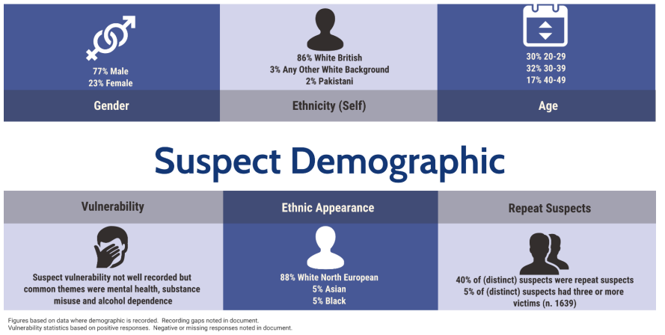

The South Yorkshire Police DA Profile considers repeat suspects:

*The Cambridge Crime Harm Index (CHI) was utilised to ascertain the relationship between offenders and harm (harm weight). From the bell curve, we can see that there was a cohort of 20% of domestic abuse offenders who were responsible for 80% of all harm.*

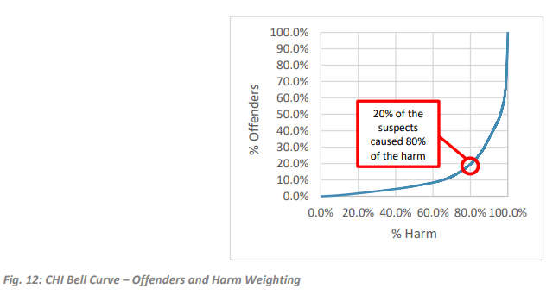*There were 14029 (40%) distinct suspects who were suspect in more than one offence over the data period and 2755 (8%) of these were suspect in five or more offences.*

*Of the top 20 suspects all, with the exception of one, were male, White British and ages were split over the 20-29 (6), 30-29 (6) and 50-59 (4) groups...* *suspects being difficult to engage and having multiple vulnerabilities including substance misuse and housing issues. Suspect vulnerability is not well recorded but most suspects had substance misuse and/or alcohol issues and offending (particularly against family members) was often in relation to them seeking money and harassing victims.*

**Domestic Stalking and Harassment**

The SYP DA Profile provides information on Stalking and Harassment. This was *the highest volume Home Office Group offence in all data years.*

* *81% of stalking victims were female and 77% of harassment victims were also female*
* *81% of stalking suspects were male and 71% of harassment suspects were also male*
* *35% of stalking victims were aged 20-29 and 28% of harassment victims were in the same age range*
* *29% of stalking suspects were aged 30-39 and 33% of harassment suspects were in the same age range*
* *84% of stalking victims were the ex-partner (heterosexual) of the suspect and 51% of harassment victims the same relationship type. 14% of harassment victims were the parent of the suspect.*
* *11% of stalking victims reported the offence 90 days after the offence was committed. For all offences in the general population this figure was 7%.*
* *30% of stalking and 16% of harassment offences had an online indicator.*
* *Common MO’s were unwanted, repeated communications through social media and 51 offences made reference to suspect using a ‘tracker’ either on a phone or car.*
* *Dip sampling of stalking suspects indicated that around 20% of stalking suspects had more than one victim. In some cases, suspect would stalk and harass an ex-partner and their family members and, in others, some suspects had multiple ex-partners who they would stalk following the end of a relationship. Common methods included peering through windows and doors of victims, sending unwanted parcels to victims, driving past victims’ homes, leaving things on doorsteps of victims and turning up at school or victims’ places of work.*
* *Around 2% of suspects committed a stalking and harassment offence whilst in prison.*
* *More victims reported stalking offences retrospectively than most other offences and it is likely that this is for fear of reporting not being taken seriously or victims not feeling that the stalking is an offence.*

In Sheffield, the SYP report found that Stalking and harassment increased by 16% over the three year period.

**Coercive Control**

The SYP DA Profile contains information on this form of offending:

*The Force have worked hard to ensure that frontline officers are aware of the dynamics of coercive control through DA Matters training and the impact of this can be seen in figures. Coercive control offences have increased by 384% during the period considered.*

* *There were nearly 300 distinct suspects of coercive control offences*
* *90% of victims were female and 34% aged 20-29. 82% were White British and 4% Any Other White Background.*
* *90% of suspects were male and 31% aged 30-39. 79% were White British and 5% Pakistani.*
* *45% of relationship type was partner (heterosexual) and 43% ex-partner (heterosexual).*
* *41% of offences were high-risk, 41% medium and 17% standard.*
* *27% of victims reported coercive control retrospectively (over 90 days), which is much higher than for all offences in the general population (7%).*
* *43% of victims did not feel able to proceed with prosecution (detection type Outcome 16).*
* *23% of victims had a recorded disability, 2% higher than the general population for all offences.*
* *29% of victims consented to a referral to domestic abuse services.*
* *20% of coercive control suspects also had been suspect of a sexual offence; this figure was 14% for the general population.*
* *5% of distinct coercive control suspects had also been non-domestic sexual offence suspects. 15% had been suspects of a domestic sexual offence.*
* *In 8% of coercive control offences, the person reporting was not the victim.*

**Organised Crime**

The South Yorkshire Police Domestic Abuse Problem Profile found that where the perpetrator is a member of an organised crime gang (OCG):

* The severity of domestic abuse is higher (although the caveat for this is that some offences may be assessed higher risk as a result of suspect being an OCG member) when suspects are part of an OCG and it is a realistic possibility that victims are more likely to be injured.

**Number of Sheffield Perpetrators using MARAC data**

From local MARAC data we know that 27% of cases heard in 2023/24 were repeat cases. Data from the community domestic abuse service tells us that in 23/24 there were 3,271 perpetrators recorded between 2,395 victims that accessed the service, equating to each victim having 1.4 perpetrators on average. If we apply this to the estimated 18,358 victims in Sheffield in the last year we can say that there could have been around 25,700 perpetrators of domestic abuse in Sheffield in the last year.

**Perpetrator Behaviour Change Programmes**

The statutory guidance on the Domestic Abuse Act 2021[43] highlights that addressing perpetrators‘ behaviour is as important as safeguarding and supporting victims, and emphasis for change should be put on the perpetrator. Young people perpetrating abuse must be supported in an appropriate way that places emphasis on tackling the drivers of their behaviour. It is important that local areas commission safe, effective perpetrator programmes which consider the needs in their areas and are accompanied by support for any associated victims.

In 2015 the Project Mirabal report ‘Domestic Violence Perpetrator Programmes: Steps Towards Change’[44] produced by the centre for research into violence and abuse at Durham University found that whilst there was still more work to be done and improvements to be made to the support provided, for many men, women and children, their lives are improved following involvement with a good quality, accredited domestic violence perpetrator programme.

Initially commencing in 2018, a perpetrator programme is commissioned across South Yorkshire to provide support to perpetrators of domestic abuse. The aims of commissioning the service are:

* To reduce the harm caused to families by domestic abuse
* To challenge the acceptance of abusive behaviour, by using a neutral rather than a collusive or persecutory stance [45]
* To change the behaviour of individual perpetrators of domestic abuse
* To prevent abusive behaviour in the future
* To make all efforts to ensure victims and children are receiving appropriate support
* Reduce crime and anti-social behaviour

This is delivered by:

* Offering individuals engaged in abusive behaviour to recognise, acknowledge and change that behaviour to increase the safety of victims and children
* Providing multi-component interventions ranging from prevention and early interventions through to engaging with perpetrators who have patterns of repeat offending
* Provide training to ensure that staff working at partner agencies are skilled to identify, challenge and address abusive behaviours.
* Working with partner agencies to promote referrals and engagement with the perpetrator service.

In 2023/24 144 perpetrators were referred to the perpetrator programme in Sheffield, this equates to around 30% of the referrals received in 2022/23 when 491 referrals were made. Out of the 144 referrals 75 (52%) perpetrators engaged with the programme. In comparison, only 14% (69 perpetrators) of the referrals received in 2022/23 engaged with the programme. For those perpetrators engaging with the service emotional abuse and physical violence are the most common forms of abuse perpetrated.

During 2023/24 25 individuals completed the programme, there was an additional 15 individuals who dropped out of the programme during the year.

In 2023/24 86% of all referrals were received were male, 50% of perpetrators are aged 19 – 35, 40% aged 36 – 60. 64% of perpetrators are white. 27% of referrals had a substance use need and 32% a mental health need.

There is also a programme available through Probation for court mandated perpetrators – Building Better Relationships, and a programme for men using abusive behaviour against the mother of their children – Caring Dads (this is considered in the separate Children and Young People’s needs assessment document.

1. Recommendations
2. Continue to promote domestic abuse services to the general public to raise awareness of the support available, to increase awareness amongst victims but also the people they talk to.
3. Continue to commission professional domestic abuse awareness training in order to help professionals identify abuse victims.
4. Provide targeted promotion to under-represented groups, such as those with disabilities as the data suggests prevalence rates are higher amongst this group than the general population
5. Continue to engage with service users with protected characteristics to inform commissioning decisions.
6. Ensure that awareness and prevention campaigns are targeted to areas of highest prevalence and informed by survivors and specialist services.
7. There is a continued need to improve the recording and reporting of client disability data to meet the requirements of the Equalities Act 2011, so that all clients are asked about disability.
8. Ensure commissioned services continue to include provision that is accessible for people with physical disabilities.
9. Agree methods for collection of data on virginity testing / people at risk of virginity testing with partners

1. [The Measurement of Domestic Abuse – Redeveloping the Crime Survey for England and Wales | Journal of Family Violence (springer.com)](https://link.springer.com/article/10.1007/s10896-023-00507-9#Sec29)
2. <https://assets.publishing.service.gov.uk/government/uploads/system/uploads/attachment_data/file/1089015/Domestic_Abuse_Act_2021_Statutory_Guidance.pdf>
3. <https://www.legislation.gov.uk/ukpga/2003/42/contents>
4. <https://assets.publishing.service.gov.uk/government/uploads/system/uploads/attachment_data/file/1033934/Tackling_Violence_Against_Women_and_Girls_Strategy_-_July_2021.pdf>
5. Information taken from the About the Survey section of the Crime Survey website <https://www.crimesurvey.co.uk/en/AboutTheSurvey.html>
6. <https://www.ons.gov.uk/peoplepopulationandcommunity/crimeandjustice/bulletins/crimeinenglandandwales/yearendingmarch2022#domestic-abuse-and-sexual-offences>
7. Gadd, D., Farrall, S., Dallimore, D & Lombard, N (2002) *Domestic abuse against men in Scotland*, Scottish Executive Central Research Unit <http://www.gov.scot/Publications/2002/09/15201/9609> - pages 33-46
8. Respect Men’s Advice Line Service Review 2020/21: Supporting male victims of domestic abuse during Covid-19
9. Supporting Local Domestic Abuse Partnership Boards, Mankind Initiative, June 2021
10. <https://www.ons.gov.uk/peoplepopulationandcommunity/culturalidentity/sexuality/bulletins/sexualidentityuk/2020>
11. The definition of disability used in the CSEW is consistent with the core definition of disability under the Equality Act 2010. A person is considered to have a disability if they have a long-standing illness, disability or impairment which causes difficulty with day-to-day activities.
12. <https://www.ons.gov.uk/peoplepopulationandcommunity/crimeandjustice/datasets/partnerabuseindetailappendixtables>
13. <https://www.ons.gov.uk/peoplepopulationandcommunity/crimeandjustice/articles/domesticabuseandthecriminaljusticesystemenglandandwales/november2023>
14. [Domestic abuse victim characteristics, England and Wales - Office for National Statistics (ons.gov.uk)](https://www.ons.gov.uk/peoplepopulationandcommunity/crimeandjustice/articles/domesticabusevictimcharacteristicsenglandandwales/yearendingmarch2023#domestic-homicide)
15. <https://www.nomisweb.co.uk/census/2021/bulk>
16. <https://safelives.org.uk/practice-support/resources-marac-meetings/latest-marac-data>
17. <https://www.ons.gov.uk/peoplepopulationandcommunity/culturalidentity/genderidentity/bulletins/genderidentityenglandandwales/census2021>
18. <https://safelives.org.uk/sites/default/files/resources/Briefing%20-%20Transgender%20Victim-Survivors%27%20Experiences%20of%20Domestic%20Abuse%20Final.pdf>
19. <https://www.womensaid.org.uk/wp-content/uploads/2022/03/The-Domestic-Abuse-Report-2022-The-Annual-Audit.pdf>
20. <https://safelives.org.uk/sites/default/files/resources/Idva%20Dataset%202022_FINAL.pdf>
21. <https://www.stonewall.org.uk/system/files/rainbow_britain_report.pdf>
22. <https://www.ons.gov.uk/peoplepopulationandcommunity/culturalidentity/sexuality/bulletins/sexualorientationenglandandwales/census2021>
23. Safelives data for the 12 month period between April 2022 and March 2023.
24. <https://www.ons.gov.uk/visualisations/censusareachanges/E08000019/>
25. <https://assets.publishing.service.gov.uk/government/uploads/system/uploads/attachment_data/file/480942/Disability_and_domestic_abuse_topic_overview_FINAL.pdf>
26. <https://www.ons.gov.uk/peoplepopulationandcommunity/crimeandjustice/datasets/domesticabuseprevalenceandvictimcharacteristicsappendixtables>
27. <https://safelives.org.uk/knowledge-hub/spotlights/spotlight-2-disabled-people-and-domestic-abuse>
28. <https://www.gov.uk/forced-marriage>
29. <http://www.legislation.gov.uk/ukpga/2014/12/contents/enacted>
30. <https://www.gov.uk/forced-marriage>
31. Forced Marriage Unit (FMU) Statistics January to December 2013. Home Office, Foreign and Commonwealth Office.
32. Section 1 (1) The Female Genital Mutilation Act (2003)
33. <http://www.legislation.gov.uk/ukpga/2003/31/contents>
34. <https://assets.publishing.service.gov.uk/media/5a755af1e5274a3cb2869c59/Fact_sheet_-_FGM_-_Act.pdf>
35. <https://questions-statements.parliament.uk/written-questions/detail/2020-03-02/HL2070/#:~:text=The%20first%20UK%20conviction%20for,collate%20information%20on%20prosecutions%20centrally>.
36. <https://digital.nhs.uk/data-and-information/publications/statistical/female-genital-mutilation/april-2022-to-march-2023>
37. <https://www.forwarduk.org.uk/violence-against-women-and-girls/female-genital-mutilation/>
38. <https://www.cps.gov.uk/legal-guidance/so-called-honour-based-abuse-and-forced-marriage-guidance-identifying-and-flagging>
39. <https://www.gov.uk/government/statistics/so-called-honour-based-abuse-offences-2022-to-2023>
40. The Economic and Social Costs of Domestic Abuse <https://assets.publishing.service.gov.uk/media/5f637b8f8fa8f5106d15642a/horr107.pdf>
41. IDVAs work with victims / survivors at all risk levels in Sheffield
42. [Sheffield Marac Report (sheffielddact.org.uk)](https://sheffielddact.org.uk/domestic-abuse/wp-content/uploads/sites/3/2024/04/Sheffield-Marac-Review-2023-Final-Report.pdf)
43. <https://www.gov.uk/government/publications/domestic-abuse-act-2021>
44. <https://projectmirabal.co.uk/wp-content/uploads/2020/06/ProjectMirabalfinalreport.pdf>
45. Iwi &Newman 2013