# SHEFFIELD

# CHILDREN AND YOUNG PEOPLE

# DOMESTIC AND SEXUAL ABUSE

# NEEDS ASSESSMENT 2024



1. **Introduction**

This section of the needs assessment considers the needs of children and young people affected by domestic and sexual abuse in Sheffield.

Part 1 of The [Domestic Abuse Act 2021](https://www.legislation.gov.uk/ukpga/2021/17/enacted) formally recognised that where domestic abuse is happening in children’s lives they are to be considered as direct victims of the abuse.

***Children as victims of domestic abuse***

*(1)This section applies where behaviour of a person (“A”) towards another person (“B”) is domestic abuse.*

*(2)Any reference in this Act to a victim of domestic abuse includes a reference to a child who—*

*(a)sees or hears, or experiences the effects of, the abuse, and*

*(b)is related to A or B.*

*(3)A child is related to a person for the purposes of subsection (2) if—*

*(a)the person is a parent of, or has parental responsibility for, the child, or*

*(b)the child and the person are relatives.*

*(4)In this section—*

* *“child” means a person under the age of 18 years;*
* *“parental responsibility” has the same meaning as in the Children Act 1989 (see section 3 of that Act);*
* *“relative” has the meaning given by section 63(1) of the Family Law Act 1996.*

This legislation reflects what is widely understood about children and domestic abuse. They are not simply passive witnesses to single incidents of violence but instead experience the abuse often just as acutely as the primary focus of the perpetrator’s harmful behaviour and are best understood as *co-victims and co-survivors*.

We also know that the harm caused to children by domestic abuse can be serious and long lasting and therefore, must ensure that our systems and services are domestic abuse informed and equipped to respond effectively to children and families at times of crisis and high risk, but also quick to intervene at the earliest possible opportunity.

The change in legislation is additionally significant for local authorities and for those commissioning services for victim/survivors of domestic abuse as it means that children’s needs must be considered when developing a citywide strategic response to domestic abuse.

The Domestic Abuse Act (2021) also strengthened legislation around post separation abuse and from 5th April 2023 the section of the act that criminalises coercive or controlling behaviour that takes place post separation came into force. This means that any domestic abuse that happened after the 5th April 2023 can be considered as coercive or controlling behaviour. Research[1] also confirms that children continue to be harmed post separation. It is important to note that, given the relatively recent change in legislation, it is difficult to quantify the scale of the issue in Sheffield as no specific data sets exist.

In line with the legislation and also with language in the wider needs assessment, this section will refer to children as victims/survivors of domestic and sexual abuse, it includes data and information relating to children and young people and,

* Domestic abuse perpetrated by one parent/carer towards another & domestic abuse happening in children’s wider families (Adult Family Violence)
* Harmful cultural practices, such as so-called honour-based abuse (HBA), female genital mutilation (FGM), forced marriage/child marriage (FM) and virginity testing
* Children, post separation abuse and the Family Court
* Young people aged 11-18 who are using harmful behaviour in their own intimate relationships, including those aged 16 & 17 who perpetrate domestic abuse
* Children and young people who use harmful behaviours towards their parents or other family members, often known as CAPVA (Child and Adolescent towards Parents Violence and Abuse)
* Adverse Childhood Experiences (ACEs) and domestic abuse
* Sheffield Children’s Services data on domestic abuse (Children’s Social Care and Early Help Services data)
* The Strengthening Families team and the Safe and Together Model
* Domestic abuse and education including South Yorkshire Police’s Operation Encompass
* Specialist commissioned services for children affected by domestic abuse in Sheffield
* National child sexual abuse and sexual exploitation (CASE) prevalence estimates
* Local child sexual abuse and sexual exploitation prevalence estimates
* Sheffield Children’s social care data on CSAE (Child Sexual Abuse and Exploitation)
* Other Sheffield support services for children harmed by sexual abuse
* Young people (under 18) who use harmful sexual behaviour

1. **Scope**

Sheffield City Council Domestic Abuse Co-ordination Team (DACT) commission support for adults and children affected by domestic abuse.

This section of the needs assessment aims to provide an understanding of the impact domestic abuse has on children, using national and local prevalence figures and research findings.

It is of note that, given the legal definition of abuse applies to those aged 16 and over, there, is some overlap in services whereby they support young people aged 16 and 17 and also adults aged 18 and over. These services are commissioned as adult services with specialist workers for young people.

The DACT are also clearly linked strategically with the Children’s Safeguarding Partnership as illustrated in the governance structure below

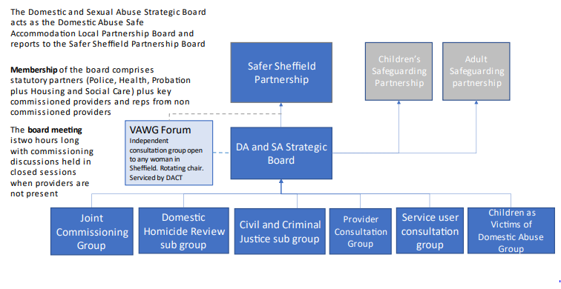

The Children and Young People as Victims of Domestic Abuse Group within the above structure also reports into the Learning Practice and Improvement Group of the Children Safeguarding Executive Group which further strengthens the strategic link between DACT and the Children Safeguarding Partnership (SCSP).

Children as victims of domestic abuse is a new priority area for Sheffield Children Safeguarding Partnership and is outlined in the 2023-2025 business plan [2]. It is anticipated that information outlined in this needs assessment and the accompanying citywide strategy will evidence the need to take a multi-agency citywide approach to achieving the recommendations below,

**Recommendation 4**. For 2023-25 the SCSP should have the following two new priorities areas:

Priority 3: **Children as victims of Domestic Abuse -** Reflecting on the priorities outlined in the [new Domestic Abuse Plan](https://www.gov.uk/government/publications/tackling-domestic-abuse-plan/tackling-domestic-abuse-plan-command-paper-639-accessible-version) (September 2022) child safeguarding partners should recognise their central role in the local response to domestic abuse.

The report recommends:

* Local partnerships should connect closely with the community safety partnership or domestic abuse board to ensure priorities and work plans align, including commissioning and budget priorities, with clear accountability mechanisms.
* Local child safeguarding and domestic abuse partnerships should involve specialist domestic abuse services and experts by experience (children, young people, and adults) in the development of strategies and local responses, including commissioning, service design and delivery. Specialist services, including those working with minoritized and disadvantaged victims and their families, should be appropriately recognised and resourced for this work.
* Local partnerships should look at local safeguarding systems and responses, focusing not only on the ‘front door’, and move beyond the need to ‘manage demand’ resulting from domestic abuse notifications.
* Training should be embedded across all safeguarding partners for all practitioners to ensure they provide a domestic abuse-informed response, and for this to be supported within supervision and reflective practice opportunities.
* Rapid reviews and local child safeguarding practice reviews should involve local specialist domestic abuse services in every review where domestic abuse is mentioned whether the domestic abuse is perceived to be current or historic. Specialist services should be appropriately recognised and resourced for this work.
* Rapid reviews and local child safeguarding practice reviews should identify and record the protected characteristics of each family member, along with details of the whole family, to ensure that families’ diverse needs, experiences and wider family networks are identified and analysed appropriately.

Safeguarding partners should read recommendation eight in the national review into the murders of Arthur Labinjo-Hughes and Star Hobson, which relates to specific practice improvements in relation to domestic abuse. They should consider these alongside the above, including:

* Safeguarding partners to improve how they work with specialist domestic abuse services by establishing stronger working relationships and clear information sharing protocols.
* Safeguarding partners must be committed to, and fully invested in, the commissioning of domestic abuse services and ensure all staff have a robust understanding of what the domestic abuse support offer is in their area.
* Appropriate responses to domestic abuse should feature clearly in any new proposed National Child Protection Practice Framework as recommended by the national review into what happened to these children. Training should be embedded across all safeguarding partners for all practitioners to ensure they provide a domestic abuse informed response.

1. **Linked National Strategies and Reports**

* DA plan [Tackling Domestic Abuse Plan - Command paper 639 (accessible) - GOV.UK (www.gov.uk)](https://www.gov.uk/government/publications/tackling-domestic-abuse-plan/tackling-domestic-abuse-plan-command-paper-639-accessible-version)
* Tackling Violence Against Women and Girls [Tackling violence against women and girls (publishing.service.gov.uk)](https://assets.publishing.service.gov.uk/media/6194d05bd3bf7f054f43e011/Tackling_Violence_Against_Women_and_Girls_Strategy_-_July_2021.pdf)
* DA Act Stat guidance [Domestic abuse: draft statutory guidance framework (accessible version) - GOV.UK (www.gov.uk)](https://www.gov.uk/government/consultations/domestic-abuse-act-statutory-guidance/domestic-abuse-draft-statutory-guidance-framework)
* Children’s safeguarding practice review [Multi-agency safeguarding and domestic abuse (publishing.service.gov.uk)](https://assets.publishing.service.gov.uk/government/uploads/system/uploads/attachment_data/file/1107448/14.149_DFE_Child_safeguarding_Domestic_PB2_v4a.pdf)
* [The Child Safeguarding Practice Review Panel Annual Report 2022-23 (publishing.service.gov.uk)](https://assets.publishing.service.gov.uk/media/65bce1df7042820013752116/Child_Safeguarding_Review_Panel_annual_report_2022_to_2023.pdf)
* [DAC_Mapping-Abuse-Suvivors_Summary-Report_Feb-2023_Digital.pdf (domesticabusecommissioner.uk)](https://domesticabusecommissioner.uk/wp-content/uploads/2023/02/DAC_Mapping-Abuse-Suvivors_Summary-Report_Feb-2023_Digital.pdf)
* [domesticabusecommissioner.uk/wp-content/uploads/2023/10/DAC_Famliy-Court-Report_Oct-2023.pdf](https://domesticabusecommissioner.uk/wp-content/uploads/2023/10/DAC_Famliy-Court-Report_Oct-2023.pdf)
* [Domestic Abuse Commissioner responds to consultation on children’s social care - Domestic Abuse Commissioner](https://domesticabusecommissioner.uk/briefings/domestic-abuse-commissioner-responds-to-consultation-on-childrens-social-care/)
* Homicide Abuse Learning Together (HALT) [Briefing-Paper-Childrens-Services-Domestic-Homicide-Oversight-Mechanism-2023.pdf (domesticabusecommissioner.uk)](https://domesticabusecommissioner.uk/wp-content/uploads/2023/12/Briefing-Paper-Childrens-Services-Domestic-Homicide-Oversight-Mechanism-2023.pdf)2
* Marriage And Civil Partnership (Minimum Age) Act 2022 (legislation.gov.uk)
* [Working Together 2023](https://assets.publishing.service.gov.uk/media/65cb4349a7ded0000c79e4e1/Working_together_to_safeguard_children_2023_-_statutory_guidance.pdf)

1. **Linked Local Strategies & Plans**

* [The Council Plan](https://democracy.sheffield.gov.uk/documents/s66496/Appendix%201%20-%20Council%20Plan%202024-28%20v1.pdf)
* [Sheffield Children Safeguarding Partnership - Business Plan 2023-2025](https://www.safeguardingsheffieldchildren.org/scsp/scsp-information/annual-report-business-plan-and-workforce-development-strategy)
* Domestic Abuse Safe Accommodation Strategy
* [SCSP Thresholds of Need](https://www.safeguardingsheffieldchildren.org/scsp/processes/early-help-thresholds-of-need)
* [White Ribbon and Violence Against Women and Girls | Sheffield City Council](https://www.sheffield.gov.uk/public-health/white-ribbon-and-violence-against-women-and-girls)
* Suicide prevention Strategy
* Hidden Harm Strategy
* Female Genital Mutilation Strategy

**5 CHILDREN AND DOMESTIC AND SEXUAL ABUSE PREVALENCE**

It is difficult to make an accurate estimate of the number of children affected by domestic abuse in England and Wales. It is well known that domestic abuse and sexual abuse are underreported crimes, and when children are involved, fear of statutory services often makes it even more difficult for survivors to report and seek help.

This section of the needs assessment, will use various sources of data to estimate national and local prevalence.

**5.1 National Children and Domestic Abuse Prevalence and data**

The [National Domestic Abuse Commissioner,](https://domesticabusecommissioner.uk/) in her response to the ‘Stable Homes Built On Love’ consultation on children’s social care uses the NSPCC estimate that 1 in 5 children will experience domestic abuse at some point in their childhoods.

Additionally, Safelives estimate that as children start primary school, there will be at least one child in every classroom who has lived with domestic abuse since they were born[3].

In 2022, the national Domestic Abuse Commissioner carried out mapping research. The resulting report, ‘A Patchwork of Provision’[4] found that only 29% of victims and survivors who wanted support for their children received it.

The Commissioner also states that in terms of statutory children’s services,

‘*Domestic abuse is the most common adverse background factor in children deemed ‘in need’ of support from local authority children’s social care and is recorded in around 50% of all children’s social care assessments, with the actual figure estimated to be significantly higher*[5]’

In 2023, Domestic abuse was recorded in 160,690 Child in Need social care assessments in England[6] in with similar figures recorded dating back to 2018. The Children’s Commissioner notes that this was the ‘most common factor identified at the end of a child’s assessment’.[7]

Domestic abuse was also the most common family characteristic found within Serious Case Reviews, which concerned the most extreme and grievous failures to protect children from harm[8].

A report published the Foundations institute using Office of National Statistics (ONS) and Crime Survey of England and Wales (CSEW) data reveals that at least 827,000 children suffered domestic abuse in England and Wales by end of calendar year 2023[9], this figure relates to children who were likely to be ‘present’ at the time of the incident, therefore the actual figure is likely to be much higher.

Additionally, SafeLives national data[10] notes that in England and Wales in 2022/2023

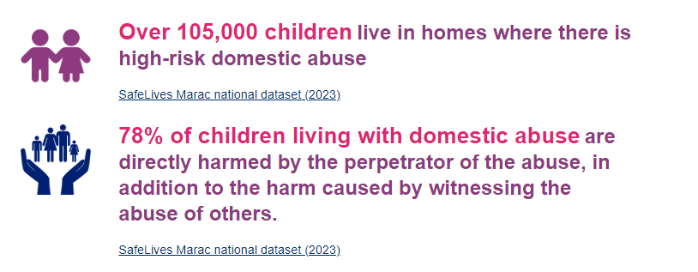

**5.2 Sheffield Children and Domestic Abuse Prevalence and Data**

Using the Crime Survey of England and Wales (CSEW) national estimate of the prevalence of domestic abuse across England and Wales, this needs assessment estimates that there were 85,355 people in Sheffield who have been a victim at some point since the age of 16, with an estimate of 18,358 adult victims (aged 16-74) in the previous year. These estimates include intimate partner violence and abuse (IPV) and adult family violence (AFV).

Using this figure and data from the Women’s Aid Annual Audit 2022/23[11] which calculates that for every domestic abuse service user there are 1.3 children affected, and the overall Sheffield prevalence above, we can estimate that there were 23,865 children affected by domestic abuse in Sheffield in the previous calendar year.

Additionally, the National Women’s Aid Audit notes the ages of children of service users below

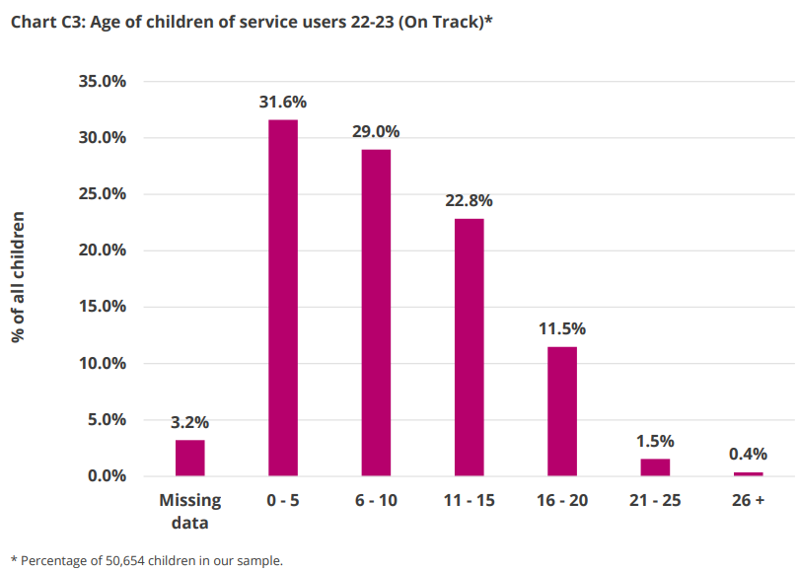We can therefore estimate that of the total number of children we estimate to have been affected by domestic abuse in the previous year, there could be 7,541 children aged 0-5 and 6,920 children aged 6-10, making pre-school and primary school aged children the most common age group of children whose non abusing parents make contact with a specialist domestic abuse service.

Further evidencing the prevalence of domestic abuse in the very early years, following a Freedom of Information Request sent to 39 police forces across England, the For Baby’s Sake Trust[12] found that;

* According to data from the ONS, an average of approximately 1,444,225 domestic abuse incidents are reported to the police annually in England, based on figures from 2021 to 2023.
* The For Baby’s Sake Trust’s FOI findings suggest that around 13% of these incidents during this period involve an infant being present, based on the rates across 15 police forces.
* This translates to an estimated 187,750 babies (aged 0 to 2) across England on average each year.

IDAS provide Sheffield’s community based commissioned domestic abuse service. In 2022/23 64% of all of those referred to IDAS by any means (helpline, self-referral, police referral etc) had at least one child. We can therefore estimate that this was at around 2,000 children whose non abusing parent was referred for support around domestic abuse during 2022/23

**Recommendation: Over the course of the strategy work with commissioned providers and partners, to ensure that all children of victim/survivors and perpetrators of abuse are recorded accurately to ensure more accurate prevalence estimates.**

The Sheffield Multi-Agency Risk Assessment Conference (MARAC) takes place approximately three times a calendar month. MARAC is a multi-agency meeting where agencies come together to share information and create safety plans for high risk (i.e. at risk of serious harm or death) victim/survivors and their dependants.

In 23/24, the MARAC data tells us that there are on average 1.14 affected children for each case heard at MARAC, so from a total of 1217 cases there were 1387 children harmed by (reported) high risk domestic abuse.

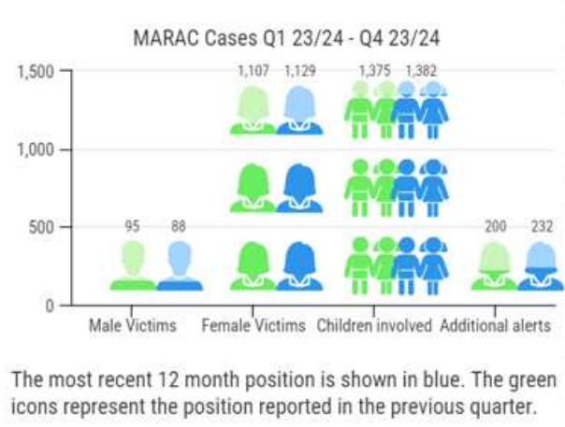

Using police data from July 2019 to June 2022, South Yorkshire Police created a Domestic Abuse Profile document[13].

Where a child was in the household at the time of the incident reported to SYP, the breakdown of the type of domestic abuse reported is as follows,

* 32% were stalking and harassment
* 26% were violence without injury
* 21% were violence with injury

The Profile also notes that the overall volume of domestic abuse offences with children registered in households increased by 15% over a three-year period

Of the total number of children who were registered as living in households, 7% were under one year old. Police analysis notes that this could be as a result of the domestic abuse either starting or worsening during pregnancy.

Recommendation: Given the high prevalence of stalking and harassment offences noted by SYP, DACT to work with partners to gather data to better understand the prevalence of post separation abuse and its impact on children and young people.

**5.3 Young people’s experience of domestic abuse and harmful behaviour happening in relationships where the young people are under 16**

In 2022, Sheffield introduced the Young Persons DASH risk assessment (YP DASH) to better support professionals to identify abuse and to understand more about the impact of domestic abuse and harmful behaviour on those aged 13 – 18. This includes young people experiencing abuse from an intimate partner and also abuse perpetrated by a family member.

Anecdotally, this has worked well. However, it has not been possible to quantify the numbers of YP DASHs completed and connect this with, for example, the numbers of 16 & 17 year olds heard at MARAC or 13s and over referred to Sheffield Children’s Social Care as a result of their own experience of domestic abuse.

Recommendation: Work with partners and providers to gather data on numbers of Young Person’s DASH risk assessments being completed, complete risk level and referral source.

4% of victims/survivors in the dataset analysed within the South Yorkshire Police Domestic Abuse Profile were aged 13-17, with the most common age being 17 and 16. The vast majority of young people who reported domestic abuse to South Yorkshire Police were female (77%).

The following illustrates the demographic difference between young victims/survivors aged 13-17 and adult victims/survivors

An infographic from SYP showing victim demographics of young victims 


The diagram illustrates that a significant proportion (25%) of young victims/survivors were experiencing abuse from their parent/carer, this is much higher than in the general population.

**Recommendation: ensure that existing pathways to support young people experiencing domestic abuse perpetrated by a family member (including parent/carer) are promoted/strengthened/refreshed. Promote the use of the young person’s DASH risk assessment in the context of adult family violence.**

South Yorkshire Police analysis also considered the demographics of those causing harm to young victims/survivors and compared them to the suspect demographic of the general population. It is notable that the largest number of those causing harm to young victims /survivors were themselves young (14-19) and although data on vulnerability was not well recorded, in cases where it was noted the most common themes were mental health, learning disability and Autism. This is in comparison to the suspects causing harm to adults where the vulnerabilities that were noted were most commonly mental health, substance misuse and alcohol dependence.

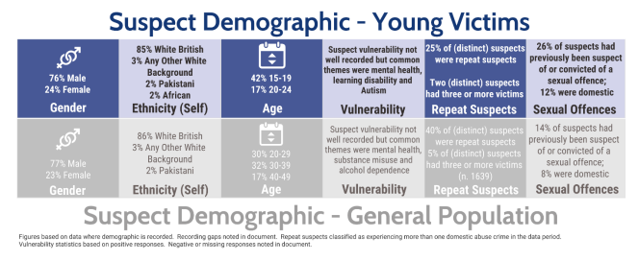

**Recommendation: Work with partners to ensure that behaviour change interventions for young people are appropriate and accessible for those with alternative learning needs.**

**5.4**  **16- & 17-year-olds and MARAC**

Despite SYP data taking into consideration those aged 13 and over in the Domestic Abuse Profile, the legal definition of domestic abuse includes all those aged 16 and over. Therefore, there are some victims/survivors of domestic abuse in Sheffield who are legally classed as children and young people but who can access some services commissioned for adults and be supported by the same processes (i.e. MARAC) as adults.

As mentioned above, it has not been possible to collect the numbers of YP DASHs received into commissioned domestic abuse support services or to the Sheffield Children’s Safeguarding Hub (SSH) but we can record numbers of 16/17 year old victim/survivors heard at MARAC.

In Q3 23/24 (below) 1.7% of total referrals to MARAC were for victim/survivors who were 16/17 at point of referral; this amounts to 5 out of 291 cases in the quarter. The highest proportion it has ever been in the chart below is approximately 3.2% of total referrals, thus giving us an indication that improvements need to be made, both in the identification of domestic abuse (of any ‘type’) in this cohort, but also in the promotion and effective use of the YP DASH.

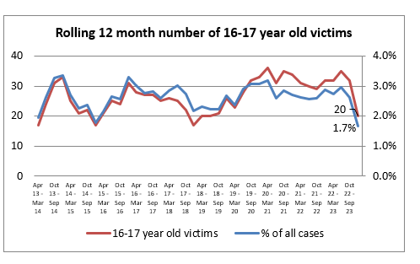

The low numbers of 16- & 17-year-old victim/survivors heard at MARAC are also reflected in those accessing the community based domestic abuse support service with just 37 16/17 year old victim/survivors supported via one to one casework by IDAS in 2023/24. Whilst this is an increase from 2022/23 where 28 young people accessed one to one support it does not appear to be a realistic figure with which to estimate prevalence.

The graph below illustrates the numbers of 16/17 year-old perpetrators who have been heard at MARAC over a five year period, and whilst there has been some progress made it is clear that along with identifying those at risk of harm aged 16/17, the numbers are low and suggest that work around the identification of young perpetrators of domestic abuse needs to progress.

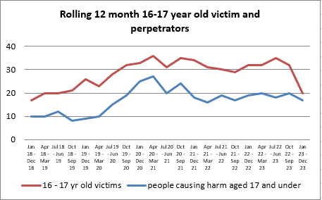

Recommendation: Work with education, social care, youth services to make identification, assessment and support to 16 and 17 year old victims/survivors of domestic abuse a priority for the strategy.

**5.5** **Adult Family Violence and Children**

Domestic abuse takes place within intimate partner relationships but also within the family. This is known as Adult Family Violence (AFV) and is sometimes missed or misunderstood. For a child to be considered as a victim of domestic abuse they need to be personally connected to either the victim or the perpetrator.

This is illustrated in the chart below, taken from a Sheffield City Council Housing training package. Should there be domestic abuse happening with any of the family members in the diagram, under the DA Act Legislation the child is now considered a victim of the abuse too. We do not currently have any relevant prevalence data on children affected by AFV.

A diagram of a family tree
showing that all relatives of person B would meet the definition of AFV

**Recommendation: During the course of the strategy, we will work with partners to increase awareness of and gather more reliable prevalence data on AFV and children.**

**5.6 Harmful Cultural Practices and Children**

There is no statutory definition of HBA or a specific offence of HBA though it is recognised in legislation as a specific ‘type’ of domestic abuse. The Crown Prosecution Service[14] describes it as

‘A collection of practices which are used to control behaviour within families or other social groups to protect perceived cultural and religious beliefs and/or honour. Such abuse can occur when perpetrators perceive that that a relative has shamed the family and/or community by breaking their code of honour.’

HBA includes practices that are perpetrated on victims/survivors for cultural motives and have harmful and very long-term consequences as families often feel a sense of shame long after the incident of so called ‘dishonour’ has passed. Examples of HBA include, forced marriage (FM), Female Genital Mutilation (FGM) and Virginity Testing.

Children who experience HBA are at risk of significant harm through physical, sexual, psychological, emotional harm and neglect. There is also a risk of children being taken abroad for a forced marriage, or, as a punishment for perceived dishonourable behaviour. In some cases they are also at risk of being killed.

It is difficult to make an accurate prevalence estimate of the numbers of children affected by HBA, in part due to the fact that there are often multiple perpetrators in these cases. The legislation in the domestic abuse act sets out clearly that children are considered to be victims of domestic abuse if it is happening in their families and if there are multiple perpetrators of one victim, there could be many children affected in each case. HBA is also unreported and so any prevalence estimates made need to be treated with caution.

In 2022/2023 out of a total of 1,217 cases that were heard at MARAC, there were 70 HBA cases equating to 6% of all MARAC cases in the year. If we are to apply the estimate that for every case heard at MARAC where there are 1.14 children affected for each case heard then we can very conservatively estimate that there were approximately 80 children in Sheffield who were harmed by high risk HBA in 2022/23. In the following year there was an increase in the number of HBA cases that were referred to MARAC, with 78 referrals and 4 withdrawals so 74 cases were heard. This equates to 84 children affected in 23/24.

**Recommendation: During the course of the strategy, work closely with local by and for services to create a more robust data set to better understand the prevalence of HBA and harm caused to children.**

**5.7 Female Genital Mutilation (FGM)**

A person is guilty of committing Female Genital Mutilation (FGM) if they excise, infibulate or otherwise mutilate the whole or any part of a girl or young woman’s labia majora, labia minora or clitoris32. FGM is a crime, and it is child abuse.  It is illegal in the UK under The FGM Act (2003)33 which made it illegal for UK citizens of permanent residence to take a child from the UK abroad for FGM, even to a country where the practice is legal. These offences carry up to a maximum of a 14-year maximum prison sentence. FGM is also covered under the Serious Crime Act 201534 to extend protection to victims so that FGM acts carried out outside of the UK by a UK national or resident in the UK, or acts carried out on a UK national or resident in the UK, are prohibited.

SCSP’s webpage on FGM notes that[15]

‘…(FGM is) mainly carried out on girls between the ages of five and ten. In some countries it is practised on babies as young as two or three days old and in other areas, it is practised prior to marriage or as part of the wedding rituals’

The first UK conviction for FGM took place on 1st February 2019, the perpetrator was sentenced to 11 years in prison35.

The Health & Social Care Information Centre (HSCIC) releases experimental statistics36 for FGM. In 2022/23 there were 5,870 women and girls who had a healthcare attendance where FGM was identified, this was higher than the previous year but remains lower than in 2019/20 before pressure on NHS services increased because of coronavirus.

Forward UK37 estimate that 137,000 women in the UK are living with the consequences of FGM.

Commissioned adult domestic abuse services can provide support to individuals over the age of 16 when FGM is an issue in the family and adult sexual violence services can provide support to those who are an adult survivor of FGM. However, in 2022/23 no one who accessed the domestic abuse service was recorded to be at risk of FGM. Data from the sexual violence service does not capture the number of people they supported who had experienced FGM, this should be improved so that we can get a better understanding of the local need and requirements.

In Sheffield, a Task and Finish Group led by the NHS Integrated Care Board is working to develop a citywide FGM strategy [16]. This is still in development and not yet published. The FGM Strategy sets out how communities and agencies in Sheffield will work together to safeguard children and support adults from the abuses associated with FGM.

According to National NHS data[17]

* There were 2,090 individual1 women and girls who had an attendance where FGM was identified in the period January 2024 - March 2024. These accounted for 3,900 attendances reported at NHS trusts and GP practices where FGM was identified.
* There were 945 newly recorded women and girls in the period January 2024 - March 2024. Newly recorded means that this is the first time they have appeared in this dataset. It does not indicate how recently their FGM was undertaken, nor does it mean that this is the woman or girl’s first attendance for FGM. The number of newly recorded women and girls has reduced over time. This is to be expected as the longer the collection continues, the greater the chance of a woman or girl having been recorded in it previously.
* Since April 2015, 37,525 individual women and girls had an attendance where FGM was identified.
* In the period January 2024 - March 2024, 93 NHS trusts and 26 GP practices submitted one or more FGM attendance records.

In Sheffield, the number of women being identified during the antenatal period has having previously undergone FGM has remained relatively stable since 2020, with an average of 175 women every year for the past three years.

National NHS data[18] also tells us the following information about the characteristics of those who have undergone FGM.

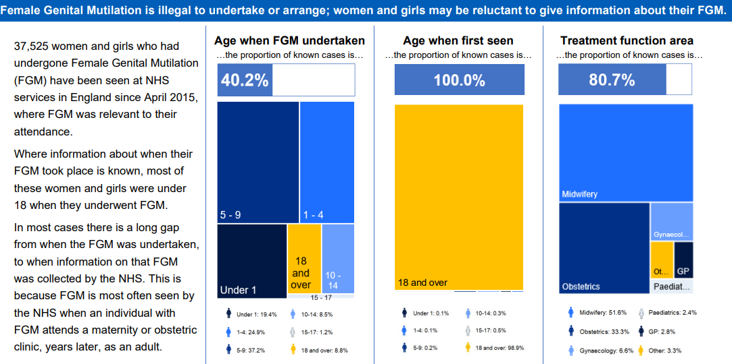In Sheffield there is a monthly FGM panel meeting. This is a children’s safeguarding process where cases are brought to discuss and create multi-agency safety plans to safeguard girls who may be at risk of undergoing FGM. There are approximately 15 new cases that are discussed at this panel meeting every month, with the majority being identified via midwifery teams. However, it is likely that there will be additional cases that are identified via gynaecology services where the affected woman is over 18 and therefore, will not come to the attention of children’s services (other than in the ante-natal period).

A key partner on this panel, South Yorkshire Police take a highly proactive approach to FGM and, as of March 2024, the following FGM Protection Orders were in place.

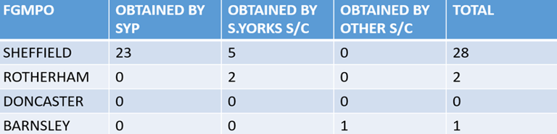

**5.8 Virginity Testing**

The Health and Care Act 2022[19] made it illegal to carry out, offer or aid and abet virginity testing or hymenoplasty in any part of the UK. Since this time, South Yorkshire Police have not recorded this as a crime in relation to any child.

**5.9** **Child Marriage**

On the 27th February 2023, legislation[20] was enacted banning any marriage of a 16 or 17 year old even with parental consent as the legal age to marry rose to 18. It is now a criminal offence to exploit vulnerable children by arranging for them to marry, under any circumstances whether force is used or not.

The Karma Nirvana Child Marriage Factsheet[21] notes that from calls to their national child marriage helpline between 2020 and 2022 there were,

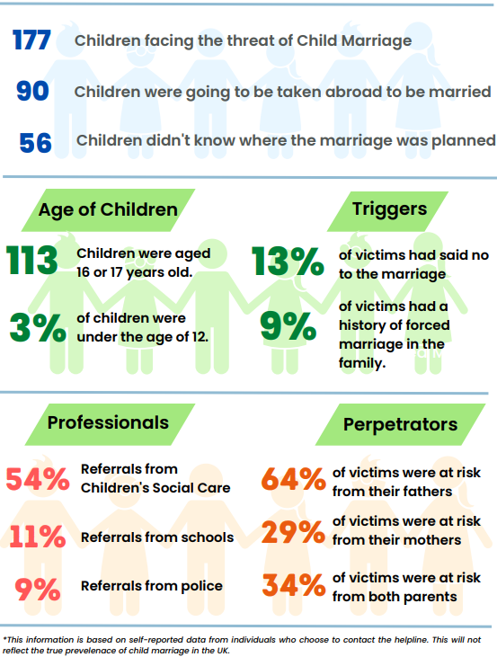

More recently, in July 2024, plans have been announced in the King’s Speech[22] for the government to set out in their Education Bill the introduction of a national register for school children, with which to monitor school absenteeism and which will require local councils to maintain a register of all children who are not attending school. It is thought that this will support the early identification and intervention for those children who are withdrawn from school and who are at risk of child (forced) marriage.

**5.10 Children, Post Separation Abuse and the Family Court**

As stated in the introduction to this section of the needs assessment, it is very difficult to quantify the scale of post-separation abuse and make an accurate prevalence estimate. Anecdotal evidence gathered from survivors of domestic abuse tells us that the harm caused by post separation abuse is often overlooked and misunderstood and that their children continue to be harmed by perpetrators’ patterns of behaviour post separation, sometimes for many years and often in the Family Court arena, where domestic abuse is noted as a factor in over 60% of cases heard in Family Court involving child contact.[23]

IDAS[24] are an independent charity across Yorkshire with services in Sheffield, Barnsley, Doncaster and North Yorkshire. They have established a standalone website aimed at domestic abuse survivors who are going through family court processes. The website includes information about protective orders, child contact arrangement and what to expect during the court hearings, including how to attend safely etc.

* Each month, 6800 people visit the family court website and during the last 6 months. 7301 individual users visited the family court website to learn more about non-molestation orders and 4023 people visited the site to learn more about the first hearing at family court for child arrangement proceedings.
* Following meetings with the management team at Sheffield combined court, IDAS have agreed processes for the successful implementation of PD27c[25] improving the support IDVAs can provide their clients at court.
* Domestic abuse best practice training has been provided by IDAS to court staff, including Magistrates, ushers, security and CAFCASS. 83% of those trained said the training was ‘outstanding’ with 100% of attendees reporting increased knowledge of domestic abuse, applicable to their roles within the family court, that will enhance the experience and safeguarding of survivors.

Using funding from the Ministry of Justice, via the South Yorkshire Mayoral Office (formerly the Office of Police and Crime Commissioner), IDAS have specialist court IDVAs working in the Sheffield Family Court,

* 95% of people exiting the Family Court IDVA (Independent Domestic Violence Advisor) service felt in control of the situation and able to deal with their problems.
* The largest area of support is for clients with ongoing proceedings for child arrangement orders, followed by injunctions, civil protection orders such as non-molestation orders. Survivors typically need help to submit initial applications to court, referrals can be made any stage throughout the process, prior to a hearing or following a CAFCASS safeguarding letter or Section 7 Report
* In Q1 2024/25 there were 28 domestic abuse survivors in Sheffield supported by a specialist Family Court IDVA who, between them, had a total of 48 children.
* The most commonly identified needs for these clients were economic needs, with 12 clients seeking additional support around debt and money management or accessing benefits.
* 50% (14/28) of those supported by the Family Court IDVA also had an identified housing need.
* 80% of those supported had needs relating to safety, either their own or that of their children.

**Recommendation: During the course of the next strategy, improve data collection on post- separation abuse and the continued harm to children, using the data to support better identification and to demonstrate the necessity for specialist support for survivors and their children, and to evidence the need for further training for specialist organisations such as CAFCASS.**

**5.11 Child & Adolescent to Parent Violence and Abuse (CAPVA)**

At the time of writing, there is no current legal definition of Child and Adolescent to Parent Violence and Abuse (CAPVA). This causes challenges when estimating prevalence. For example, when it is reported, the recording is inconsistent across agencies and services. What a social worker considers to be CAPVA may not be understood as such by the police and so on. It is anticipated that a government consultation[26] that took place in late 2023 will result in an agreed definition in the near future. In the meantime, Respect[27] defines CAPVA as,

‘..the dynamic where a young person (8-18 years) engages in repeated abusive behaviour towards a parent or adult carer. Abusive behaviour can include physical violence; emotional, economic or sexual abuse; and coercive control. It may also include damage to property and abuse toward other family members, particularly siblings.’

Whilst it is not possible to draw a direct link between a child or young person’s own experience as a victim of domestic abuse (i.e. it is either happening or has happened at some point in their lives), there is a correlation which is illustrated in this ecological model below which explores some of the reasons why CAPVA happens.

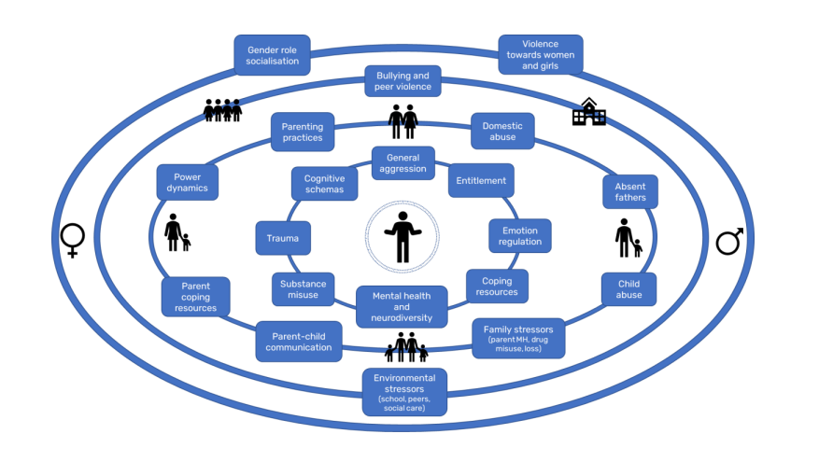

A literature review[28] undertaken at the request of the National Domestic Abuse Commissioner noted that CAPVA is becoming more widely recognised in the UK and internationally as a ‘growing social problem’. However, high quality research into the prevalence and incidence of CAPVA is lacking, with existing studies producing wildly varying estimates. Such diversity is due to variation in how CAPVA is defined and measured – with studies that include one-off incidents or behaviour typical of adolescence producing inflated estimates. Population and community survey studies in the US, Canada, UK and Spain indicate that more serious physical violence towards parents is likely to sit somewhere between 3 and 5% with multidimensional definitions including patterned physical and psychological aggression sitting around 10%. However, in the UK there is currently no population-level data on CAPVA, meaning there is little understanding of how prevalent it is in the general population in the UK.

However, if we are to use the estimates above and the most recent Census Data[29] (2021), we can estimate that CAPVA could be happening in somewhere between 1,888 and 6,296 households in Sheffield.

Additionally, research[30] undertaken by London’s Violence Reduction Unit in 2022 found that,

* 40% of those experiencing CAPVA refuse to report it.
* The majority of CAPVA cases involve boys in late adolescence and their mothers, and it is most likely to be physical violence.
* Parents/carers interviewed said they only contacted the police at crisis points when they felt they had no other choice and were afraid for their physical safety.
* All parents/carers affected said they had experienced multiple incidents of violence before reaching crisis point.

In order to better understand the scale of the issues, a comprehensive needs assessment of CAPVA in London[31] in 2022 suggested the following as a means of estimating prevalence,

* Analysis of existing police (or CJS) data (for example, of reported incidents, arrests or convictions).
* The analysis of existing data from service users (such as families engaged with CAPVA intervention programmes).
* Community surveys with parents and/or young people about their experiences of perpetration/victimisation.
* Estimate prevalence though surveys using large and representative samples, such as CSEW.

We know that the injuries caused by to victims/survivors CAPVA can be severe. In 2023/24 Sheffield Teaching Hospital’s Emergency Department saw 226 parents where domestic abuse was the initial presenting factor that brought them to ED. Amongst these parents, 10 were attending ED as a result of CAPVA.

**Recommendation: Once the statutory definition for CAPVA is agreed, work with partners to gather more reliable prevalence data.**

South Yorkshire wide police information states that most CAPVA incidents stemmed from domestic arguments between victims and suspects, and that the most common reported type of CAPVA is physical assault. Police information also suggests that there is an increase in CAPVA during weekends and school holidays where children are more likely to spend time with their families. Police information (below) also notes the potential links between a family history of domestic abuse and the child or young person then behaving harmfully themselves.

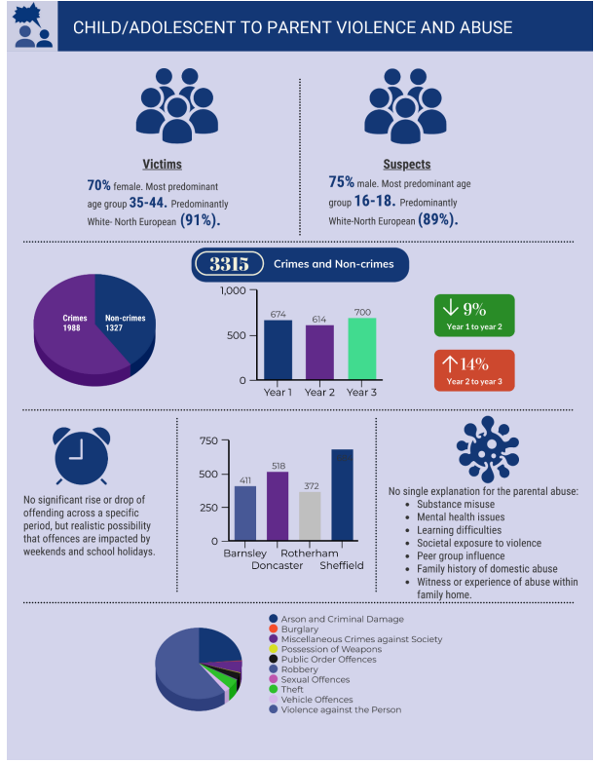

**Level Up**

Alongside the Inspire to Change Domestic Abuse Perpetrator Programme [32] Cranstoun also are commissioned on a county wide basis to deliver a programme called ‘Level Up’. The current commission started on in February 2022 and ends in December 2024. This dh

Since the programme started in early 2022 to the end of September there were,

* 124 young people referred to service in total.
* 33 of those referrals were from Sheffield, all of which related to CAPVA.
* 15 referrals from Children’s Social Care, 7 from Education and 11 from other sources (including 2 from South Yorkshire Police).
* Ages spread across full range with 13 & 15 year olds slightly higher.

**Sheffield Child and Adolescent Mental Health Services (CAMHS) and CAPVA**

The increase in harm caused by CAPVA in Sheffield has been noted specifically within the CAMHS service, who have reported a significant rise in the number of referrals they have made to Sheffield Children’s Social Care with concerns around CAPVA. From 1st April 2023 to 13th February 2024 CAMHS practitioners have made a total of 102 referrals to Children’s Social Care, for either physical, sexual, emotional abuse, neglect, and/or CAPVA.

Of the 102 referrals, 16 cases were due to CAPVA, equating to 15% of all referrals. Whilst this figure represents an increase, it is also noted that not all CAPVA cases referred to social care capture the actual number of CAPVA that CAMHS practitioners see as many of these cases are significantly underreported. Therefore, the cases which are referred to Children’s Social Care have generally reached crisis point, whereby there is risk of family breakdown due to the extent of abuse evident.

From the 1st January to 31st March 2024, Quarter 4, CAMHS practitioners have made a total of 30 referrals to Children’s Social Care. Of these referrals, a total of 13 were referred due to concerns regarding Domestic Abuse & CAPVA, so 43% of referrals in the quarter. 6 due to concerns around domestic abuse affecting the child and 7 where the child or young person was using CAPVA.

**Recommendation: DACT continue to commission specialist young person’s behaviour change intervention.**

**5.12 Child Death Adverse Childhood Experiences ACE’s Thematic review 2023**

Adverse Childhood Experiences were initially identified following a study undertaken in 1995 by the Centre for Disease Control under Harvard University[33] which found that the following ten ACEs can lead to a ‘Toxic Stress’ response, which then can harm a child’s development, both physically and emotionally and have a significant and long-lasting negative impact on a child’s life, including well into adulthood.

* Physical abuse/ neglect
* Sexual abuse
* Emotional abuse/ neglect
* Mental illness
* Divorce
* Substance abuse
* Alcohol abuse
* Violence against mother (Domestic Abuse)
* Having a relative who has been sent to jail or prison.

A thematic review on ACEs and child deaths was written for the South Yorkshire Child Death Overview Panel by Nichola Kelly (Deputy Designated Nurse for Safeguarding Children, South Yorkshire Integrated Care Board, Sheffield Place.) The information within this report was taken from the National Child Mortality Database[34]. The findings from Child Death Adverse Childhood Experiences ACE’s Thematic review 2023 were based upon all children 0-18 years who lived in Sheffield and died between1st April 2021 and 31st March 2022.

During this time period, in Sheffield, there were 49 child deaths, 33 (67%) were expected deaths and 16 (33%) children died unexpectedly. It is important to note that, although there were ACE’s identified by professionals during the child’s life, they were not necessarily attributed to the child’s death.

The thematic review is included in this needs assessment as it found that out of the 10 ACEs above, the second most common ACE was children’s experience of domestic abuse. 15 out of 49 of those children who died (31%) who were known to have experienced domestic abuse.

The prevalence estimate of the Sheffield population as a whole is that in the past year there were 18,358 adult victim/survivors out of a total population of 556,500, so approximately 3.2% of the population, thus it is notably higher in this small cohort.

It is also worth noting that the other two most common ACEs identified in this thematic review were living with someone with a mental health illness (28/49 so 57%) and living with someone who misused substances and/or alcohol (14/49 so 29%). In conclusion, the review noted that

*‘The 3 most common ACEs within this sample are also concerns behind the Trilogy of Risk. Although most of the child deaths within this thematic review were not safeguarding related concerns, some of the deaths could be attributed to well evidenced risks within the Trilogy of Risk including, Foetal Alcohol Syndrome Disorder, birth defects, premature births, and safe sleeping environments. This information provides further evidence to support the priorities addressed within various work plans, and strategies across the City under Hidden Harm’*.

Recommendation: DACT to support on the development of the city’s new Hidden Harm Strategy and on the development of a citywide response to trauma-informed working.

**5.13** **Sheffield Children’s Services data (Children’s Social Care and Family Intervention Service)**

In 2023, through collaboration between partner agencies, including the Sheffield Children and Young People as Victims of Domestic Abuse Group, Sheffield’s Thresholds of Need[35] document was updated. Children’s legal status as victims of domestic abuse is woven throughout the document with domestic abuse most commonly an issue needing either targeted (Level 3) or statutory support (Level 4).

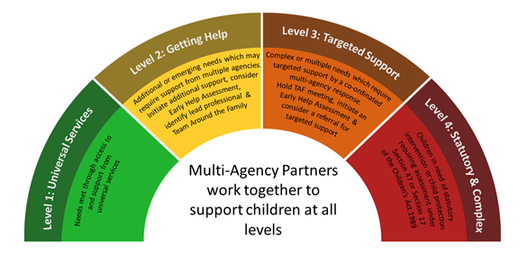

Children’s Social Care data tells us that, in Sheffield, harm caused by domestic abuse is one of the most common reasons that children come to the attention of statutory services (Level 4).

In 2022/23

* 32% of all single assessments started with domestic abuse as an issue
* 39% of all children with a Chid in Need plan (CIN) had Domestic Abuse recorded as an issue
* 26% of all contact that was made with the Sheffield Safeguarding Hub (SSH) was in relation to domestic abuse
* 58% of all Initial Child Protection Conferences (ICPCs) had domestic abuse recorded as an issue
* 59% (818) of all child protection plans had domestic abuse recorded as an issue
* 43% of all children who were classed as looked after by the Local Authority (LAC) were victims of domestic abuse
* Of all the Section 47 Assessments (Child Protection Enquiries) 47% were in relation to domestic abuse
* There were 1362 children who were discussed in a Strategy Meeting in 22/23 as a result of domestic abuse, equating to 41% of the total number
* 22% of all children allocated to the Amber Team had domestic abuse recorded as an issue
* 17% of cases open to the Family Intervention Service in Early Help (FIS) had domestic abuse recorded as an issue.

This data tells us that domestic abuse is most often identified when the risk has escalated to crisis, i.e. child protection. This is some way encouraging as it demonstrates that the relevant referrals are being made at times when risk to children is highest. However, it also suggests that opportunities to intervene and support at an earlier stage are potentially being overlooked.

**Recommendation: Continue to build Social Worker’s understanding and knowledge about domestic abuse, using the Safe and Together model.**

**Recommendation: Ensure that all social workers have accessed DASH training/consider making DASH training mandatory for all children's social workers.**

Early Help and Support for children in Sheffield is a wide ranging and broad offer and includes support for children in the early years, the Family Hub network, attendance and inclusion at school, and the Family Intervention Service (FIS) amongst others. We know that domestic abuse does not start at the point where children need statutory intervention and using the prevalence estimates above it is very likely that Early Help Services are working with a higher proportion of children and families experiencing domestic abuse than is evident in the data. It is also important to note that there have been potential recording issues identified by senior managers in Early Help and therefore, the very low proportion of cases with domestic abuse identified in the data above needs to be treated with a level of caution.

**Recommendation: Continue to develop knowledge and understanding about domestic abuse across all Early Help. In year one of the strategy, work with FIS managers to undertake a skills/competencies audit around domestic abuse in FIS.**

**Recommendation: Ensure that all FIS workers have accessed DASH training/consider making DASH risk assessment training mandatory for all FIS workers.**

**5.14** **The Strengthening Families Team and the Safe and Together Model**

The Strengthening Families Team are a small specialist domestic abuse team who work primarily in Sheffield Children’s social care to embed the Safe and Together model into practice, offering case consultations, brief interventions, and a range of training options to the Sheffield Children’s workforce. The model was introduced in 2020, at the height of the Covid-19 pandemic in response to increased concerns about domestic abuse and lockdown and also as a means for the Strengthening Families Team to upscale the positive impact that was clear from a small cohort of cases that had been worked intensively.

The Safe and Together[36] is a child centred model which aims to shift the culture and practice of the children’s workforce, to partner better with survivors and intervene more effectively with perpetrators of abuse in a family context, ultimately leading to better outcomes for children.

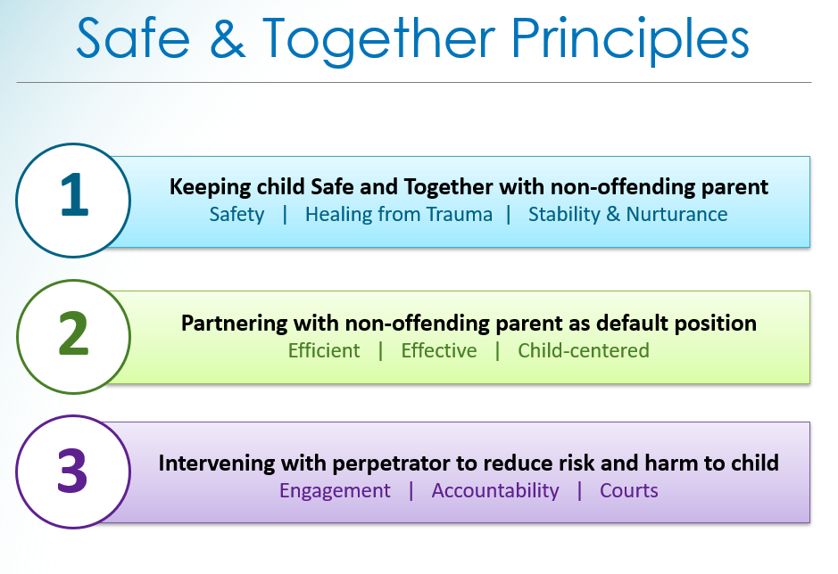

Since 2021, the Strengthening Families Team have trained 309 social workers, Senior Fieldwork Managers, Child Protection Co-ordinators etc in the 4 day CORE Safe and Together model and the team continue to roll out this training across the Sheffield children’s workforce. Those trained in the model have shared the following feedback;

*‘I now recognise that it is not the survivor’s behaviours (causing harm) but the perpetrator… I have been guilty of using phrases like ‘failed to protect’ before and that is wrong..’ (social worker)*

*‘What I have observed is that it radically changing the way cases are approached and encourages social workers to be more trauma informed and understand the impact of domestic abuse on children. It is helping us move away from an incident based model to understand patterns of behaviour. It supports realistic assessments of risk and harm and is empowering for survivors’ (social worker)*

One survivor offered her feedback on the model during a groupwork session;

*‘The mum said she could not thank social worker enough for her support, encouragement and understanding. Mum cried and said she was not crying out of sadness but out of relief as she was so grateful for the support and really felt empowered by social worker’s words. Mum couldn’t believe social worker called her a ‘survivor’ as up to that point she felt like a victim. This really struck a chord with mum and said she feels even more motivated toy continue moving forward without her abusive partner’.*

Whilst this feedback is hugely encouraging, there is still work to do to evaluate the effectiveness of the model during the course of the next strategy,

**Recommendation: Continue to develop and embed the Safe and Together model into all children’s services, with a continued offer to Social Care along with a focus on Early Help services and an offer to partners, such as health and third sector organisations.**

**Recommendation: Continue to investigate ways in which to gather data to evaluate the effectiveness of the model (for example, numbers of re-referrals to social care due to domestic abuse, numbers of children becoming looked after as a result of domestic abuse etc)**

The Strengthening Families team also deliver groupwork programmes. You and Me, Mum is a 10-week parenting programme for mothers who have experienced domestic abuse. The programme supports mothers, using a strength-based approach, to understand how the perpetrator’s pattern of behaviour and coercive control has affected their parenting and offers them ways to help their children to recover from their experience of abuse.

You and Me, Mum is offered 4 times per calendar year, and on average, approximately 7 mothers complete each programme. This programme is open to anyone across the city, from mothers whose children have been removed into local authority care to a mother who self refers.

In a recent group there were 5 mothers who were attending , between them they had 12 children. So, we can estimate that there are approximately 2.4 children helped per mother on the programme, therefore approximately 60 children helped by You and Me, Mum per calendar year.

Caring Dads is a 17 week long parenting intervention specifically for fathers who have behaved abusively towards their children’s mothers and who acknowledge their behaviour and demonstrate some motivation to change. The programme uses CBT (Cognitive Behavioural Therapy) techniques and is intended to move fathers from parent centred/abusive behaviour towards being more child centred in their parenting choices. This is a complex programme and requires ongoing involvement from the referrer (currently Children’s Social Care) and support for survivors whilst perpetrators are engaging.

Caring Dads is offered 3 times per calendar year and, on average, there are similar numbers of fathers who engage with the programme, around 7. Though fewer fathers will complete the entire programme. In a recent group, there were 7 fathers attending with a total of 24 children, so on average 3.4 children are helped per father on the programme. Therefore, approximately 71 children helped by Caring Dads per calendar year.

**Recommendation: Continue to develop and promote the Caring Dads programme across children’s services, including with specially trained staff in Early Help services with a view to intervene at the earliest opportunity.**

**5.15** **Domestic abuse and Education**

Experiencing domestic abuse as a child is well recognised as an Adverse Childhood Experience. As with other ACES, domestic abuse can have a significant impact on a child’s educational potential. This can look very different for individual children with some children not attending school due to fear for their non-abusing parent’s safety[37], children who experience a trauma response in school which is seen as challenging behaviour and not as a response to domestic abuse, and sometimes children who achieve very highly in school, potentially with a view to escape themselves and to support their non abusing parent to escape too.

There is also a link to children who are victims/survivors of domestic abuse and school exclusions. In Sheffield, where a child is at risk of exclusion (either fixed term or permanent), they can be referred to the Primary or Secondary Inclusion Panels (PIP and SIP respectively). This is a multi-agency meeting where children’s needs are discussed, and plans made with the aim of keeping them in school.

Since the start of the PIP and SIP panels in 2017/2018;

* There have been 752 children referred to PIP and 397 children referred to SIP, so 1,149 in total.
* 269 out of 752 (36%) primary aged children referred to the panel have domestic abuse recorded as an ACE, so 36%.
* 140 secondary aged children out of a total of 397 (35%) have domestic abuse recorded as an ACE

Recommendation: Given the link between domestic abuse and children at risk of exclusion, ensure that there is a continued Safe and Together offer for the Attendance and Inclusion Service, along with continued efforts to establish a network of domestic abuse champions within school settings.

Operation Encompass[38] has been in place in South Yorkshire for over 5 years. This is a police process supported by the Sheffield Safeguarding Hub to inform schools when the police have attended an incident of domestic abuse, where domestic abuse incidents have occurred in the homes of their pupils since the previous school day.

The purpose of the information sharing is to ensure schools have more information to support the safeguarding of children. By knowing that the child has had this experience, the school is in a better position to understand and be supportive of the child's needs and possible behaviours. Operation Encompass works alongside (not instead of) safeguarding procedures, and the notification relates to **ALL** domestic abuse incidents. Whereas children’s social services only intervene in the most serious cases, Operation Encompass enables every child to receive support, regardless of whether the incident has been recorded as a crime or not.

Nationally, the Operation Encompass Impact Report 2023/24[39] and written evidence provided to the Home Office Committee Enquiry[40] found that (following a FOI (Freedom of Information) made by the BBC, responded to by 27 forces) in a 145-school day period the police made 143,000 Operation Encompass notifications to schools.

Locally, in an 8-month period between July 2023 and February 2024 Sheffield Schools received 1740 Encompass notifications.

This is, on average, 217 notifications per calendar month. The highest number of notifications received by a school in this time period was 41. There were 26 schools who received over 20 notifications and there were a number of schools (13) who did not receive any notifications.

Recommendation: Consider an audit of the numbers of Designated Safeguarding Leads who have completed the ‘Key-Adult’ training about how to respond effectively to Encompass notifications and review training materials to ensure content remains helpful and appropriate.

Recommendation: Work with Education Safeguarding Advisors to ensure that DSLs in the most frequently notified schools have accessed domestic abuse training.

**5.15 Specialist Domestic Abuse Commissioned Services – Demand and Capacity**

Sheffield City Council commission specialist support for children and young people affected by domestic abuse. Services are also commissioned by the SYMCA (South Yorkshire Mayoral Combined Authority)[41] (formerly OPCC) and there are yearly rounds of grant funding available via the South Yorkshire Violence Reduction Unit[42].

The impact of domestic abuse on children is sometimes difficult to identify and so it is difficult to articulate accurately the demand placed on services in Sheffield. For example, Sheffield Young Carers Project[43] tell us that children's who are victims/survivors of domestic abuse are at an increased risk of becoming young carers. For example, when the adult victim/survivor experiences mental ill health as a consequence of domestic abuse.

During 2023/2024, there were 25 children and young people supported by the Sheffield Young Carer’s project where domestic abuse was recorded as an issue, this represented approximately 12% of the total number of children and young people referred. It is notable that this information often came to light during the support period rather than on the referral form, therefore illustrating that sometimes the impact of domestic abuse, especially when it is perceived as ‘historic’, is not always identified by those working with children and young people.

In 2023, in response to the change in legislation[44] referenced throughout this document and to better understand the current picture, the national Domestic Abuse Commissioner requested information from all commissioning bodies about the specialist services supporting children and young people in their area. Sheffield submitted a joint response on behalf of the Safer Sheffield Partnership (formerly the Community Safety Partnership) which found that in 23/24;

* Sheffield city council (via the DACT) have 7 commissioned providers supporting children and young people affected by domestic abuse (this includes specialist therapeutic support, IDVAS for 16-17 year olds, behaviour change interventions for 16-17 year old young people causing harm, specialist domestic abuse counselling, and specialist accommodation for young women).
* Where waiting times were able to be provided, this was anywhere between 3 days and 6 months

When the additional commissioning bodies’ information was added to the data, the following was found;

* There were 17 different services commissioned In 23/24. These were mostly short-term grants which all came to an end in March 2024. There were some longer contracts, which are all commissioned by Sheffield City Council.
* There are a range of services commissioned, including one to one support, counselling, healthy relationship group work, children’s hospital navigators and behaviour change interventions. The data did not include social care, education, health, childcare provision etc.
* Potentially up to 874 children helped this year by commissioned services– but the overall estimate is over 23,000 children affected in Sheffield.
* There are two DACT commissioned services only for children affected by domestic abuse (with no adult service) in Sheffield, Haven therapeutic support service and DA Counselling at Door 43. In 2022/23 Haven supported 158 children one to one, in 2023/24, this increased to 168. Door 43 DA Counsellors supported 55 children and young people in 2022/23, with a slight decrease to 48 children in 2023/24.
* There were good outcomes for children supported one to one but there is nowhere near enough capacity in the system and wait times can be very long.
* There was a common concerning theme with security of funding – no commissioner was able to say with confidence that funding was secure after the end date of the grant or contract. This was the same for every grant and contract that was reported.

Whilst this mapping activity did not take into account support via statutory or universal services, it is very clear from the data gathered that there is a significant gap in terms of the capacity of commissioned services to meet the demand in the city.

Recommendation: Given issues around capacity and demand in the city, a business case for more funding for DA support services for children and young people, including those in refuge and other domestic abuse safe accommodation to be written to coincide with the strategy launch.

Recommendation: During the course of the strategy, consider an annual refresh of the services mapping to enable gaps in provision to be identified and progress evidenced.

1. **National Children and Sexual Abuse and Exploitation (CSAE) Prevalence**

There is no source providing the current prevalence of child sexual abuse. The Crime Survey for England and Wales (CSEW)[45] provides the best available indicator by measuring the prevalence of adults who experienced sexual abuse before the age of 16 years. This includes sexual abuse perpetrated by adults or children. However, the CSEW provides an underestimate of child sexual abuse as abuse against 16- and 17-year-olds is not included. The most recent CSEW indicates that 7.5% of all adults aged 18 to 74 years experienced sexual abuse before the age of 16 .

A report published by the NSPCC in February 2024 estimates that 1 in 20 children have been sexually abused[46]. This estimate uses a large-scale study[47] (Radford, 2011) which asked children, rather than adults about their experience. The NSPCC still considers this as the best study to estimate prevalence as it represents the experience of children themselves.

Radford also found the following

* Girls are more likely to experience sexual abuse than boys.
* In 22/23 girls were also more likely than boys to be subject to child protection planning due to sexual abuse than boys.
* Older children are more likely to experience sexual abuse than younger children
* Over 90% of children who experience sexual abuse were abused by someone they know (these figures relate to contact sexual abuse and therefore, do not take into account children and young people who are harmed by online sexual abuse).

The Radford study also asked 1,761 young adults aged 18–24 about their experiences of abuse during childhood.

* 11.3% of young adults (17.8% of women and 5.1% of men) reported experiencing contact sexual abuse before the age of 18.
* 24.1% of 18- to 24- year-olds had experienced any form of sexual abuse, including non-contact abuse, by the age of 18.

Additionally, the Centre for Expertise on Child Sexual Abuse (CSA) found that in 2022/2023 children were the victims in 40% of all sexual offences, yet make up just 20% of the population in England and Wales.[48]

The Centre also reports that nationally, in 2022/2023, child protection plans for sexual abuse,

‘..*were at the lowest levels for 14 years, with 2,290 children supported through such plans. Furthermore, sexual abuse made up the lowest proportion of new child protection plans since records began; just 3.6% in 2022/23, in comparison with 23% in 1993/94…we conservatively estimate that half a million children will experience some form of sexual abuse every year in England and Wales. Ultimately, this means the gap between the number of children being sexually abused and the identification and response by statutory agencies remains far too wide’*

According to Home Office data in 2022/23 there were a total of 63,233 sexual offences recorded by police against children in England and Wales. This equates to over one third of all police-recorded sexual offences. This number is increasing[49].

This is made up of the following;

* Rape of a child under 13
* Rape of a child under 16
* Sexual assault of a child under 13
* Sexual activity involving a child under 16
* Sexual grooming
* Abuse of position of trust (offence against under 18s)
* Abuse of children through sexual exploitation (offence against under 18s)

Of the total number of offences, there were 12,111 child sexual offences that were flagged as ‘online crime’, which equates to 19% of all child sexual offences.

Recommendation: Work with partners to increase awareness of signs and indicators of childhood sexual abuse. Consider partnership communication campaigns around risk of, and harm caused by, online abuse.

It is important to note that many sexual offences that are committed against 16 and 17 year olds (including rape and sexual assault) are included in the sexual offences against adults data. Therefore, the above figure does not capture the entire picture of sexual offending against those aged under 18 in England and Wales.

Hackett’s overview of research and crime statistics[50] suggests that between one and two thirds of sexual abuse is committed by other children. The Centre of Child Sexual Abuse notes that whilst there is no accurate data to substantiate this claim, it is likely that under 18s are ‘responsible for a significant proportion’ of child sexual abuse.

The Website ‘Everyone’s Invited’[51] was established by activists as a space where children and young people could share their experience of sexual harassment, sexual assault and rape in education settings. They quote the following statistics to illustrate the scale of the issue nationally;

* 3 children are raped in school on every school day and in primary schools 3 sexual assaults are reported to police every day (Women and Equalities Select Committee report, 2016)
* 99.7% of Victim Focus UK’s sample of women (22,419) have been repeatedly subject to violence including assaults, harassment and rape (2021)
* 9/10 girls had received unsolicited images and subject to sexist name calling in school (Ofsted, 2019)

Awareness of child sexual exploitation (CSE) has increased in recent years following high profile cases, including in Rotherham. This led to changes in police recording and, according to the ONS, in 2021/22 the police recorded over 17,000 sexual exploitation crimes.[52] This is the most recent available recorded figure and it is important to note that data quality is variable across different force areas, though is expected to improve over time.

The National Policing Statement for VAWG (Violence Against Women & Girls), commissioned by the National Police Chiefs’ Council and College of Policing[53], published in July 2024 found a four-fold increase in Child Sexual Abuse and Exploitation (CSAE) from just over 20,000 to nearly 107,000 and that the first six months of 2023 saw peer on peer CSAE increase by 55.6% of cases compared to 40% of cases in the whole of the previous year.

The report also found the following;

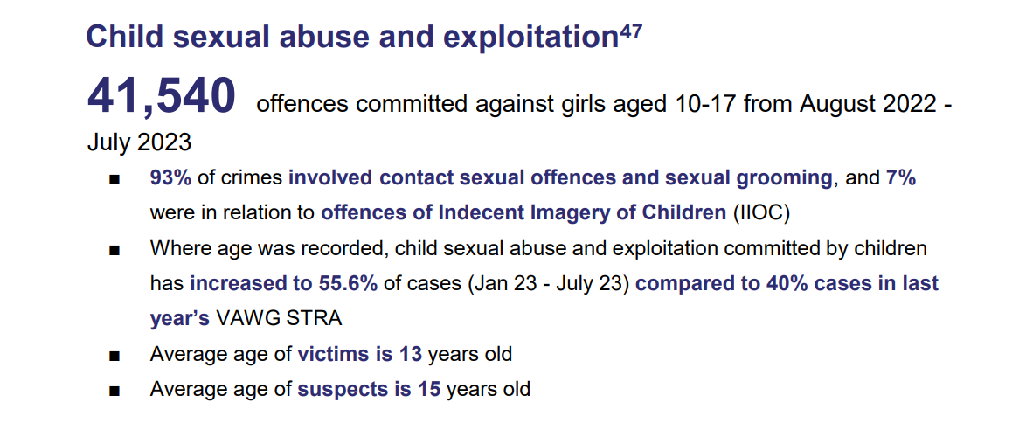

In terms of online abuse (or tech-enabled VAWG) the report found that;

*Evolving online harms are particularly prevalent among young people, likely due to higher social media usage and digital literacy. In 2022-23, the most common age of victims of online and tech-enabled VAWG was 10-15 years old. Refuge found that online abuse is twice as common among young women they surveyed, with 62% experiencing online abuse and 1 in 7 young female respondents have experienced threats to share their intimate images or videos. Girlguiding found a third of young female respondents aged 17 to 21 were harassed online in 2021[54]*

Recommendation: Ensure that training content regarding tech enabled VAWG/children and young people and domestic and/or sexual abuse keeps up to date with rapid developments in this sphere, i.e. the risks posed by more sophisticated Artificial Intelligence and cyber security and safety for children who are victims of online abuse and/or for children and young people who use harmful behaviour online.

The report also found that victims of VAWG are getting younger, in 2022 (where age was known) 52% of CSAE perpetrators were children aged 10-17 with the most common age being 14 years old. The Rape and Serious Sexual Offending Group (RASSO) data, which covers all RASSO crimes for those aged 16 and over, notes that 16-19 is the most common age group for all offences.

**6.1 Sheffield sexual abuse and Children data and prevalence estimates**

Given the hidden nature and under-reporting of child sexual abuse, it is challenging to come up with an accurate estimate of its prevalence in Sheffield.

The most recent CSEW release from the ONS[55] concerning child sexual abuse in England and Wales uses data up to the year ending March 2019.

This estimates that 7.5% of adults aged 18 to 74 experienced sexual abuse before the age of 16 years (3.1 million people in England and Wales), this includes both adult and child perpetrators.

If we are to use this estimate and map it against the Sheffield population using the most recent census data from 2021[56] we can estimate that 7.5% of those aged under 16 (100,270) have experienced sexual abuse, this amounts to a rough estimate of there being at any given time, 7,520 children and young people who are experiencing sexual abuse in Sheffield.

The NSPCC state[57] that 1 in 20 children will have been sexually abused. If we are to apply that to the population of children in Sheffield, we can estimate that there are 5,014 children and young people who are experiencing sexual abuse in Sheffield at any given point in time.

Therefore, this needs assessment estimates that there are between 5,014 and 7,520 children who are experiencing sexual abuse in Sheffield at any given point in time.

**6.2 Sheffield Children’s Social Care Data on Sexual Abuse**

Any concerns around children and sexual abuse will always sit above Level 4 on the threshold of need, therefore the data in this needs assessment relates to statutory children’s social care services.

In 2022/23;

* Out of a total of 6284 CIN plans, there were 382 with sexual abuse as an issue (6% of the total)
* There were 76 Child Protection Plans with Sexual Abuse, this equates to 5.5% of all plans
* 85 out of 999 children who were looked after in 22/23 had experienced sexual abuse
* There were 52 Initial Child Protection Conferences with concerns around child sexual abuse, this is out of a total of 743, so 7%.
* There were 175 Section 47 Investigations as a result of concerns about child sexual abuse, this is out of a total of 2369 so 7.3% of the total
* There were concerns about sexual abuse for 8% of all the children who were discussed at a strategy meeting (264/3295)
* 10 of the 221 children allocated to the Amber Service had sexual abuse as an issue, this is 4.5% of the total.

In addition to the above, there were 83 children seen and supported from across South Yorkshire in 23/24 by the children's SARC (Sexual Assault Referral Centre), with 17 acute referrals from Sheffield.

**Recommendation: The numbers of children supported by statutory services are lower than prevalence estimates, during the course of the strategy work to raise awareness of sexual abuse and exploitation of children.**

The National Policing Statement for VAWG, commissioned by the National Police Chiefs’ Council and College of Policing[58], published in July 2024 found a four-fold increase in Child Sexual Abuse and Exploitation (CSAE) from just over 20,000 to nearly 107,000 and that the first six months of 2023 saw peer on peer CSAE increase by 55.6% of cases compared to 40% of cases in the whole of the previous year.

**6.3** **Other Sheffield Services for Child victims/survivors of Sexual abuse**

Statutory services are not the only support option for children who have experienced sexual abuse. In Sheffield the CHISVA (Children’s Independent Sexual Violence Advocates) service supports children and young people who have experienced sexual violence and abuse to navigate the criminal justice system. They have supported the following numbers of children and young people;

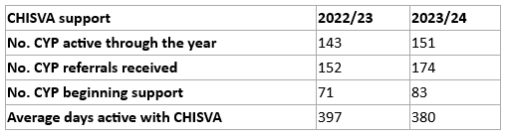

In 2022/23 100% of children and young people who had support from a CHISVA (which due to lengthy delays in the criminal justice system can often be for a lenghty period of time) said that they ‘strongly agreed’ that the CHISVA service had helped them, in 2023/2024 70% of those children and young people who provided feedback said that the service had helped them to improve their health and wellbeing.

Sheffield Rape and Sexual Abuse Centre (SRASAC) also provide a counselling service for children who have been harmed by sexual abuse and/or sexual violence. Before April 2024, this service was available to children aged 13 and over and the following numbers of children were referred and supported.

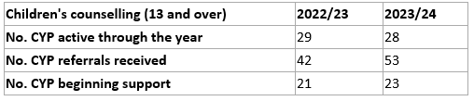

Since April 2024, the service has extended its remit to offer counselling to those aged under 13 years old, since this time;

* 20 referrals have been received for the counselling service; 4 were for children under 13 (0-12 yrs), the remaining 16 were for those aged 13-17.
* 20 CYP were active with the service; 1 was under 13 (aged 12), the remaining 19 were aged 13-17.

**6.4 Harmful Sexual Behaviour**

Hackett’s overview of research and crime statistics[59] suggests that between one and two thirds of sexual abuse is committed by other children. In Sheffield, where there are concerns about children’s harmful sexual behaviour they are referred to the Vulnerable Adolescent Team within the Edge of Care Service, in a 12 month period up to the end of November 2023, there were 87 children referred for specialist support to this team.

Sheffield holds a HSB panel meeting twice a month, where a range of behaviours are discussed, from children who have early identified problematic harmful sexual behaviour to those who are on police bail and/or involved with the criminal justice system.

The age of children being referred was 14 to 15 years old, with the youngest child being 7 years old.

Out of a total of 55 children who are supported via the HSB tracker, 87% are male

**Recommendation: Consider awareness raising re HSB and the link to trauma and ACEs.**

**Recommendation: Continue to develop work on healthy relationships and consent in schools.**

**Recommendation: Consider the commissioning of more Escape the Trap Training and a more co-ordinated approach to programme delivery**

1. **Recommendations summary**

* Over the course of the strategy work with commissioned providers and partners to ensure that all children of victim/survivors and perpetrators of abuse are recorded accurately to ensure more accurate prevalence estimates.
* Given the high prevalence of stalking and harassment offences noted by SYP, DACT to work with partners to gather data to better understand the prevalence of post separation abuse and its impact on children and young people.
* Work with partners and providers to gather data on numbers of Young Person’s DASH risk assessments being completed, complete risk level and referral source.
* Ensure that existing pathways to support young people experiencing domestic abuse perpetrated by a family member (including parent/carer) are promoted/strengthened/refreshed. Promote the use of the young person’s DASH risk assessment in the context of adult family violence.
* Work with partners to ensure that behaviour change interventions for young people are appropriate and accessible for those with alternative learning needs.
* Work with education, social care, youth services to make identification, assessment and support to 16 and 17 year old victim/survivors of domestic abuse a priority for the strategy.
* During the course of the strategy, we will work with partners to increase awareness of and gather more reliable prevalence data on AFV and children.
* During the course of the strategy, work closely with local by and for services to create a more robust data set to better understand the prevalence of HBA and harm caused to children.
* During the course of the next strategy, improve data collection on post separation abuse and the continued harm to children, using the data to support better identification and to demonstrate the necessity for specialist support for survivors and their children and to evidence the need for further training for specialist organisations such as CAFCASS.
* Once the statutory definition for CAPVA is agreed, work with partners to gather more reliable prevalence data.
* DACT continue to commission specialist young person’s behaviour change intervention.
* DACT to support on the development of the city’s new Hidden Harm Strategy and on the development of a citywide response to trauma-informed working.
* Continue to build Social Care’s understanding and knowledge around domestic abuse, using the Safe and Together model.
* Ensure that all social workers have accessed DASH training/consider making DASH training mandatory for all children’s social workers.
* Continue to develop knowledge and understanding about domestic abuse across all Early Help. In year one of the strategy, work with FIS managers to undertake a skills/competencies audit about domestic abuse in FIS.
* Ensure that all FIS workers have accessed DASH training/consider making DASH risk assessment training mandatory for all FIS workers.
* Continue to develop and embed the Safe and Together model into all children’s services, with a continued offer to social care along with a focus on Early Help services and an offer to partners, such as health and third sector organisations.
* Continue to investigate ways in which to gather data to evaluate the effectiveness of the S&T model (for example, numbers of re-referrals to social care due to domestic abuse, numbers of children becoming looked after as a result of domestic abuse etc)
* Continue to develop and promote the Caring Dads programme across children’s services, including with specially trained staff in Early Help services with a view to intervene at the earliest opportunity.
* Given the link between domestic abuse and children at risk of exclusion, ensure that there is a continued Safe and Together offer for the Attendance and Inclusion Service, along with continued efforts to establish a network of domestic abuse champions within school settings.
* Consider an audit of the numbers of Designated Safeguarding Leads who have completed the ‘Key-Adult’ training about how to respond effectively to Encompass notifications and also review training materials to ensure content remains helpful and appropriate.
* Work with Education Safeguarding Advisors to ensure that Designated Safeguarding Leads in the most frequently Encompass notified schools have accessed domestic abuse training.
* Given issues around capacity and demand in the city, a business case for more funding for DA support services for children and young people, including those in refuge and other domestic abuse safe acommodation to be written to coincide with the strategy launch.
* During the course of the strategy, consider an annual refresh of the DA services mapping to enable gaps in provision to be identified and progress evidenced.
* Work with partners to increase awareness of signs and indicators of childhood sexual abuse. Consider partnership communication campaigns around risk of, and harm caused by, online abuse.
* Ensure that training content regarding tech enabled VAWG/children and young people and domestic and/or sexual abuse keeps up to date with rapid developments in this sphere, i.e. the risks posed by more sophisticated Artificial Intelligence.
* The numbers of children who have experienced sexual abuse supported by statutory services are lower than prevalence estimates, during the course of the strategy work to raise awareness of sexual abuse, exploitation and children.
* Consider awareness raising re HSB and the link to trauma and ACEs.
* Continue to develop work on healthy relationships and consent in schools.
* Consider the commissioning of more Escape the Trap Training (or similar young person’s relationship education programme) and work with partners to establish a more co-ordinated approach to programme delivery

1. Katz, Emma, Anna Nikupeteri and Merja Laitinen (2020) When Coercive Control Continues to Harm Children: Post-Separation Fathering, Stalking, and Domestic Violence. Child Abuse Review. vol. 29, no. 4, pp. 310-324. Available from: [https://onlinelibrary.wiley.com/doi/10.1002/car.2611](https://eur03.safelinks.protection.outlook.com/?url=https%3A%2F%2Fonlinelibrary.wiley.com%2Fdoi%2F10.1002%2Fcar.2611&data=05%7C01%7CLydia.Partington%40sheffield.gov.uk%7C353e3f8b1e9b4ffabf9608db0f6308e3%7Ca1ba59b9720448d8a3607770245ad4a9%7C0%7C0%7C638120691352499350%7CUnknown%7CTWFpbGZsb3d8eyJWIjoiMC4wLjAwMDAiLCJQIjoiV2luMzIiLCJBTiI6Ik1haWwiLCJXVCI6Mn0%3D%7C3000%7C%7C%7C&sdata=qfsa1A%2BeN8BOzbDjd7ItfBqZAcyKT40ppAPNdzicQ8k%3D&reserved=0)  
2. <https://www.safeguardingsheffieldchildren.org/scsp/scsp-information/annual-report-business-plan-and-workforce-development-strategy>
3. <https://safelives.org.uk/research-policy-library/childrens-services-briefing/>
4. [DAC_Mapping-Abuse-Suvivors_Summary-Report_Nov-2022_FA.pdf (domesticabusecommissioner.uk)](https://domesticabusecommissioner.uk/wp-content/uploads/2022/11/DAC_Mapping-Abuse-Suvivors_Summary-Report_Nov-2022_FA.pdf)
5. [The-Domestic-Abuse-Commissioner-for-England-and-Wales_-Response-to-Government-consultation-on-Childrens-Social-Care-Stable-Homes-Built-on-Love-1.pdf (domesticabusecommissioner.uk)](https://domesticabusecommissioner.uk/wp-content/uploads/2023/06/The-Domestic-Abuse-Commissioner-for-England-and-Wales_-Response-to-Government-consultation-on-Childrens-Social-Care-Stable-Homes-Built-on-Love-1.pdf)
6. [Children in need, Reporting year 2023 – Explore education statistics – GOV.UK (explore-education-statistics.service.gov.uk)](https://explore-education-statistics.service.gov.uk/find-statistics/characteristics-of-children-in-need)
7. [Latest statistics on Children in Need in England | Children's Commissioner for England (childrenscommissioner.gov.uk)](https://www.childrenscommissioner.gov.uk/blog/latest-statistics-on-children-in-need-in-england/#:~:text=CIN%20plans%20set%20out%20the,likely%20to%20suffer%20significant%20harm.)
8. Dickens et al (2022) Learning for the future: final analysis of serious case reviews, 2017 to 2019, Department for Education.
9. [Over 827,000 children estimated to have experienced domestic abuse this year, with concerns of increase at Christmas underscoring urgent need for stronger support - Foundations](https://foundations.org.uk/press-release/over-827000-children-estimated-to-have-experienced-domestic-abuse-this-year-with-concerns-of-increase-at-christmas-underscoring-urgent-need-for-stronger-support/#:~:text=Staggering%20new%20figures%20reveal%20that,rise%20over%20the%20Christmas%20holidays)
10. <https://safelives.org.uk/about-domestic-abuse/what-is-domestic-abuse/facts-and-figures/>
11. <https://www.womensaid.org.uk/wp-content/uploads/2024/02/Annual-Audit-2024.pdf>
12. <https://forbabyssake.org.uk/news/2024/08/08/babies-present-at-police-callouts-for-domestic-abuse/>
13. South Yorkshire Police Problem Profile
14. [So-Called Honour-Based Abuse | The Crown Prosecution Service (cps.gov.uk)](https://www.cps.gov.uk/legal-guidance/so-called-honour-based-abuse)
15. [Sheffield Children Safeguarding Partnership - Female Genital Mutilation (safeguardingsheffieldchildren.org)](https://www.safeguardingsheffieldchildren.org/scsp/topics/female-genital-mutilation)
16. FGM Strategy
17. [Female Genital Mutilation, January - March 2024 - NHS England Digital](https://digital.nhs.uk/data-and-information/publications/statistical/female-genital-mutilation/january---march-2024)
18. [FGM 2024 Q1 - Summary Report.pdf (digital.nhs.uk)](https://files.digital.nhs.uk/12/AEFB0D/FGM%202024%20Q1%20-%20Summary%20Report.pdf)
19. [Health and Care Act 2022 (legislation.gov.uk)](https://www.legislation.gov.uk/ukpga/2022/31/contents/enacted)
20. <https://www.legislation.gov.uk/ukpga/2022/28>
21. [Child Marriage (pcdn.co)](https://s40641.pcdn.co/wp-content/uploads/Child-Marriage-Factsheet.pdf)
22. <https://schoolsweek.co.uk/labour-education-bill-to-feature-in-kings-speech/>
23. [Family courts and domestic abuse (idas.org.uk)](https://familycourts.idas.org.uk/)
24. [IDAS](https://idas.org.uk/)
25. [PRACTICE DIRECTION 27C – ATTENDANCE OF IDVAs AND ISVAs – Justice UK](https://www.justice.gov.uk/courts/procedure-rules/family/practice_directions/practice-direction-27c-attendance-of-idvas-and-isvas)
26. [Defining child to parent abuse - GOV.UK (www.gov.uk)](https://www.gov.uk/government/consultations/defining-child-to-parent-abuse)
27. <https://www.respect.org.uk/pages/114-capva>
28. [CAPVA-Rapid-Literature-Review-Exec-Summary-November-2021-Baker-and-Bonnick.pdf (domesticabusecommissioner.uk)](https://domesticabusecommissioner.uk/wp-content/uploads/2021/11/CAPVA-Rapid-Literature-Review-Exec-Summary-November-2021-Baker-and-Bonnick.pdf)
29. <https://www.ons.gov.uk/visualisations/censusareachanges/E08000019/>
30. [Mayor announces ground-breaking research into child-to-parent violence | London City Hall](https://www.london.gov.uk/press-releases/mayoral/mayors-new-research-into-child-to-parent-violence)
31. <https://www.london.gov.uk/sites/default/files/comprehensive_needs_assessment_of_child-adolescent_to_parent_violence_and_abuse_in_london.pdf>
32. <https://cranstoun.org/help-and-advice/domestic-abuse/inspire-to-change/>
33. <https://developingchild.harvard.edu/resources/aces-and-toxic-stress-frequently-asked-questions/>
34. <https://www.ncmd.info/>
35. <https://www.safeguardingsheffieldchildren.org/assets/1/threshold_of_need_document_for_sheffield.pdf>
36. [About the Safe & Together™ Model | Safe & Together Institute (safeandtogetherinstitute.com)](https://safeandtogetherinstitute.com/the-sti-model/model-overview/)
37. [Frontiers | Domestic Violence and Education: Examining the Impact of Domestic Violence on Young Children, Children, and Young People and the Potential Role of Schools (frontiersin.org)](https://www.frontiersin.org/journals/psychology/articles/10.3389/fpsyg.2018.02094/full)
38. [Home : Operation Encompass](https://www.operationencompass.org/)
39. [OE_Impact_Report_2024_May_Update.pdf (operationencompass.org)](https://www.operationencompass.org/SM4/Mutable/Uploads/medialibrary/OE_Impact_Report_2024_May_Update.pdf)
40. [committees.parliament.uk/writtenevidence/117166/html/](https://committees.parliament.uk/writtenevidence/117166/html/)
41. <https://www.southyorkshire-ca.gov.uk/>
42. [Violence Reduction Unit (VRU) | Violence Reduction Unit (VRU) (southyorkshireviolencereductionunit.com)](https://southyorkshireviolencereductionunit.com/)
43. [Sheffield Young Carers | Dedicated to helping young carers across Sheffield](https://www.sheffieldyoungcarers.org.uk/)
44. [Domestic Abuse Act 2021 (legislation.gov.uk)](https://www.legislation.gov.uk/ukpga/2021/17/contents)
45. <https://www.ons.gov.uk/peoplepopulationandcommunity/crimeandjustice/articles/childsexualabuseinenglandandwales/yearendingmarch2019#what-do-we-know-about-the-prevalence-of-sexual-abuse-during-childhood->
46. <https://learning.nspcc.org.uk/media/jwhpwojz/statistics-briefing-child-sexual-abuse.pdf>
47. Radford, L. et al. (2011) Child abuse and neglect in the UK today. London: NSPCC.

    <https://learning.nspcc.org.uk/research-resources/pre-2013/child-abuse-neglect-uk-today/>
48. [Trends in official data | CSA Centre](https://www.csacentre.org.uk/research-resources/research-evidence/scale-nature-of-abuse/trends-in-official-data/)
49. [Child sexual abuse: statistics briefing (nspcc.org.uk)](https://learning.nspcc.org.uk/media/jwhpwojz/statistics-briefing-child-sexual-abuse.pdf)
50. Hackett, S. (2014) Children and young people with harmful sexual behaviours. London: Research in Practice.
51. <https://www.everyonesinvited.uk/>
52. [Crime in England and Wales - Office for National Statistics (ons.gov.uk)](https://www.ons.gov.uk/peoplepopulationandcommunity/crimeandjustice/bulletins/crimeinenglandandwales/yearendingmarch2022)
53. [National Policing Statement 2024](https://cdn.prgloo.com/media/034ed60aa6564c1fbdcfb03fd8e6a210.pdf)
54. [National Policing Report 2024](https://cdn.prgloo.com/media/034ed60aa6564c1fbdcfb03fd8e6a210.pdf)
55. [Child sexual abuse in England and Wales - Office for National Statistics (ons.gov.uk)](https://www.ons.gov.uk/peoplepopulationandcommunity/crimeandjustice/articles/childsexualabuseinenglandandwales/yearendingmarch2019#what-do-we-know-about-the-prevalence-of-sexual-abuse-during-childhood-)
56. <https://www.ons.gov.uk/visualisations/censusareachanges/E08000019/>
57. <https://learning.nspcc.org.uk/media/jwhpwojz/statistics-briefing-child-sexual-abuse.pdf>
58. [National Policing Statement 2024](https://cdn.prgloo.com/media/034ed60aa6564c1fbdcfb03fd8e6a210.pdf)
59. Hackett, S. (2014) Children and young people with harmful sexual behaviours. London: Research in Practice.