Birley Spa Primary Academy
Office Manager
Candidate
Information Pack:

Role: Office Manager

Salary:

Location: Birley Spa Primary Academy

Contract Type: Full-time

Contract Term: Permanent

Closing Date: Sunday 14th April 2024

We are now recruiting for an efficient and experienced Office Manager to lead our administrative team within the Academy.
The Office Manager will be responsible for ensuring the highest standards of administration across a number of aspects of school business including HR, Health and Safety, Governance, Procurement and Premises in addition to general school administration. This role forms part of the Academy leadership team and will be expected to make a major contribution to the strategic direction of the school. As the Office Manager you will need to be a capable individual with assured skills in admin, organising staff, HR and recruitment, compliance and customer service. The school are therefore looking for a committed individual with outstanding communication skills to play a key role in the busy day-to-day operation of the school.
We are looking for someone who will:
• Manage the full range of administrative support to the Headteacher and other leaders within the Academy
• Line manage the administrative function to ensure effective and efficient customer service to parents/carers and other colleagues
• Support and adhere to safeguarding procedures in relation to visitors to the Academy
• Ensure all pupil records are effectively managed
• Ensure all the administrative team are compliant with any relevant statutory or Academy processes in relation to pupil or staff data, equality and diversity requirements, health and safety procedures and safeguarding policies
• Ensure procurement processes are adhered to and that value for money is always considered
• Have knowledge of and apply all relevant HR procedures to support the Headteacher with staff management
• Ensure HR systems are updated daily and all information is accurate to link to payroll processing
• Prepare all documentation for both internal and annual audit processes
• Act on any recommendations that result from the Audit and the Trust
• Work with the Trust’s Health & Safety Officer to formulate, implement and monitor the Academy’s Health and Safety policy.
• Ensure a safe environment for the stakeholders of the Academy. Monitor statutory Health and Safety
• Participate in the work of the Academy through attendance at meetings and participation in working parties.
• Promote the Academy to different audiences and raise the profile within the local community

The successful candidate will:
• Have a strong background in administration and office management, ideally in the education sector
• Have excellent written and oral communication skills
• Be able to manage and work to tight deadlines with the ability to prioritise workloads effectively
• Be working with a supportive team in a modern, welcoming Academy
• Have access to regular CPD to ensure that personal skills are continuously improved
• Have wider support from Trust colleagues with opportunities for development

Application Forms:
Can be downloaded from the LEAD site, or can be obtained by email from Leanne Moore at leannemoore@birleyprimaryacademy.co.uk. Visits can also be arranged this way.
We are committed to safeguarding and promoting the welfare and safety of children and vulnerable adults and expect all staff to share this commitment. All successful candidates will be required to complete an Enhanced Disclosure and Barring Service Check.

We welcome applicants from diverse backgrounds and promote accessibility and inclusivity for all. L.E.A.D. Academy Trust is a committed to the recruitment and promotion of all on the basis of ability and suitability for the role irrespective of disability, race, gender, health, social class, sexual preference, marital status, nationality, religion, employment status or age. The Trust is committed to treating your application fairly on these grounds.

L.E.A.D. Academy Trust

L.E.A.D. Academy Trust comprises of twenty five academies across Nottingham, Leicester, Derby, Lincoln and Sheffield. Our philosophy is to; lead, empower, achieve and drive.

At the heart of our Trust is the development of outstanding leaders. We empower individuals in our schools to provide the highest quality education, enabling every pupil to realise their full potential. We have also been recognised by Ofsted as a leading academy sponsor, securing rapid and sustainable improvement through the research and application of best practice across operational areas.

The combination of autonomy and collaboration across key areas of leadership and management underpinned by shared vision, values and best practice positions L.E.A.D. as a truly unique Academy Trust.

To view our ‘L.E.A.D. Family Brochure’ please visit:
www.leadacademytrust.co.uk

To see the wonderful achievements, proud moments and diverse events happening across our Trust please follow our twitter account: @LEADAcadTrust

Our Leaders

One of the core priorities for the L.E.A.D. Academy Trust is the development of outstanding school leaders. We are dedicated to providing an organisation which will:
• develop inspirational school leaders for the future through high quality recruitment, professional development and coaching;
• invest in joint training, peer coaching, sharing good practice and professional dialogue in a climate of trust;
• continually improve, exploring new ways of working, alternative curriculums and innovation;
• strategically plan to produce the next generation of high quality school leaders.

The L.E.A.D. Teaching School Alliance

The L.E.A.D. Teaching School Alliance is a dynamic, cross-phase collaboration of schools committed to harnessing, nurturing and sharing the specific skills and attributes required to teach and lead in areas with diverse pupil populations. Everything we do in our schools is about providing children with an outstanding, broad and balanced education.

Our innovative Initial Teaching Training (ITT) route aims to increase the number of quality teachers in our schools. In addition, we offer a range of high quality Continuing Professional Development (CPD) for staff at all levels and tailored school-to-school support. We are keen to nurture and grow staff across our alliance and offer a range of opportunities to develop the leaders of tomorrow. By working in partnership with The University of Nottingham and other regional Universities, we are also creating a research culture within our alliance that will impact positively on teaching, learning and the achievement of young people.

Our Support

We provide a range of high quality, professional services to schools in nine core areas:

Financial Management

Project Management

Procurement

ICT Management

Human Resources

Leadership Development

Legal Support

Governor Support

Education

How to Apply

Please send a completed application form and covering letter, with a supporting CV if you wish to:
Leanne Moore, Regional Business Manager (leannemoore@birleyprimaryacademy.co.uk)

Closing Date: Sunday 14th April 2024

Applications will be reviewed upon receipt therefore shortlisted candidates may be contacted in advance of the closing date.

The L.E.A.D. Academy Trust is committed to safeguarding and promoting the welfare of children and young people and we can expect all staff and volunteers to share this commitment. This post is subject to an enhanced DBS check.
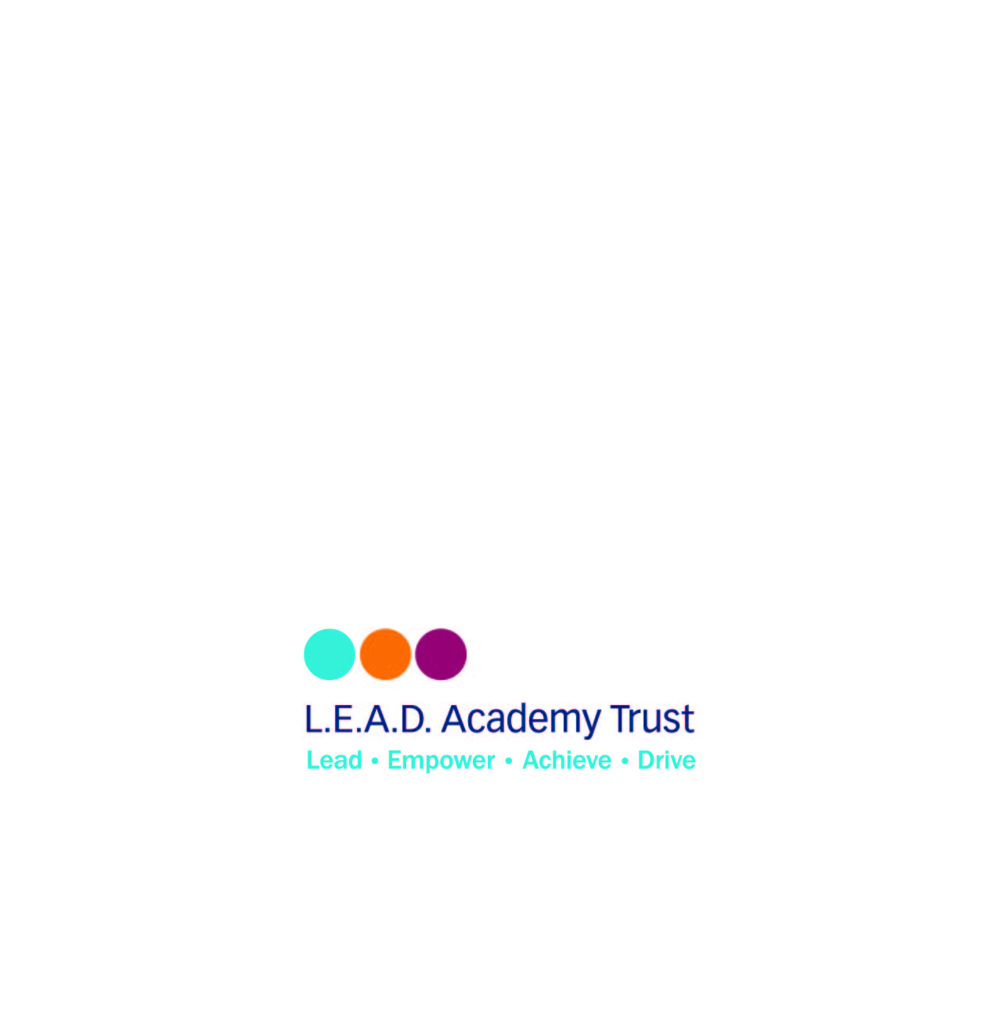
L.E.A.D. Academy Trust
5a The Ropewalk
Nottingham
NG1 5DU

Email: admin@leadacademytrust.co.uk

Telephone: 0115 822 5440

