**

**Sheffield City Council Armed Forces Community Newsletter**

**Edition Number 2**

**Welcome!**

Hello and welcome to the second edition of our Armed Forces Newsletter, produced by Sheffield City Council and issued on behalf of Sheffield’s Community Covenant Partnership Board. It has been a busy few months and we hope that you enjoy reading more about it.

**Sheffield’s New Armed Forces Champion**

We start this edition with a message from our new Armed Forces Champion

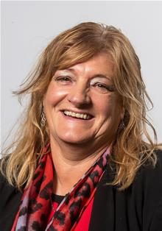

“Hello - my name is Cllr Denise Fox. I’m married with 2 children and 4 grandsons, who are full of energy but give me so much joy and laughter.

“I’ve recently been given the honour of becoming **Armed Forces** **Champion** for Sheffield City Council, and will still be carrying on with my role with the **Reserve Forces and Cadets Association.**I have taken over from Cllr Tony Downing who has stepped down for personal reasons. I would like to put on record my thanks for all he has done for the veterans and wish him well for the future.

“I have been a councillor for 18 years and was Lord Mayor in 2016/17. I chose the Soldiers Charity as one of my charities to raise money and to lift the profile of serving and veteran soldiers. I did this because of the experiences my father faced after he had fought in World War II, and to endeavour to deliver for those who are wanting help and assistance. Although my Dad is no longer with me, I felt I wanted to do something in his and his comrades’ memory.

“During my time as a local councillor and Lord Mayor, I have come across many veterans from all different regiments and services. My son served in the RAF, and my grandson is in the Royal Marine cadets. This has given me the opportunity to influence and deliver a number of events and more importantly to assist with individual personal casework and hopefully get the support that people need.

I look forward to meeting and working with you all.”

Paul Taylor will continue in his role as the Sheffield City Council Armed Forces Staff Lead.

**Sheffield Community Covenant Partnership Board (SCCPB) update**

The Armed Forces Covenant ensures that services:

* recognise the contribution made by the Armed Forces Community
* remember the sacrifices made by members of the Armed Forces Community
* share knowledge, experience and expertise to provide help and advice to members of the Armed Forces Community
* encourage the integration from service life into civilian life

The Sheffield Community Covenant Partnership Board has held two meeting since the last newsletter, the most recent being on 5th July. The minutes of that meeting will shortly be available on the Sheffield City Council Armed Forces website. Amongst other things the Board welcomed the new Armed Forces Champion, discussed the importance of and process for Armed Forces personnel joining and remaining on Council Housing Waiting List, and received an update on the efforts of Home Mess to seek to contact “hidden veterans” within our Sheffield Communities.

The Board had also had sight of a distressing email which set out details regarding historical instances (from as recently as the 1990’s) of gay soldiers being subjected to electroshock therapy and other Conversion Therapy practices. The Board noted its unanimous shock at and condemnation of these practices. The Board also noted that the Fighting with Pride charity is working to try to repair the damage done by these practices.

**Op COURAGE**

At the above meeting the Board also heard from Clare Haynes, Veteran Liaison Support Officer at Walking With The Wounded, about Op COURAGE – a Veterans’ Mental Health and Wellbeing Service.

Op COURAGE is an NHS-led service for forces leavers, veterans and their families. It is supported by trained professionals who are from or have experience of working with the armed forces community. We know that some people find life difficult after leaving the military and we’re here to help.  Working together with armed forces charities, we’ll help you get the right type of specialist care, support and treatment for your specific needs.

If you’re experiencing mental health problems and due to leave the armed forces, a reservist or have already left the military, or you are a family member or carer - Op COURAGE can help. Op COURAGE offers a range of specialist support and treatment, tailored to your specific needs. This includes:

* helping you to recognise and treat early signs of mental health problems, as well as more advanced mental health conditions and psychological trauma,
* providing support and treatment for substance misuse and addictions,
* liaising with charities and local organisations to support your wider health and wellbeing, such as help with housing, relationships, finances and employment,
* referring you to other NHS services where needed, and
* recognising that your family may also need help and care, and supporting them to access this.

If you live in the North of England and want to access Op COURAGE, you can do this by:

* Calling 0300 373 33 32
* Emailing: [OpCourageNORTH@cntw.nhs.uk](mailto:OpCourageNORTH@cntw.nhs.uk)

To find out more search [www.nhs.uk/opcourage](https://eur03.safelinks.protection.outlook.com/?url=http%3A%2F%2Fwww.nhs.uk%2Fopcourage&data=05%7C01%7CPaul.Taylor%40sheffield.gov.uk%7Cdd645a03eeff4d31caff08db8447a65b%7Ca1ba59b9720448d8a3607770245ad4a9%7C0%7C0%7C638249215556314278%7CUnknown%7CTWFpbGZsb3d8eyJWIjoiMC4wLjAwMDAiLCJQIjoiV2luMzIiLCJBTiI6Ik1haWwiLCJXVCI6Mn0%3D%7C3000%7C%7C%7C&sdata=0qVR7OVSbijbmDojPYTwqBd3hcPDzsotZBe7sKN3lIM%3D&reserved=0)

**Owls in Force!**

The Sheffield Wednesday Community Programme has recently become an active part of the Sheffield Community Covenant Partnership Board. The Programme has recently secured funding to work with Veterans. A launch event was held at Hillsborough on 7th June, with many members from the Armed Forces Owls Group attending. As well as hearing about potential activities for veterans to get involved with, guests were also treated to a tour of the ground and a chance to take pictures.

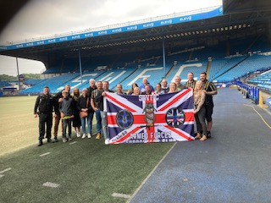

The activities being offered to veterans by the programme include a variety of gym sessions, and future plans include a Talk Club, Walking Football and possibly a matchday Breakfast Club. Veterans who are interested in being part of these activities can contact Sean Graves, Active Through Football Co-ordinator, by emailing [sean.graves@swfc.co.uk](mailto:sean.graves@swfc.co.uk).

**The Sheffield Armed Forces Directory**

Just a reminder that Sheffield City Council produces an Armed Forces Directory which directs members of the Armed Forces Community in the city to sources of help, support and advice both locally and nationally. The Directory is available online at [www.sheffield.gov.uk/armedforces](http://www.sheffield.gov.uk/armedforces) or paper copies can be made available (please contact [Paul.Taylor@sheffield.gov.uk](mailto:Paul.Taylor@sheffield.gov.uk)).

**Armed Forces and Veterans Day in Sheffield 2023**

This year’s Armed Forces and Veteran Day in Sheffield took place on Saturday 17th June. The weather stayed favourable and attendees were well entertained by the Ashby Big Band. The day saw the usual veterans parade and speakers at the event included the Lord Mayor of Sheffield, Cllr Colin Ross and the Council’s Armed Forces Champion, Cllr Denise Fox.

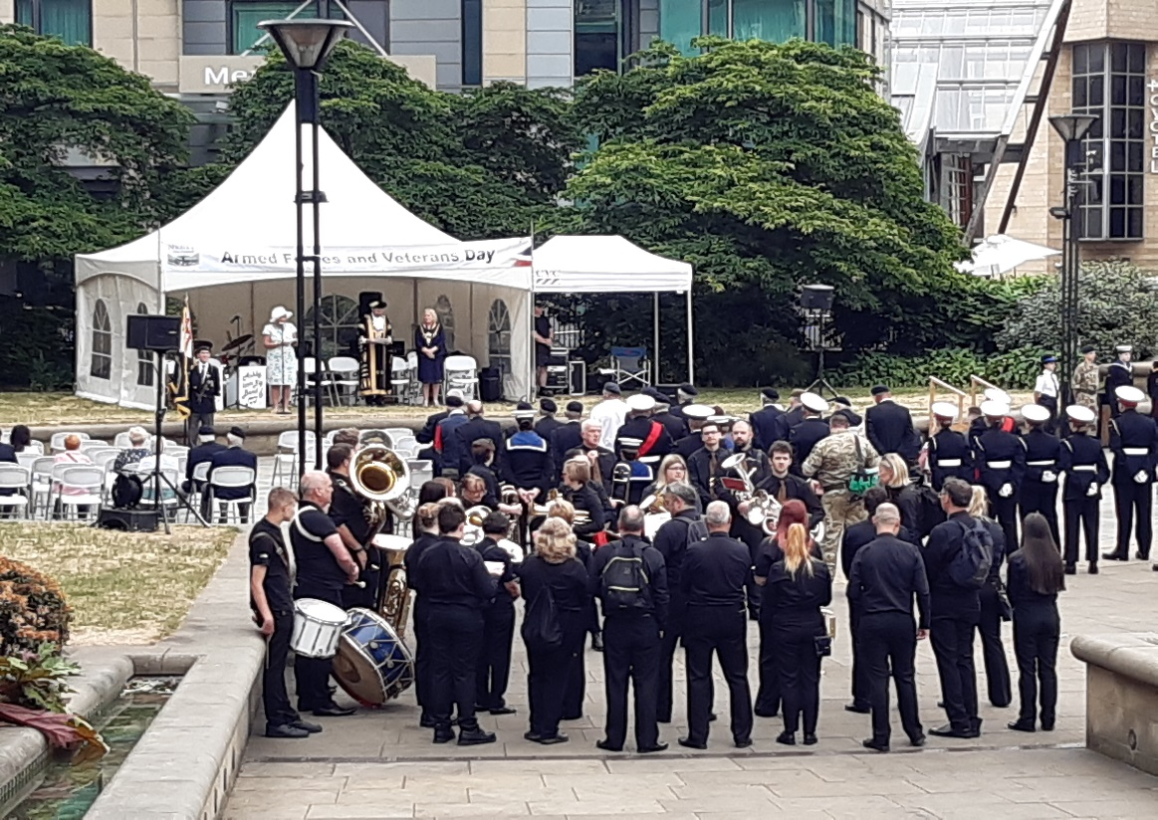

A number of organisations – including Royal British Legion, Home Mess, Sheffield Hallam University and Sheffield City Council - hosted stalls on the day of the event, and citizens were also able to learn more about the work and activities of various military bodies, as well as South Yorkshire Police. The interest shown by citizens highlighted that many people are very aware of the excellent service given by the Armed Forces community and veterans.

If anyone has any ideas for activities at next year’s Armed Forces Day we would be very happy to hear from them.

**21-Gun Salute**

Cllr Denise Fox, our new Armed Forces Champion, was delighted to join representatives from other Local Authority Covenant Signatories on 17th July for a 21 Gun Salute for Queen Camilla’s Birthday. The event took place in the York Museum Gardens.

As well as being a fantastic spectacle, the day provided a great opportunity to touch base with other Covenant colleagues, including those from the Reserve Forces and Cadets Association who provide hugely valuable support for our Armed Forces Community-related activities.

**Onwards to Edition number 3!**

That’s all for this edition; we would love to hear your comments about this newsletter or about anything that you might want to include in future editions. Please contact Paul Taylor – [Paul.Taylor@sheffield.gov.uk](mailto:Paul.Taylor@sheffield.gov.uk) You can also contact Paul if you would like paper copies of this newsletter.