Looking after your personal information
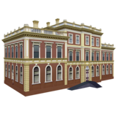 | We (Sheffield City Council) hold personal information about the people who use our services.
We use this information to:
- Understand your care and support needs.
- Give you the right information.
- Arrange services to meet your care and support needs.
- Understand if you or other people are at risk of abuse. And do something about it.
We store personal information securely.

We try to make sure the information is right.

We only keep the information for as long as it is needed.
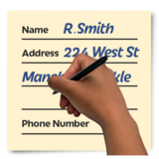 | What does this information include?  It includes personal details.  And which services are given.
You can ask to see your information by emailing us at : subjectaccess@sheffield.gov.uk or write to us at:
Resources Business Support
Sheffield City Council
PO Box 1283
Sheffield
S1 1UJ

Many of our services are provided with other organisations.

This means we need to share information to make sure services are right.

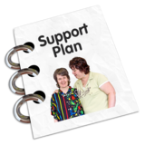 | We will ask your permission to do this.  You can say no, but it may mean you don't get all the services you need.
We can sometimes share information without people’s permission.

For example when someone is in danger or to stop a crime taking place.

You can find out more about your rights on the Council’s website www.sheffield.gov.uk/privacy

You can ask for a copy of this privacy notice by phoning First Contact 0114 2734908.

