**HANDWASHING**

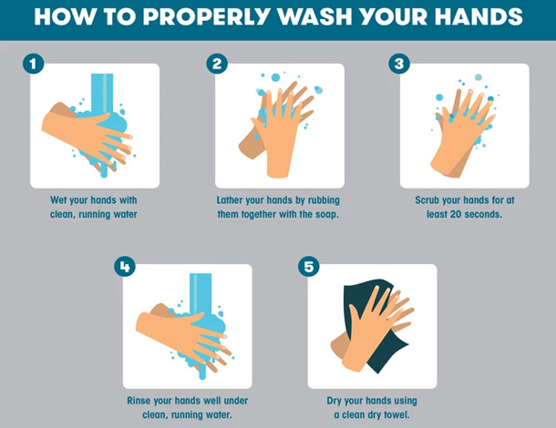

**What can be used?**

Hands can be cleaned with soap and warm water, however alcohol-based hand gel may be more convenient, especially when out and about.

**When to wash hands?**

* Before touching anyone
* Before doing tasks such as connecting a PEG feed or assisting with eyedrops
* After contact with bodily fluid, including saliva, blood, urine and faeces.
* After touching anyone
* After touching the immediate surroundings, such as a bed or chair

**Hand washing products**

* liquid hand soap
* paper towels, hand towels (washed regularly)
* Alcohol based hand gel preferably at least 60% alcohol

|  |  |  |  |
| --- | --- | --- | --- |
| **Author:** | Cinnamon Verge & Blake Williamson | **Version:** | 1.0 |
| **Approved by:** | Direct Payment Steering Group | **Published on:** |  |
| **Approved on:** | 2 November 2022 | **Review due:** | 1 November 2024 |

H:\Sheffield-CCG-PMS-Blue.emf