**

**Sheffield City Council Armed Forces Community Newsletter**

**Edition Number 1**

**Welcome!**

Hello, and a very warm welcome to the first edition of Sheffield City Council’s Armed Forces Community newsletter. We will be producing this newsletter on a twice-yearly basis, to let everyone in Sheffield – and in particular the Armed Forces Community – know what we have been doing, and have planned, in respect of Armed Forces Community support and activity in Sheffield. So, let’s start the first edition by sharing an item of exciting news….

**Sheffield gets the Gold!**

Sheffield City Council has been awarded the Defence Employer Recognition Scheme Gold Award by the Ministry of Defence for our support of the Armed Forces Community in Sheffield. The Council has held the Silver award for some time and we are both delighted and proud that the work we are doing to support the city’s Armed Forces Community is now deemed worthy of gold status. The application was worked up by Cllr Tony Downing, SCC’s Armed Forces Champion, and Paul Taylor, the Council’s Armed Forces Staff Lead, with support from our Community Covenant Partnership Board.

The award recognises not only the work going on with Armed Forces personnel and veterans within our communities, but also the Council’s support for its own personnel wishing to take on e.g. Reservist or part-time Armed Forces roles.

The awards were presented on 14th November following a 21 Gun Salute ceremony in York Museum Gardens for the Birthday of HM The King. Pictured above (left to right) are Lieutenant General James Swift OBE, Chief of Defence People, Paul Taylor, SCC Head of Customer Services and Armed Forces Staff Lead, Councillor Denise Fox, Councillor Tony Downing, SCC Armed Forces Champion and Mrs Johanna Ropner, Lord Lieutenant of North Yorkshire.

Going forward Sheffield City Council is resolved that our work with the Armed Forces Community will stay at the Gold standard for many years to come.

**Sheffield’s Armed Forces Champion – Cllr Tony Downing**

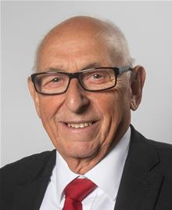 Councillor Tony Downing is Sheffield City Council’s current Armed Forces Champion. In his role as champion, Cllr Downing acts on behalf of the council to help reintegrate veterans back into civilian society and provides help and support for them. Cllr Downing chairs the Sheffield Community Covenant Partnership Board and is a source of help and advice around issues concerning the Armed Forces Community in our city.

Cllr Downing is also closely involved with both the Sheffield Sea Cadets and the HMS Sheffield Association. Cllr Downing was made an Honorary Life Member of the HMS Sheffield Association for his services to veterans in Sheffield. During his time as Lord Mayor (2019-2021) Cllr Downing actively encouraged events involving Armed Forces personnel.

Cllr Downing is supported in his Champion role by Paul Taylor, the Council’s Head of Customer Services, who acts as the Council’s Armed Forces Staff Lead.

**Sheffield Community Covenant Partnership Board (SCCPB)**

The Armed Forces Covenant ensures that services:

* recognise the contribution made by the Armed Forces Community
* remember the sacrifices made by members of the Armed Forces Community
* share knowledge, experience and expertise to provide help and advice to members of the Armed Forces Community
* encourage the integration from service life into civilian life

The Sheffield Community Covenant Partnership Board is made up of representatives of Sheffield City Council and our partners from across the city who have signed the Armed Forces Covenant, along with representatives from the Armed Forces Community and their families. The main focus of the Partnership Board is to enhance and join up the services, organisations and resources available for members of the Armed Forces Community in Sheffield. The Board meets every four months.

**The Sheffield Armed Forces Directory**

Sheffield City Council produces an Armed Forces Directory which directs members of the Armed Forces Community in the city to sources of help, support and advice both locally and nationally. The Directory was last updated in November 2021, and is available online at [www.sheffield.gov.uk/armedforces](http://www.sheffield.gov.uk/armedforces) or paper copies can be made available (please contact [Paul.Taylor@sheffield.gov.uk](mailto:Paul.Taylor@sheffield.gov.uk)).

**New Armed Forces Covenant Duty**

**Guidance around the new Armed Forces Covenant Duty came into force on 22nd November 2022.** The new Covenant Duty is a legal obligation on certain public bodies to ‘have due regard’ to the principles of the Armed Forces Covenant, and requires decisions about the development and delivery of certain services to be made with conscious consideration of the needs of the Armed Forces Community. The new legal obligation affects organisations that are responsible for delivering principally statutory functions in healthcare, education, and housing services. The Armed Forces Community will be affected as beneficiaries of the new Duty.

The new Covenant Duty will raise awareness amongst organisations that provide services in healthcare, education, and housing of how Service life can impact on the Armed Forces Community, and how disadvantages can arise due to Service when members of that community seek to access key local services.

The Duty will require organisations delivering local services to pay due regard to the Covenant principles when exercising functions in the areas of housing, healthcare, and education. “Due regard” means that organisations in scope of the Duty will need to consciously consider the unique obligations and sacrifices made by the Armed Forces; that it is desirable to remove disadvantages faced by the Armed Forces Community; and that special provision may be justified in some circumstances.

This new duty has been introduced because whilst there has been good progress under the Armed Forces Covenant to date, more work is needed to improve consistency of delivery.  The increased awareness that is inherent in the new Duty will help to improve delivery as understanding grows.

Service life affects serving personnel, veterans, and their families in many ways.  Whether it’s through frequent house moves, separation from loved ones and support networks, or unfamiliarity with civilian life. The Covenant Duty will raise awareness amongst providers of public services, like schools and hospitals, about how Service life can impact the Armed Forces Community.  In turn, this will lead to more informed policymaking as these organisations will better understand the uniqueness of Service and how this can cause disadvantage when accessing these services compared to civilians.

Key functions covered by the new Duty include issues such as: the allocation of social housing; healthcare waiting list policies; and schools’ admissions. The new Duty applies to organisations responsible for delivering education, healthcare, and housing services. A range of organisations are covered by the scope of the Duty, such as local authorities, NHS trusts, and schools and academies.

**Armed Forces and Veterans Day in Sheffield 2022**

Although it probably feels like a long time since last Summer, Saturday 18th June 2022 was Armed Forces and Veterans Day in Sheffield. Although there was a limited event in June 2021, this was the first full Armed Forces Day celebration since before the pandemic.

Armed Forces and Veterans Day honours the outstanding contribution made by current members of the armed forces and by veterans of all ages. The day provided an opportunity for us all to join together to pay tribute to our armed forces past, present and future. This year’s event marked the 40th anniversary of the end of the Falklands War and the sinking of HMS Sheffield, and provided a poignant opportunity to commemorate the service and sacrifice of those who lost or risked their lives.

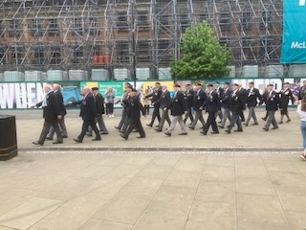

The day included a Veterans Parade and a ceremony which included speeches from the Lord Mayor, Cllr Tony Downing and Patricia Davey. The Ashby Big Band entertained everyone with wartime classics and some dancefloor favourites, and numerous organisations provided stalls and displays. These included those organisations working with the Armed Forces Community, Cadet groups and the Armed Forces themselves.

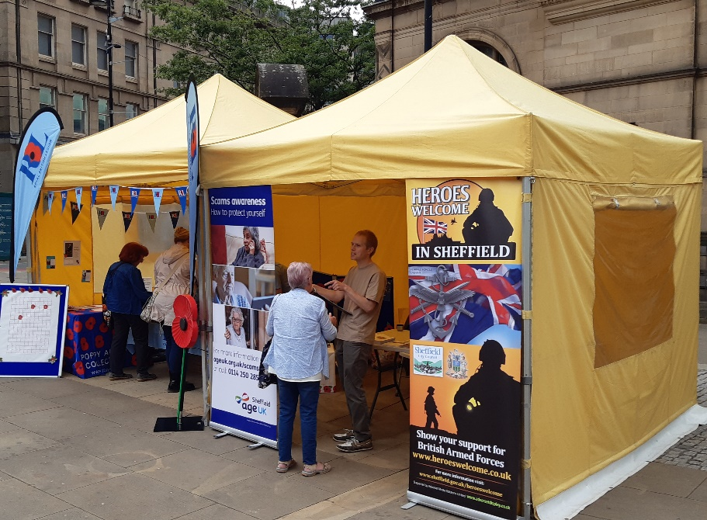

**That’s all for now**

We hope that you have enjoyed reading this first SCC Armed Forces Community Newsletter. We would love to hear your comments or about anything that you might want to include in future editions. Please contact Paul Taylor – [Paul.Taylor@sheffield.gov.uk](mailto:Paul.Taylor@sheffield.gov.uk)