Paper 4 - for agreement

Primary Schools Falling Rolls

Key Messages

Forum members are asked to:
- Note the potential impact of the current forecasts of city-wide/area-based primary schools.
- Agree the guiding principles for developing a school place planning action plan.
- Agree the allocation of a £250k fund from the growth fund in 2020/21 to support schools through a period of falling rolls and to receive an update in February 2021 to agree a top-slice of Schools Block to setup a Falling Rolls Fund for 2021/22

- Introduction/background
  - The number of births in Sheffield has been falling since 2012. This has resulted in a growing number of surplus places in primary schools and the expectation is that this trend will continue for the next few years.
  - Falling rolls across the city mean more schools are likely to move into a category of experiencing potential funding issues. Our work should seek to reduce the impact of this.
  - A financial support package may be required to support some schools in the short to medium-term during this period of falling rolls, to sustain schools where demand for places is anticipated to return
  - The fund would be underpinned by a policy which is balanced and equitable, supports a whole schools partnership approach and enables families to continue to access quality education in their area.

- The principles
  - The following guiding principles have been set out for school place planning:

- To ensure that every child in Sheffield has access to a great local school place.
- To ensure that schools are of the right size and in the right location to meet local demand for places.
- To ensure that school provision is sustainable and well placed to deliver high quality education that meets the needs of their local community and makes best use of public funding.
- Where there is sustained evidence that a school is failing to meet the needs of its local community and/or to deliver improved outcomes and/or is not financially viable, to explore a range of partnership solutions.
- To ensure any change to school organisation impacts positively on school performance and on the life chances of children.
- To support governing bodies and multi-academy trusts to review their viability.
- To develop an approach to school organisation review that enables stakeholders to engage fully and effectively in the process.
- Ensure that planning takes into account potential future population growth cycles and space is not lost where it could be utilised in the future.

- Primary school forecasts
  - Sheffield City Council produces forecasts of future demand taking into account factors such as births trend data, parental preference, housing growth and existing and planned capacity as well as patterns of inward and outward migration. Live birth rates are the primary driver.
  - Current forecasts suggest 2023/24 could be a city-wide “low point” after which ONS predictions are that birth rates will begin to rise again. ONS birth forecasts should however be treated with caution, and it should be noted some areas and schools will be affected more than others.
  - Whist periods of low birth rates create surplus places there remains a need to retain sufficient primary school provision for the system to expand with corresponding demand for school places.
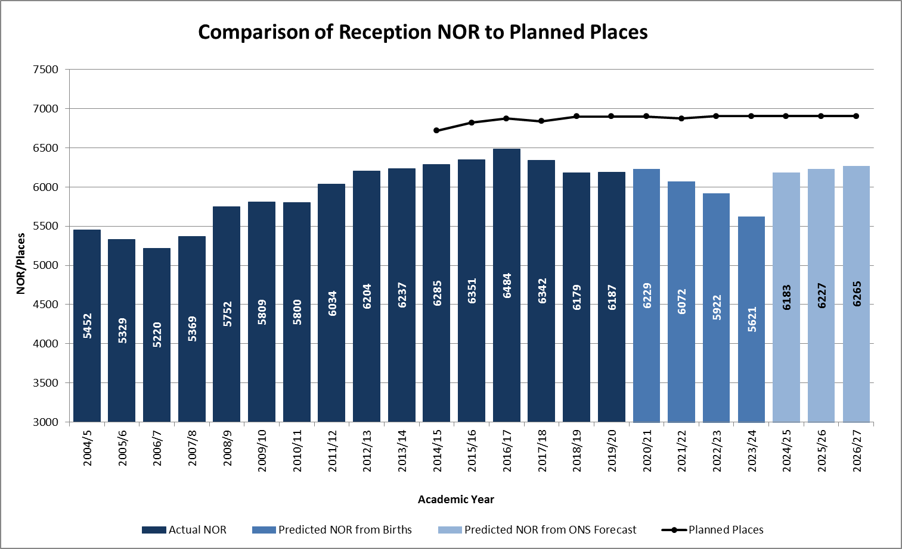

- RAG rating

  - We have produced a RAG rating system for schools against forecast surplus places in reception year averaged over a period of four years only in order to develop an action plan and prioritise areas for discussion. A total of nine primary schools have been identified as ‘Red’ and 28 as ‘Amber’.
  - These RAG ratings will be assessed against an “appraisal form” to consider other factors which may impact on a school’s viability. These are to include: pupil numbers across all year groups, fluctuation of pupil numbers (i.e. does the predicted NOR fluctuate or is there a sustained drop?), Ofsted rating, the actions of neighbouring primary schools such as planned reduction in PAN, and management of finances. This may result in change to current RAG rating.

- Finance

  - Principles for Consideration – the Falling Rolls Fund:
- National policy allows setting up of a Falling Roll Fund with the agreement of the Schools Forum.
- This could be funded from a virement from the school growth fund or could be funded through a Schools Block top-slice.
- Population vs popularity. While local authority should seek to meet parental preference, the primary concern must be to ensure there are sufficient places in a given area, and to support the sustainability of our schools.
- Local planning data shows that the surplus places will be needed within the next three financial years.
- Support is available only for schools judged Good or Outstanding at their last Ofsted inspection (this is a DFE mandatory requirement) although the Schools Forum may decide to allow all schools to apply no matter their Ofsted rating.
- Planned Reduction in Numbers on Roll is not the result of an agreed reduction in PAN.
- Falling rolls not as a result of bulge classes passing through.

  - The Schools Forum is asked to consider a contingency for schools who do not meet the criteria for the Falling Rolls Fund (i.e. Requires Improvement), but can demonstrate considerable improvements since the inspection through their action plan. This would need to be monitored as Ofsted inspections have been adjusted/delayed in light of Covid-19. Under the current RAG rating, two schools in the red category and five schools in amber have Requires Improvement rating. Consideration should also be given to schools that are ‘not yet inspected’; three are in Red and Amber category.

- Recommendations

Forum members are asked to:
- Agree to a £250k budget for falling rolls from a virement from the growth fund in 2020/21.
- Agree to fund all schools that meet the agreed criteria (to be developed).
- Agree to receive a further paper on the funding allocation process and criteria at the next meeting.

