Office Ref:……………….

DOMESTIC VEHICULAR CROSSING APPLICATION
HIGHWAYS ACT 1980 – SECTION 184

Please Note: The Application fee is £120. This is an administration fee only, which is non-refundable should your application be refused. Details of how to pay can be found at the end of this form.
Name of Applicant: Mr/Mrs/Miss/Ms/Dr

Tel:
Email:
Applicant Address:
Proposed Site Address/Crossing Location (If different from above):

1. Do you own the property at the proposed crossing location or is it rented?

 Private
 Private (Ex Council)
 Private rented*
 Housing Association*
 Council**

* If privately rented or Housing Association you will need written permission
from the Landlord.

** If Council owned you must first seek permission from Housing Services by emailing
RepairsPolicy&ImprovementsTeam@sheffield.gov.uk

2. Is the proposed crossing on a classified road?

You can check online at www.sheffield.gov.uk/highwayrecords
or by calling Highway Records on 0114 273 6125
 No
 Yes*

* If yes you will need to apply for Planning permission. The Planning Department can be contacted on (0114) 203 9183 or by email planningdc@sheffield.gov.uk. This requirement will not apply if the works are undertaken by AMEY as part of a maintenance scheme.

3. Is your house located within a conservation area or is it a listed building?

You can check by calling the Planning Department on (0114) 2039183
or email planningdc@sheffield.gov.uk
 No
 Yes*
* If yes you may require Planning permission for any works.

4. Do you have an existing vehicular crossing?

 No
 Yes*

*If you intend to extend an existing crossing please note the maximum
width for any one access is 6.3 metres (including taper kerbs and
your existing crossing).

5. Do you require a single or double width crossing?

 Single (4.5m including taper kerbs)
 Double (6.3m including taper kerbs)
 Other (please state) ………………………...
(please note the maximum is 6.3m including taper kerbs and your existing crossing)

6. Is the parking area less than 5m long, measured at right angles to the highway?

 No
 Yes

Please see the diagram at the end of this application for guidance.

7. Do you live close to a junction?

 No
 Yes*
* The crossing must be a minimum of 10 metres from any road junctions
(15 metres on major roads/busy junctions).

8. Do you live close to a bus stop?

 No
 Yes*
* The crossing must be a minimum of 1 metre from the bus stop.

9. Are there any trees near the proposed crossing?
 No
 Yes*
* To provide a suitable root protection area, the distance from the tree
trunk to the start of the proposed lowered kerb must be
greater than the circumference of the tree trunk x 4.
10. Are there any street lighting columns/BT poles/street furniture near to where you
would like the crossing?

 No
 Yes*
* The vehicle crossing must be a minimum of 1m away from any such
apparatus. Please refer to the diagram at the end of this application.

11. Are there any ironworks such as manhole covers in the footway or verge?

 No
 Yes*
*You may need to contact the utility company.

12. Is there a steep verge/footway?

 No
 Yes*
* If yes, you must check the gradient as anything greater than 1 in 6
may not be approved as it could lead to vehicles ‘grounding’.

13. Is there a parking bay or service strip in front of the property?

 No
 Yes*
* It may not be possible to use this location.

If you have answered Yes to any of the above questions (1 to 13) then
you may wish to contact us between 10am to 4pm on 0114 273 6136 or 07770 641 761
for advice before applying. If we are not available, please leave
an answerphone message and we will call you on our return to the office.

14. Can a 2 metre clear line of sight (visibility) be achieved
to the left and right of the proposed crossing?

 No
 Yes
Consideration will be given to the driver’s line of sight both vertically and horizontally.

15. Can the parking area within your property be built so that water does
not drain from it onto the highway?

 No*
 Yes
* It is an offence under the Highways Act to discharge water across the Highway.
You will need to install a suitable means of disposing of surface water run-off,
such as soakaways or the installation of a water permeable surface.
Please note: loose chippings/unbound surface materials are not permitted.

16. Does anyone other than the property owner have access rights across
the land you wish to park on/cross over?

 No
 Yes*
* If yes, you must provide written details of the access rights.

How we will use your information:

The information provided to us will be used to evidence exactly what has been applied for, granted or refused on an adopted highway under Section 184 of the 1980 Highways Act.

Who we will share your information with:

Your information will be used by the Council and we will share your information with the following third party: AMEY.

How long we will keep your information:

The information you provide will be kept for 3 years from the date of your permission/refusal letter

What are your rights:

You have rights under Data Protection law. For further details about your rights, the contact details of our Data Protection Officer and your right to make a complaint please see our Data Protection web page: https://www.sheffield.gov.uk/privacy

Signed:…………………………………….. Dated:………………………………..

Please include a sketch of the location of the proposed crossing and parking area with your application. Include measurements and indicate with a red line the outline of your ownership. A typical example is shown below.

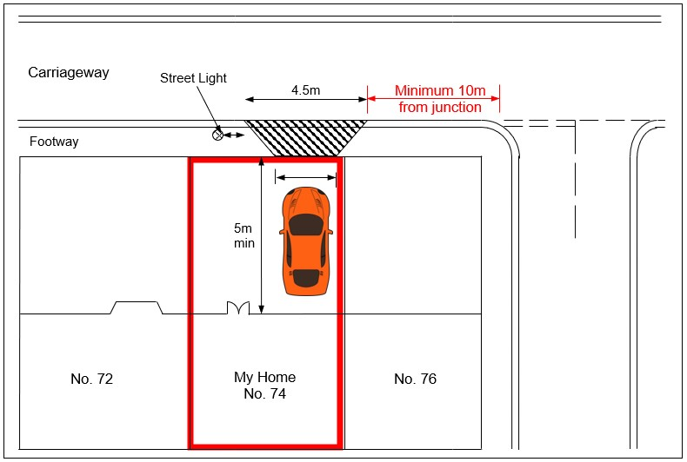

The application form should be returned to:
dawn.jones@sheffield.gov.uk

PLEASE NOTE IT CAN TAKE AROUND 10 WEEKS FROM RECEIPT OF YOUR APPLICATION TO RECEIVE NOTIFICATION OF OUR DECISION. Sheffield City Council, reserves the right to refuse any application for a vehicular crossing/access over a public highway. If you have any questions please contact us on:

Miss D Jones: 07770 641 761

Sheffield City Council does not carry out construction of the vehicle crossing/access. If permission is granted you will be required to pay your chosen contractor all costs associated with construction of the new crossing. A list of registered contractors can be viewed at: http://www.sheffield.gov.uk/home/parking/request-dropped-kerb

Should you wish to use any non-registered contractor, then we must approve them in advance of the works being carried out. They must hold £2,000,000 Public Liability Insurance and be accredited, at supervisor level, to work on the highway (written proof is required for our approval prior to the start of construction).

A maintenance period of 12 months shall commence from the date of completion of the crossing, you/your contractor may be held responsible for any defects to the crossing or adjacent public highway that arise during this period.

How to Pay:

Payment can be made securely online. A link to our pay site can be found at https://www.sheffield.gov.uk/home/parking/request-dropped-kerb

If you experience any issues with payment please email dawn.jones@sheffield.gov.uk

