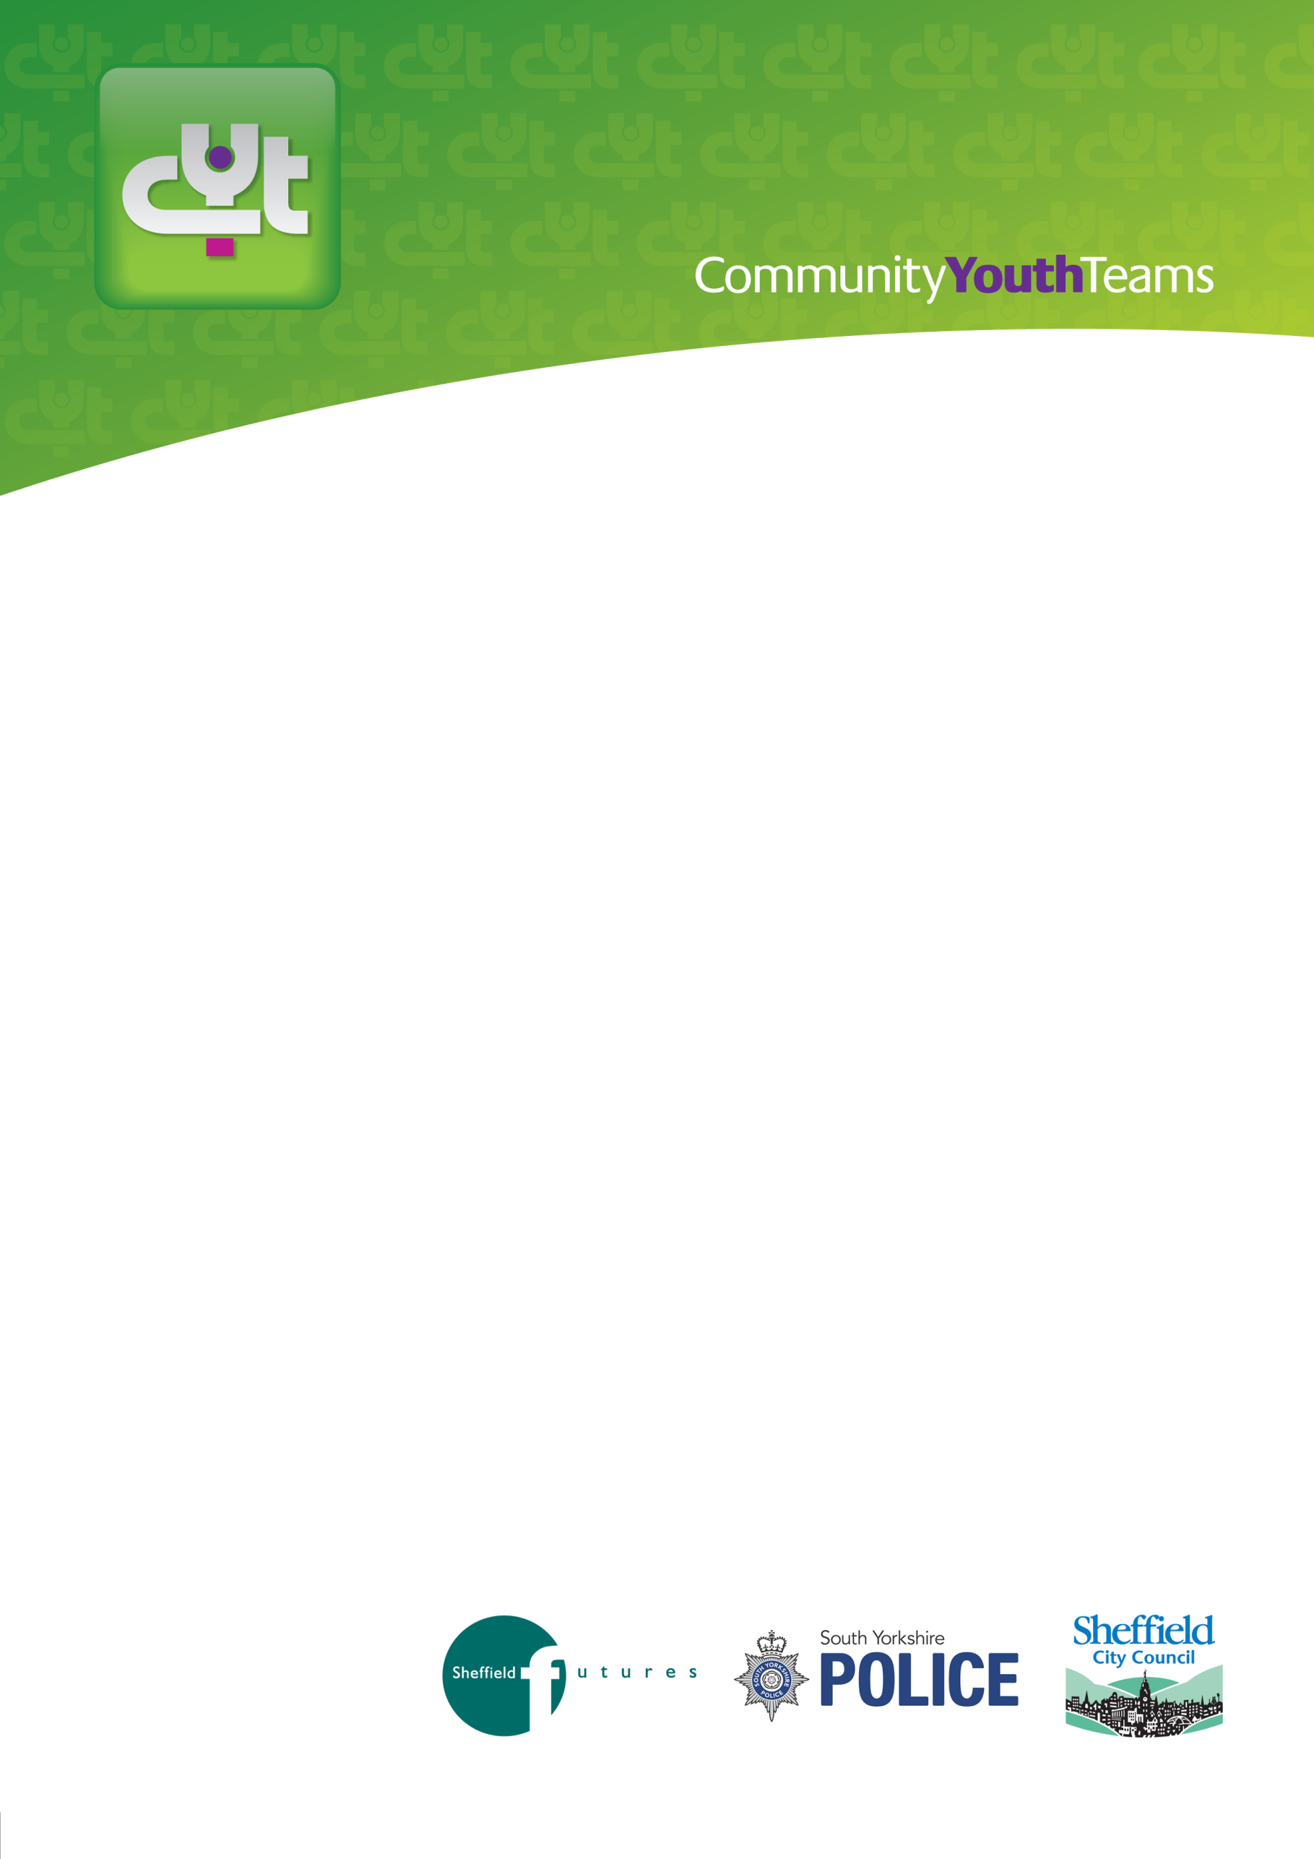

GROUP
REFERRAL FORM

Completed referrals to:
Post | CYT  Unit C7  Alison Business Centre  39/40 Alison Crescent  Sheffield  S2 1AS
Email | cyt@sheffield.gov.uk
For information or queries contact our Freephone number or visit our website | 0800 138 8381 or 0114 205 7450  Community Youth Teams (CYT) | Sheffield City Council

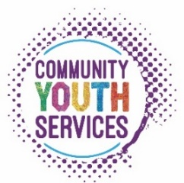

NOTE: If you have any specific concerns about an individual young person please complete a
Professional referral form.

 | Referring agency/individual:
Your name: ________________________________________________________________________________

Role: _____________________________________________________________________________________

Name of organisation: ________________________________________________________________________
Address: __________________________________________________________________________________

Post code: _____________________________

Tel no: ________________________________ Signed: ______________________________
E-mail: ________________________________ Date: ________________________________
 | Have any of the young people been recently referred to any other agencies/services? If yes, please include details on the following page | Yes ☐ No ☐ Don’t know ☐
 | Are any other agencies known to be working with any of these young people? If yes, please include details on the following page | Yes ☐ No ☐ Don’t know ☐
Name | Date of Birth | School (if known) | Status of young person within the group ‘leader’ or ‘follower’  or ‘unknown’
Please complete the following table for the young people you wish to refer:
REFERRAL DETAILS:
What are the main issues or concerns surrounding this group of young people that you would like CYT to address? Please include the behaviours of concern, any specific incidents and if there are any risks with the group working together.

SUMMARY OF GROUP REFERRAL AND FURTHER DETAILS
Please include any previous or current contact/support with any of the young people listed, i.e., previous involvement with CYT, Youth Justice Service, MAST etc. Include any recent referrals to other agencies.

CONSENT
- Please complete the following sheet and gain consent from all parents/carers and young people involved in this group referral.

- A meeting will take place between CYT staff and the referrer prior to starting the group-work to ascertain the content and level of the programme and risk assessment.

Parent/Carer Consent:

- I have had the referral process explained to me and I agree to this referral.

- I understand that this may involve an assessment of my child’s needs in order that appropriate support is planned.

- I agree that the information on this form and other relevant information held by partner agencies may be shared for the purpose of deciding which support is appropriate. The agencies involved are Community Youth Teams, Children & Young People and Families (SCC), Housing, Police, Health Services (including CAMHS), School and other voluntary and community agencies.

Signed_____________________________ (Parent/Carer) Date______________

Signed_____________________________ (Parent/Carer) Date______________

Young person’s consent:

Name: ___________________________________

Are you willing to work with the Community Youth Team? Yes ☐ No ☐

Signed___________________________________ (Young person)

Date_____________________________________

Parent/Carer Consent:

- I have had the referral process explained to me and I agree to this referral.

- I understand that this may involve an assessment of my child’s needs in order that appropriate support is planned.

- I agree that the information on this form and other relevant information held by partner agencies may be shared for the purpose of deciding which support is appropriate. The agencies involved are Community Youth Teams, Children & Young People and Families (SCC), Housing, Police, Health Services (including CAMHS), School and other voluntary and community agencies.

Signed_____________________________ (Parent/Carer) Date______________

Signed_____________________________ (Parent/Carer) Date______________

Young person’s consent:

Name: ___________________________________

Are you willing to work with the Community Youth Team? Yes ☐ No ☐

Signed___________________________________ (Young person)

Date_____________________________________

