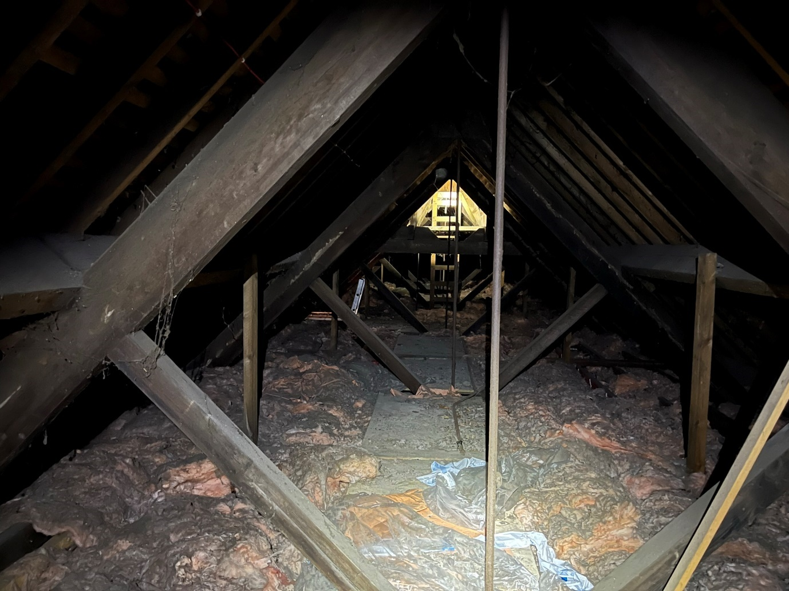

Roof truss inspection 1

Roof truss inspection 2

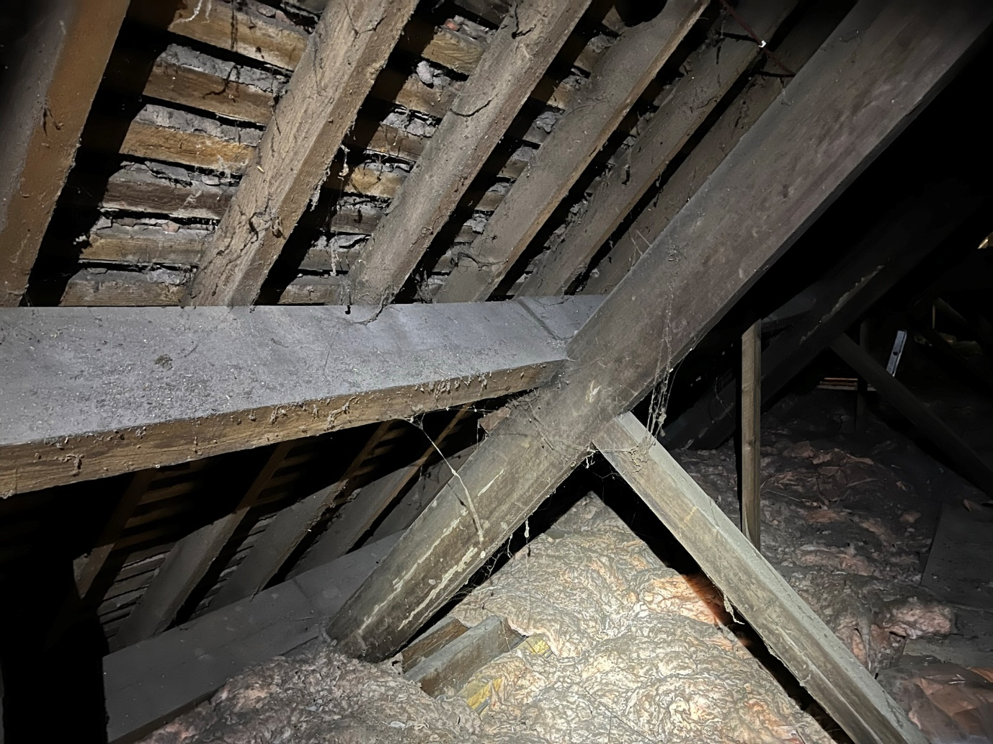

Roof truss inspection front 1

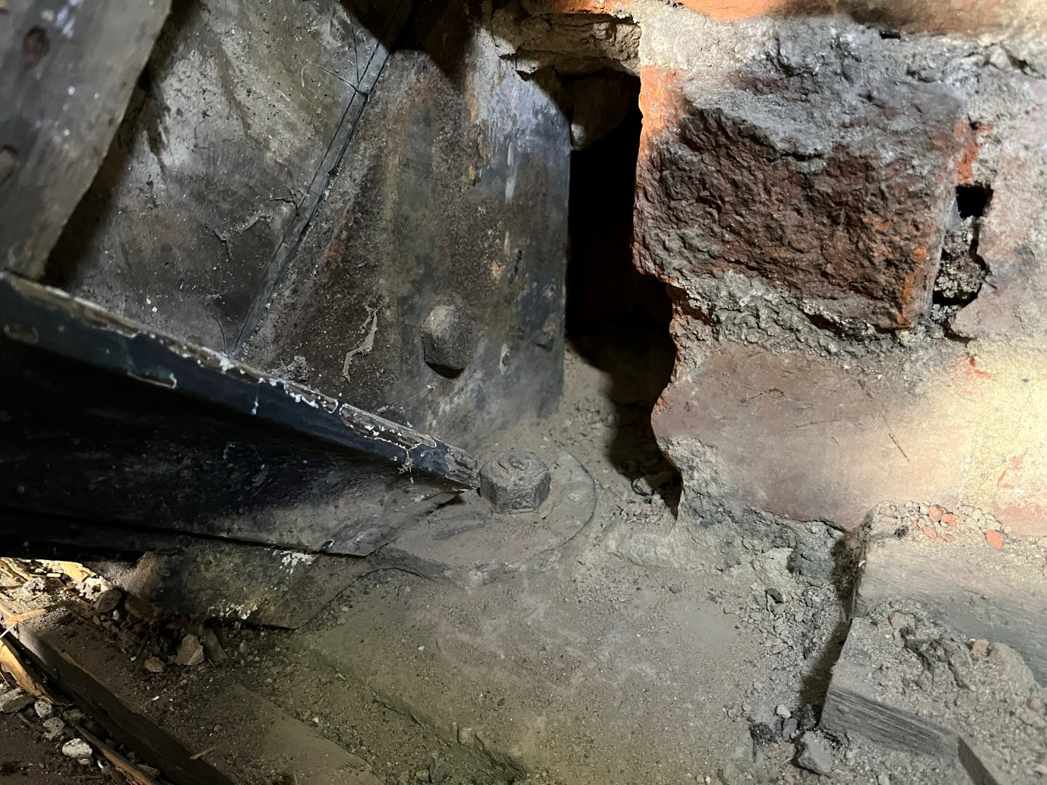

Roof truss inspection end 1

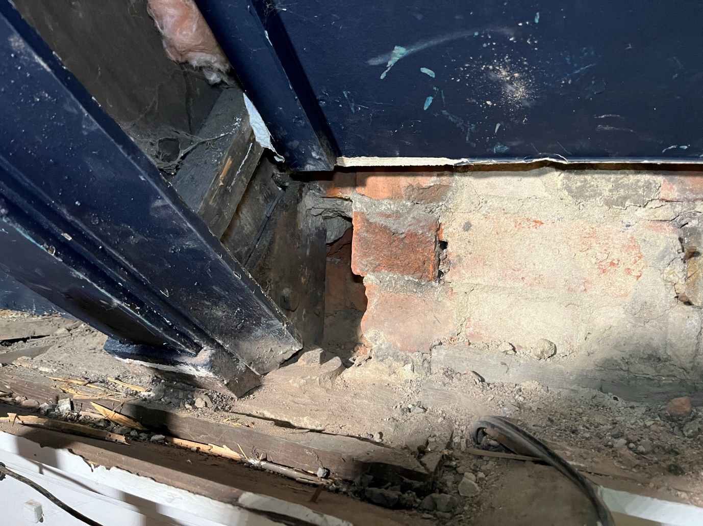

Roof truss inspection end 2

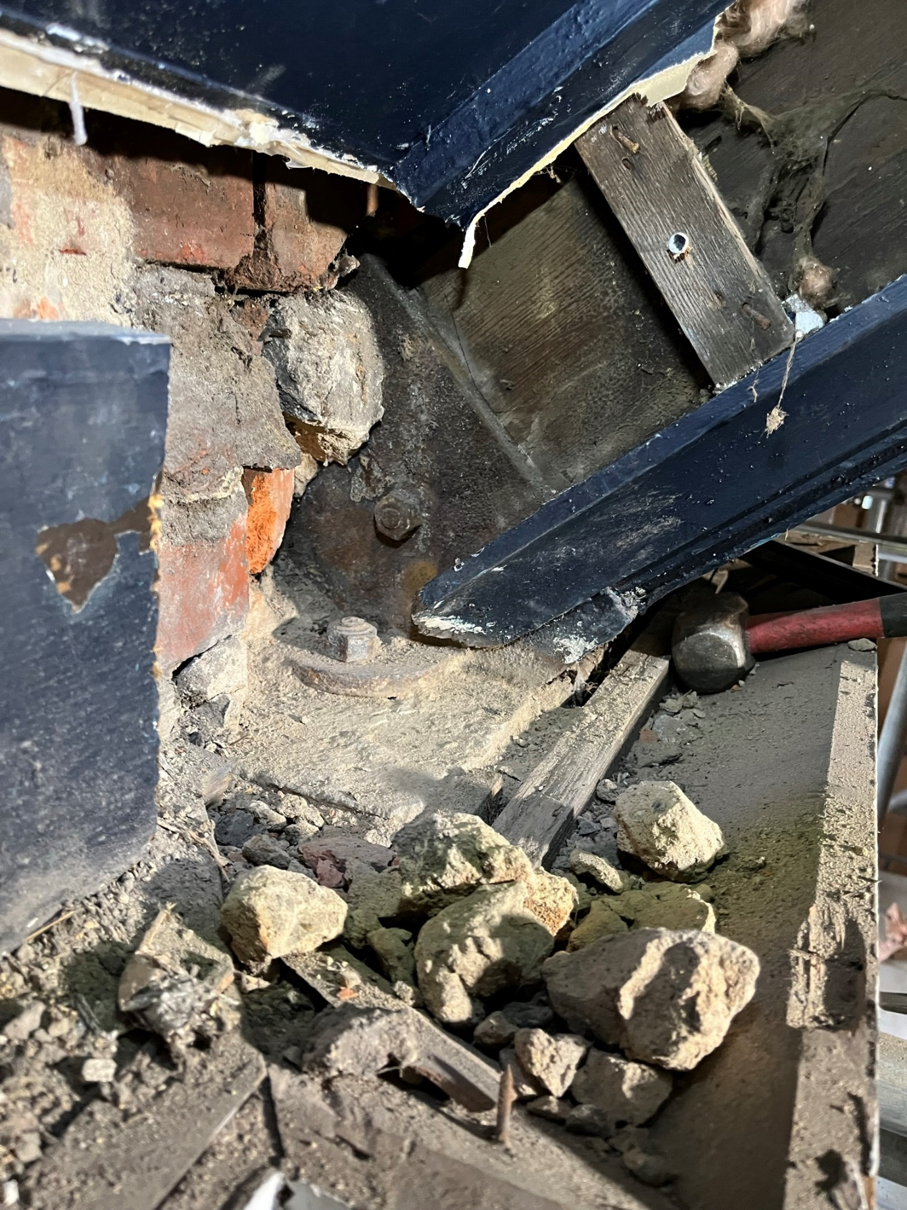

Roof truss inspection end 3

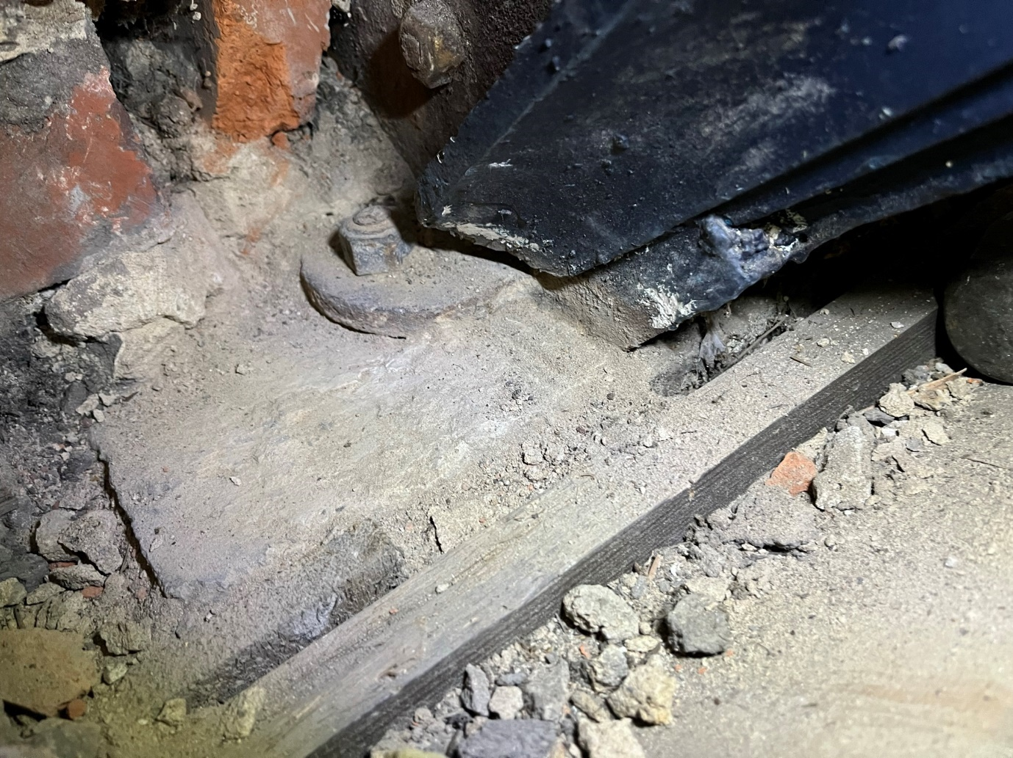

Roof truss inspection end 4